**Setup Java**

* Java VM version
* Java compiler version

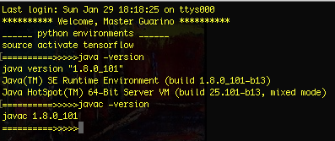

**Create an account on GitHub**

### Profile

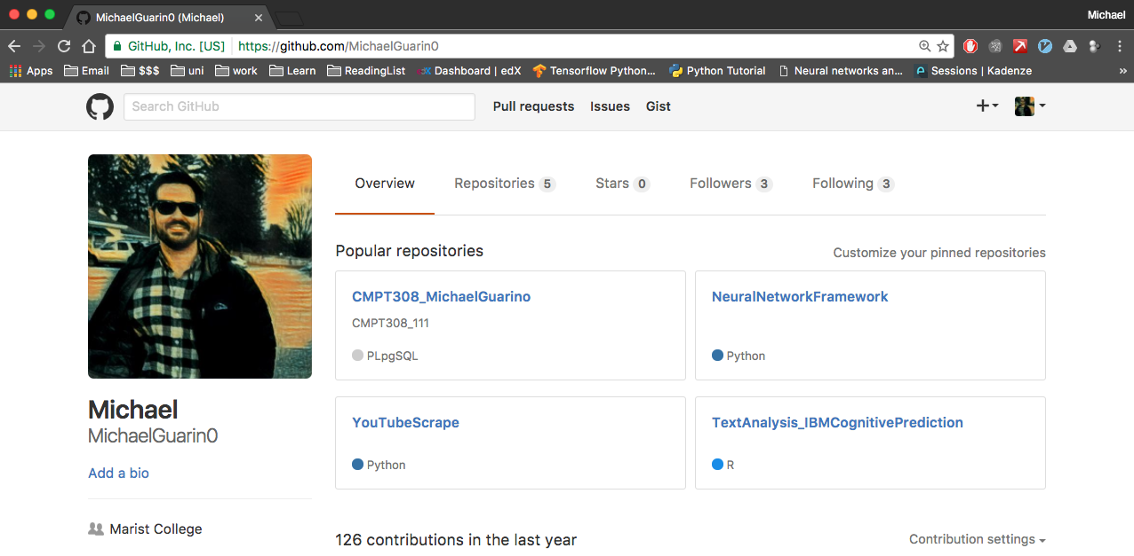

### Repository