User Manual — Requester
Who you are: a regular employee who needs to leave the premises, use a vehicle, or release items.
Creating a Request
1. Log in with your Employee ID and password.
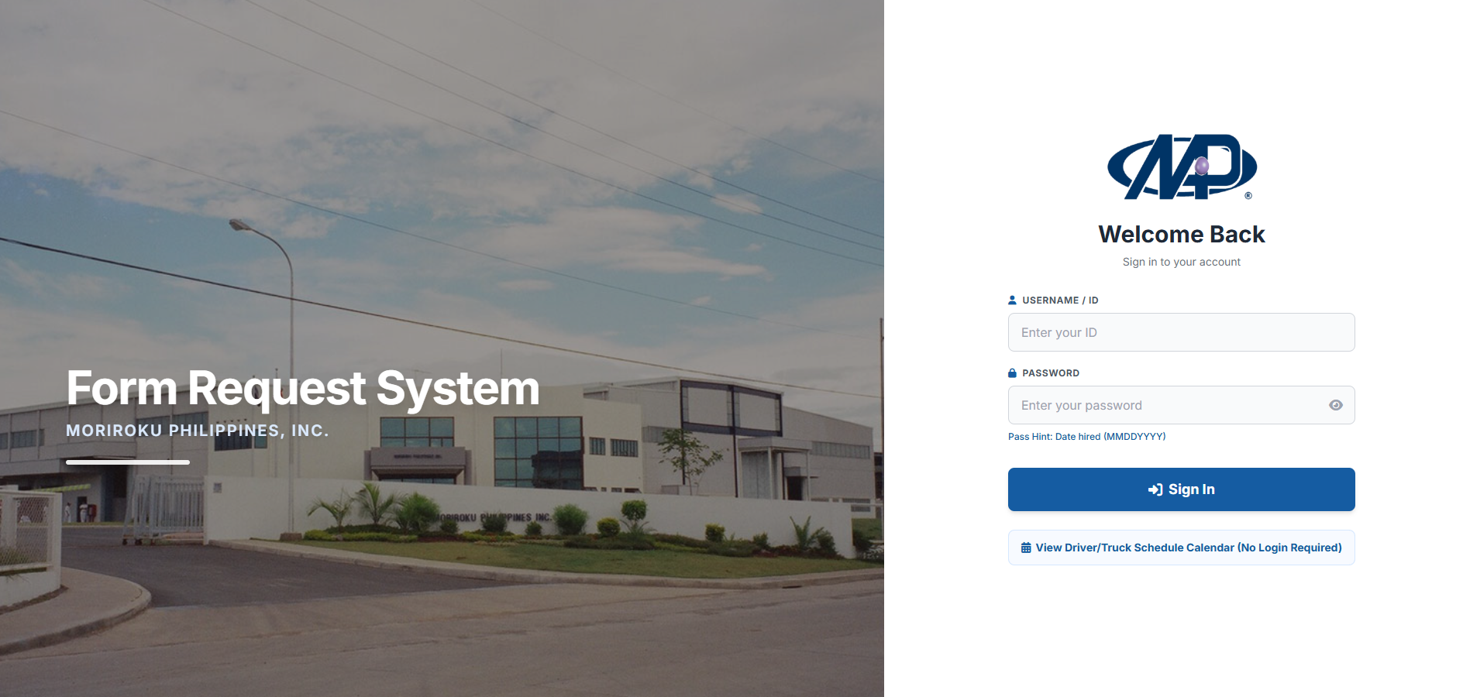

2. On the dashboard, choose the gate pass type (Person / Vehicle / Material).
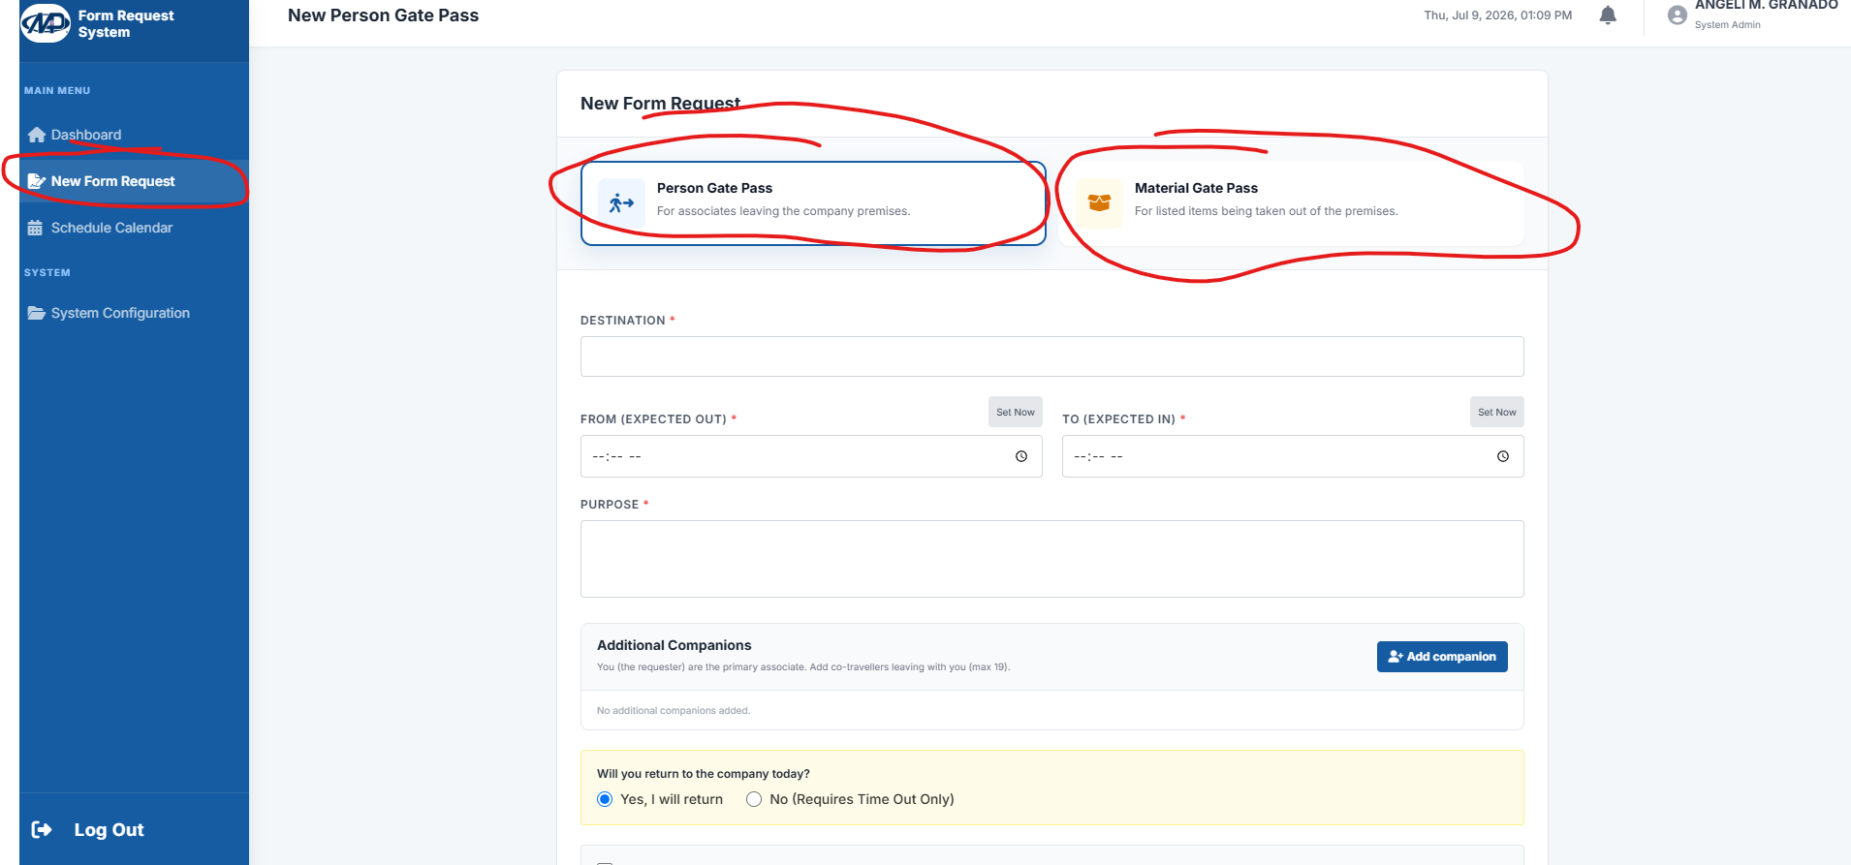

3. Fill in the details: name, date, time, purpose, and destination. If a company vehicle is needed, select the trip type.
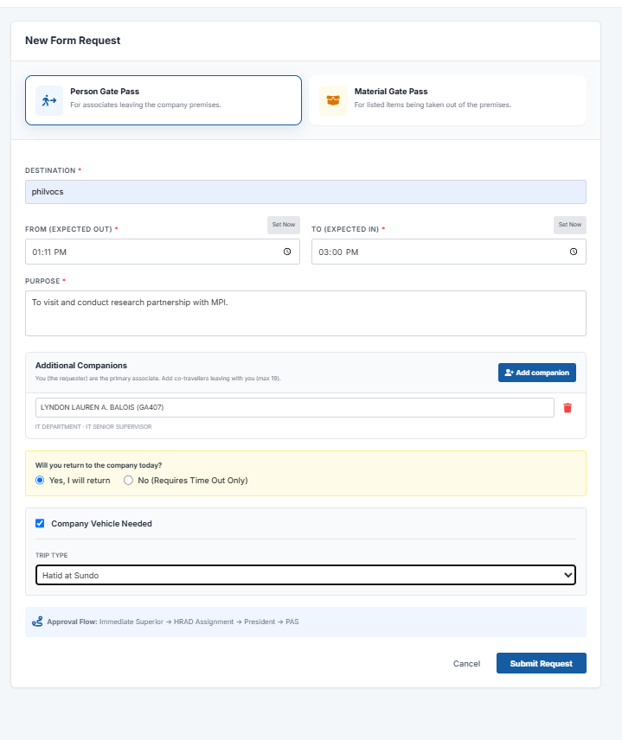

4. Click Submit and wait for approval from your superior or the person in charge.
Checking Status and Printing
1. Go to the My Requests tab.
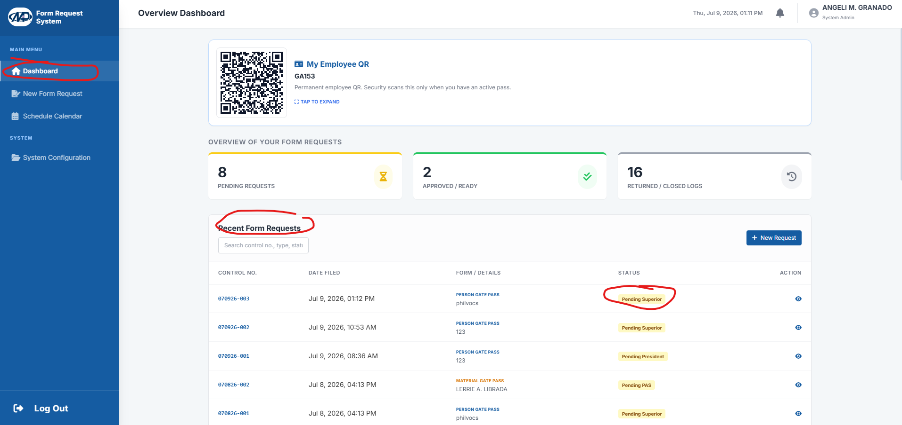

2. Check whether the request is Pending, Approved, or Rejected.
3. Once Approved, a Print button appears - this produces the formal gate pass form with the QR code and signatures.
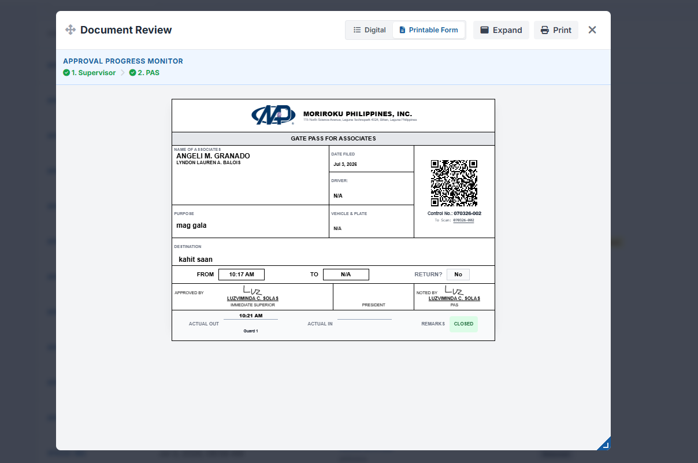

Note: Tip: print only once the request is Approved. The QR code on the form is what the guard scans, so make sure the print is clear.

