User Manual — Approver (Superior and President)
Who you are: the person with the authority to permit an employee's request.
Approving or Rejecting a Request
1. Log in and go to the Approval Dashboard.
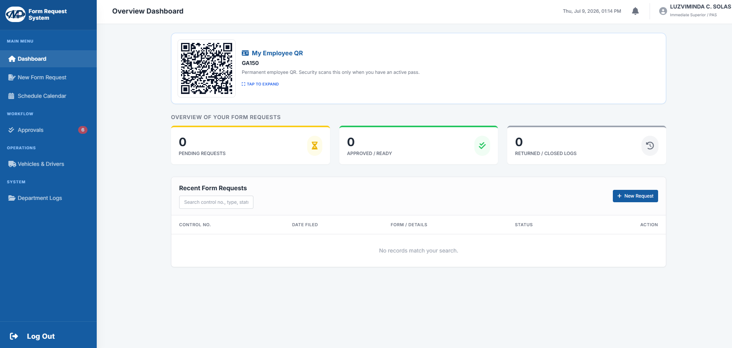

2. Click Review beside the requester's name. 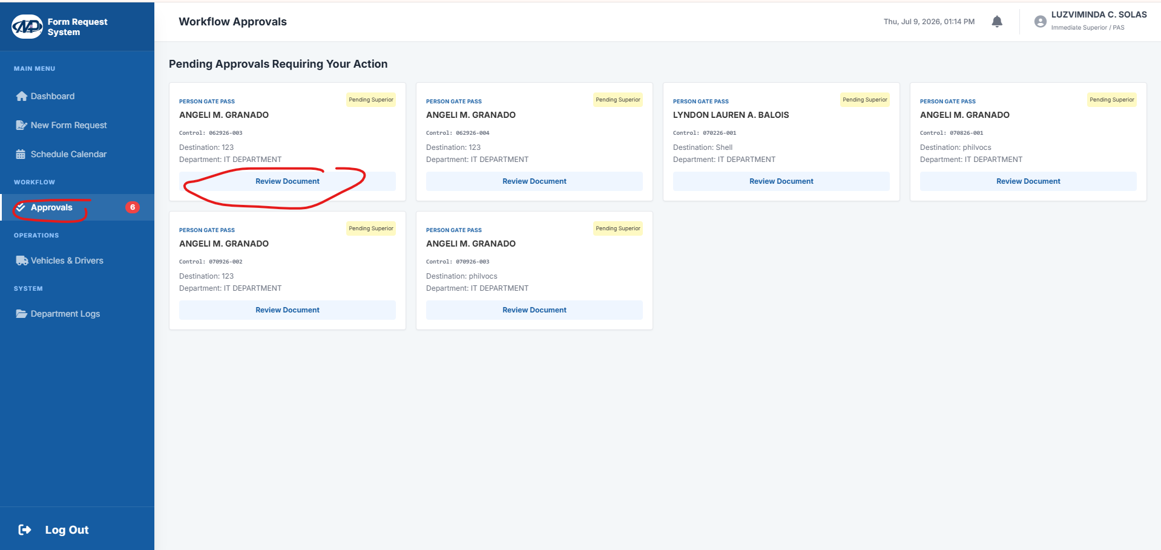
3. Read the details - destination, purpose, and (if a vehicle is involved) the schedule.
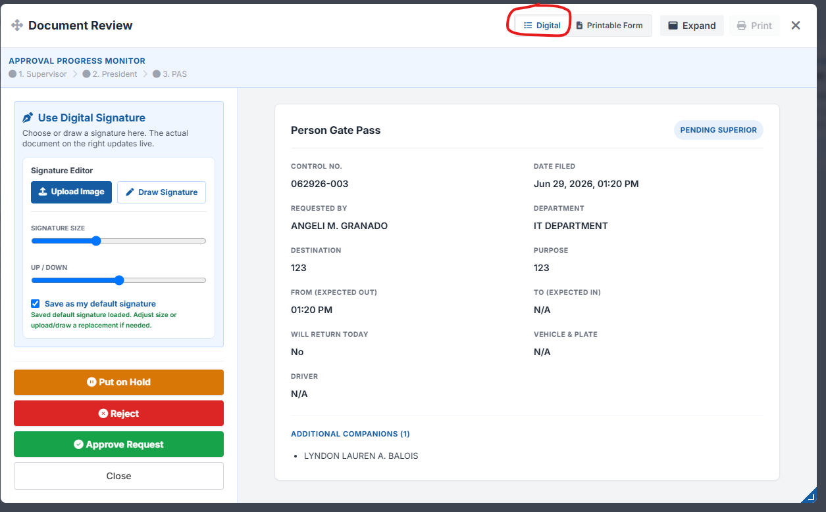

4. Apply your e-signature on the digital canvas (mouse or touchscreen).
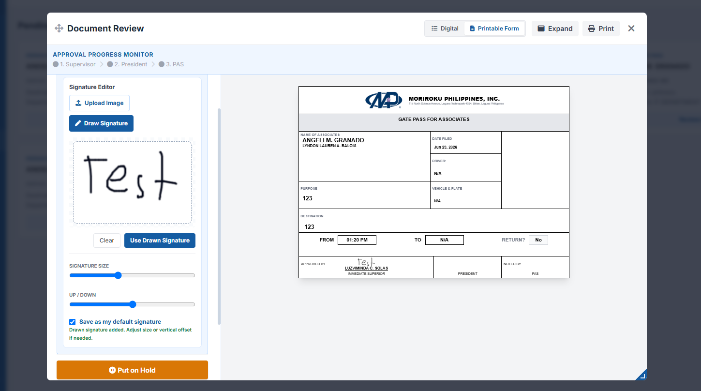

5. Click Approve. If it cannot be approved, click Reject and provide a clear reason.
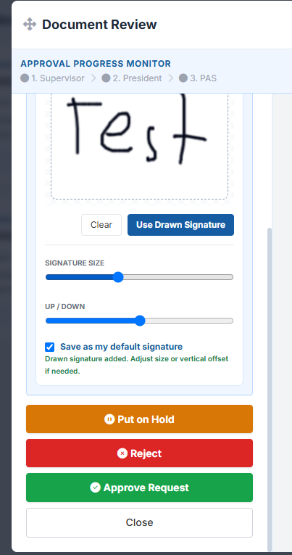
Note: Once you approve, the request moves to the next step (HRAD / President / PAS) until the full route is complete.

