User Manual — PAS / HRAD (Vehicle Scheduling)
Who you are: the person who controls the vehicle, driver, and schedule.
Managing Vehicles and Schedules
1. Log in and open the Vehicle Schedule / Calendar view.
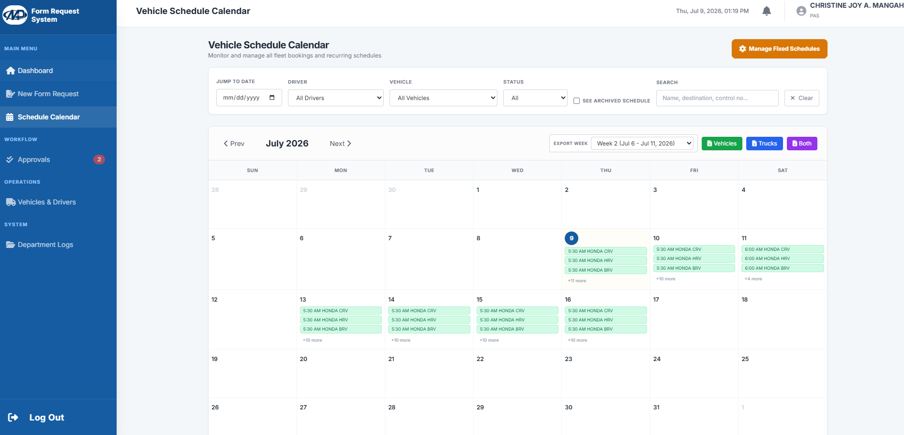

2. Vehicle requests that require a company vehicle appear as a Pending Schedule on the calendar.
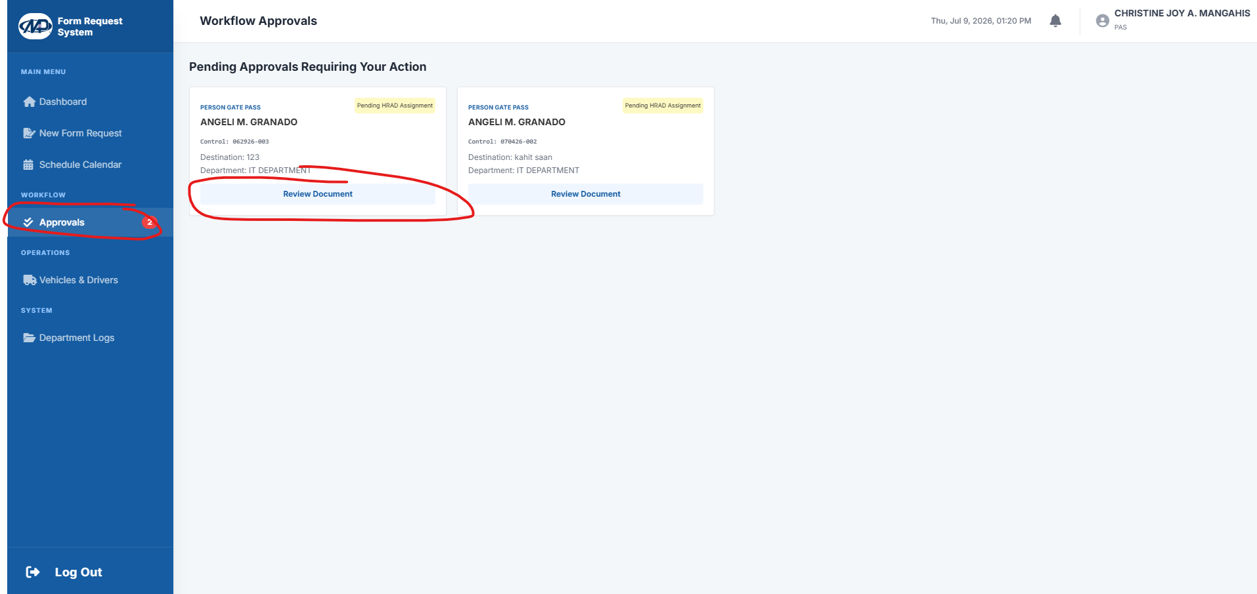

3. Click the request and select the vehicle and driver. The trip type is locked to the requester's choice; you may still choose whether the schedule is straight or split for a round trip.
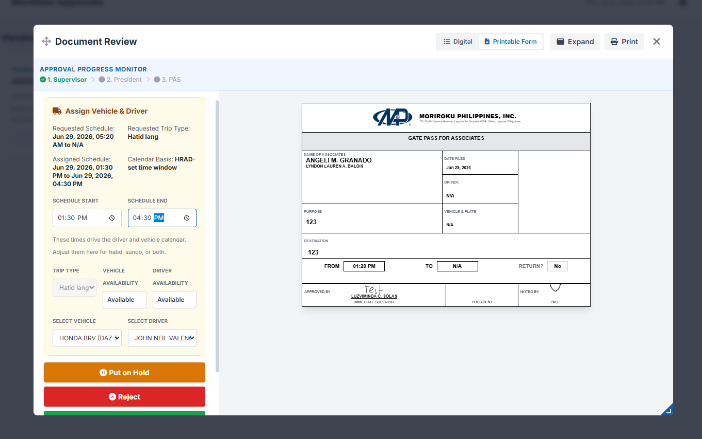

4. Save to update the calendar. It remains Pending until fully approved; the "Pending" label disappears once Approved.
Fixed / Permanent Schedules
1. For recurring trips, click Manage Fixed Schedules.
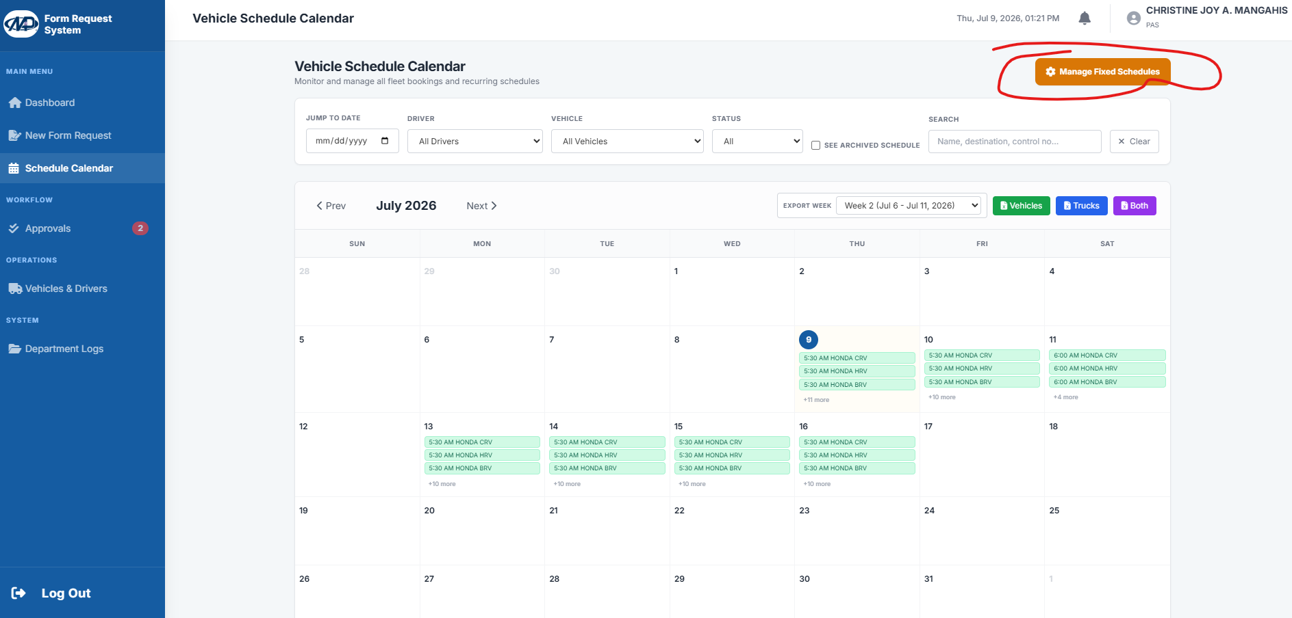

2. Set a trip for each day so it does not need to be entered daily. You can click on blank spaces to input informations, edit, and delete.
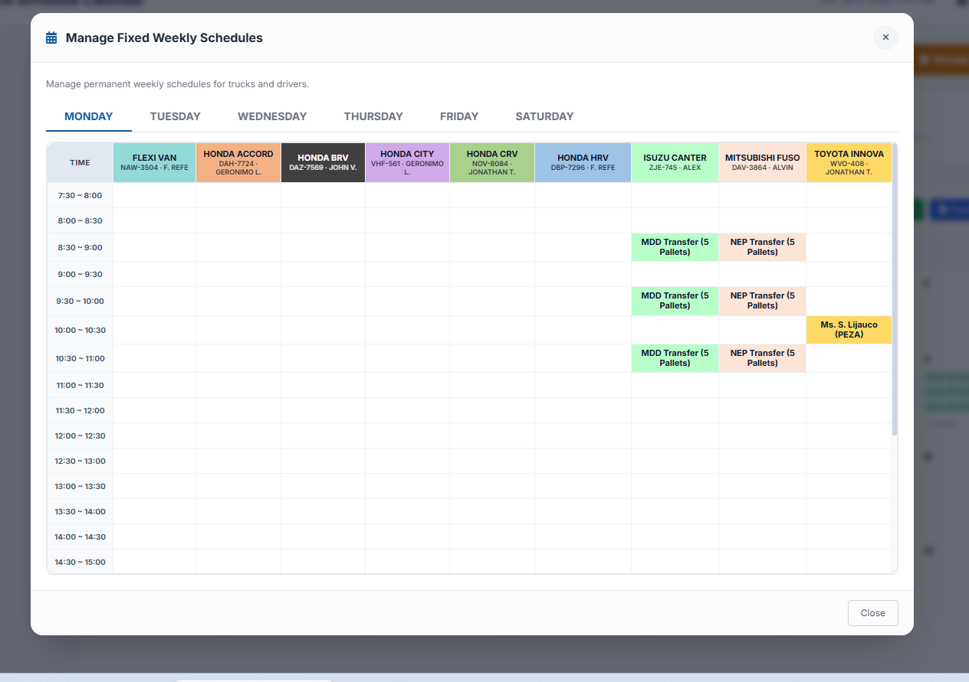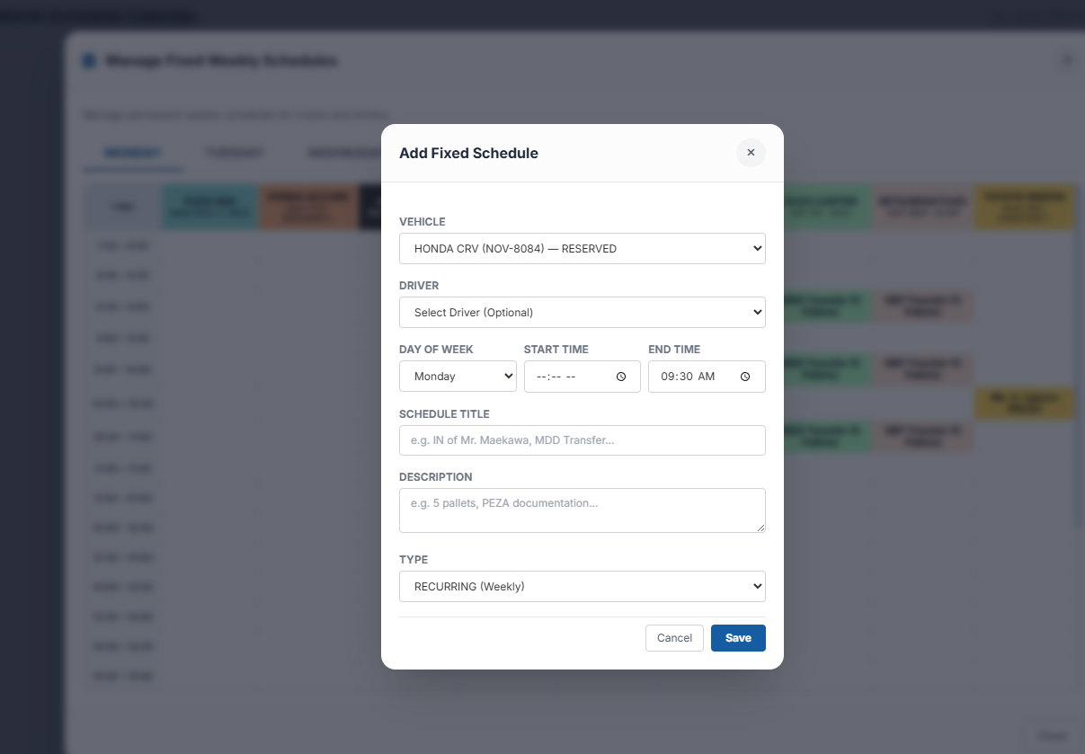
Note: Truck schedules (Logistics/PPC): Logistics/PPC staff have separate access limited to truck schedules only - regular vehicles are not included.

