User Manual — Security Guard
Who you are: the person who ensures only authorized people enter and exit.
Scanning a Gate Pass
1. Open the Guard Scanner page on a tablet or computer.
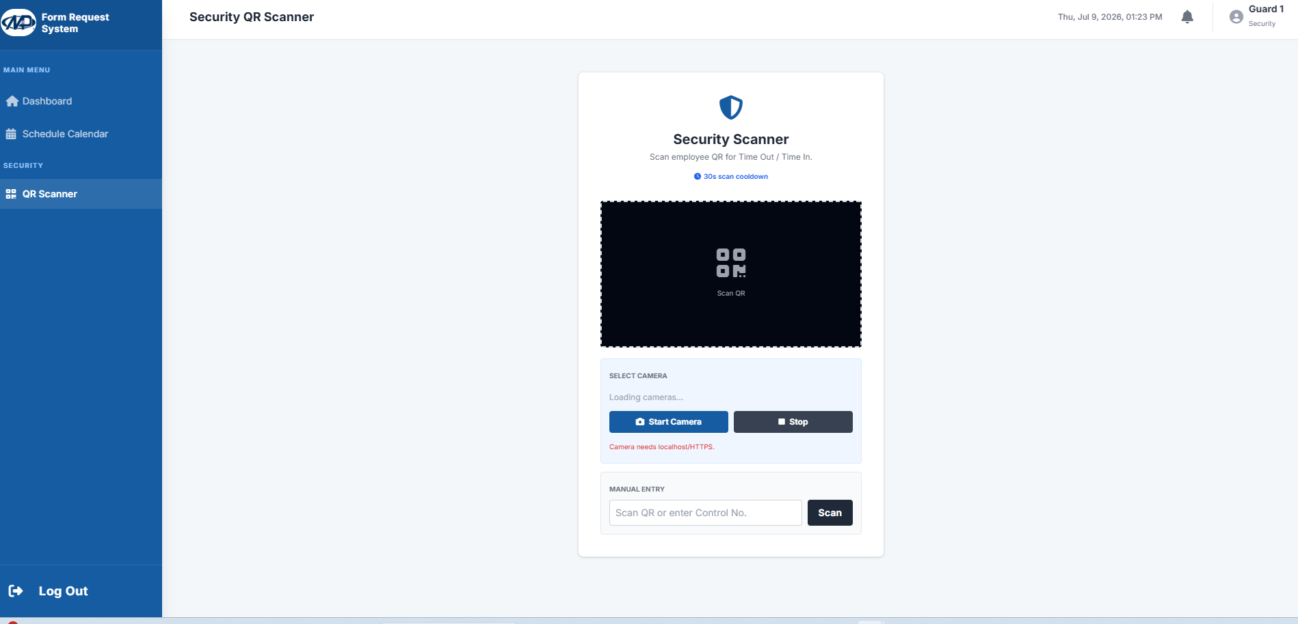

2. Present the printed gate pass (with QR code) to the camera.
3. After scanning: GREEN if valid and Approved; RED if Rejected, expired, or not allowed. 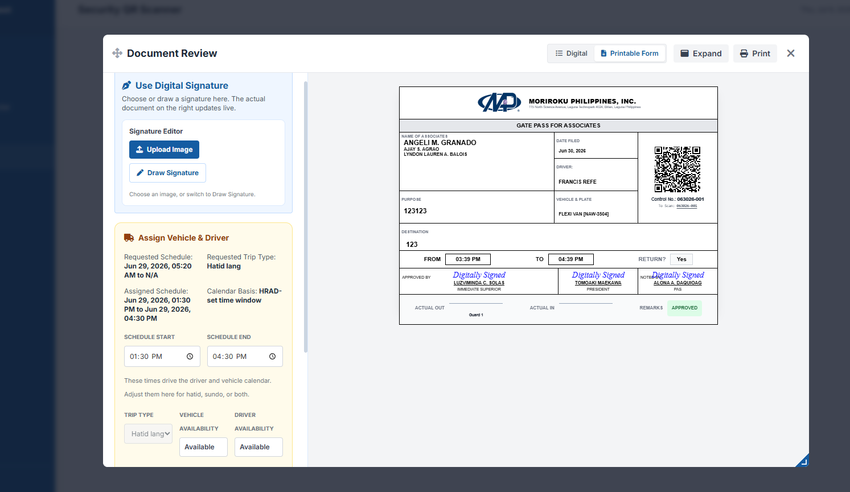
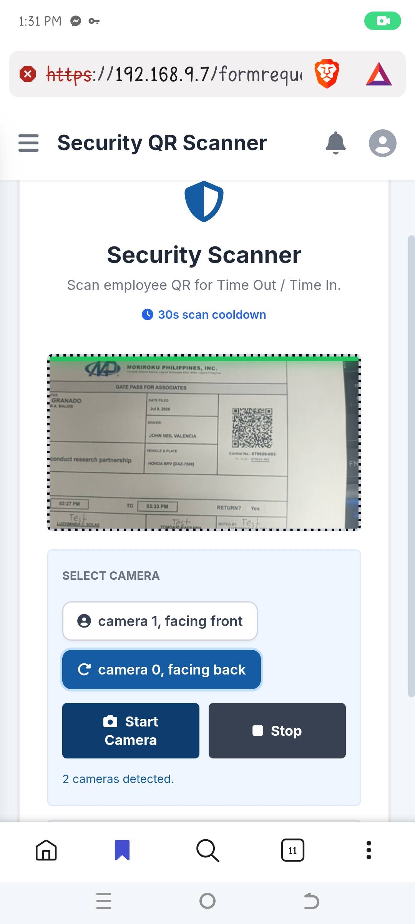

4. Click Mark as OUT when the person or vehicle exits.
5. Click Mark as IN upon return. It is saved automatically - no logbook entry is needed. 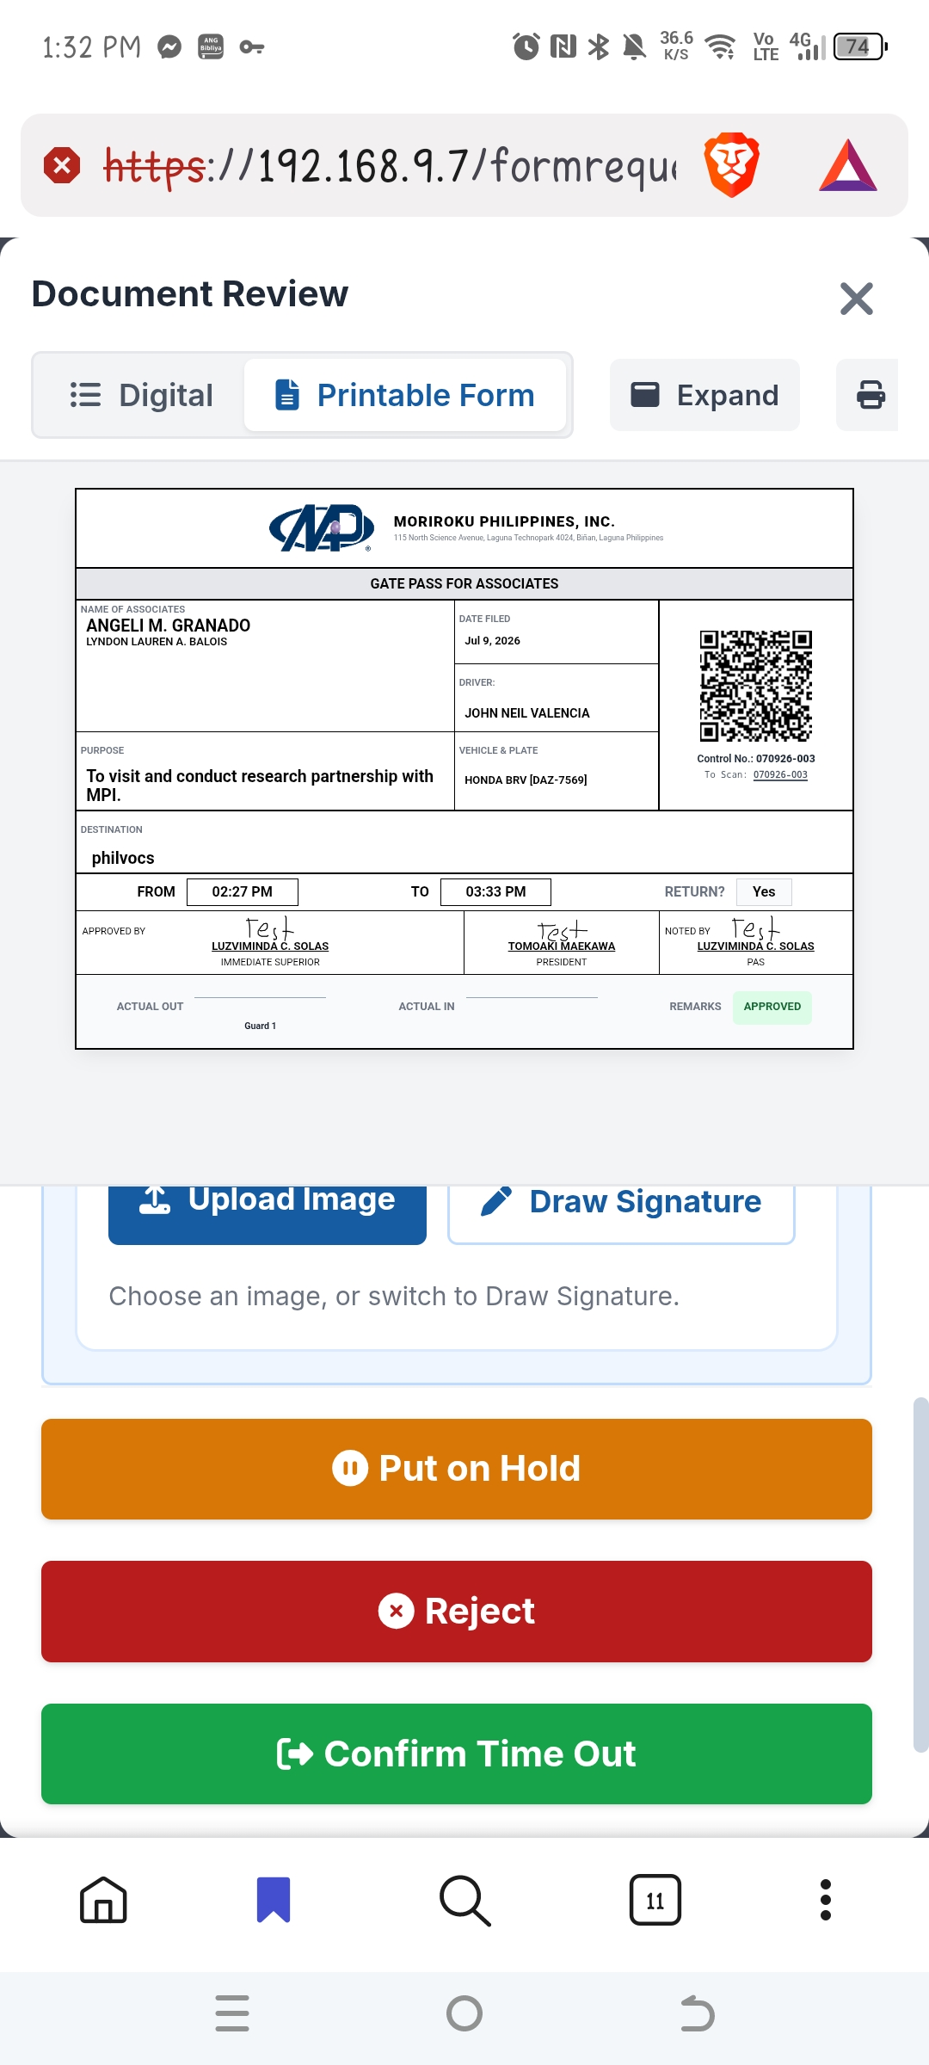
Note: If the QR code cannot be read, type the Control No. on the form for a manual lookup.

