User Manual — System Administrator
Who you are: the person who maintains users and master data.
Managing the System and Users
1. Go to the Admin Panel.
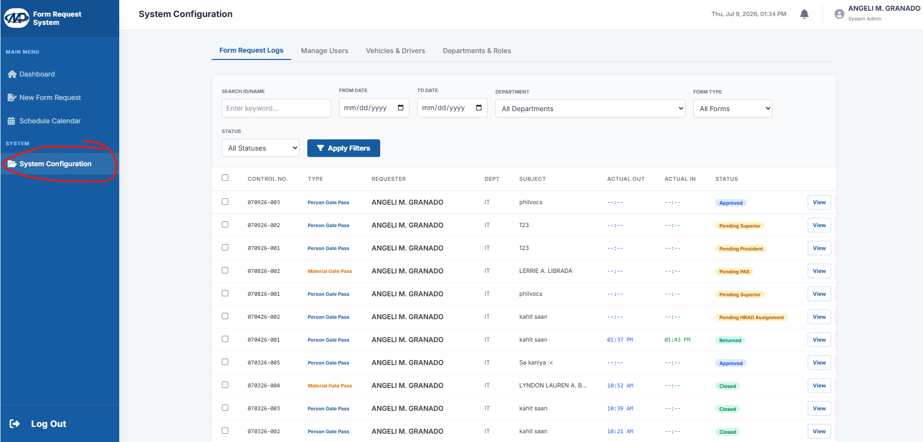

2. In User Management, add a new employee, reset a password, or deactivate a resigned user.
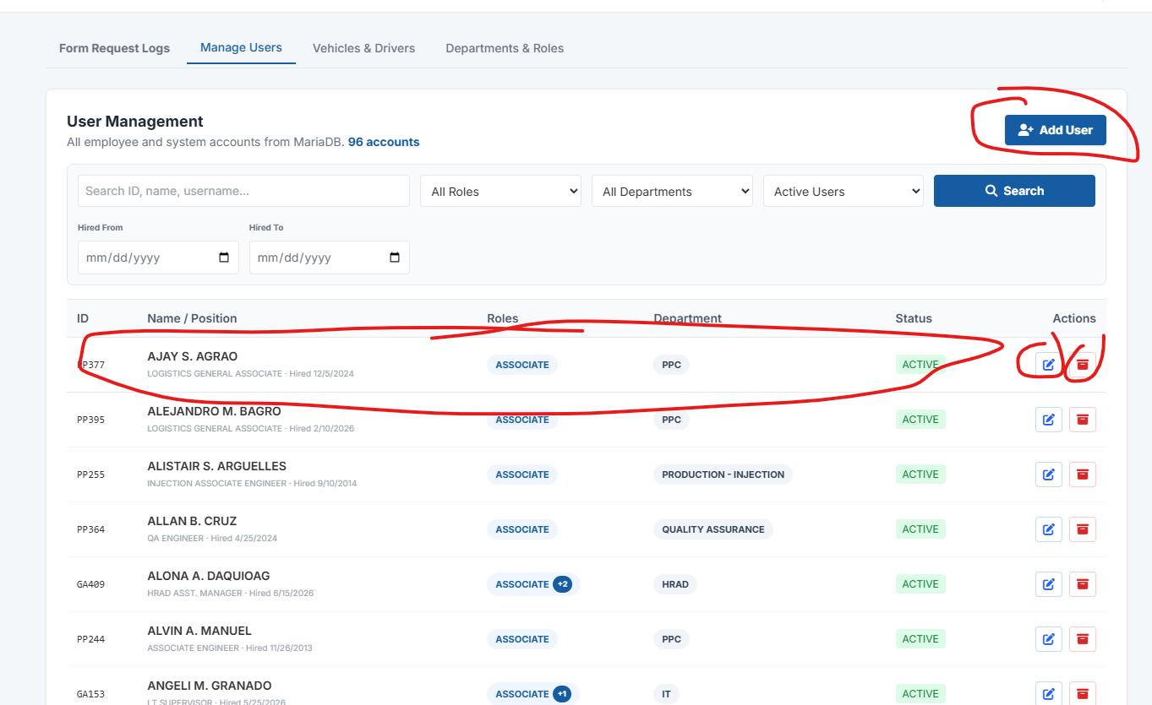

3. In Master Lists, update Trucks, Drivers, and Destinations so the choices in the forms stay current.
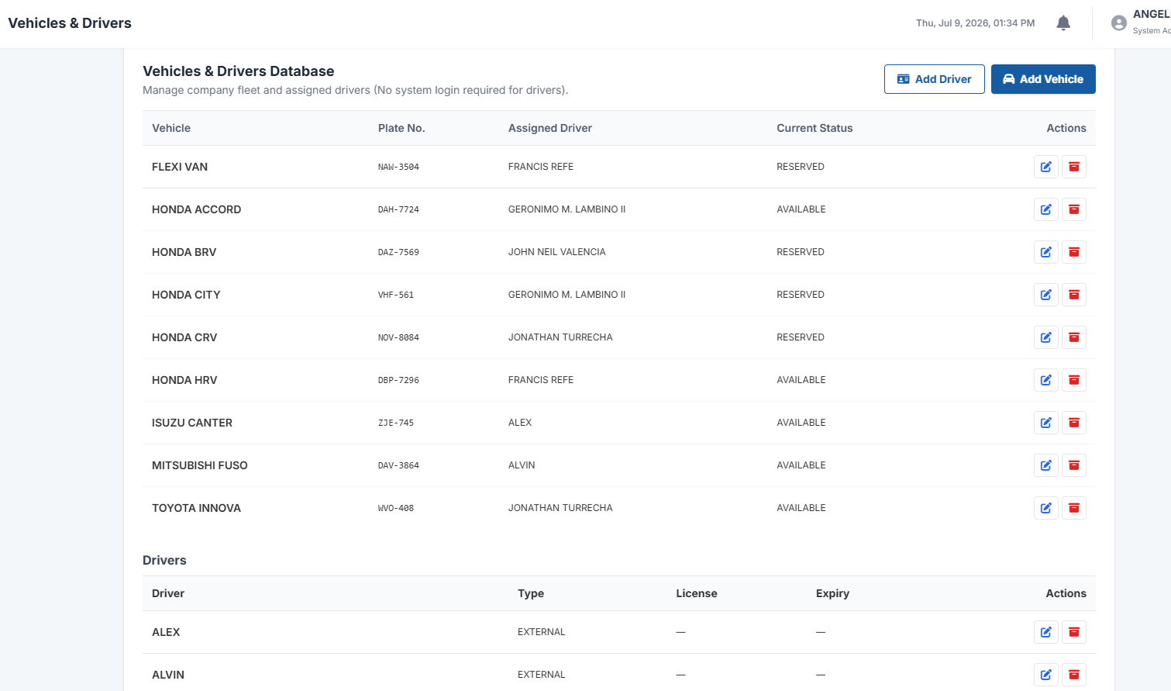

4. The full Audit Trail is also available to trace who approved or changed records.
