**TRINITY BUSINESS SCHOOL**

# INDIVIDUAL ASSIGNMENT COVER SHEET

### 

### Module: Financial Econometrics Date Due: 20/12/2020

This sheet must be attached to your assignment. **The onus is on the student to keep a hard copy of all assignments.**

I/We have read and understand the plagiarism provisions in the General Regulations of the University Calendar for the current year, found at:  <http://www.tcd.ie/calendar>

I/We have completed the Online Tutorial on avoiding plagiarism ‘Ready, Steady, Write’, located at<http://tcd-ie.libguides.com/plagiarism/ready-steady-write>

|  |  |  |
| --- | --- | --- |
| **Student Number** | **Student Surname**  **(BLOCK CAPS)** | **Signature** |
| 20313177 | IVANOVSKII |  |

**Bitcoin movements and its correlation with household spending (on the Canadian example)**

1. **Introduction**

Our topic is devoted to the issue of Bitcoin quotes and its correlation with household spending. The issue examined on the example of Canada, because as for 2020 Canada is one of the top-countries with significant growth of the interest towards cryptocurrency market[1].

The cryptocurrency market is a very hot and happening topic in the present conditions. It demonstrated impressive growth in the last few years. In the graph below we can see its capitalization in the recent 5 years.

Graph 1. Crypto Market Cap, Total, $Billions[2].

So we see that the crypto market is very unstable and it demonstrated huge volatility and growth of popularity in recent 3 years.

It is a very young market and therefore it is still not quite good explored. Our idea is to make an exploration and try to describe how the crypto market influences on the real economy, e.g. households spending.

1. **Research Hypothesis**

The main research hypothesis of our paper is that there is a positive correlation between Bitcoin movements and household spending. That means that when Bitcoin’s rate growth, it leads to increase in household spending, and vice versa. The logic is:

* When Bitcoin grows, the interest towards this cryptocurrency grows as well. As long as Bitcoin is the most popular and influential cryptocurrency, its growth means growth the crypto market in general;
* Above mentioned facts lead to new business possibilities. A growing market always attracts enterprising people, who create new start-ups, consulting and investment companies related to the crypto market. So the business activity rise, which means that new workspaces are created;
* As new businesses and workspaces are created, the incomes should rise. That means that the spending is likely demonstrating growth as well.

This is our theoretical findings and concept. We need to prove our theory using the real indicators: Bitcoin’s rate and household spending in specified time period on the example of one country with developed crypto market.

1. **Data Presentation**

To prove our theory we need the data for Bitcoin’s rate and the data for household spending.

We understand that the household spending is a very broad concept, which is influenced by many indices. According to OECD[3], household spending is the amount of final consumption expenditures which are made by resident households to meet their everyday demands, e.g. food, clothes, rent, transport fees, utility charges etc. The amount of household spending depends on the amount of money that has the household, so it really depends on the overall well-being of households[4]. It is related to the incomes of the household. The incomes are connected with the economical situation in the country: specifically with the economic growth and business activity, socially responsible internal policy, credit policy and even some macroeconomic external factors[5]. As we see there are many factors affecting household spending, as well as special psychology explored by C. Yiwei Zhang and A.B. Sussman[6]. Consequently, we may not educe the distinct dependence of household spending on Bitcoin’s rate, because there might be other, more important factors.

On the other hand we understand that there are specific actors tied with crypto market in the country’s economy: traders, entrepreneurs, miners etc. and their revenue is a direct function of situation on crypto market.

Furthermore we suggest exploring the specific period: 2017-2019 (three years dynamics). The reasons are as follows:

1. We have the most impressive growth of Bitcoin in this period as well as crypto market cap (according to Graph 1). It should come as no surprise that in 2017-2019 we see a great rise of scientific and practical interest towards Bitcoin and crypto market, for instance, A. Seetharaman, A.S. Saravanan , Nitin Patwa & Jigar Mehta explored the issue whether Bitcoin can influence the real currencies (such as USD) rate[7]. We suppose this is the best period to study potential Bitcoin’s effects;
2. It is inappropriate to examine the period before 2017 due to comparative weakness of Bitcoin[8] – it couldn’t influence significantly on country’s economy;
3. It is reasonable to limit our study period by the most recent 3-years period to get the most relevant and applicable information;
4. It is better to exclude the year 2020, because:
   1. We don’t have the aggregate picture of the year – it hasn’t finished yet;
   2. The year 2020 is the year of Covid-19 disease which exacted a heavy toll on all the spheres of life, therefore we can get noisy irrelevant results.

Thus we can create the following data table (table 1).

Table 1

Bitcoin’s rate and household spending in Canada in 2017-2019

|  |  |  |
| --- | --- | --- |
| **Time Period** | **Bitcoin’s Price*, USD[9]** | **Household Spending**, billions[10]** |
| 2017 Q1 | 1,039.11 | 296,759CAD=222,584USD |
| 2017 Q2 | 2,526.65 | 300,625CAD=230,552USD |
| 2017 Q3 | 4,199.46 | 303,221CAD=243,820USD |
| 2017 Q4 | 13,534.62 | 307,833CAD=244,835USD |
| 2018 Q1 | 7,062.54 | 310,321CAD=240,613.6USD |
| 2018 Q2 | 6,397.75 | 312,179CAD=237,630.7USD |
| 2018 Q3 | 6,580.67 | 315,741CAD=244,740.3USD |
| 2018 Q4 | 3,805.25 | 317,086CAD=232,595.3USD |
| 2019 Q1 | 4,098.71 | 319,959CAD=239,786.87USD |
| 2019 Q2 | 12,115.31 | 322,814CAD=246,552.4USD |
| 2019 Q3 | 8,021.64 | 325,304CAD=245,751USD |
| 2019 Q4 | 7,290.04 | 328,338CAD=251,378.86USD |

*The price is stated as for the end of the quarter (e.g., 2017 Q1 is the price on 31 March, 2017 Q2 - 30 June, Q3 – 30 September, Q4 – 31 December).

**Household spending were calculated in USD according to the exchange rate CAD to USD as for the end of the respective quarter[11].

At the first glimpse we can state that there is a possible correlation between the indices. The obvious problem is that Bitcoin is very volatile. He demonstrated huge elevations and depressions twice during the period of our study. And we should articulate that Bitcoin’s movements were very vigorous. Although if we count Canadian household spending in USD, we can trace some analogy with Bitcoin’s price. We need to do calculations and modeling to prove our theory.

1. **Methodology**

Graph 2. Bitcoin’s rate in 2017-2019

Graph 3. Household spending in Canada in 2017-2019

Note, that we used only USD to avoid possible deviation caused by currency difference.

We can state the common trend here: even taking into account Bitcoin’s volatility we see the growing tendency of all three indices.

We see that the household spending in Canada during 2017-2019 period was unstable as well and experienced some changes throughout the time. Distinct interrelation is found undoubtedly.

But of course we need some econometrical methods to demonstrate it.

Let’s examine the possible correlation between Bitcoin’s rate and household spending.

For that we used autocorrelation test, heteroskedasticity test, we examined the distribution, resudials, scale etc.

Finally we

The result of preliminary regression test is:

1. Pr(>|t|) < 0.00871 <5% <1%. We state that the strong significance exists between two variables;
2. Standard error of X is 4.860e+05.

The result of Durbin-Watson Test:

DW = 1.8236.

We know that when 0<DW<1.8, the model is a positive autocorrelation; when 2.2<DW<4, the model is a negative autocorrelation.

We are in a really tricky situation: on the one hand we have value of DW which is mathematically greater than 1.8. But on the other hand our result is 1.8236 and it has very small excess of 1.8 value (only 0.0236).

The calculations with the help of R software shows us the conclusion that we have positive autocorrelation. That means that Bitcoin rate has a positive autocorrelation relationship with household spending in Canada.

The result of Breusch-Pagan test shows that p-value = 0.5922. We know that if our p-value is below the appropriate threshold (<0.05), then we should reject null hypothesis and assume heteroskedasticity. But as we have value 0,5922 > 0.05, then we cannot reject the null hypothesis and state that there is no heteroskedasticity in our case.

The result of Normal Distribution Testing is represented on the following graph.

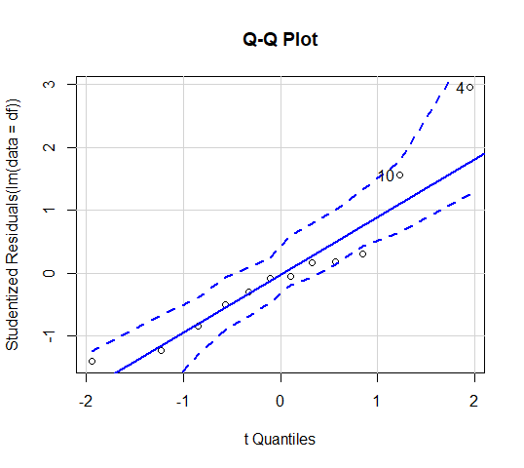

Graph 5. Q-Q Plot

All the black dots (except only one of them) are within the two dotted lines.

Moreover we can see many points that are on our blue line (5 from 12 of them are on the line, 2 more are very near, another 3 dotes are not far away as well and only 2 are appeared distantly.

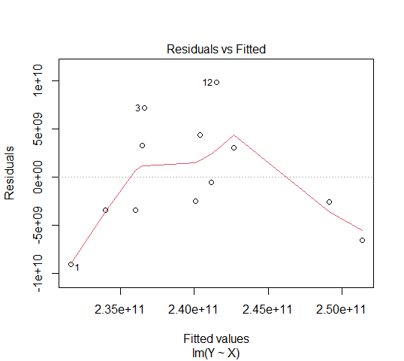

Graph 6. Residuals vs Fitted

We see a down tendency on this graph.

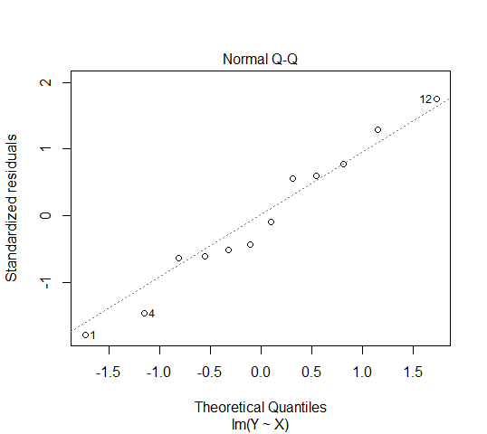

Graph 7. Normal Q-Q

We see here that our black dotes are normally distributed along the line. Dispersion is very small – all the dotes are either practically on the line or not far away from it. Again we can see just a couple of dotes which are drifted away more than others.

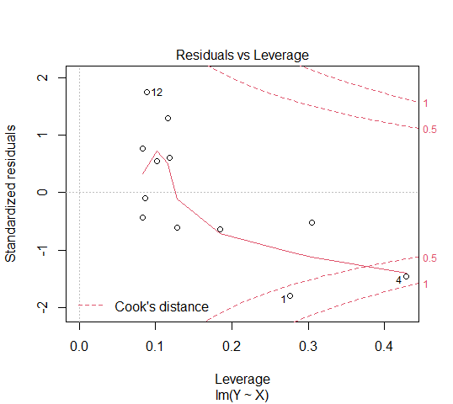

Graph 8. Residuals vs Leverage

As we already did the Breusch-Pagan test that shows that we don’t have heteroskedasticity in our case, we don’t need to demonstrate it again.

The results of our plots are good but still there are some moments which lead us to a conclusion that correlation is not perfect.

So we decided that to make some correlation calculations and OLS should be a good idea.

First of all, to prove our correlation once more we calculated Pearson’s Correlation Coefficient.

The formula for this coefficient is as follows[12]:

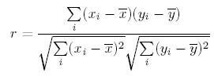

We did calculations in the Excel file (in the Annex attached) and got that r = 0,716788.

As a result we can speak about rather strong positive correlation. That means that if the Bitcoin’s rate goes higher, we have a strong likelihood that Canadian household spending goes up as well.

And last but not least: we’d like to create a linear regression.

The formula we know is[13]:

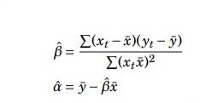

We have Bitcoin’s rate and household spending in the table 1.

Again we’ll paste it here and do additional calculations. Suppose that Bitcoin’s rate is xt and household spending is yt.

|  |  |  |  |  |  |  |
| --- | --- | --- | --- | --- | --- | --- |
| **Xt** | **X-** | **Xt - X-** | **Yt** | **Y-** | **Yt - Y-** | **(Xt - X-)( Yt - Y-)** |
| 1,039.11 | 6,389.42 | -5350.42 | 222,584,000,000 | 240,070,000,000 | -17486000000,00 | 93557444120000,00 |
| 2,526.65 | 6,389.42 | -3862.42 | 230,552,000,000 | 240,070,000,000 | -9518000000,00 | 36762513560000,00 |
| 4,199.46 | 6,389.42 | -2190.42 | 243,820,000,000 | 240,070,000,000 | 3750000000,00 | -8214075000000,00 |
| 13,534.62 | 6,389.42 | 7145.58 | 244,835,000,000 | 240,070,000,000 | 4765000000,00 | 34048688700000,00 |
| 7,062.54 | 6,389.42 | 673.58 | 240,613,600,000 | 240,070,000,000 | 544000000,00 | 366427520000,00 |
| 6,397.75 | 6,389.42 | 8.58 | 237,630,700,000 | 240,070,000,000 | -2439000000,00 | -20926620000,00 |
| 6,580.67 | 6,389.42 | 191.58 | 244,740,300,000 | 240,070,000,000 | 4670000000,00 | 894678600000,00 |
| 3,805.25 | 6,389.42 | -2584.42 | 232,595,300,000 | 240,070,000,000 | -7475000000,00 | 19318539500000,00 |
| 4,098.71 | 6,389.42 | -2290.42 | 239,786,870,000 | 240,070,000,000 | -283000000,00 | 648188860000,00 |
| 12,115.31 | 6,389.42 | 5725.58 | 246,552,400,000 | 240,070,000,000 | 6482000000,00 | 37113209560000,00 |
| 8,021.64 | 6,389.42 | 1632.58 | 245,751,000,000 | 240,070,000,000 | 5681000000,00 | 9274686980000,00 |
| 7,290.04 | 6,389.42 | 900.58 | 251,378,860,000 | 240,070,000,000 | 11309000000,00 | 10184659220000,00 |

x- and y- are simply the average value of x and y, so

x- = 6,389.42

y- = 240,070,000,000

The top of our equation is just the sum of **(Xt - X-)( Yt - Y-)** which is equal to 233,934,035,000,000.

The bottom part is the sum of (**Xt - X-)2**.

|  |
| --- |
| (**Xt - X-)2** |
| 28626994.18 |
| 14918288.26 |
| 4797939.776 |
| 51059313.54 |
| 453710.0164 |
| 73.6164 |
| 36702.8964 |
| 6679226.736 |
| 5246023.776 |
| 32782266.34 |
| 2665317.456 |
| 811044.3364 |

Sum is 148,076,901.

So the result will be

β = 233,934,035,000,000 / 148,076,901 = 1,579,814.5

α = 240,070,000,000 - 1,579,814.5*6,389.42 = 229,975,901,637.41

And the relationship between household spending in Canada and Bitcoin’s rate might be expressed as:

ŷ = 229,975,901,637.41 + 1,579,814.5xt.

If we paste the Bitcoin’s rate instead of xt we may see how much will be the amount of household spending in Canada.

But the question is how precise is this formula.

To understand that we’ve also calculated the residual sum of squares, standard deviation of the residuals and standard errors (it was done in the Excel file). They are:

SE(α) = 1,873,264,550;

SE(β) = 256,914.55

Unfortunately our standard error are big and so we can’t be sure that this is a perfect formula that will help us to accurately forecast the amount of household spending in Canada with relation to Bitcoin’s quotes.

Still it gives us approximate idea about the changing of Canadian household spending with respect to Bitcoin’s price.

1. **Results**

So far we can state the following results that were achieved:

1. There is an obvious correlation between Bitcoin’s price and household spending in Canada according to Pearson’s Correlation Coefficient and Durbin-Watson test. The correlation is positive: that means that if Bitcoin’s price goes up, there is a strong likelihood that household spending in Canada will go up as well;
2. We created a linear regression equation that demonstrates dependence between Bitcoin’s price and household spending in Canada. The equation is ŷ = 229,975,901,637.41 + 1,579,814.5xt, where ŷ is household spending in Canada and xt is Bitcoin’s price. However, the standard errors of this equation are rather big and we cannot be sure that this is a precise way to predict Canadian household spending. It can give us just approximate number;
3. We can’t state that dependence and correlation are perfect: household spending is influenced by many factors and Bitcoin’s price is only one of them. Still the correlation exists and common trend is positive. We proved these facts in the part 4 of our paper.
4. **Conclusion**

In conclusion we’d like to articulate that the growing crypto market influences different aspects of the real life undoubtedly. Even considering that Bitcoin is very volatile and it is not easy to use this cryptocurrency in purchases we can see the attempts to adapt the Bitcoin as a legal payment instrument. There are plenty of researches and start-ups which are closely related to that topic.

Taking these facts into account we can underline that Bitcoin’s price correlation with household spending is no surprise.

We suppose that the correlation and interconnection between the Bitcoin’s price and household spending will grow further. For instance if more countries will allow to use Bitcoin as a legal payment instrument, it is likely that Bitcoin can become as influential as some real currencies.

But even taking that into account we cannot be sure that the Bitcoin will be able to challenge some strong international real currencies like US Dollar. The reasons for this are:

* USD is a very popular currency all over the world;
* USD is a stable currency and many people and organizations trust it;
* There are absolutely not enough possibilities for practical application of the Bitcoin right now. Not so many companies accept it like a legal payment instrument.

Bitcoin has a potential possibility to strengthen its positions in the future and gain stronger influence on different real life indices, like household spending. But this will greatly depend on the efforts of those who involved in crypto market. More should be done about the strengthening of stability and development of practical use of the Bitcoin.

**Bibliography**

1. Bunn P., Le Roux J. (2012), *Influences on household spending: evidence from the 2012 NMG Consulting survey,* Bank of England Quarterly Bulletin 2012 Q4. P. 332-342.
2. Coindesk, (2020). *Bitcoin (BTC),* viewed on 28 November 2020 <https://www.coindesk.com/price/bitcoin>
3. CoinMarketCap, (2020). *Bitcoin Charts*. viewed on 29 November 2020 <https://coinmarketcap.com/currencies/bitcoin/>
4. CoinMarketCap (2020). *Global Charts.* viewed on 28 November 2020 <https://coinmarketcap.com/charts/>
5. Helms K., 2020. *9 Countries Show Huge Growth in Cryptocurrency Interest: Coinmarketcap,* Bitcoin.com, viewed on 28 November 2020 <https://news.bitcoin.com/countries-growth-cryptocurrency-coinmarketcap/>
6. OECD iLibrary, (2020). *Household spending.* viewed on 28 November 2020 <https://www.oecd-ilibrary.org/economics/household-spending/indicator/english_b5f46047-en >
7. Seetharaman A., Saravanan A.S., Patwa N., Mehta J. (2017). *Impact of Bitcoin as a World Currency,* Accounting and Finance Research, Vol.6, No. 2. P. 230-246.
8. Social Science Statistics, (2020). *Pearson Correlation Coefficient Calculator. .* viewed on 29 November 2020 <https://www.socscistatistics.com/tests/pearson/#:~:text=The%20Pearson%20correlation%20coefficient%20is,means%20a%20perfect%20negataive%20correlation>
9. Statistics Canada, (2020). *Detailed household final consumption expenditure, Canada, quarterly.* viewed on 29 November 2020 <https://www150.statcan.gc.ca/t1/tbl1/en/tv.action?pid=3610012401&pickMembers%5B0%5D=2.1&pickMembers%5B1%5D=3.1&cubeTimeFrame.startMonth=01&cubeTimeFrame.startYear=2017&cubeTimeFrame.endMonth=10&cubeTimeFrame.endYear=2019&referencePeriods=20170101%2C20191001>
10. Vigne S. (2020). *Financial Econometrics Test Bank for Trinity College Dublin.* viewed on 29 November 2020 <https://tcd.blackboard.com/webapps/blackboard/execute/content/file?cmd=view&content_id=_1680850_1&course_id=_62920_1>
11. XE, (2020). *XE Currency Charts: CAD to USD,* viewed on 29 November 2020 <https://www.xe.com/currencycharts/?from=CAD&to=USD&view=5Y>
12. Yiwei Zhang C., Sussman A.B. (2017). *The Role of Mental Accounting in Household Spending and Investing Decisions,* Chicago Booth Working Paper №19-07.p.9

1. Helms K., 2020. *9 Countries Show Huge Growth in Cryptocurrency Interest: Coinmarketcap,* Bitcoin.com, viewed on 28 November 2020 <https://news.bitcoin.com/countries-growth-cryptocurrency-coinmarketcap/>
2. CoinMarketCap (2020). *Global Charts.* viewed on 28 November 2020 <https://coinmarketcap.com/charts/>
3. OECD iLibrary, (2020). *Household spending.* viewed on 28 November 2020 <https://www.oecd-ilibrary.org/economics/household-spending/indicator/english_b5f46047-en >
4. Yiwei Zhang C., Sussman A.B. (2017). *The Role of Mental Accounting in Household Spending and Investing Decisions,* Chicago Booth Working Paper №19-07.p.9
5. Bunn P., Le Roux J. (2012). *Influences on household spending: evidence from the 2012 NMG Consulting survey,* Bank of England Quarterly Bulletin 2012 Q4. P. 332-342.
6. Yiwei Zhang C., Sussman A.B. (2017). *The Role of Mental Accounting in Household Spending and Investing Decisions,* Chicago Booth Working Paper №19-07.
7. Seetharaman A., Saravanan A.S., Patwa N., Mehta J. (2017). *Impact of Bitcoin as a World Currency,* Accounting and Finance Research, Vol.6, No. 2. P. 230-246.
8. Coindesk, (2020). *Bitcoin (BTC),* viewed on 28 November 2020 <https://www.coindesk.com/price/bitcoin>
9. CoinMarketCap, (2020). *Bitcoin Charts*. viewed on 29 November 2020 <https://coinmarketcap.com/currencies/bitcoin/>
10. Statistics Canada, (2020). *Detailed household final consumption expenditure, Canada, quarterly.* viewed on 29 November 2020 <https://www150.statcan.gc.ca/t1/tbl1/en/tv.action?pid=3610012401&pickMembers%5B0%5D=2.1&pickMembers%5B1%5D=3.1&cubeTimeFrame.startMonth=01&cubeTimeFrame.startYear=2017&cubeTimeFrame.endMonth=10&cubeTimeFrame.endYear=2019&referencePeriods=20170101%2C20191001>
11. XE, (2020). *XE Currency Charts: CAD to USD,* viewed on 29 November 2020 <https://www.xe.com/currencycharts/?from=CAD&to=USD&view=5Y>
12. Social Science Statistics, (2020). *Pearson Correlation Coefficient Calculator. .* viewed on 29 November 2020 <https://www.socscistatistics.com/tests/pearson/#:~:text=The%20Pearson%20correlation%20coefficient%20is,means%20a%20perfect%20negataive%20correlation>
13. Vigne S. (2020). *Financial Econometrics Test Bank for Trinity College Dublin.* viewed on 29 November 2020 *<*https://tcd.blackboard.com/webapps/blackboard/execute/content/file?cmd=view&content_id=_1680850_1&course_id=_62920_1>