Michael Erwin

Data Analytics

Exercise 10

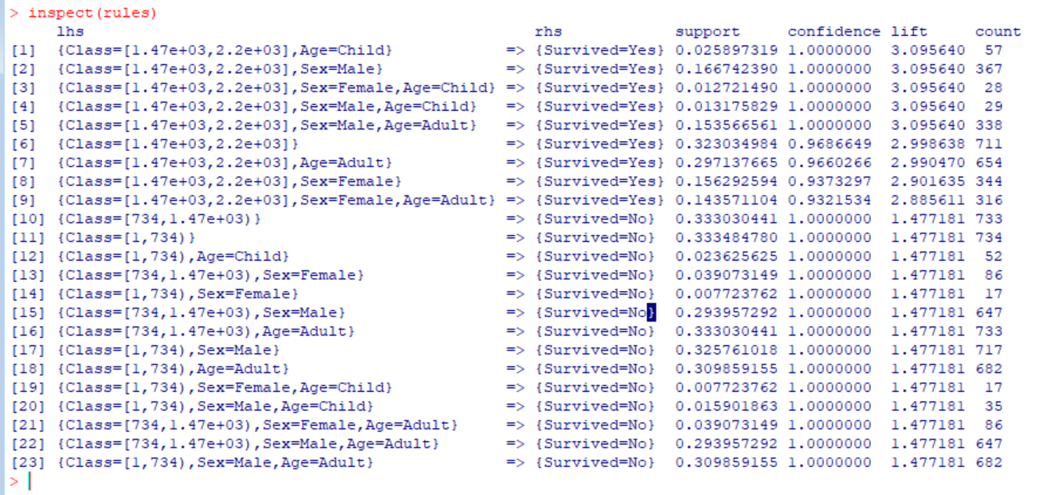

The Apriori algorithm tells us that sex and age had the biggest impact on whether or not the passenger survived. We would expect that women and children had a higher priority.

The lift value was very useful here for determining the importance of factors that determined if passengers survived or not. The higher the lift value, the stronger the (positive) correlation between the factor and the outcome.