Michael Erwin

Data Analytics

Exercise 5

1. Visualization

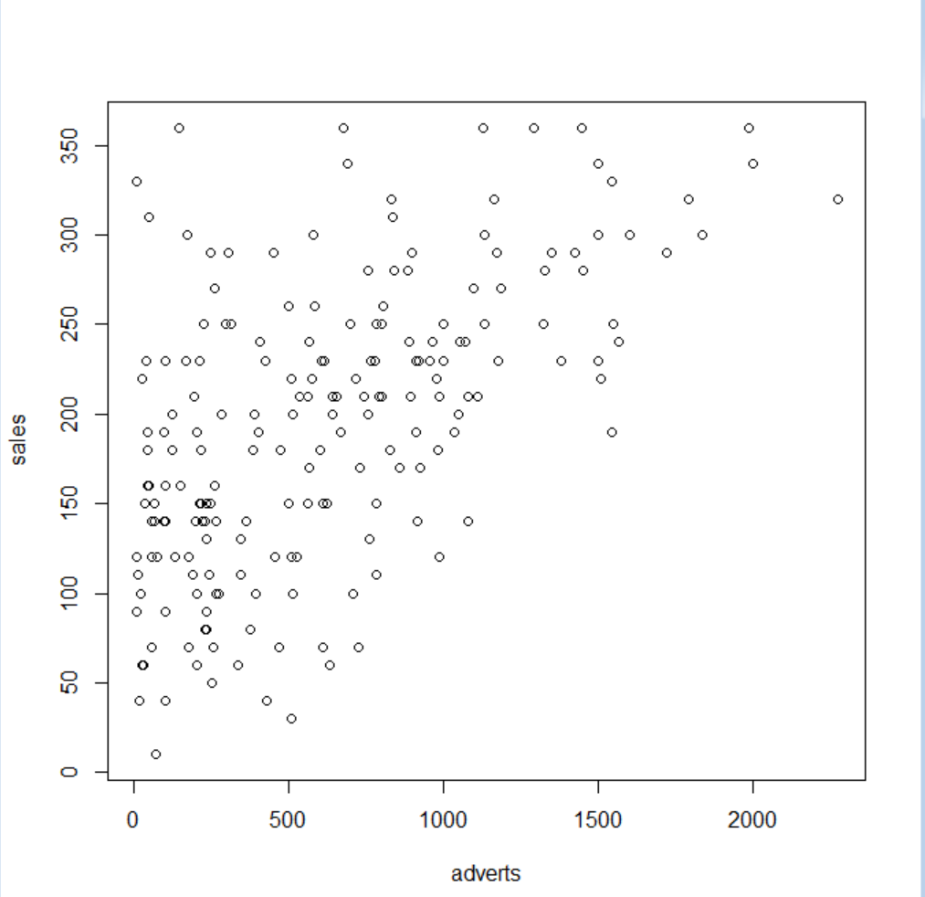

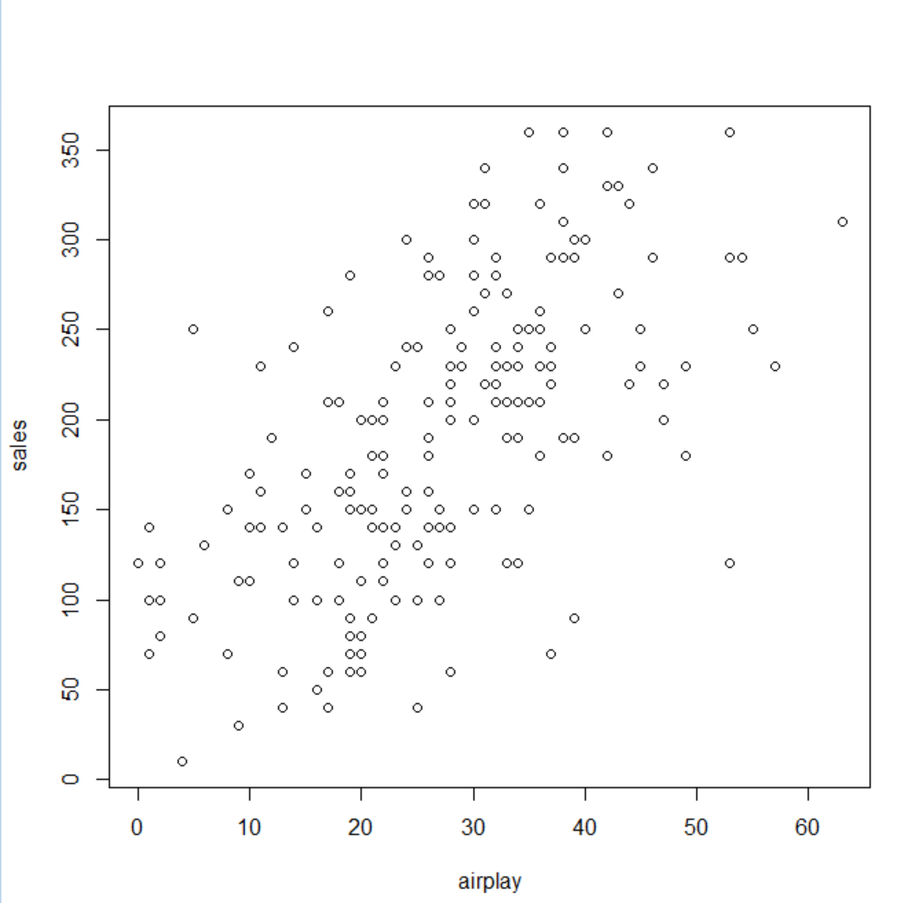

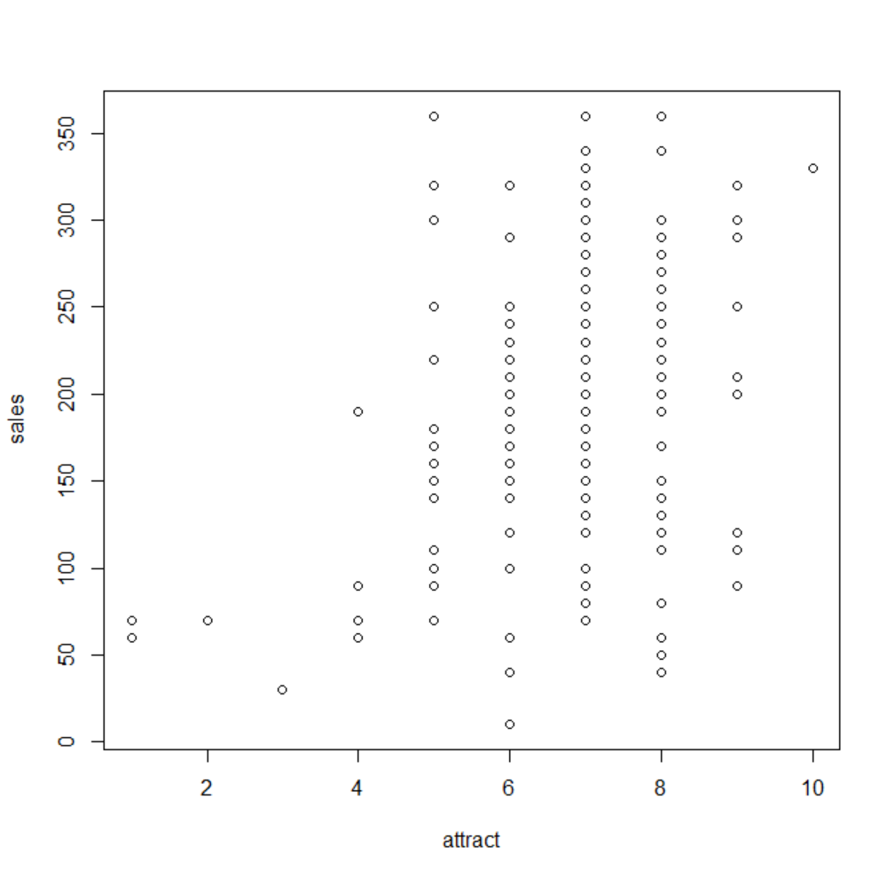

The variables in the graphs look like they could have a linear relationship, especially the first 2 graphs.

1. Linear regression

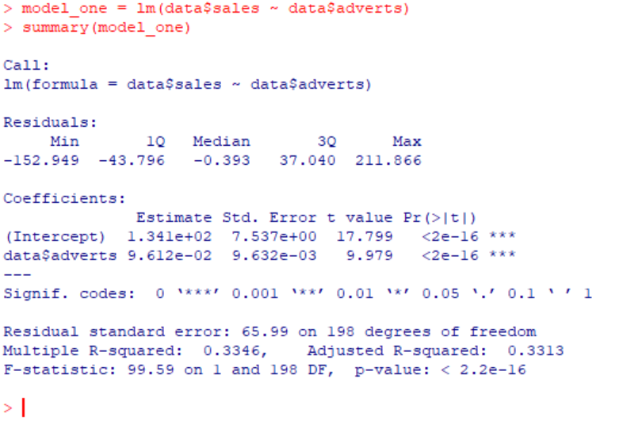

Our p value is below 0.05, so we can reject the null hypothesis with an assumed alpha of 95%. The F-statistic is for determining if a group of variables is *jointly* statistically significant, so it isn’t really applicable here.

1. Model Coefficients

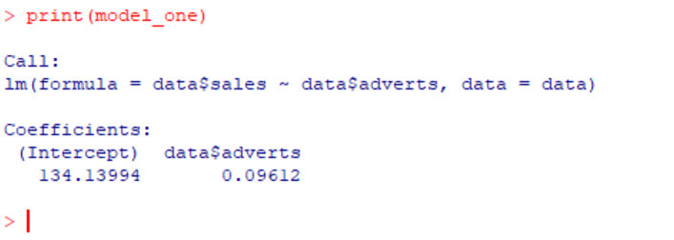

Predict sales with an advertising budget of $135,000:

Sales = 134.13994 + (0.09612 \* 135000) = about 13,110‬ sales

1. Multiple Regression

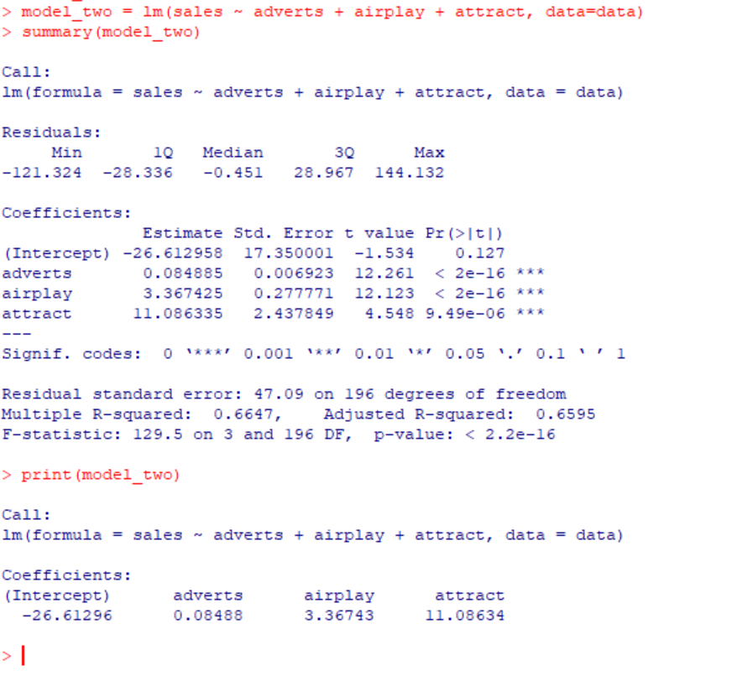

Here we have a large F-statistic, so our variables are *jointly* statistically significant since we reject the null hypothesis.

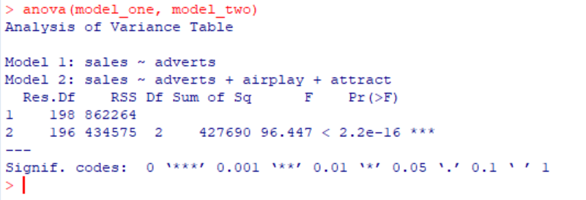

We reject the null hypothesis for model 2, and the R-squared value is higher for model 2 than for model 1. This means that more variance is explained by the model, so the multiple linear regression model is the superior model in this example.