**COMP3064 – Game Programming**

**Assignment 1**

**2D Shooter**

**Michael Jimma**

Table of Contents

Game Description 3

Controls 3

Interfaces 4

Screen Description 5

Enemies 7

Scoring 7

# Game Description

This 2D shooter game is about defending the universe from alien invasion. The player should fly the spaceship and face several enemy ships who start shooting randomly in the vast of the universe. It is up to the player to find a way to skip the lasers and destroy the enemy ships. Every time the player shoot and destroy the entire enemy ships, the enemies will be re-generated again with additional one ship. This increases the number of lasers projected towards the player but there is always a tiny space to cheat the enemy’s lasers and shoot back. The player has been granted five life points at the beginning of the game. Every time an enemy laser hits the players ship, the health will be decreased by one and after having five shots the game will be over. The enemy ships need to be shoot twice to be destroyed.

# Controls

To move the player ship:

* “Up Arrow” or “W” – move up.
* “Down Arrow or “S” – move down.
* “Left Arrow” or “A” – move left.
* “Right arrow” or “D” – move right.

To shoot the enemy ship:

* “Space Key”

# Interfaces

Menu Scene

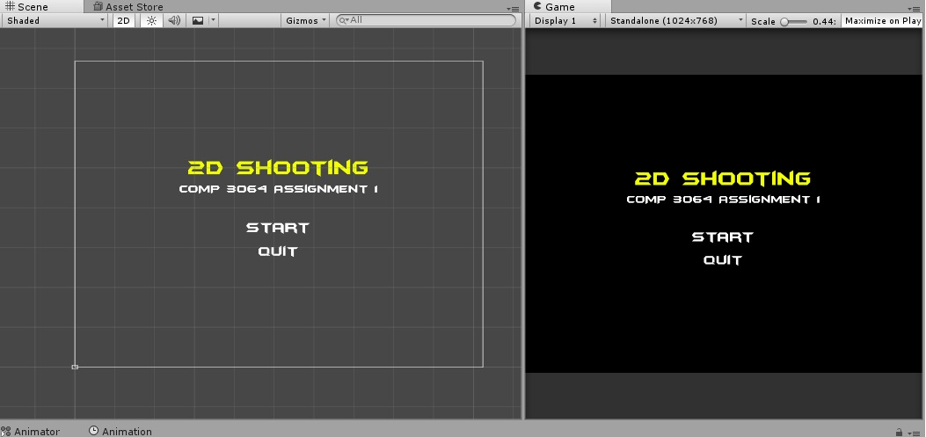

Game Scene

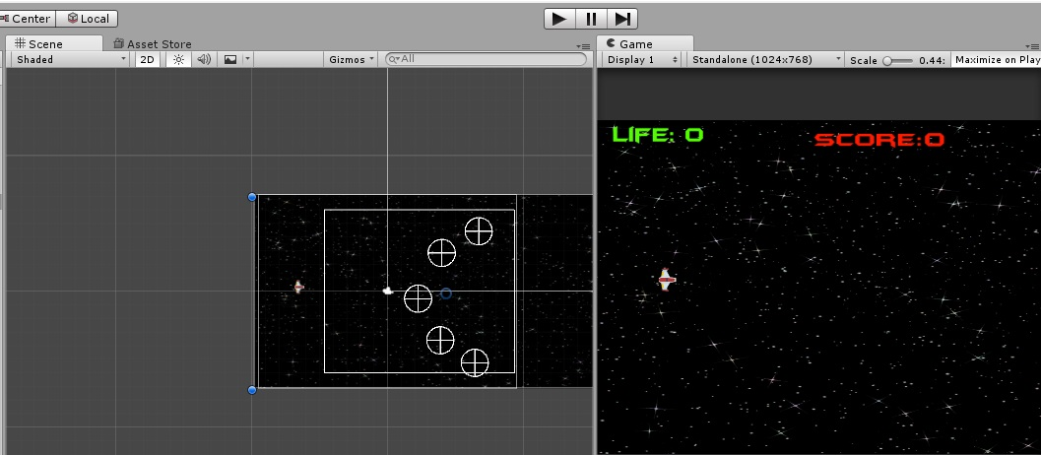

Game Over Scene

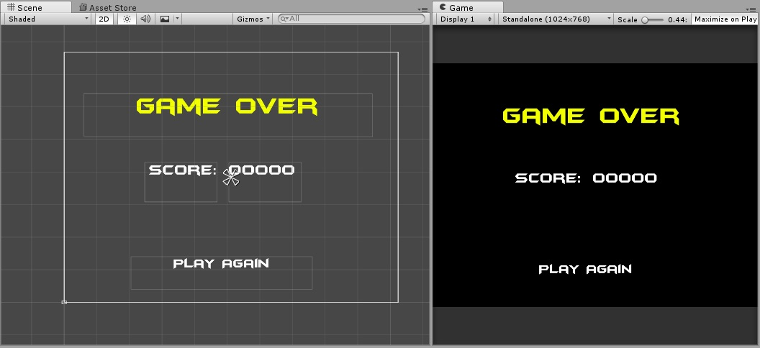

# Screen Description

At the start of the game, the player ship comes from the left side and six enemy ships at the right side. The score is zero and player has five lives.

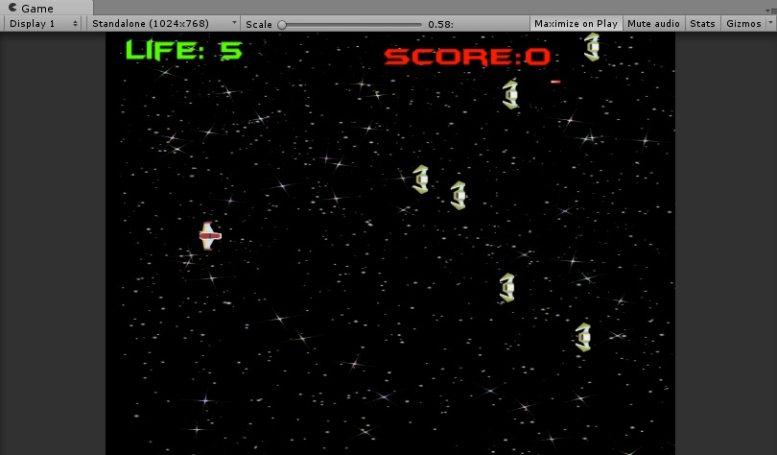

Gameplay, the player has left two lives and scores 1050 points

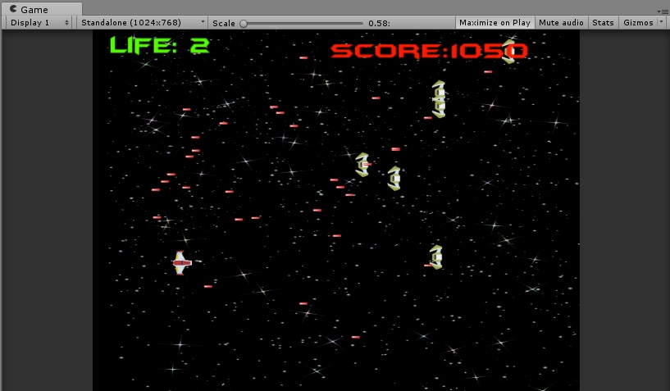

Game Over, the player scores 6150 points before destroyed by the enemies

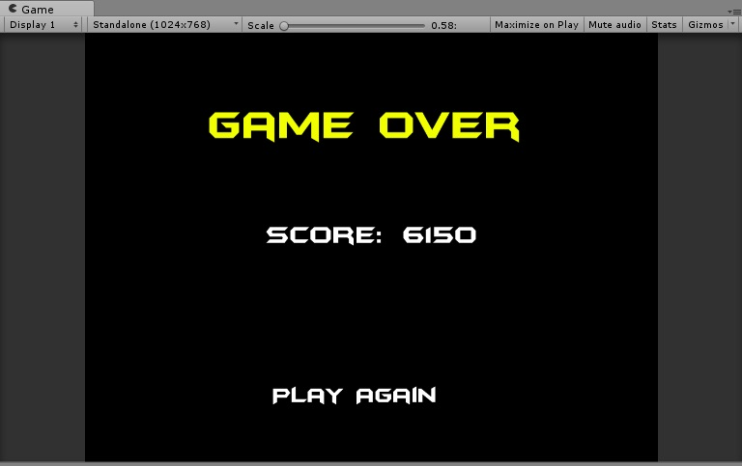

# Enemies

The enemies are computer controlled objects who moves up and down nonstop firing laser weapons in a random interval. The program calculates the time and probability of their shooting intervals to determine the number of shoots per second. The speed of their lasers and the number of life are also set by the computer. When every time an enemy got shot by the player, the life of that object is decreased and destroyed at the second shot.

# Scoring

Each time the player destroys an enemy ship a score of 150 points will be added to the player’s score.