React Project

Michael Johnston

2018

**Idea:** Color Tool

**Mockup:**

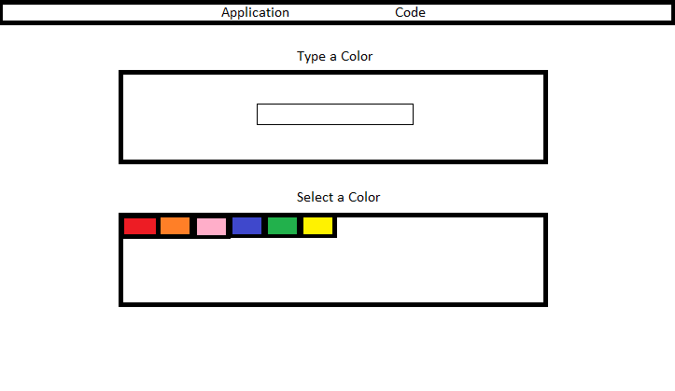

**Features:** *(prioritized in order)*

* Accept user input and change the background color to whichever color they type
* Allow users to select from a list of colors to change the background color
* View code behind each of the components