**Chapter 9**

**Pointers - Dynamic Memory Allocation**

**What is Static Memory Allocation**

All variables declared in our programs up to this point have been statically allocated by the compiler (before the program runs)

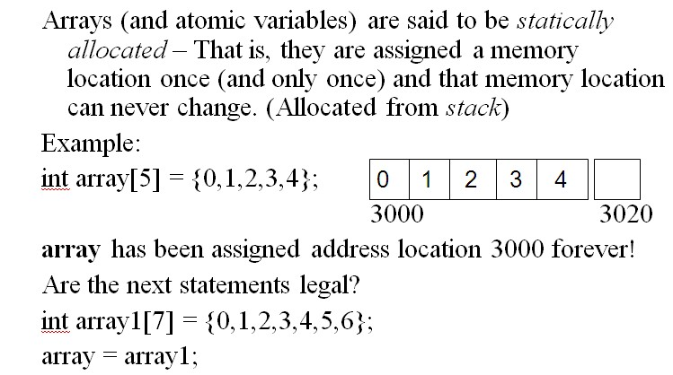

Do we always know how much memory is needed by our program? Do we always know the appropriate size for our array?

Can I do something like this instead?

int no_of_test_scores = 0;

cout << “Enter no of test scores: “;

cin >> no_of_test_scores;

int test_scores[ no_of_test_scores];

What is the problem here?

**Introduction to Dynamic Memory Allocation**

* Dynamic memory allocation is used for a allocating **exactly as much memory** as you need (when you need it)
* Used for creating variables/data structures at **run-time**.
* Only pointer variables can be assigned to a dynamically allocated memory location
* Use the *new* operator for dynamic memory allocation
* **Once an address has been allocated dynamically by *new*, it can never be used again until it is freed by using *delete*!**
* Dynamic memory allocation more complicated because *programmer* *must manage the memory*.

**What is the *new* operator?**

new is used for dynamically allocating memory (i.e., variables) at run time. Its most basic syntax is:

new dataType;

new always returns an address of where the variable is allocated. To allocate a single integer

use:

new int;

Not useful unless you store the address. Must declare pointer variable to store the address:

int* ptr;

ptr = new int;

Generally don’t use new to allocate single variables. Usually use new to allocate arrays. The syntax for dynamically allocating 1-d array is:

int *test_scores;

test_scores = new int[no_of_test_scores];

Placed in context, here is how we can dynamically allocate array:

cout << “Enter no of test scores: “;

cin >> no_of_test_scores;

int *test_scores = new int[no_of_test_scores];

for (int ii = 0; ii < no_of_test_scores; ii++)

{

cout << “Enter test score # ii: “ ;

cin >> test_scores[ii]

Dynamic memory allocation requires a pointer variable. One of the most important uses is to dynamically allocate a 1-d array.

**Steps For Dynamically Allocating 1-d array of integers**

1. Declare Pointer Variable (int* ptr; int* ptr1)

2. Use new to allocate the array (new int[no_ele))

Store the address returned by new in the pointer variable:

ptr = new int[no_ele]; //array of ints with no_ele elements

ptr1 = new int; //allocates one integer off the heap

3. Initialize the data at the dynamic heap address (Just like you

would with a statically declared array)

ptr[0] = 9;

ptr[1] = 22;

......

*ptr1 = 8;

ptr1[0] = 23; //Can only use index 0!

4. cleanup memory when done

delete[] ptr; //Use [] when cleaning up an allocated array

delete ptr1; //When deleting a non-array*/

**Difference between Stack and Heap**

Statically allocated memory (i.e., memory allocated by the compiler by declaring arrays, variables, structures, classes) is allocated from a section of memory called the *stack*. The size of the stack is approximately 1 MB on most computers.

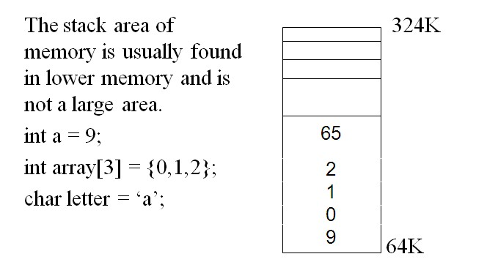

All dynamically allocated pointers are allocated from the *heap*. The *heap* is a massive amount of memory - much larger than the stack.

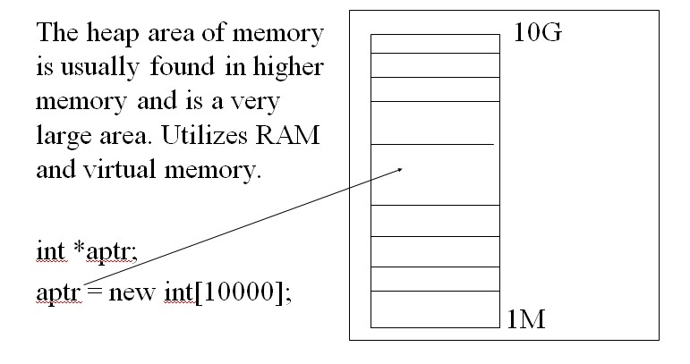

**Returning Pointers from Functions**

Consider the following program:

#include <iostream>

using namespace std;

int* getData(int no_ele);

int main()

{

//Variable Declaration/Initialization

int i = 0;

int no_elements = 0;

int* data = NULL;

//Prompt the user for # of elements to process

cout << "Enter number of elements: ";

cin >> no_elements;

//Get the data as an array

data = getData(no_elements);

//Display all data

for (i = 0; i < no_elements; i++)

{

//Display each element

cout << data[i] << " ";

}

cout << endl;

//Cleanup memory

delete[] data;

return 0;

}

int* getData(int no_ele)

{

//Variable Declaration/Initialization

int i = 0;

const int MAX_ELE = 500;

int array[MAX_ELE] = {0};

//Iterate thru each element

for (i = 0; i < no_ele; i++)

{

cout << "Enter element # " << (i+1) << ": ";

cin >> array[i];

}

return(array);

}

This statement generates the following warning message:

warning C4172: returning address of local variable or temporary

Why this warning?

* Automatic variables are allocated in the stack area of memory
* The stack area is very temporary. Each time a function call is performed, many addresses of the stack are overwritten by the automatic variables of the newly called function!
* The stack is an area of memory which contains:
  + All locally declared variables pertaining to the function (object) currently being performed
* The stack is constantly changing! Each time a function is called, the stack will reflect the variables needed by the newly called function.

Where are local variables allocated?

* Local variables (automatic variables) are created on the stack.
* As soon as the variable goes out of scope (a function call), the variable can be overwritten by the local variables of the function being called.
* Local variables **cannot** maintain their values between function calls!

What happens when running this program:

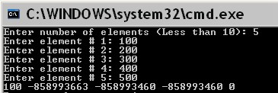

Why is this displayed?

The reason this occurs is because the stack address pertaining to *array* is re-used in main. The data is overwritten/destroyed.

**Only returns pointers that are dynamically allocated**

Correct the program as follows (within getData function):

int* getData(int no_ele)

{

//Variable Declaration/Initialization

int i = 0;

//Dynamically allocate array

int* array = new int[no_ele];

//Iterate thru each element

for (i = 0; i < no_ele; i++)

{

cout << "Enter element # " << (i+1) << ": ";

cin >> array[i];

}

return(array);

}

Re-running this program results in the following:

