Review- Graphics/Numeric Arrays

Graphics Review

The graphics library has the capability of drawing the following shapes or objects:

- Point
- Line
- Rectangle
- Circle
- Windows Bitmap Image

All graphics can be built from these primitive shapes. These shapes are drawn in the graphics window by using the following functions (see GraphicsProgrammingGuide for complete function description )

int drawPoint(int x, int y);
int drawLine(int x1, int y1, int x2, int y2, int width);
int drawRect(int x1, int y1, int width, int height);
int drawCircle(int radius, int x, int y);
int displayBMP(char* fn, int x, int y);
int displayPNG(char* fn, int x, int y);

Each function returns a unique integer identifier representing the object. This identifier can be used when subsequently modifying the color, moving the object, or removing the object.

Objects can be modified in the following ways:

Moving an object
void moveObject(int obj_no, int x, int y);

Coloring an Object
void setColor(int obj_no, int r, int g, int b);

Removing an Object
void removeObject(int obj_no);

Text can be displayed using gout:

gout << setPos(300,450) << setColor(255,0,0) << "The value is: " << setPrecision(2) << value << endg;

Note how the color of the text can be changed along with the precision of floating point values.

1-d Numeric Arrays

Array: variable that can store multiple values of the same type
Values are stored in adjacent memory locations
Declared using [] operator:

Syntax:
data_type array_name[ConstIntExpression];

Example:

int tests[5];

0 1 2 3 4
1st ele 2nd ele 3rd ele 4th ele 5th ele

The last element’s subscript is n-1 where n is the number of elements in the array.

Note:

Named constants are commonly used as size declarators.
const int SIZE = 5;
int tests[SIZE];
This eases program maintenance when the size of the array needs to be changed

Accessing Arrays

Syntax:
array_name[index_expression]; //Does not need to be constant integer expr

Array elements can be used the same as regular variables:
tests[0] = 79;
cout << tests[0];
cin >> tests[1];
tests[4] = tests[0] + tests[1];

Arrays must be accessed via individual elements:

//What does this display
cout << tests << endl;

Array Component Access

Zero out an entire array. (initialize every element to 0.0)

for(i = 0; i < 4; i++)
{
angle[i] = 0.0;
}

//Often use for loops for stepping through an array

No Bounds Checking in C++!

- When you use a value as an array subscript, C++ does not check it to make sure it is a valid subscript.

- In other words, you can use subscripts that are beyond the bounds of the array

Be careful not to use invalid subscripts.
- Doing so can corrupt other memory locations, crash program, or lock up computer, and cause elusive bugs.

Declare and Initializing Arrays:

int values[3] = {0,1,2};
int value1[3] = {0,1};
int scores[] = {210,198,203,188}

- If array is initialized with fewer initial values than the size declarator, the remaining elements will be set to 0:

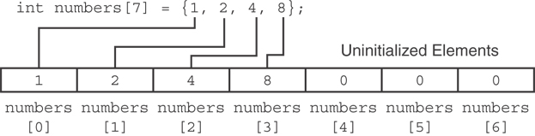

- Can determine array size by the size of the initialization list:
int quizzes[]={12,17,15,11};

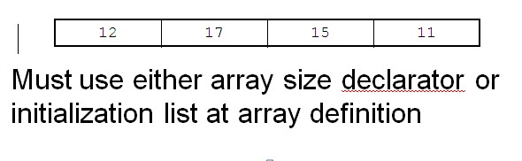

Loading an Array

double grade[10];
int index;

for(index = 0; index < 10; index++)
{
cout << “Enter a grade”;
cin >> grade[i];
}

Using arrays as function arguments

To pass an array to a function, just use the array name:

showScores(tests);

To define a function that takes an array parameter, use empty [] for array argument:

void showScores(int tests[], int no_tests); // function prototype
….

void showScores(int tests[], int no_tests) // function header

Use the array name only when passing as an argument

Example:

showScores(tests, no_tests);

