CSCI 1480
University of Central Arkansas
Lab 2 In-class Assignment

Topic: Pointers
Reading: Ch. 9

*Note: Include the following set of comments at the top of your source code for all assignments.
//Your Name
//Assignment # (Example: Lab1In)
//Brief description of the purpose of the program (Example: //Calculates the area of a square.)

Assignment
(Save this file as lab2in.cpp)
Write a C++ program that simulates the rolling of a set of dice. A single 6-sided die is represented by the following 6 images.


1Die.png 2Die.png 3Die.png 4Die.png 5Die.png 6Die.png

The simulation allows for a minimum number of dice to be rolled is set to 1, while the maximum number of dice to be rolled is set to 5.

The program first prompts the user for the number of dice to be rolled:
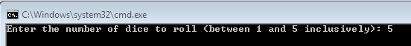
This prompt is performed by the getDiceCount function (for a complete description see Required Functions section below). For this example the user wants to roll a set of 5 dice.

Next the program will simulate the rolling of the dice by simulating a random number between 1 and 6 for each die and storing the random numbers in an array named dice. This functionality is performed by the rollDice function (for a complete description see Required Functions section below).

Next the program will compute the score of the dice roll by simply adding up the random numbers generated by the rollDice function. (for a complete description see Required Functions section below).

The dice and score are then displayed by the displayResults function. An example of displaying a set of randomly generated dice is shown below:
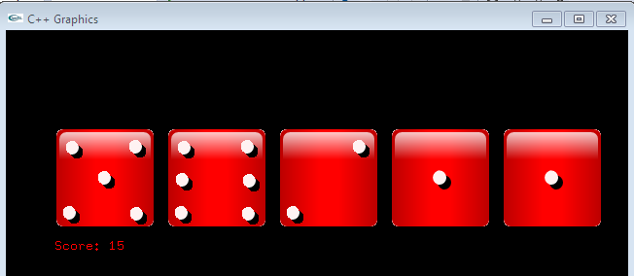

(50,100)

(50,225)

Each die should be separated by 25 pixels. The score should be displayed beneath the set of dice as shown. . (for a complete description see Required Functions section below).

Required Functions
The following functions are required by this program:

void getDiceCount(int* noDice);
This function prompts the user for the number of dice to roll. Valid values are between 1 and 5 inclusively.

Input: noDice - pointer to integer, similar to pass by reference, but uses pointer instead. Variable noDice is changed when function completes.

void rollDice(int* dice, int noDice);
This function generates noDice random numbers (one random number for each dice to be displayed). Each random number should be between 1 and 6 inclusively. Each random number will be stored in the dice array indicated by the 1st parameter.

Input: noDice - The number of dice to display (between 1 and 5 inclusively).

Input: dice - Array of integers used in storing the randomly generated values. These values are between 1 and 6 inclusively. These numbers correspond to the dice face shown on the 1st page.

void computeScore(int* dice, int noDice, int* score)
This function accumulates the value of each dice stored in the dice array and then assigns the result in the variable score.

Input : dice - Array of integers used in storing the randomly generated values. These values are between 1 and 6 inclusively. These numbers correspond to the dice face shown on the 1st page.

Input: noDice - The number of dice to display (between 1 and 5 inclusively).

Output: score – The total accumulation of all random numbers stored in the dice array

void displayResults(int* dice, int noDice, int score)
This function displays each image of a given die that corresponds to a generated random number stored in the dice array. The total score corresponding to the accumulation of all random values contained in the dice array is assigned to score. An example of the displayed results is shown on page 2.

Input : dice - Array of integers used in storing the randomly generated values. These values are between 1 and 6 inclusively. These numbers correspond to the dice face shown on the 1st page.

Input: noDice - The number of dice to display (between 1 and 5 inclusively).

Input: score – The total accumulation of all random numbers stored in the dice array

Use the following template when implementing this program:

#include <iostream>
#include <ctime>
#include "graph1.h"

using namespace std;

//Protoypes
void getDiceCount(int* noDice);
void rollDice(int* dice, int noDice);
void computeScore(int* dice, int noDice, int* score);
void displayResults(int* dice, int noDice, int score);

int main()
{
//Variable Declaration/Initialization
int noDice = 0;
const int MAX_DICE = 5;
int dice[MAX_DICE] = {0};
int score = 0;

//Initialize random number generator

//Display Graphics

//1. Get the number of dice to roll

//2. Roll the Dice (i.e., generates a random number for each dice

//3. Compute the score

//4. Display the dice and results

return 0;

}

//Functions
void getDiceCount(int* noDice)
{
//Prompts for the number of Dice to display and stores in the noDice variable
//User input should be between 1 and 5 inclusively – reprompt if not within range
}

void rollDice(int* dice, int noDice)
{
//Generates noDice random numbers corresponding to the rolling of the dice
//Each random number is stored in the dice parameter
//Each random number should be stored

}

void computeScore(int* dice, int noDice, int* score)
{
//Variable Declaration
int i = 0;
*score = 0;

//Adds up each random number stored in the dice array
//Stores the result in the score parameter

}

void displayResults(int* dice, int noDice, int score)
{
//Display each Die starting at 100,100
//Each Die has a width of 104
//Display the Score at (50,225)
}

Have program repeat as many times as desired.
Submit lab2in.cpp via Blackboard.

