Lab Test 1 Review

There will be 2 programming problems for Lab Test #1 – each problem will count 50 points for a total of 100 points. The test counts 10% of your total grade. Both problems will involve graphics and will be graded on the accuracy of your results. The lab test will cover the following chapters:

Chapters 7, 9

The lab test will cover the following in/out labs:

Lab1in/lab1out
Lab2in/lab2out
Lab3in/lab3out

The following topics are covered:

Numeric Arrays Only (no character arrays will be utilized)
Input/Processing of Numeric Arrays
Declaring Pointers
Initializing Pointers using & operator
Passing pointers to functions using & operator
De-referencing pointers using * operator
Dynamic Memory Allocation of Numeric Arrays
Returning Dynamically Allocated Arrays from Functions

Both problems utilize the graphics library used for the first 3 in class/out class labs.

The lab test is open book/open note.

Example Problems:

1. Write a C++ program that will display a chain formed by drawing overlapping circles. Your program will perform the following steps:

a. Prompt the user for the radius, and desired rgb color for each circle. Also prompt the user for the number of circles to display. This is performed by the following prompts:

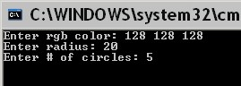

These prompts should be implemented within the getData function whose prototype is shown below:

void getData(int* r, int* g, int* b, int* radius, int* no_circles)
Valid values for the radius is between 15 and 25 inclusively. Valid values for the number of circles is between 3 and 10 inclusively. This function is called in main as follows:

getData(&r, &g, &b,&radius, &no_circles);

b. Draw the first circle at coordinate (100,100). Each subsequent circle should overlap the previous one by 50%. Circles are numbered from 0,1,… starting from the left. Every even numbered circle should be colored to the rgb color entered by the user in getData. The display for this example is shown below:

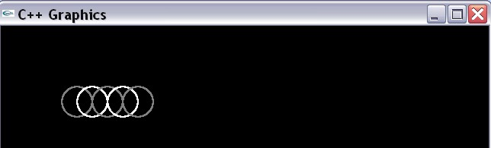
Use the following functions for implementing step b:

//Draws the overlapping circles - all white
//Returns an array containing the object number for each circle
int* drawChain( int radius, int no_circles);

//Colors the even chains to the desired color
//Uses the array containing the object numbers and the desired r/g/b //color
void colorChain(int* objects, int no_circles, int r, int g, int b);

Problem 2: Write a program that processes information for rectangles. The program should perform the following:

1. Prompt the user for the number of rectangles to process
2. Prompt the user for the x coordinates for each rectangle
3. Prompt the user for the y coordinates for each rectangle.
4. Return dynamically allocated arrays for the x/y coordinates from corresponding functions
Example prompts for this data are shown below:

- # of rectangles to process
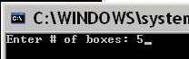

- x-coord data entered for each box
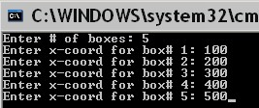

- y-coord data entered for each box
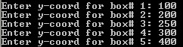

The first prompt is implemented from the
void getData(int* no_rects);

The function call in main for getData is shown below:
getData(&no_rects);

Where the declaration in main for no_rects is as follows:

int no_rects = 0;

The second set of prompts is implemented from

int* getXCoords(int no_rects);

And a dynamically allocated array of integers containing the x-coord for each rectangle is returned.

The third set of prompts is implemented from

int* getYCoords(int no_rects);

And a dynamically allocated array of integers containing the y-coord for each rectangle is returned.

4. Display the rectangles with rgb color (255,0,0) at their x/y coordinate. The width for each rectangle is 50 while the height is 25. Each even numbered box is displayed as red. Each odd numbered block is displayed as blue. The graphics display is shown below:
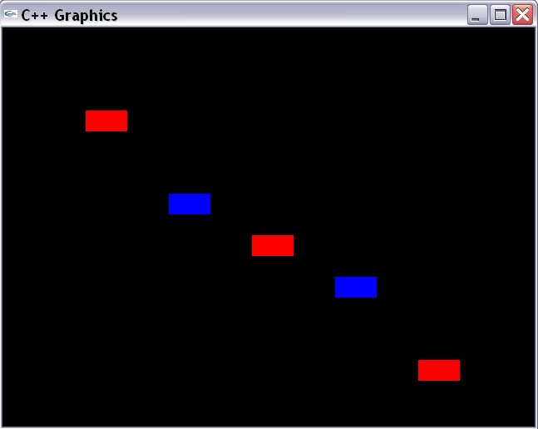

The function that displays the rectangles is shown below:

void displayRectangles(int no_rects, int* x, int* y);

Where no_rects is the total number of rectangles to display, x is the dynamically allocated array containing the x-coords, and y is the dynamically allocated array containing the y-coords.

You will need to repeat your programs as many times as desired.

