CSCI 1480
University of Central Arkansas
Lab 3 In-class Assignment

Topic: Pointers - Dynamic Memory Allocation - 5 points
Reading: Ch. 9

*Note: Include the following set of comments at the top of your source code for all assignments.
//Your Name
//Assignment # (Example: Lab1InP1)
//Brief description of the purpose of the program (Example: //Calculates the area of a square.)

Assignment
(Save this file as lab3in.cpp)
Write a C++ program that displays a set of images at random locations in the graphics window. The objects are in form of 2 png images:

even.png odd.png

The central concept is that evenly numbered indexes will display the leftmost image above (even.png), while odd numbered indexes will display the right most image named odd.png. Even indexes are defined as 0, 2, 4, …, while odd indexes are defined as 1, 3, 5,… The images will be displayed by the displayObjects function described below (see Required Functions sections below). Your program will first prompt for how many total objects (i.e., images) to display:
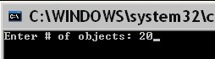
Valid input values are between 2 and 30.

Next, the x/y coordinates for each image is generated randomly. Valid values are between 0 and 600 for x coordinates, and between 0 and 440 for y coordinates. These values should be stored in dynamically allocated parallel arrays returned by the following functions (getXCoords and getYCoords).

Next, the images are displayed onto the graphics window. The even.png image is displayed on an even numbered indexes while odd.png image is displayed on odd numbered indexes. An example for the input given (e.g., 20) the output is shown below:

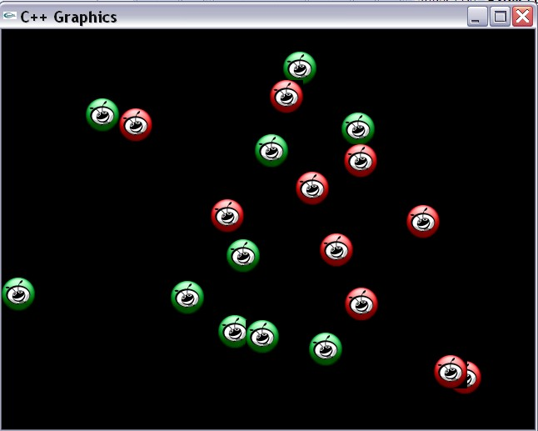

Your program will need to cleanup all dynamically allocated arrays when finished with them.

Required Functions
The following functions are required by this program:

int getNoObjects();
This function prompts for the number of objects to display. Valid values are between 2 and 30 inclusively.

Return Value: int - the number of objects that the user wants to display.

int* getXCoords(int no_objects);
This function dynamically allocates an array of integers with no_objects elements and sets each element to a random number between 0 and 600. These numbers coorespond to the x-coordinate for each object used as input to the displayObject function..

Input Parameter: no_objects - The number of objects to display in the graphics window. Also corresponds to the number of elements to allocate in the dynamically allocated array of integers returned by this function.

Return value - int* - a dynamically allocated array of pointers containing the random x-coordinate for each object.

int* getYCoords(int no_objects);
This function dynamically allocates an array of integers with no_objects elements and sets each element to a random number between 0 and 440. These numbers correspond to the x-coordinate for each object used as input to the displayObject function.

Input Parameter: no_objects - The number of objects to display in the graphics window. Also corresponds to the number of elements to allocate in the dynamically allocated array of integers returned by this function.

Return value - int* - a dynamically allocated array of integers containing the random y-coordinate for each object.

void displayObjects(int* x_coords, int* y_coords, int no_objects);
This function displays the images in a loop. If the loop control variable (e.g., i) is even, even.png is displayed. If the loop control variable is odd, odd.png is displayed. The images are displayed at the corresponding x /y coordinates stored in input parameters x_coords/y_coords. Utilize the following rule for displaying the appropriate image:

1. If the corresponding index of the parallel array (e.g., x_coords/y_coords) is
even - display even.png. If it is odd, display odd.png

Input: int* x_coords - Parallel array containing the x-coordinate for each displayed image.

Input: int* y_coords - Parallel array containing the y-coordinate for each displayed image.

Input no_objects - # of objects (images) to be displayed

Use the following template when implementing this program:
//Lab 3 in
//Displays a set of images at random location

#include <iostream>
#include <ctime>
#include "graph1.h"

using namespace std;

//Protoypes
int getNoObjects();
int* getXCoords(int no_objects);
int* getYCoords(int no_objects);
void displayObjects(int* x_coords, int* y_coords, int no_objects);

int main()
{
//Variable Declaration/Initialization
int no_objects = 0;
int* x_coords = NULL;
int* y_coords = NULL;

//Initialize seed

//Display graphics

//1. Get the number of objects to be displayed

//2. Generate the x-coords for each object

//3. Generate the y-coords for each object

//4. Display the objects at the randomly generated coordinates

//Cleanup memory

return 0;
}

//Implement functions below
int getNoObjects()
{
//Variable declaration/initialization

//Prompt for # objects – should be between 2 and 30 inclusive
//Perform data validation

}

int* getXCoords(int no_objects)
{
//Variable declaration/initialization

//Dynamically allocate the array for x-coords

//Generates x-coords for each object randomly

}

int* getYCoords(int no_objects)
{
//Variable declaration/initialization

//Dynamically allocate the array for y-coords

//Generates y-coords for each object randomly

}

void displayObjects(int* x_coords, int* y_coords, int no_objects)
{
//Variable declaration/initialization

//Dynamically allocate objects to have no_objects

//Display all objects at x/y random positions stored in x_coords/y_coords

}

Have program repeat as many times as desired.

Submit lab3in.cpp via Blackboard.

