CSCI 1480
University of Central Arkansas
Lab 3 Out-class Assignment

Topic: Pointers - Dynamic Memory Allocation - 20 Points
Reading: Ch. 9 and Supplement

*Note: Include the following set of comments at the top of your source code for all assignments.
//Your Name
//Assignment # (Example: Lab3out)
//Brief description of the purpose of the program (Example: //Calculates the area of a square.)

Overview
(Save this file as lab3out.cpp)
Write a C++ program that implements a game named Bug Zapper that utilizes the following images:
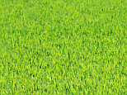

bugs.png

grass.png

The user will attempt to “zap” randomly displayed bugs by entering guesses for the bugs’ x/y coordinates. If the x/y coordinate guessed by the user resides anywhere within the bug, the bug will be removed from the screen.

You will need to use the displayPNG function in order to display these bug images. The initial scene of the game only displays the grass.png image and header as shown below. This is performed by the void initDisplay function – See the Required Functions section below for more details.

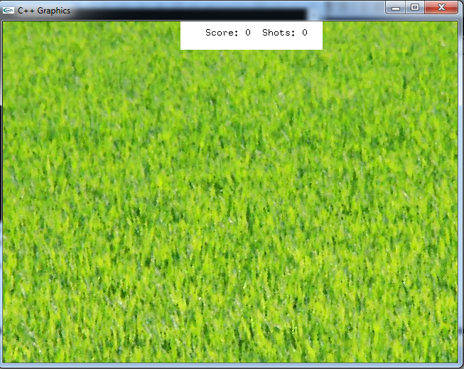
(250,0)

Width: 200

Height: 40

(285,20)

Header Area

Next, the user is prompted for the number of bugs to be displayed in the Graphics Window. This prompt is displayed by the int getNoBugs() function – See Required Functions section below for more details.

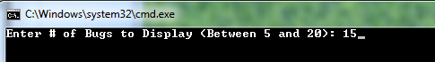
Valid input values for the number of bugs to display is between 5 and 20 inclusively. Your program will perform data validation on this input value. If the input value is not within range, your program will display an appropriate message and allow the user to re-enter the value until it is entered correctly. In this example, the user correctly enters 15 for the number of bugs.

The dimensions of each bug is 64x64. Your program will then generate random-x coordinates and random-y coordinates for each bug to be displayed on the grass background. Two functions are used for generating these coordinates:

int* getXCoords(int no_bugs);
int* getYCoords(int no_bugs);

Valid x-coordinates are between 0 and (640 – BUG_WIDTH)
Valid y-coordinates are between 40 and (440 – BUG_HEIGHT)

Two parallel arrays (one for x-coordinates and another for y-coordinates) are returned by these functions. See the Required Functions section for more details pertaining to these two functions.

Next, the bugs are displayed at the random x/y coordinates generated in the previous step. The displayBugs function performs this operation. An example of this display for 15 bugs is shown below:
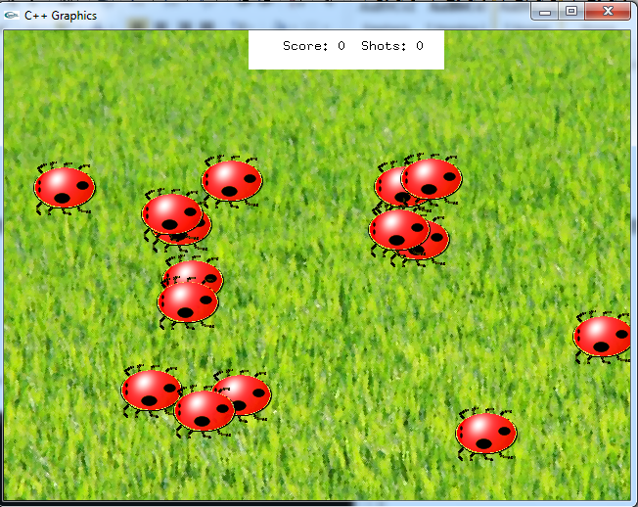
Next, the user attempts to zap bugs by entering x/y coordinates where he believes the bugs to reside. Note that some bugs overlap. It is possible to zap multiple bugs with only one try.

The zapBugs function is utilized for allowing the user to enter the desired x/y coordinates when attempting to zap the bugs. See Required Functions section for more details.

The following steps are performed when zapping bugs:

- User enters x/y coordinate guess where he believes bug(s) reside. An example of this entry is shown below:
For this example the user believes that bug(s) reside at coordinate 275,200.

- Upon entering the x/y coordinate guess (for this example it is 275,200), the program will draw a black filled circle showing the location of the guess in the Graphics Window and increment the shot count. For this example, the guess 275,200 is shown below:
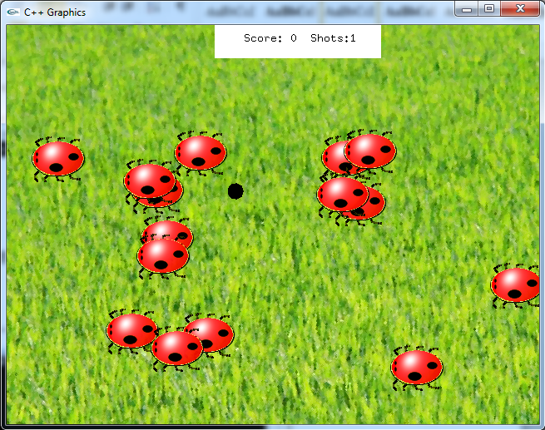
- Seeing the position of his guess, the user can now refine the next guess to more accurately locate the bug. In order to hit this bug, the guess will need to be up and to the left. The user makes the following guess of 245,175 as shown below:

- For this case, the center of the black circle is within the enclosing image area of the bug. The following steps are done once the guess for the x/y coordinates has been determined to be within the area of the bug:
  - Display both the Black Circle and the bug that was “hit” for 1 second
  - Remove the Bug from the screen
  - Increment the Score by 1
  - Increment the Shots by 1
The resulting Graphics Window by performing these 2 operations is shown
below:

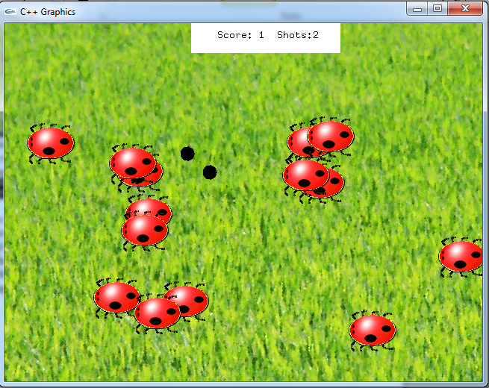
Note how bug has been removed after 1 second of entering the guess.

- The game continues with the user making guesses. The user is allowed a total of twice as many guesses as bugs that are initially displayed on the screen. For the example above, the user is allotted 30 total guesses for the entire game (he has currently used two of them)

- The game ends when one of the following cases occurs:

  - The user has used up all of his guesses (30 for this example)
  - The user has “zapped” all of the bugs

An example of the user making a series of guesses (14) for this example are shown below:
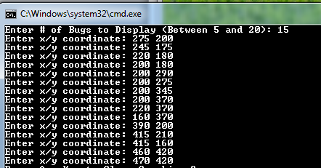

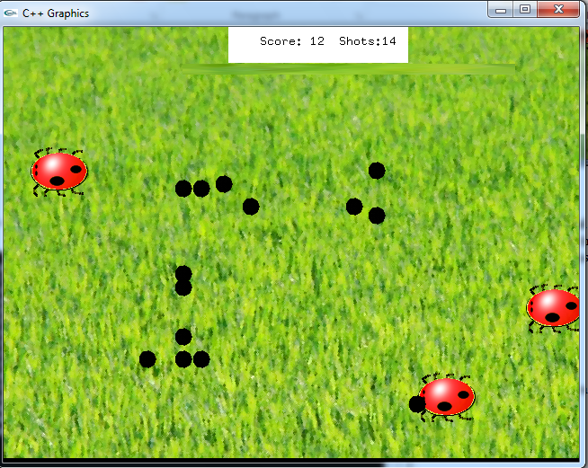

Display “Winner” in the white box if all bugs are “zapped” in the allotted number of guesses.

Display “Game Over” in the white box if the user used all of his allotted number of guesses. In this example, the total number of allotted guesses is 30.

Allow the user to repeat the game as many times as desired.

Required Functions

The following functions are required when implementing this program. You are free to add any extra functions that you like.

void initDisplay()
Displays grass.png and header area as shown on page 2.

int getNoBugs();
This function prompts for the number of bugs to display. Valid values are between 5 and 20 inclusively.

Return Value: int - the number of bugs that the user wants to display.

int* getXCoords(int no_bugs);
This function dynamically allocates an array of integers with no_objects elements and sets each element to a random number between 0 and 640-WIDTH where WIDTH is the width of the bugs.png image (64x64 is the dimension of the bugs.png).

These numbers correspond to the x-coordinate for each object used as input to the displayBugs function..

Input Parameter: no_bugs - The number of bugs to display in the graphics window. Also corresponds to the number of elements to allocate in the dynamically allocated array of integers returned by this function.

Return value - int* - a dynamically allocated array of integers containing the random x-coordinate for each bug.

int* getYCoords(int no_bugs);
This function dynamically allocates an array of integers with no_bugs elements and sets each element to a random number between 40 and 440-HEIGHT, where HEIGHT is the height of the bugs.png image (the dimension of bugs.png is 64x64). These numbers correspond to the y-coordinate for each object used as input to the displayBugs function.

Input Parameter: no_bugs - The number of objects to display in the graphics window. Also corresponds to the number of elements to allocate in the dynamically allocated array of integers returned by this function.

Return value - int* - a dynamically allocated array of integers containing the random y-coordinate for each object.

int* displayObjects(int* x_coords, int* y_coords, int no_objects);
This function displays a bugs.png at the corresponding x coordinate/y coordinates stored in input parameters x_coords/y_coords. Perform the following steps when implementing this function.

1. Dynamically allocate an array of integers with no_objects elements. This is a
parallel array holding the object number of each displayed image.

2. Display a bugs.png image for a corresponding x/y coordinate referenced in x_coords/y_coords. In other words, the 0th element in x_coords and the 0th element in y_coords is used for display the 1st bug.png image. The corresponding object number is stored in the dynamically allocated array of integers.

Input: int* x_coords - Parallel array containing the x-coordinate for each displayed image.

Input: int* y_coords - Parallel array containing the y-coordinate for each displayed image.

Input no_objects - # of objects (images) to be displayed

Return Value: A dynamically allocated array of integers containing the corresponding object numbers for each displayed bugs.png image.

int zapBugs(int* x, int* y, int* objects, int no_bugs)
This function allows the user to guess the x/y coordinate of where a given bug is displayed. If the user’s guesses an x/y coordinate that resides inside any part of the bug, the bug is considered “zapped” and will be removed from the screen. The definition of residing inside any part of the bug is given below:
(bx,by) width
(x,y)
height

Point (x,y) is said to reside in the bug positioned at (bg,by) if the following is true

if ( (x > bx) && (x < bx + width) && (y > by) && (y < by + height)

Where width and height are the width/height of the bugs.png image

A filled black circle of radius 10 is always displayed at the x/y coordinate in the Graphics Window corresponding to the guess made by the user. The “zapped” bug and the black circle are displayed for 1 second followed by the “hit” bug being removed from the screen.

Multiple bugs can be removed by a single guess.

The user is allotted twice as many guesses as bugs that are displayed on the screen. Once those guesses have been exhausted, the game is over.

A message “Game Over” is displayed in the header area if the number of guesses were exhausted.

The message “Winner” is displayed in the header area if the user “zaps” all the bugs within the number of allotted guesses

The details and examples pertaining to this function are outlined on pages 3 thru 6.

Input: int* x- Parallel array containing the x-coordinate for each displayed bug.

Input: int* y- Parallel array containing the y-coordinate for each displayed bug.

Input no_bugs - # of bugs (images) that have been displayed

Input: int* objects - Parallel array containing the object number for each displayed image (bug).

Return value:: integer – This integer is the total number of bugs zapped by the user (i.e., the score)

Special Note

The example screen capture is provided only as an example of what the results should look like. You will not be deducted points if your results are not identical to the one shown (your results should be neatly done and readable though).

What you Submit

Submit lab3out.cpp via Blackboard.

