CSCI 1480
University of Central Arkansas
Lab 5 Out-class Assignment

Topic: Basic Classes
Reading: Ch.13

*Note: Include the following set of comments at the top of your source code for all assignments.
//Your Name
//Assignment # (Example: Lab5out)
//Brief description of the purpose of the program (Example: //Calculates the area of a square.)
Overview
(Save this file as lab5out.cpp)
Lab5out implements a class representing an analog/digital clock simulation. A class named Clock will be utilized in implementing this simulation and the declaration for this class is shown below:

class Clock
{
private:
int hour;
int min;
int sec;

public:
Clock();
bool setHour(int hour);
bool setMin(int min);
bool setSec(int sec);
int getHour();
int getMin();
int getSec();
void draw();

};
And the following image is included (clock_face.png) as shown below:
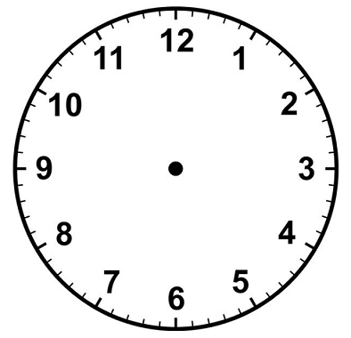

Your program will initially prompt the user for values for the seconds, minutes and hours as shown below (all prompting must be done in main):

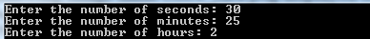
Valid values for seconds is between 0 and 59 inclusively.
Valid values for minutes is between 0 and 59 inclusively.
Valid values for hours is between 0 and 11 inclusively (0 corresponds to where the 12 is on clock_face.png))

An informational message should be displayed to the user when this input is out of range. The informational message is displayed by main based on the return value of the setter – for example – if false is returned from the setter, inform the user that he has entered a value out of range and that this input has been set (i.e. clipped) to a default value instead (See the Required Methods section for all setters).

The prompting shown above must be done in main (see the guidelines for main later in this document) . Assume all numbers are entered as integers only.

The program next displays the following image name clock_face.png as shown below within the draw method (See the Required Methods section for details of the draw method) .
Dimensions: 394x380
Note that the image is of a clock missing the hour, minutes and second hands.

The second hand, minute hand, and hour hand will be drawn on the empty clock_face.png based on the corresponding values entered by the user. The draw method that displays clock_face.png will also be responsible for drawing the second hand, minute hand and the hour hand.

An example of how the input data entered above is translated into the display of the second, minute, and hour hands is shown below:
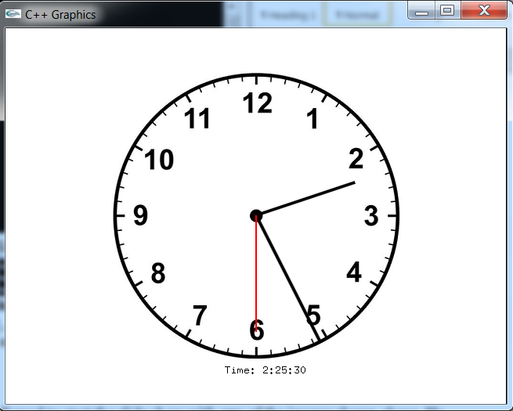

Hour hand

Minute hand

Second hand is in red

Center of the clock is
(197,189)

(280, 440)
Suggested graphics positions:

The draw method of the Clock class will be responsible for displaying clock_face.png and then displaying the hands of the clock on clock_face.png.

The digital time will be displayed by your main by invoking the corresponding getters on a clock object.

The clock_face.png should be displayed at (123,50) with a white background.

The second hand should be drawn first, displayed in red, drawn from the center point of the clock face at the appropriate angle with a length of 150 pixels.

The minute hand should be drawn next, displayed in black, drawn from the center point of the clock face, at the appropriate angle, with a length of 180 pixels.

The hour hand should be drawn last, displayed in black, drawn from the center point of the clock fact, at the appropriate angle, with a length of 133.

The appropriate angle for second hand can be computed as:

alpha = sec*6

Where alpha is declared as an integer. This approach is assuming 0 degrees is at the 12, 90 degrees is at the 3, 180 degrees is at the 6, and 270 degrees is at the 9. Each mark on the clock’s face corresponds to 6 degrees (Why is this so?)

The appropriate angle for the minute hand can be computed as:

alpha = min*6 + (sec/60.0)*6;

Note how the number of seconds must be used for displaying the minute hand as well.

And the appropriate angle for the hour hand can be computed as:

alpha = hour*30 + (min/60.0)*30; //Why 30?

Note how the number of minutes must be accounted for displaying the hour hand as well.

The end points for the second hand (and the minute/hour hands as well) can be computed depending on which quadrant the angle falls into:

Q4 Q1

Q3 Q2

Quadrant 1 (Q1) contains angles greater than and equal to 0 less than 90.
Quadrant 2 (Q2) contains angles greater than and equal to 90 but less than 180
Quadrant 3 (Q3) contains angles greater than and equal to 180 but less than 270
Quadrant 4 (Q4) contains angles greater than and equal to 270 but less than 360.

Once alpha has been computed, for a given hand, the following equations can be applied in computing the endpoints of the line corresponding to the hand:

If alpha is in Quadrant 1 the endpoints for the given hand (either hour/min/sec) can be computed as:

end_x = center_x + (cos((90-alpha)*PI/180.0))*length_of_hand;
end_y = center_y - (sin((90-alpha)*PI/180.0))* length_of_hand;

if alpha is in Quadrant 2, the endpoints for the given hand can be computed as:

end_x = center_x + (cos((alpha-90)*PI/180.0))* length_of_hand;
end_y = center_y + (sin((alpha - 90)*PI/180.0))*length_of_hand;

if alpha is in Quadrant 3, the endpoints for the given hand can be computed as:

end_x = center_x - (cos((270- alpha)*PI/180.0))*length_of_hand;
end_y = center_y + (sin((270 - alpha)*PI/180.0))*length_of_hand;

if alpha is Quadrant 4, the endpoints for the given hand can be computed as:

end_x = center_x - (cos((alpha-270)*PI/180.0))*length_of_hand;
end_y = center_y - (sin((alpha-270)*PI/180.0))*length_of_hand;

Where length_of_hand is the length of either the second, minute, or hour hand.

Each hand can be drawn as a line between the two required points –
(center_x, center_y) and (end_x, end_y).

The user will be allowed to repeat the program as many times as desired – each time re-prompting for the seconds, minutes, and hours and re-displaying the clock_face.png image and re-drawing the hands.

Class Declaration

Use the following class declaration (repeated from Page 1) when implementing this lab 5 Out :

class Clock
{
private:
int hour;
int min;
int sec;

public:
Clock();
bool setHour(int hour);
bool setMin(int min);
bool setSec(int sec);
int getHour();
int getMin();
int getSec();
void draw();
};
Private Datafield Description

int hour;
Stores the integer corresponding to the desired hour as previously entered by the user. Valid values are between 0 and 11 inclusively.

int min;
Stores the integer corresponding the desired minute as previously entered by the user. Valid values are between 0 and 59 inclusively.

int sec;
Stores the integer corresponding the desired seconds as previously entered by the user. Valid values are between 0 and 59 inclusively.

Method Description

The following methods are required by this program. Feel free to add any additional methods.

Clock();
Default Constructor. Initializes all private data fields to 0.

bool setHour(int hour);
Setter for the hour private data field.

Returns true if the input parameter is within the valid range of 0 and 11 inclusively. Otherwise false is returned. If the input parameter is greater than 11, set the private data field hour to 11. If the parameter is less than 0, set the private datafield to 0.

int getHour();
Getter for the hour private data field.

bool setMin(int min);
Setter for the min private data field.

Returns true if the input parameter is within the valid range of 0 and 59 inclusively. Otherwise false is returned. If the input parameter is greater than 59, set the private data field min to 59. If the parameter is less than 0, set the private datafield to 0.

int getMin();
Getter for the min private data field.

bool setSec(int sec);
Setter for the sec private data field.

Returns true if the input parameter is within the valid range of 0 and 59 inclusively. Otherwise false is returned. If the input parameter is greater than 59, set the private data field sec to 59. If the parameter is less than 0, set the private data field sec to 0.

int getSec();
Getter for the sec private data field.

void draw();
Method that displays clock_face.png and the 3 hands – hour, minute, and second – as shown on page 3. The hands are drawn as lines. One endpoint for each hand is the center of the clock as given on page 3. The other endpoint for each hand is computed using one pair of equations given on pages 4 and 5.

Guidelines for main

Your main should perform the following steps:

1. Declare a Clock object using the default constructor.

2. Prompt the user for the seconds, minutes, and hours as shown on page 2.

3. Invoke the setters for second, minute and hour using the prompted data from step 2 as input arguments to the setters. Display any messages informing the user that the entered data for either seconds, minutes, or hours was not in range.

4. Invoke the draw method.

5. Display the digital time beneath the clock using a gout statement. The digital time must be accessed using the getters of the Clock class.

6. Allow the user to repeat the program as many times as desired. The Graphics Window should be completely cleared each time before re-running it

Special Note

The example screen capture is provided only as an example of what the results should look like. You will not be deducted points if your results are not identical to the one shown (your results should be neatly done and readable though).

What you Submit

Submit lab5out.cpp via Blackboard.

