CSCI 1480
University of Central Arkansas
Lab 6 Out-class Assignment

Topic: Classes - Destructors, this pointer, sorting, and searches
Reading: Ch.13, Ch 8

*Note: Include the following set of comments at the top of your source code for all assignments.
//Your Name
//Assignment # (Example: Lab6out)
//Brief description of the purpose of the program (Example: //Calculates the area of a square.)
Overview
(Save main file as lab6out.cpp)
Lab6out implements a lottery game simulation that involves the following 40 images – found in lottery.zip: (Each image is 40x40)


1.bmp 2.bmp…..(other balls follow) ……. 40.bmp

The 40 images represent 40 lottery balls used in creating the simulation. One class, named Lottery, and a driver function named main are needed for implementing this simulation. Your main function should perform the following steps:

1. First, main should prompt the user for the number of lottery balls (i.e., numbers) to play:
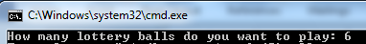

The minimum number of lottery balls is 3, while the maximum number of balls is 10. No data validation need be performed in main – data validation rules in the form of clipping the values will be implemented in the setter of the Lottery class.

2. Next, main will use the following setter:
setNoBalls

to set the number of lottery balls (i.e., numbers) that the user wants to play. (see Required Functions section below for detailed description). In this example, the number of balls (i.e., numbers) is equal to 6.

Note: Perform the following steps in main if the user has entered a value at the above prompt that is not between 3 and 10 inclusively.

- Check return value of setNoBalls – The return value will be false if its input parameter is less than 3 or greater than 10 inclusively.
- Display an informational message in main informing the user that he has entered an invalid value for the number of lottery numbers.
- The setter – setNoBalls – will then automatically set the number of balls (i.e., numbers) to play based on the following rules:

If input < 3 then no_balls = 3
If input > 10 then no_balls = 10

In other words, the input parameter will be clipped to the min/max possible values.

3. Next, main will prompt the user for the lottery numbers. The number of prompts will be equal to the no_balls entered in step 2 . For this example the user will be prompted for 6 numbers. The first of these prompts are show below:

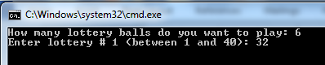
For this example, the user has entered 32. The lottery numbers should be stored within the Lottery class by invoking the addNumber method as shown below:

res = lottery.addNumber(val);

The details for the addNumber method are provided in the Required Functions section below. The variable val contains the current input from the user (32 for this example) and res contains a boolean. The lottery numbers entered by the user must follow these rules:

- All numbers must be between 1 and 40
- All numbers must be unique

The addNumber method will return false if either the above conditions are violated and will not add the number to the Lottery class. Your main should check this return value. If the return value is false, then display an error message (e.g., “Incorrect Input – Please Reenter”) and have the user continually re-enter this lottery number until it matches the above criteria 1 and 2.

For this example, all 6 numbers are entered correctly as shown below:

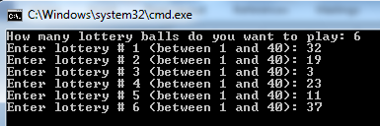
4. Next, main will display lottery balls that represent the numbers that you have chosen. The numbers must be sorted from smallest to largest displaying the smallest at the left most position. There should be 20 pixels between each image. Use the selection sort algorithm to perform this step.

The displayYourNumbers method is used for performing the task described above – see Required Methods section below. An example of displaying the 6 selected numbers in sorted order is shown below:
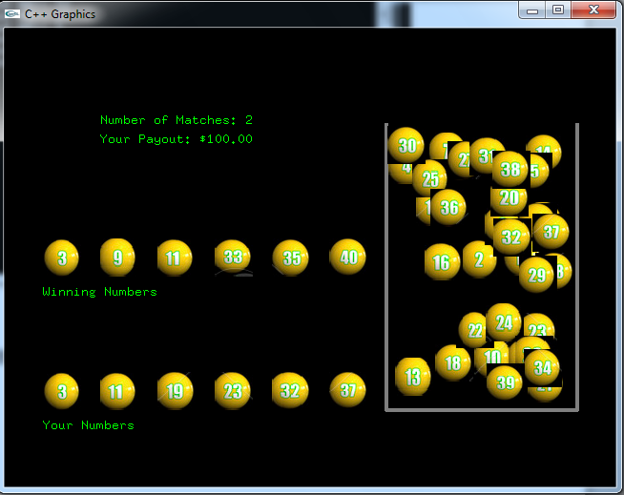

5. Next, the winning numbers are generated and displayed in the Graphics Window one lottery ball at a time. The method processWinningNumbers performs this operation – See Required Methods section. This step involves the following tasks:

Generate a unique random numbers between 1 and 40 inclusively. You will eventually generate no_balls random numbers, but all these numbers will be unique. For this example, no_balls has been set to 6.

Display the lottery ball representing the 1st randomly generated number from the cylinder to position (40,220) – the left edge of the window as shown below (For this example the first winning numbers is 32)
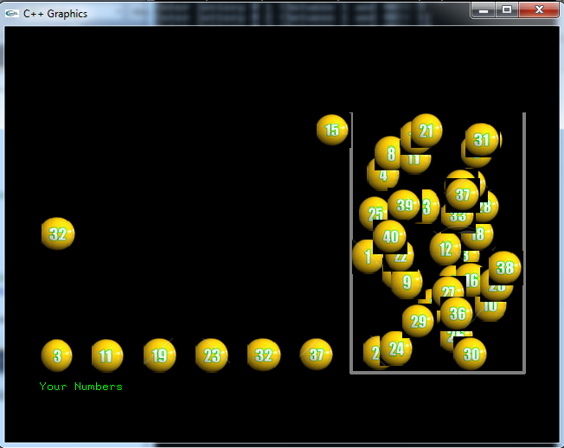

This first ball should be displayed for 1 second before generating/displaying a 2nd winning number.

Suppose the 2nd winning lottery number (15 for this example) is generated and its corresponding lottery ball displayed 20 pixels to the right of the 1st lottery ball as shown below:
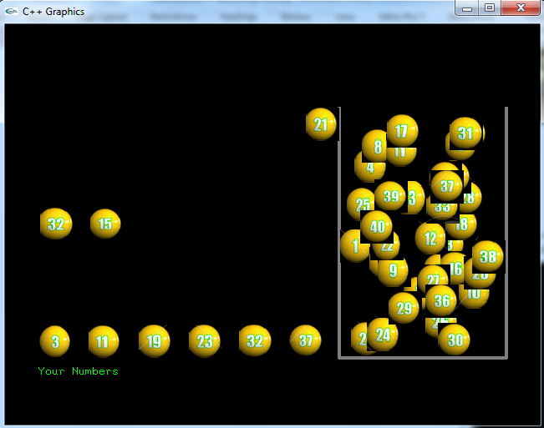

These two lottery balls should be displayed for one second as well before the 3rd lottery ball is displayed

Suppose that the third winning ball that is randomly generated next is 21 as shown below . The entire process is repeated for it as well as shown below:

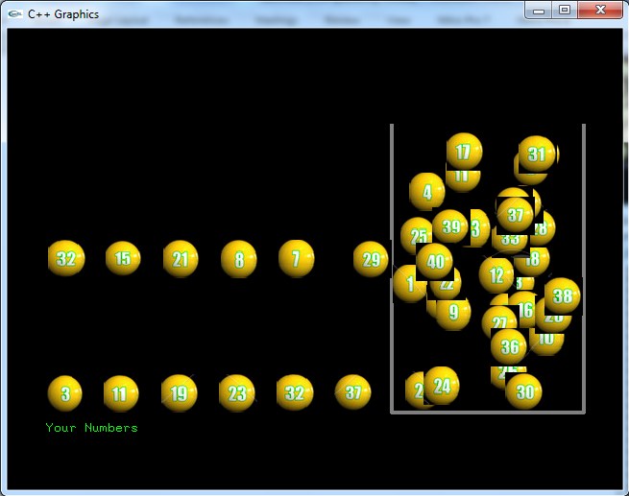
The 3 winning balls are displayed for 1 second before the 4th ball is generated and displayed.

The entire process is repeated until all 6 lottery balls are displayed as shown below in unsorted order
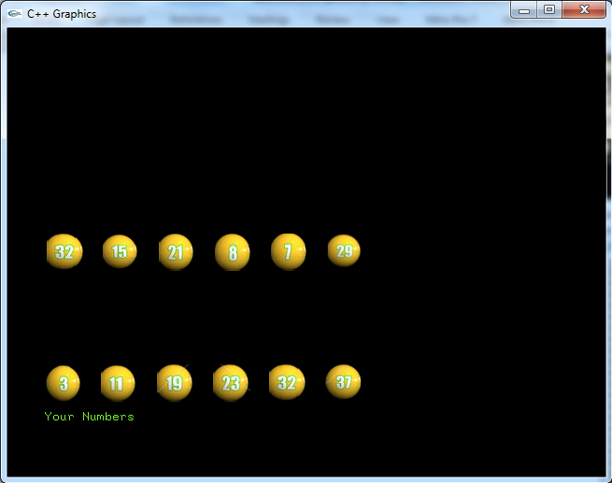
Note that the lottery balls have not been sorted. The numbers are displayed as shown above as unsorted for 3 seconds. Next, the insertion sort algorithm is applied to the winning numbers and they are re-displayed in sorted order as shown below:

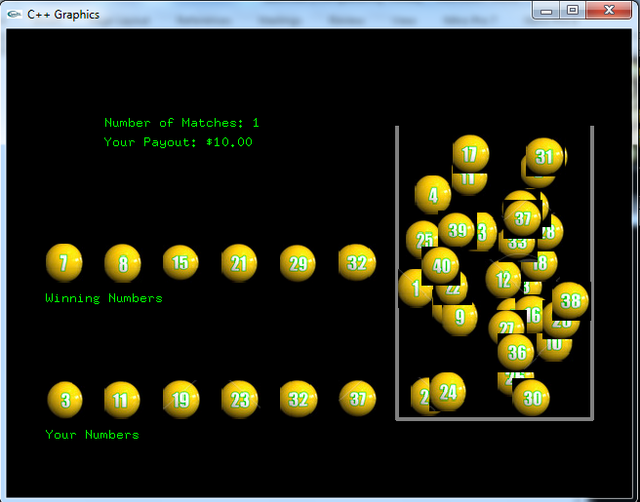

Note that the caption “Winning Numbers” has now been added
The method processWinningNumbers is responsible for performing all tasks outlined in the previous step 5 on pages 4 thru 7.

6. The number of matches between the numbers you selected and the winning numbers is next computed along with any winnings (i.e., payout) that occur. This should be done in a method called computeWinnings –see Required Methods section below . The details for this step are given below:

- Use binary search algorithm to search each of your lottery numbers (one at a time) among all the winning lottery numbers.
- Each of your lottery number that matches a winning lottery number results in a match being detected.
- Compute the winnings by using the following formula:
winnings = pow(10.0,matches);

Where matches is the number of your lottery numbers that matches the winning lottery numbers. For this example, matches = 1 (i.e., your 32 matches the winning numbers 32). The payout is computed as $10.00 for this example

7. Your main then displays the number of balls played, the number of matches, and the winnings as shown below:
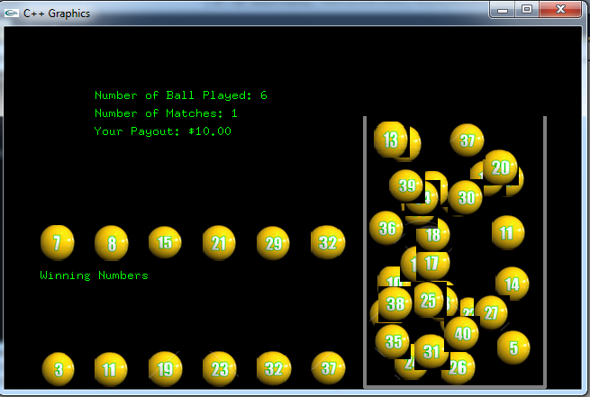

8. Your main will prompt to repeat as shown below:
Entering ‘y’ repeats the entire program again; entering ‘n’ stops the program.

Note: The winnings are not accumulated for each time the user repeats the program. Instead, the winnings are newly computed each time and only corresponds to the current set of lottery balls displayed.

Class Declaration

Use the following class declaration for implementing the Lottery class:

#ifndef LOTTERY_H
#define LOTTERY_H

class Lottery
{
private:
int no_balls;
int* yourNumbers;
int* winningNumbers;
int matches;

public:
Lottery();
~Lottery();
int getNoBalls();
bool setNoBalls(int no_balls);
bool addNumber(int num);
void displayYourNumbers();
void processWinningNumbers();
void selectionSort();
void insertionSort();
int getMatches();
int binarySearch(int target);
int computeWinnings();
};

#endif
Private Datafield Description
Utilize the following private datafields when implementing this class:

int no_balls – The number of lottery balls (i.e., numbers) to be played

int* yourNumbers – dynamically allocated array of integers containing the numbers that you have entered (added).

int* winningNumbers – dynamically allocated array of integers containing the winning numbers that are generated

int matches – how many numbers match between the numbers you chose and the winning numbers that were generated.

.

Method Description
Utilize the following methods for the Lottery class. Feel free to implement any additional methods.

Setters/Getters/Constructors/Destructors

Lottery(); - sets all datatfields to 0 or NULL
~Lottery();
int getMatches(); //Returns the # of balls that match
int getNoBalls();

bool setNoBalls(int no_balls); //Rules for this setter are given in step 3 on
//page 2
This method should dynamically allocates the winningNumbers and yourNumbers
array based on the no_balls input parameter.

bool addNumber(int number);
This method inserts a number (corresponding to input parameter number) into the dynamically allocated array yourNumbers. The number is inserted at the next unfilled element. Valid subscripts start with subscript 0 and end with no_balls -1. The input parameters number represents the lottery number entered by the user in main and to be inserted into the yourNumbers array by this method. The method returns false if either of the following failing condition occurs:

- The number is less than 1 or greater than 40
- The number is not unique (i.e., it was previously entered)

The method must not insert the number if either of the above conditions occur.

void displayYourNumbers ();
Display the lottery balls corresponding to the numbers that the user has entered. An example of this display is shown at the top of page 3.

void processWinningNumbers();
Generates and displays the winning numbers (one at a time), and stores each winning number in the winningNumbers array, and performs the display for each winning number as outlined on pages 4 -7.

void selectionSort();
Performs the selection sort algorithm on the yourNumbers dynamically allocated array.

void insertionSort();
Performs the insertion sort algorithm on the winningNumbers dynamically allocated array.

int binarySearch(int target);
Performs the binary search algorithm on the winningNumbers array. The input parameter, target, corresponds to one of your numbers to be searched for within the winningNumbers array.

Returns: -1 if target is not found within the winningNumbers array
or
Returns: the subscript corresponding to the element of the winningNumbers array that is equal to target.

int computeWinnings();
Determines the number of matches between your lottery numbers and the winning lottery numbers. The binarySearch method should be used to perform this operation. Once the number of matches have been determined, the winnings is computed in main using the following formula:

winnings = pow(10.0,matches);

(You may have to typecast matches to a double).

Returns: The winnings as computed above

Guidelines for main

Your main should perform the following steps.

- Declare one Lottery object

- Initialize the random number generator

- Prompt the user for the number of lottery balls to play as shown on page 2

- Utilize the setNoBalls method with the value entered in step 4 as its input parameter.

- Prompt the user for his lottery numbers one at a time as shown on page 3.

  - Invoke the addNumbers method with each desired lottery number as its input parameter
  - Check the return value of addNumbers
    - If true, allow the user to enter his next lottery number
    - If false, force the user to re-enter the current lottery number
    - Repeat step b until the user enters the lottery number correctly

- Invoke the displayYourNumbers method to display the user’s selected lottery numbers as shown on page 4.

- Invoke the processWinningNumbers method to display the winning numbers one at a time and the sorting of the winning numbers as shown on pages 4 thru 7.

- The number of balls played, the number of matches and the total winnings are displayed as shown on page 8. Invoke the getNoBalls, getMatches, and computeWinnnings methods in order to display this information.

Special Note

The example screen captures are provided only as an example of what the results should look like. You will not be deducted points if your results are not identical to the one shown (your results should be neatly done and readable though).

What you Submit

Submit Lottery.h, Lottery.cpp and main.cpp via Blackboard. (You can zip these three files up if you like)

