**Project Application**

**Los Angeles Parking Citations**

**Author / Developer**Michael Kahr

**Vision**

* **Benefit for the users:** The user can just select a new csv file and see where the most citations happened, when and which type they were.
* 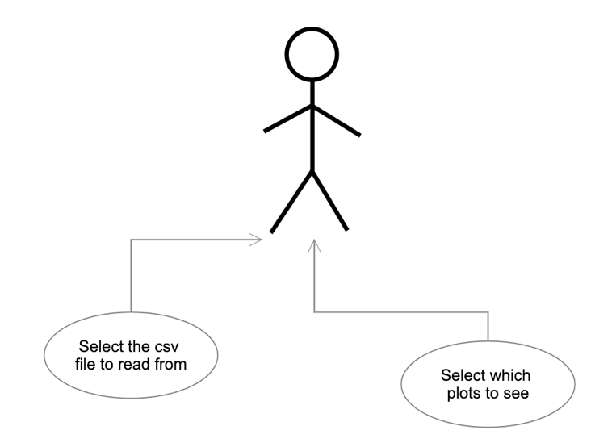**Business value:** The city of Los Angeles can use this map to see where they need to put more security or improve the signage

**Project Objectives**

* **Use Case Diagram:**
* **Product Backlog:**
  + As a user, I am  
    able to select a csv

File that should be used.

* + As a user, I can decide which plots

I want to see.

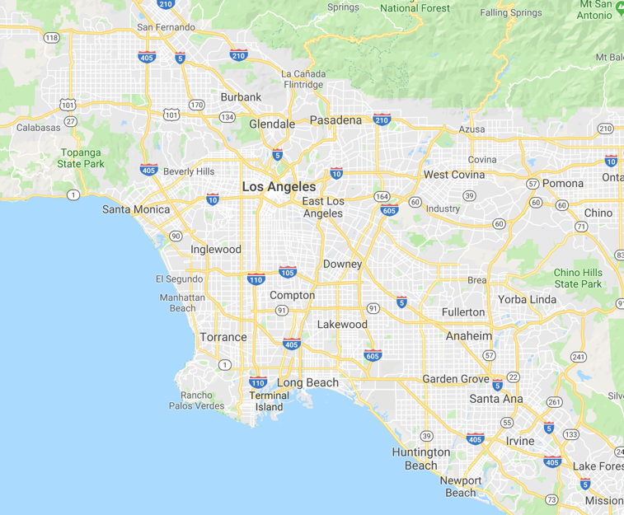**Technical Areas**The programming language will be python 3. The library for reading the csv file in and creating a dataframe is pandas. For calculation in the rows numpy will be used. Plotly or matplotlib will be used for the plots. Folium or gmaps will be used for the map.

**Mock-up**

**Milestones**

1. Read the csv file in and clean it
2. Collect important information
3. Display basic plots about the citations
4. Show a map where the most cases happened.