

**School of Computing**

*Department of Computing*

**Bachelor of Science in Computing**

**Programme Code: DT211C/4**

|  |  |  |
| --- | --- | --- |
| Room Occupancy Measurement using Image Processing | | |
| Michael Kane | C14402048 | Yupeng Liu |

Abstract

The purpose of this project is to count the number of people in a room using image processing techniques. This application could be used to monitor the elderly people in their homes. The reason for monitoring them could be for example to detect a fall. To detect people in a room, a raspberry pi NoIR camera will be used. This camera will be combined with super bright infra red LED's to shine light on the room making people visible. Once an image has been captured, the result will be posted to a web server. The web server will display the image of the room and the number of people in the room. The image and result posted to the server will be stored in a database until the end of the next day.

# Project statement

The main application of this project is to help Elderly or disabled people in their homes. The application will monitor a room and attempt to detect if a person has fallen over using image processing techniques.

# What research has been done and what are the outputs?

## 2.1 Background research

2.1.1 Digital Image Processing

Digital Image processing is the ability to manipulate images through the use of a computer. The purpose of digital image processing is to create applications to generate a specific output on an image. There are some elements which can affect the quality of an image or video such as noise or blurring. These elements can be found in old images or videos and a user can use image processing to reduce or even remove them.[1]

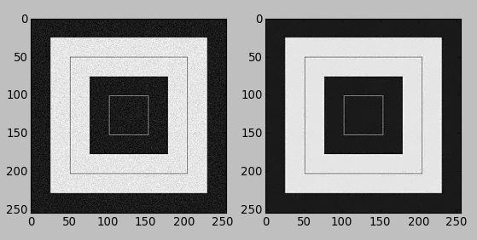[2]

2.1.2 Infrared VS digital camera

Near infrared (IR) imaging can be captured using a camera with the IR filter removed. IR works on a different visual spectrum then we as humans can see. Clement Fredembach defines the wave lengths of infrared as follows "*The near-infrared spectrum is located just after the red wavelength and comprises wavelengths that range from 700 to 1100 nanometers*" This means that the infrared wavelength is outside of a humans visual spectrum. [3] IR LEDS can be used to illuminate dark areas with the area only being visible to an IR camera, as the IR wavelength is out of our visual spectrum. The IR camera also has the ability to take daytime photos, these images appear drastically different due to the way IR wavelengths interact with the environment.[4]

insert an image taken from raspberry pi at home

Digital images can be taken with an ordinary camera, the light used to capture these images is in our visual spectrum. Meaning to capture day and night images we need a light source to illuminate the area E.G. the sun or a lamp. The reason to keep the IR filter on the camera is to prevent the IR radiation from interfering with the quality of the image as Clement Fredembach says here "*digital cameras' sensors are so sensitive to near-infrared that a "hot mirror", a filter that lets only visible light pass, is placed in front of them in order to prevent NIR contamination of the visible signal.*".[5] Digital cameras with an IR filter provide a higher quality image during daylight, and images can appear blurred in IR daylight images depending on the lighting conditions.

Take Pictures with the camera when I get home and insert

There are two application for the camera chosen to be used in. These are Monitoring an elderly or disabled person in their home and detecting the occupancy of a room in the college to see if its free or occupied. For the applications to perform acceptably, the camera must be able to function is daylight, lowlight and dark conditions. The digital camera has the ability to produce high quality images in any light, but the issue is having to shine a bright light onto an area 24 hours a day in the case of monitoring a person. The advantage of using an IR camera in this situation is that the IR LED light is invisible to the human eye. While the room is dark for humans the room will be bright enough for the IR camera to pick up. The goal of this application is to detect a person, and the IR camera is in my opinion the best choice as it can provide an image where people can be segmented out and located using object detection.[6]

2.1.3 Segmentation

Image segmentation is the splitting an image into individual pixel values then transforming the image into something new. Examples of this can be done by reducing noise or extracting certain object or elements from the image. There are two examples of Segmentation these are thresholding and morphology. Image thresholding is converting a grayscale or coloured image to a binary mask. There are two types of thresholding, there's thresholding and adaptive thresholding. The difference between the two is that the adaptive thresholding will try to find the average value of the pixels and apply the answer as the binary mask. " *It assumes that (i) each peak coincides with the mean grey level for all pixels that relate to that peak and (ii) the pixel probability decreases monotonically on the absolute difference between the pixel and peak values both for an object and background peak.*"[7]

insert threshold example pics:

Morphology is the use of morphological transformations which are algorithms, to alter an image based on its shape. These algorithms are performed on binary masks which can have jagged edges or spots of noise in the background, and can be used to extract and clean the overall look of an image. There are four main types of morphological transformations and these are Erosion, Dilation, Opening, and closing. Erosion and Dilation are opposites of each other, Erosion will shrink the white areas of an image while also removing noise. Dilation increases the white in an image and is usually paired with Erosion to return the image to its previous size. Opening is erosion followed by dilation, it's a algorithm which combines Erosion and dilation. Closing is Dilation followed by Erosion, this is useful for cleaning the objects in the image itself.[8]

2.1.4 Flesh Detection

One of the biggest challenges in this project is to detect a person. With a regular camera a user would have the ability to use colour to segment out a person from a background. With an IR camera it's based on what level wavelength a object such as skin will absorb light. [FIL THIS WITH THE REFERENCES NUMBER]Describes the wavelength where human skin is detected is 970nm while clouds and the sky are detected at 940nm. This means that the clouds and sky can cause interference with skin detection. Their solution to this problem was a 6 band camera which is a combination of a VIS camera and NIR(Near infrared camera) which is out of the scope for my prototype and capabilities.[9]

2.1.5 Contouring and object Detection

Contours in image processing are a way of joining similar areas of interest. Contours are a great way of finding a particular object.[10] A list of contour object can be created on a binary mask for a specific region of interest. From this list of objects a specific object can be chosen by a developer to be displayed to the user. In the below image[insert image number] we can see the use of contours on a peak flow meter from one of my image processing assignments. To find contours a binary mask must be created of the region of interest i.e. what the user wants to see. In the below image I wanted to segment out the red and yellow parts, as you can see the colour range I specified also takes in some of the white areas due to the white being within the colour range specified.

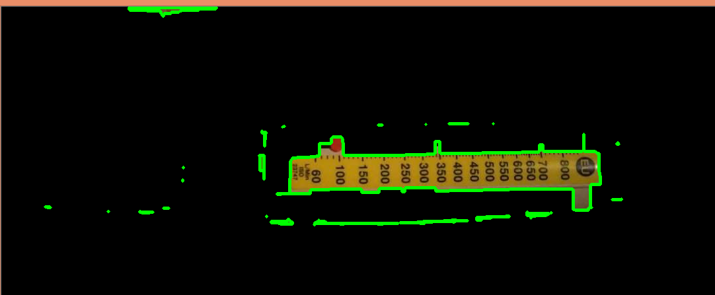

2.1.6 Conclusion

## 2.2 Alternative existing solutions to the problem you are solving

2.2.1 Human Skin Detection by Visible and Near-Infrared Imaging.

The purpose of this application is to use spectroscopy to increase the effectiveness of pedestrian detection in Advanced Driver Assistance Systems (ADAS). Yusuke Kanzawa, Yoshikatsu Kimura and Takashi Naito define spectroscopy as “Spectroscopy is the study of how substances absorb, transmit, or reflect light."[11] They go on further to say that they use a method to detect human skin using spectroscopy.

This solution uses near infrared and visible processing to detect humans. They created their own camera to combine both processing types, as human skin, clouds and the sky share the same wavelength. The NIR camera will find the human skin and the visible camera will be used to filter out the sky and clouds.

tech used

algorithm use/prototype

2.2.2 Project name

Describe the project

how is it similar

tech used

algorithm use/prototype

2.2.3 Project name

Describe the project

how is it similar

tech used

algorithm use/prototype

## 2.3 Technologies researched

What candidate technologies did you examine? What criteria did you use for selection? What experience you have in the chosen technologies? If new to you, what have you done to familiarise yourself with the new technology?

2.3.1 OpenCV VS Mat Lab

There are two main independent development environments (IDE) to use when developing an image processing application. For this application I chose OpenCV, OpenCV (Open Source Computer Vision) is an open source library of methods used for image processing.[12]

2.3.2 Python VS C++

2.3.3 Raspberry PI

2.3.4 Web Server Technology

2.3.5 Database Technology

## 2.4 Resultant findings/requirements

For example, a list of requirements for your solution – based on your research and analysis

## 2.5 Bibliography (research sources)

https://karanjthakkar.wordpress.com/2012/11/21/what-is-opencv-opencv-vs-matlab/

* <https://www.raspberrypi.org/documentation/hardware/camera/>
* <http://ivrl.epfl.ch/research/infrared/imaging>
* <https://thepihut.com/products/raspberry-pi-camera-module>
* <https://www.raspberrypi.org/products/camera-module-v2/>
* <https://pimylifeup.com/raspberry-pi-camera-vs-noir-camera/>
* <https://www.raspberrypi.org/products/pi-noir-camera-v2/>
* https://www.tutorialspoint.com/dip/
* http://www.bogotobogo.com/python/OpenCV_Python/python_opencv3_Image_Non-local_Means_Denoising_Algorithm_Noise_Reduction.php
* C. Fredembach and S. Süsstrunk, [Colouring the near infrared](http://infoscience.epfl.ch/record/129419/files/IR_colour.pdf), Proceedings of the IS&T 16th Color Imaging Conference, pp. 176-182, 2008.
* https://docs.opencv.org/3.1.0/d4/d73/tutorial_py_contours_begin.html
* <http://citeseerx.ist.psu.edu/viewdoc/download?doi=10.1.1.389.6745&rep=rep1&type=pdf>
* <https://www.navicat.com/en/download/navicat-data-modeler>
* http://staruml.io/download

# Analysis: Describe clearly what your solution will do

3.1.1 Problem and solution created

The problem to be solved is the use of Infrared image processing to measure room occupancy, and to display this information in a user friendly way. The solution to this problem was to design a system which connected all stages through a web server. The web server receives connections from both the user and the raspberry pi but the two never meet. The raspberry pi receives an image from the IR camera, runs an algorithm to count the people in a room and posts it to the web server, the web server stores this in a database where it analyses the data to present it in a user friendly format. The user can then log into the web server, and view the images and data analysed.

3.1.2 Person Detection Algorithm

3.1.3 Hosting the Web Server

3.1.4 Storing Data

3.1.5 Security

3.1.6 Accessing the Data

# Approach and Methodology

What is your approach to this project? Are you using any particular software methodology? Eg. Are you delivering design/ code in phases, or are you completing all design up front, followed by all coding? Have you some sections lower priority if time runs short?

What is agile scrum

Why am I using it

Product owner and scrum master

Sprints

# Design

## Technical architecture diagram:

## low level view.jpg

## The above image is a low level design of my system. It shows how each individual piece is connected.

## Other design documents

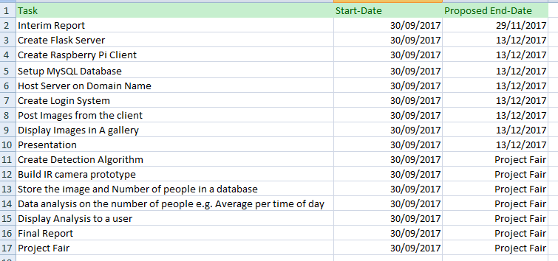

The above image is a Gantt chart of the work I have planned for the year.

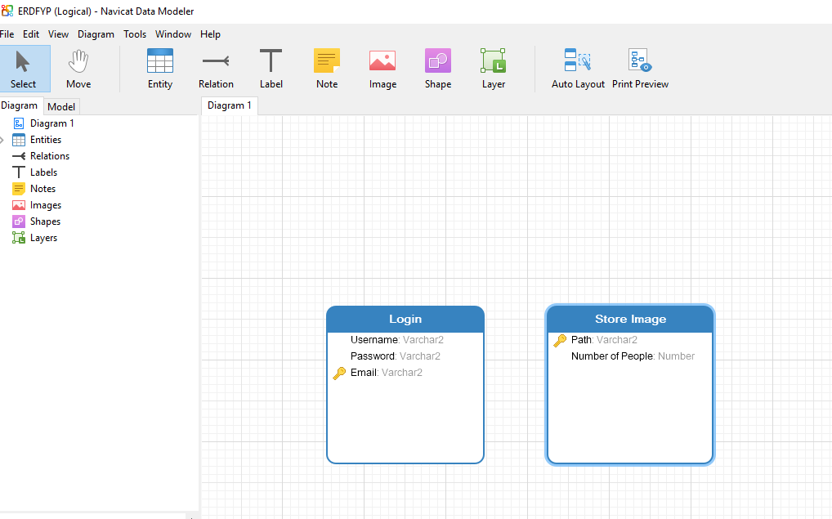

The above image is of the entity relationship diagram for my MYSQL database. It shows two tables login and store image.

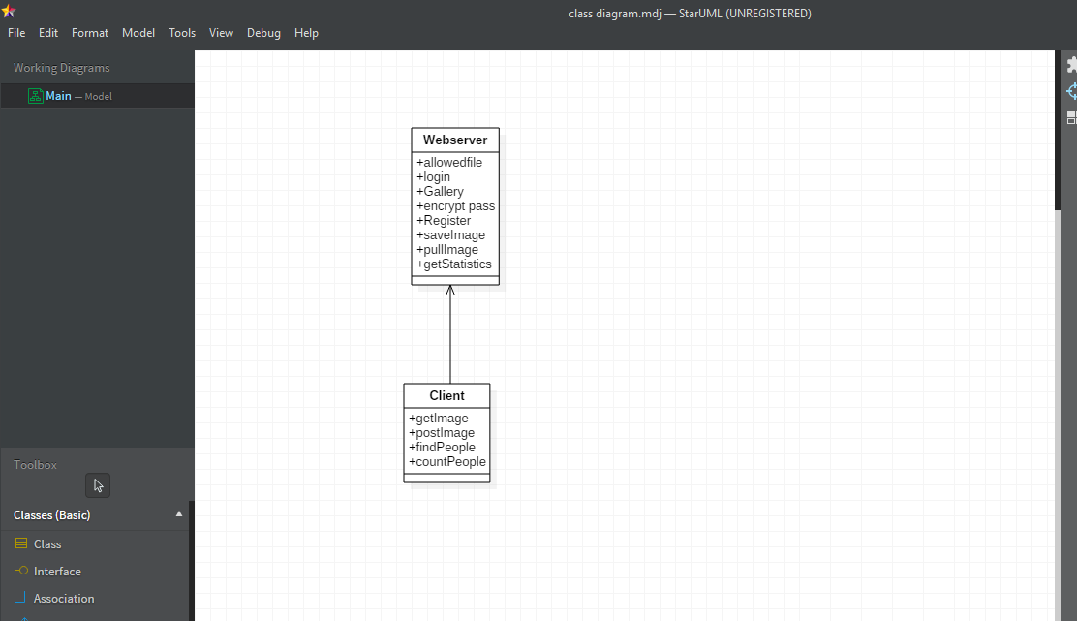

The above image is the class diagram for my web server and client programs. It shows the methods used in the classes.

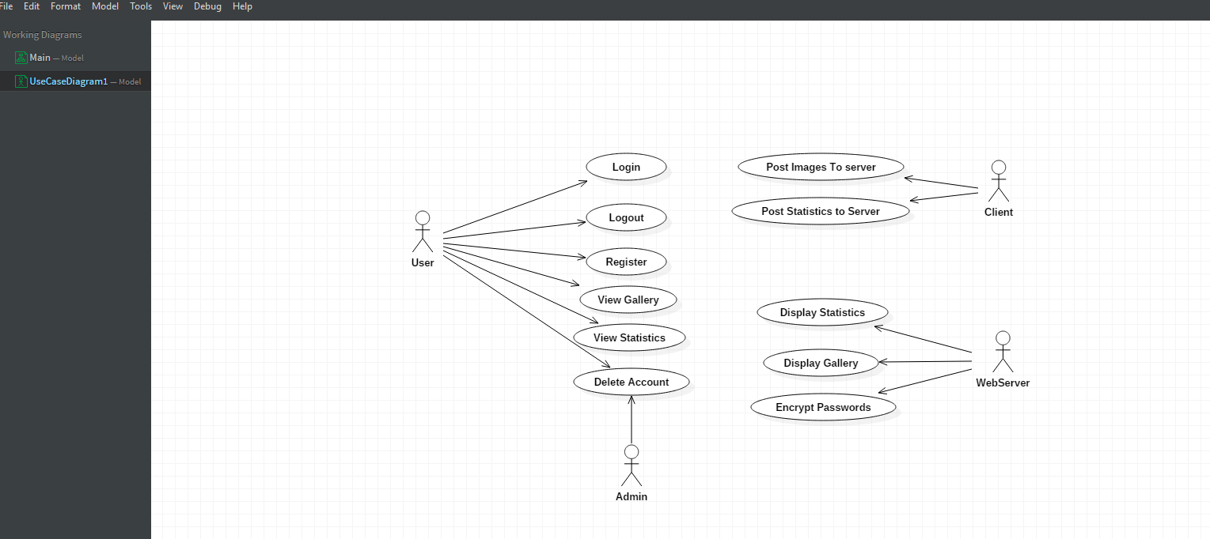

The above image is the use case diagram for my system. It shows the basic functionality for the user and each system component.

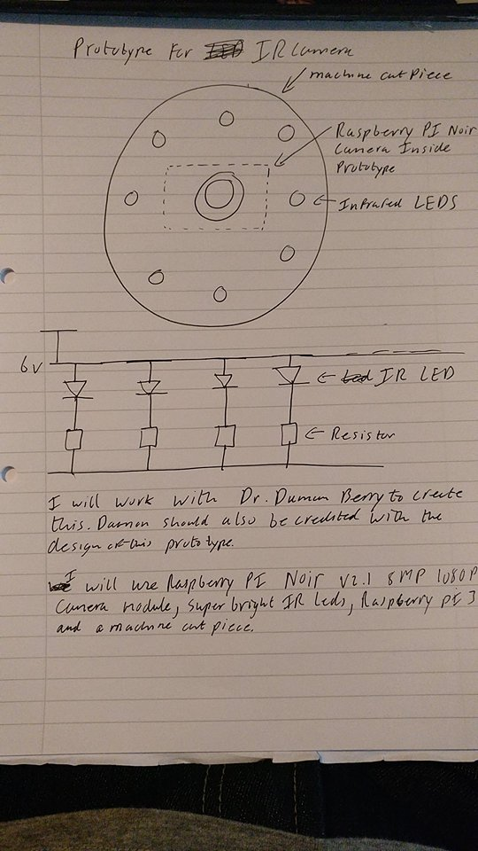

The above image is the prototype camera for the project. It shows how the Infrared camera will be assembled.

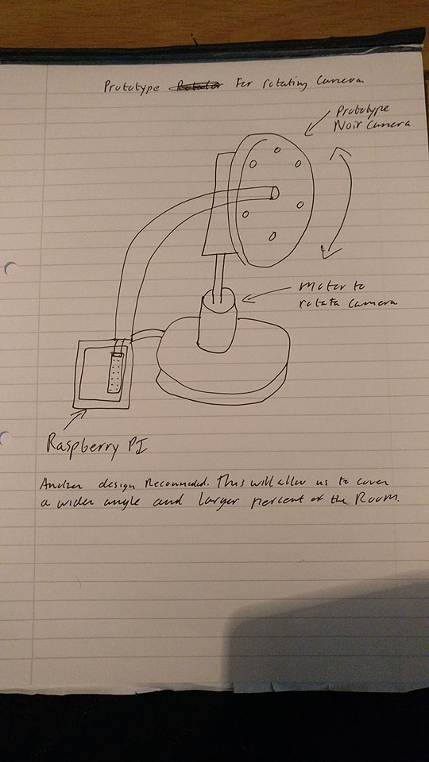

The above image is of the proposed approach to obtaining a wide angle shot of the room using a motor to rotate the camera.

# Prototyping and Development

The camera I am using for this project is the raspberry pi NoIR camera. The reason for choosing this camera is that it has no infrared filter attached. The lack of an IR filter allows the taking of lowlight and infrared images. For this camera to take infra red(IR) images, IR LEDS must be shined onto the target area.

Creating the web server.

Setting up the domain name and hosting.

Creating the database.

Creating the client.

<https://www.raspberrypi.org/blog/infrared-camera-you-asked/>

<https://www.dynu.com/en-US/ControlPanel/BasicEdit?ATVPDKIKX0DER=SQBEAD0AOAAwADEANQA4ADMAMwA%7C>

<https://code.tutsplus.com/tutorials/creating-a-web-app-from-scratch-using-python-flask-and-mysql--cms-22972>

<https://www.youtube.com/watch?v=vzojwG7OB7c&t=2959s&index=6&list=WL>

<https://www.amazon.co.uk/Raspberry-Pi-1080p-Camera-Module/dp/B01ER2SMHY>

<https://www.youtube.com/watch?v=Y2fMCxLz6wM&t=472s&index=7&list=WL>

# Testing

Monitoring the results being posted.

Code to prevent unwanted code.

Unit tests

Usability test

# Issues and risks

The prototype camera designed to take the IR photos did not arrive on time. This has stalled my work on the algorithm for person detection. I contacted the company, who posted my piece of equipment, and they said “on this occasion our postal service has failed you and we will be sending you out a replacement part. Please contact us if you do receive your first package.” The package has arrived since the message was sent and I hope to begin construction of the prototype before or after Christmas. It is regrettable that it will not be complete for the presentation.

The web server currently has no security, my goal for after Christmas is to encrypt the user passwords and store them in the database and to create security for SQL injections. I propose to use an encryption algorithm to encrypt the passwords, and to use regular expressions to prevent the use of SQL injections on the server. I will also need to setup sessions so a user who isn’t logged in can’t piggyback off the current users session.

From the research I have done so far I am worried that the IR camera may not be able to detect people at its current state. The project using spectroscopy to find people uses a 6 band camera to find a person, while I am using a lone infrared camera with IR led’s. I hope to solve this problem by finishing the prototype and getting to test it with real world examples.

There is a small error with the raspberry pi where the images being returned to the web server are unusable. Currently working on a fix to the problem but it may be a problem with the format they are saved in.

# Plan and future work

* Create the prototype Infrared camera and test it.
* Setup Security for the web server in the form of Regex and encryption algorithms.
* Continue creating an algorithm to find locate people in a room.
* Running analysis on the data in the database to for example find the average number of people for the time of day.
* Usability testing on the website to insure user satisfaction.
* Creating unit tests for the expected results from client, server and database, especially the database as the content maybe confidential.

# Conclusions

Identify interim conclusions viz. summary of findings thus far, plausibility of the proposed system and personal development conclusions.

1. https://www.tutorialspoint.com/dip/
2. http://www.bogotobogo.com/python/OpenCV_Python/python_opencv3_Image_Non-local_Means_Denoising_Algorithm_Noise_Reduction.php
3. http://ivrl.epfl.ch/research/infrared/imaging
4. C. Fredembach and S. Süsstrunk, [Colouring the near infrared](http://infoscience.epfl.ch/record/129419/files/IR_colour.pdf), Proceedings of the IS&T 16th Color Imaging Conference, pp. 176-182, 2008.
5. http://ivrl.epfl.ch/research/infrared/imaging
6. https://pimylifeup.com/raspberry-pi-camera-vs-noir-camera/
7. https://www.cs.auckland.ac.nz/courses/compsci773s1c/lectures/ImageProcessing-html/topic3.htm
8. https://docs.opencv.org/trunk/d9/d61/tutorial_py_morphological_ops.html
9. http://citeseerx.ist.psu.edu/viewdoc/download?doi=10.1.1.389.6745&rep=rep1&type=pdf
10. https://docs.opencv.org/3.1.0/d4/d73/tutorial_py_contours_begin.html
11. http://citeseerx.ist.psu.edu/viewdoc/download?doi=10.1.1.389.6745&rep=rep1&type=pdf
12. https://karanjthakkar.wordpress.com/2012/11/21/what-is-opencv-opencv-vs-matlab/