

**School of Computing**

*Department of Computing*

**Bachelor of Science in Computing**

**Programme Code: DT211C/4**

|  |  |  |
| --- | --- | --- |
| Room Occupancy Measurement using Image Processing | | |
| Michael Kane | C14402048 | Dr Yupeng Liu |

Table of Contents:

1. Project Statement........................................................................................................................................................5

2. What research has been done and what are the outputs...........................................................................5

2.1 Background research..........................................................................................................................................5

2.1.1 Digital Image Processing...........................................................................................................................5

2.1.2 Infrared VS digital camera........................................................................................................................6

2.1.3 Segmentation..................................................................................................................................................7

2.1.4 Flesh Detection...............................................................................................................................................8

2.1.5 Contouring and object Detection............................................................................................................8

2.1.6 Conclusion........................................................................................................................................................9

2.2 Alternative existing solutions to the problem you are solving..........................................................9

2.2.1 Human Skin Detection by Visible and Near-Infrared Imaging.................................................. 9

2.3 Technologies Researched..........................................................................................................9

2.3.1 OpenCV VS Mat Lab............................................................................................................. 9

2.4 Resultant Findings / requirements...........................................................................................9

2.5 Bibliography...............................................................................................................................10

3. Analysis: Describe clearly what your solution will do..................................................................11

3.1 Problem and solution created..................................................................................................11

3.2 Person Detection Algorithm.....................................................................................................11

3.3 Raspberry Pi..............................................................................................................................11

3.4 Web Server................................................................................................................................11

3.5 Storing Data...............................................................................................................................12

3.6 Accessing the web server and client. .......................................................................................12

3.7 Security.......................................................................................................................................12

4. Approach and methodology...........................................................................................................12

4.1 What is Agile Scrum...................................................................................................................12

4.2 Why use Agile Scrum.................................................................................................................13

5. Design...............................................................................................................................................14

6. Prototyping and Development.......................................................................................................20

6.1 Creating the prototype camera................................................................................................20

6.2 Creating the web server .........................................................................................................20

6.3 Setting up the domain name and hosting..............................................................................21

6.4 Creating the database ............................................................................................................21

6.5 Creating the Client ..................................................................................................................21

6.6 Accessing the web server and client. ....................................................................................21

7. Testing............................................................. .............................................................................21

7.1 Testing Outputs ......................................................................................................................21

7.2 Regular Expressions and test functions................................................................................21

7.3 Unit Tests................................................................................................................................22

7.4 Usability testing......................................................................................................................22

8. Issues and Risks............................................................................................................................22

8.1 Prototype camera....................................................................................................................22

8.2 Security ............................................................. .....................................................................22

8.3 Person Detection using Infra Red..........................................................................................22

8.4 Posting Error Raspberry pi.....................................................................................................22

9. Plan and Future Work...................................................................................................................23

9.1 Creating the prototype camera...............................................................................................23

9.2 Setup Security ..........................................................................................................................23

9.3 Creating an algorithm to find locate people in a room...........................................................23

9.4 Running Analysis on the Database .........................................................................................23

9.5 Usability Testing........................................................................................................................23

9.6 Creating unit tests for the expected results from client, server and database.....................23

10. Conclusion............................................................. .......................................................................24

Table of Figures:

Figure 1. Image Denoising............................................................................................5

Figure 2. Fingers detected by Infrared Camera............................................................6

Figure 3. Standard picture from Infrared Camera........................................................7

Figure 4. Contouring Example......................................................................................8

Figure 5. Week 12 sprint..............................................................................................13

Figure 6. Low level diagram of architecture.................................................................14

Figure 7. More detail into the architecture..................................................................15

Figure 8. Gantt Chart....................................................................................................15

Figure 9. MYSQL ERD...................................................................................................16

Figure 10. Class Diagram.............................................................................................16

Figure 11. Use Case.......................................................................................................17

Figure 12. Prototype Camera.......................................................................................17

Figure 13. Motorised Prototype camera.....................................................................18

Figure 14. Daisy chain solution to infrared LEDS...........................................................19

Figure 15. Breadboard Prototype..................................................................................20

Figure 16. IR LEDS........................................................................................................20

Abstract

The purpose of this project is to count the number of people in a room using image processing techniques. This application could be used to monitor the elderly people in their homes. The reason for monitoring them could be for example to detect a fall. To detect people in a room, a raspberry pi NoIR camera will be used. This camera will be combined with super bright infra red LED's to shine light on the room making people visible. Once an image has been captured, the result will be posted to a web server. The web server will display the image of the room and the number of people in the room. The image and result posted to the server will be stored in a database until the end of the next day.

# Project statement

The main application of this project is to help Elderly or disabled people in their homes. The application will monitor a room and attempt to detect if a person has fallen over using image processing techniques.

# What research has been done and what are the outputs?

## 2.1 Background research

2.1.1 Digital Image Processing

Digital Image processing is the ability to manipulate images through the use of a computer. The purpose of digital image processing is to create applications to generate a specific output on an image. There are some elements which can affect the quality of an image or video such as noise or blurring. These elements can be found in old images or videos and a user can use image processing to reduce or even remove them.[1]

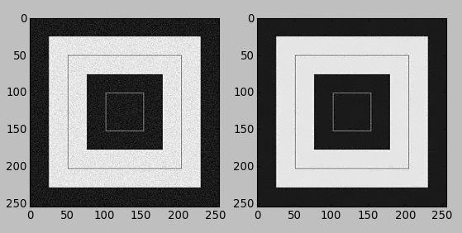[2]

Figure 1 Image Denoising

2.1.2 Infrared VS digital camera

Near infrared (IR) imaging can be captured using a camera with the IR filter removed. IR works on a different visual spectrum then we as humans can see. Clement Fredembach defines the wave lengths of infrared as follows "*The near-infrared spectrum is located just after the red wavelength and comprises wavelengths that range from 700 to 1100 nanometers*" This means that the infrared wavelength is outside of a humans visual spectrum. [3] IR LEDS can be used to illuminate dark areas with the area only being visible to an IR camera, as the IR wavelength is out of our visual spectrum. The IR camera also has the ability to take daytime photos, these images appear drastically different due to the way IR wavelengths interact with the environment.[4]



Figure 2 Fingers detected by Infrared Camera

Digital images can be taken with an ordinary camera; the light used to capture these images is in our visual spectrum. Meaning to capture day and night images we need a light source to illuminate the area E.G. the sun or a lamp. The reason to keep the IR filter on the camera is to prevent the IR radiation from interfering with the quality of the image as Clement Fredembach says here "*digital cameras' sensors are so sensitive to near-infrared that a "hot mirror", a filter that lets only visible light pass, is placed in front of them in order to prevent NIR contamination of the visible signal.*".[5] Digital cameras with an IR filter provide a higher quality image during daylight, and images can appear blurred in IR daylight images depending on the lighting conditions.



Figure 3 Standard picture from Infrared Camera

There are two applications for the camera chosen to be used in. These are monitoring an elderly or disabled person in their home and detecting the occupancy of a room in the college to see if its free or occupied. For the applications to perform acceptably, the camera must be able to function is daylight, lowlight and dark conditions. The digital camera has the ability to produce high quality images in any light, but the issue is having to shine a bright light onto an area 24 hours a day in the case of monitoring a person. The advantage of using an IR camera in this situation is that the IR LED light is invisible to the human eye. While the room is dark for humans the room will be bright enough for the IR camera to pick up. The goal of this application is to detect a person, and the IR camera is in my opinion the best choice as it can provide an image where people can be segmented out and located using object detection.[6]

2.1.3 Segmentation

Image segmentation is the splitting an image into individual pixel values then transforming the image into something new. Examples of this can be done by reducing noise or extracting certain object or elements from the image. There are two examples of Segmentation these are thresholding and morphology. Image thresholding is converting a grayscale or coloured image to a binary mask. There are two types of thresholding, there's thresholding and adaptive thresholding. The difference between the two is that the adaptive thresholding will try to find the average value of the pixels and apply the answer as the binary mask. " *It assumes that (i) each peak coincides with the mean grey level for all pixels that relate to that peak and (ii) the pixel probability decreases monotonically on the absolute difference between the pixel and peak values both for an object and background peak.*"[7]

Morphology is the use of morphological transformations which are algorithms, to alter an image based on its shape. These algorithms are performed on binary masks which can have jagged edges or spots of noise in the background, and can be used to extract and clean the overall look of an image. There are four main types of morphological transformations and these are Erosion, Dilation, Opening, and closing. Erosion and Dilation are opposites of each other, Erosion will shrink the white areas of an image while also removing noise. Dilation increases the white in an image and is usually paired with Erosion to return the image to its previous size. Opening is erosion followed by dilation, it's a algorithm which combines Erosion and dilation. Closing is Dilation followed by Erosion, this is useful for cleaning the objects in the image itself.[8]

2.1.4 Flesh Detection

One of the biggest challenges in this project is to detect a person. With a regular camera a user would have the ability to use colour to segment out a person from a background. With an IR camera it's based on what level wavelength a object such as skin will absorb light. Describes the wavelength where human skin is detected is 970nm while clouds and the sky are detected at 940nm. This means that the clouds and sky can cause interference with skin detection. Their solution to this problem was a 6 band camera which is a combination of a VIS camera and NIR(Near infrared camera) which is out of the scope for my prototype and capabilities.[9]

2.1.5 Contouring and object Detection

Contours in image processing are a way of joining similar areas of interest. Contours are a great way of finding a particular object.[10] A list of contour object can be created on a binary mask for a specific region of interest. From this list of objects a specific object can be chosen by a developer to be displayed to the user. In the below image we can see the use of contours on a peak flow meter from one of my image processing assignments. To find contours a binary mask must be created of the region of interest i.e. what the user wants to see. In the below image I wanted to segment out the red and yellow parts, as you can see the colour range I specified also takes in some of the white areas due to the white being within the colour range specified.

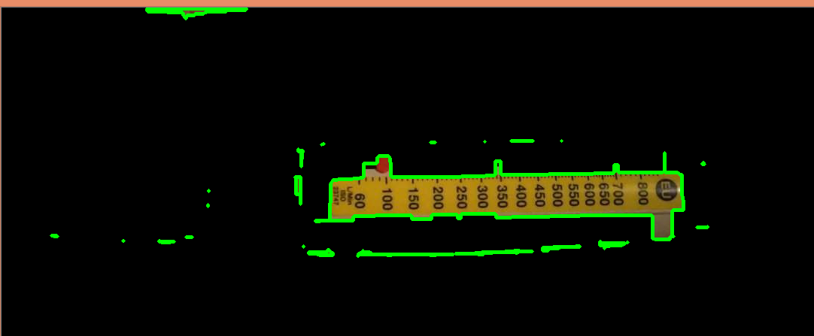

Figure 4 Contouring Example

2.1.6 Conclusion

The research above shows what methods and algorithms are needed to get this project of the ground and the difference between the digital and IR camera. We will see further in the report that the Infra red camera is not as easy to work with as the digital camera is.

## 2.2 Alternative existing solutions to the problem you are solving

2.2.1 Human Skin Detection by Visible and Near-Infrared Imaging.

The purpose of this application is to use spectroscopy to increase the effectiveness of pedestrian detection in Advanced Driver Assistance Systems (ADAS). Yusuke Kanzawa, Yoshikatsu Kimura and Takashi Naito define spectroscopy as “Spectroscopy is the study of how substances absorb, transmit, or reflect light."[11] They go on further to say that they use a method to detect human skin using spectroscopy.

This solution uses near infrared and visible processing to detect humans. They created their own camera to combine both processing types, as human skin, clouds and the sky share the same wavelength. The NIR camera will find the human skin and the visible camera will be used to filter out the sky and clouds.

## 2.3 Technologies researched

2.3.1 OpenCV VS Mat Lab

There are two main independent development environments (IDE) to use when developing an image processing application. For this application I chose OpenCV, OpenCV (Open Source Computer Vision) is an open source library of methods used for image processing.[12] Mat Lab is a pay to use development environment which is based of Java. I chose OpenCV because it is faster than Mat lab when it comes to processing algorithms, it’s free and the resources needed to run it are less than they are to run Mat lab. The downsides to not using Mat Lab would be that it’s a development environment and the advantages that would bring.

## 2.4 Resultant findings/requirements

* Infrared LED prototype to shine infrared light.
* Use python with OpenCV to program the client.
* Create a client on the raspberry pi to post images.
* Create a python flask web server to store and run analysis on the images and data.
* Create a MYSQL database to store the data.
* Stack Overflow, SO. (2017)How to detect edge and crop an image in Python.

## 2.5 Bibliography (research sources)

karanjthakkar, KT. (2017)What is OpenCV? OpenCV vs mat lab Available at: <https://karanjthakkar.wordpress.com/2012/11/21/what-is-opencv-opencv-vs-matlab/> (29/11/2017)

* raspberrypi, RP. (2017)Camera Module Available at: <https://www.raspberrypi.org/documentation/hardware/camera/> (29/11/2017)
* ivrl epfl, IE. (2017)Near Infrared imaging

Available at: <http://ivrl.epfl.ch/research/infrared/imaging> (29/11/2017)

* thepihut, PH. (2017)Raspberry pi camera module V2.

Available at: <https://thepihut.com/products/raspberry-pi-camera-module> (29/11/2017)

* raspberrypi, RP. (2017)Pi NoiR camera V2

Available at: <https://www.raspberrypi.org/products/camera-module-v2/> (29/11/2017)

* pimylifeup, PL. (2017)Raspberry pi camera vs NoiR camera

Available at: <https://pimylifeup.com/raspberry-pi-camera-vs-noir-camera/> (29/11/2017)

* raspberrypi, RP. (2017) Pi NoiR camera V2

Available at: <https://www.raspberrypi.org/products/pi-noir-camera-v2/> (29/11/2017)

* tutorialspoint, TP. (2017)Digital Image Processing

Available at: <https://www.tutorialspoint.com/dip/> (29/11/2017)

* bogotobogo, BB. (2017)Image Noise Reduction: Non-local means denoising algorithm

Available at: <http://www.bogotobogo.com/python/OpenCV_Python/python_opencv3_Image_Non-local_Means_Denoising_Algorithm_Noise_Reduction.php> (29/11/2017)

* C. Fredembach and S. Süsstrunk, [Colouring the near infrared](http://infoscience.epfl.ch/record/129419/files/IR_colour.pdf), Proceedings of the IS&T 16th Color Imaging Conference, pp. 176-182, 2008.
* Opencv, OC. (2017)Contours getting started

Available at: <https://docs.opencv.org/3.1.0/d4/d73/tutorial_py_contours_begin.html> (29/11/2017)

* citeseerx, CE. (2017)Human Skin Detection by Visible and Near-infrared Imaging

Available at: <http://citeseerx.ist.psu.edu/viewdoc/download?doi=10.1.1.389.6745&rep=rep1&type=pdf> (29/11/2017)

* navicat, NC. (2017)Navicat.

Available at: <https://www.navicat.com/en/download/navicat-data-modeler> (29/11/2017)

* staruml, SU. (2017)StarUML

Available at: <http://staruml.io/download> (29/11/2017)

* raspberrypi, RP. (2017)Infrared Camera you asked us so we are making them

Available at: <https://www.raspberrypi.org/blog/infrared-camera-you-asked/> (29/11/2017)

* DYNU, DYNU. (2017)DYNU.

Available at: <https://www.dynu.com/en-US/ControlPanel/BasicEdit?ATVPDKIKX0DER=SQBEAD0AOAAwADEANQA4ADMAMwA%7C> (29/11/2017)

* tutsplus, TP. (2017)Creating a web app from scratch Using Python Flask and MySQL

Available at: <https://code.tutsplus.com/tutorials/creating-a-web-app-from-scratch-using-python-flask-and-mysql--cms-22972> (29/11/2017)

* youtube, YT. (2017)setup a Raspberry Pi Web server with you own .COM using google domains

Available at: <https://www.youtube.com/watch?v=vzojwG7OB7c&t=2959s&index=6&list=WL> (29/11/2017)

* Amazon, A. (2017)Raspberry Pi NoiR V2

Available at: <https://www.amazon.co.uk/Raspberry-Pi-1080p-Camera-Module/dp/B01ER2SMHY> (29/11/2017)

* youtube, YT. (2017)Displaying images in server using flask and python

Available at: <https://www.youtube.com/watch?v=Y2fMCxLz6wM&t=472s&index=7&list=WL> (29/11/2017)

# Analysis: Describe clearly what your solution will do

3.1 Problem and solution created

The problem to be solved is the use of Infrared image processing to measure room occupancy, and to display this information in a user friendly way. The solution to this problem was to design a system which connected all stages through a web server. The web server receives connections from both the user and the raspberry pi but the two never meet. The raspberry pi receives an image from the IR camera, runs an algorithm to count the people in a room and posts it to the web server, the web server stores this in a database where it analyses the data to present it in a user friendly format. The user can then log into the web server, and view the images and data analysed.

3.2 Person Detection Algorithm

The algorithm will use thresholding to find lightest and darkest pixels. In the case of this application the darkest pixels will be the areas which do not have infra red light shining on them. Once a mask has been created from the threshold value the image will be segmented, the area we are looking for in the image for a proof of concept will be the brightest areas. For example the application will try to find skin over clothing. Once the person's skin has been found contours will be used to show how many areas in the image are recognised as skin, for now the application will count these areas and return them to the server. For future work it is hoped that the application will use machine learning to understand that a grouping of body parts are equal to one person from a side view or from a top down view when the camera detects a person’s head or arms that they are recognised as a person.

3.3 Raspberry pi

The raspberry pi 3 is used to host the client and is also used to mount the Pi NoiR camera to take photos. The reason for using the raspberry pi is that it can be taken and positioned anywhere with a wifi connection and can begin taking photos and posting them back to the server. The raspberry pi will run the person detection algorithm which involves thresholding, segmenting and contouring the image. The finished image is then posted back to the web server along with the number of people detected.

3.4 Web Server

The web server is based on my home pc and the IP of my machine is being projected from a domain name server. The client will post images to the server and the server will store it on the hard disk drive of the home computer. The web server will then take the path to the image and store it in the MYSQL database for querying later. A user can access the server from their laptop or pc and they will first have the ability to login or register. When a user has successfully registered or logged in they will have access to view the image display page. This page will show a gallery of the days images and depending on the selected image a number representing the amount of people in the room. Another piece of functionality the user will be able to see in analysis which has be run on the data. This will be displayed in the form of for example "Average No. of people for day/month/year hour/minutes/seconds". Another example of a query which could be implemented is checking if rooms are empty at certain peak times during the day.

3.5 Storing Data

The MYSQL database will be installed on the home computer just like the web server. The images and data posted to the web server will be stored in this database. The schema for this database will consist of two tables. The first table is the login table and will store the username and password which will be varchars, and will also store the email address which will also be a varchar and a primary key for the table. The second table will be the data storage table, this table will have two values the first will be the directory path for the images, and this will be a varchar and primary key. The second attribute will be the number of people counted or occupancy measurement, this will take the form of a Number in the database.

3.6 Accessing the web server and client.

For administration purposes the user will be able to SSH into the server and the raspberry pi client. The purpose for this is to allow an administrative user to make changes to the server, database or the code running on the raspberry pi client. It also allows an admin to troubleshot any errors off site.

3.7 Security

The web server will be available through a domain name so it is important to protect it from unauthorized users. The use of regular expression will help prevent SQL injections through the login and registration page, and encrypting the user passwords before they are stored in the database will help protect the user accounts. When using SSH between the client and server authentication mechanisms such as password and public/private SSH keys will be used.

# Approach and Methodology

What is your approach to this project? Are you using any particular software methodology? Eg. Are you delivering design/ code in phases, or are you completing all design up front, followed by all coding? Have you some sections lower priority if time runs short?

4.1 What is Agile Scrum

Agile Scrum is a software methodology where scrum teams usually comprised of two or more people break down a large task into smaller tasks, the development team will then have a sprint planning session where they decide what task to bring into the weeks sprint. The team will then estimate the cost of each task i.e. how many hours it will take to complete. The person who owns the project is called the product owner and during the sprint planning meetings the will tell the dev team what they would like to see worked on in the next sprint. The scrum master is a person typically who is outside the team, they will try to keep the work on track by resolving blockers while keeping the product owner reasonable with their requests. At the end of a sprint the team will have a product backlog refinement, A PBR is where the product owner dev team and scrum master sit down and discuss the priority of upcoming tasks and if they should be prepared for the next sprint or three sprints down the line.[13]

4.2 Why use Agile Scrum

The reason I chose to use Agile Scrum is that it allows me to split the project into smaller parts and work on them as needed. It helps with the time keeping aspect of the project as you set a goal to get x amount of work done in a single sprint. Currently working eight hours a day seven days a week, will give fifty eight hours time to complete work. In the latest sprint which can be seen below, the weeks work takes fifty one hours leaving five hours of free time.

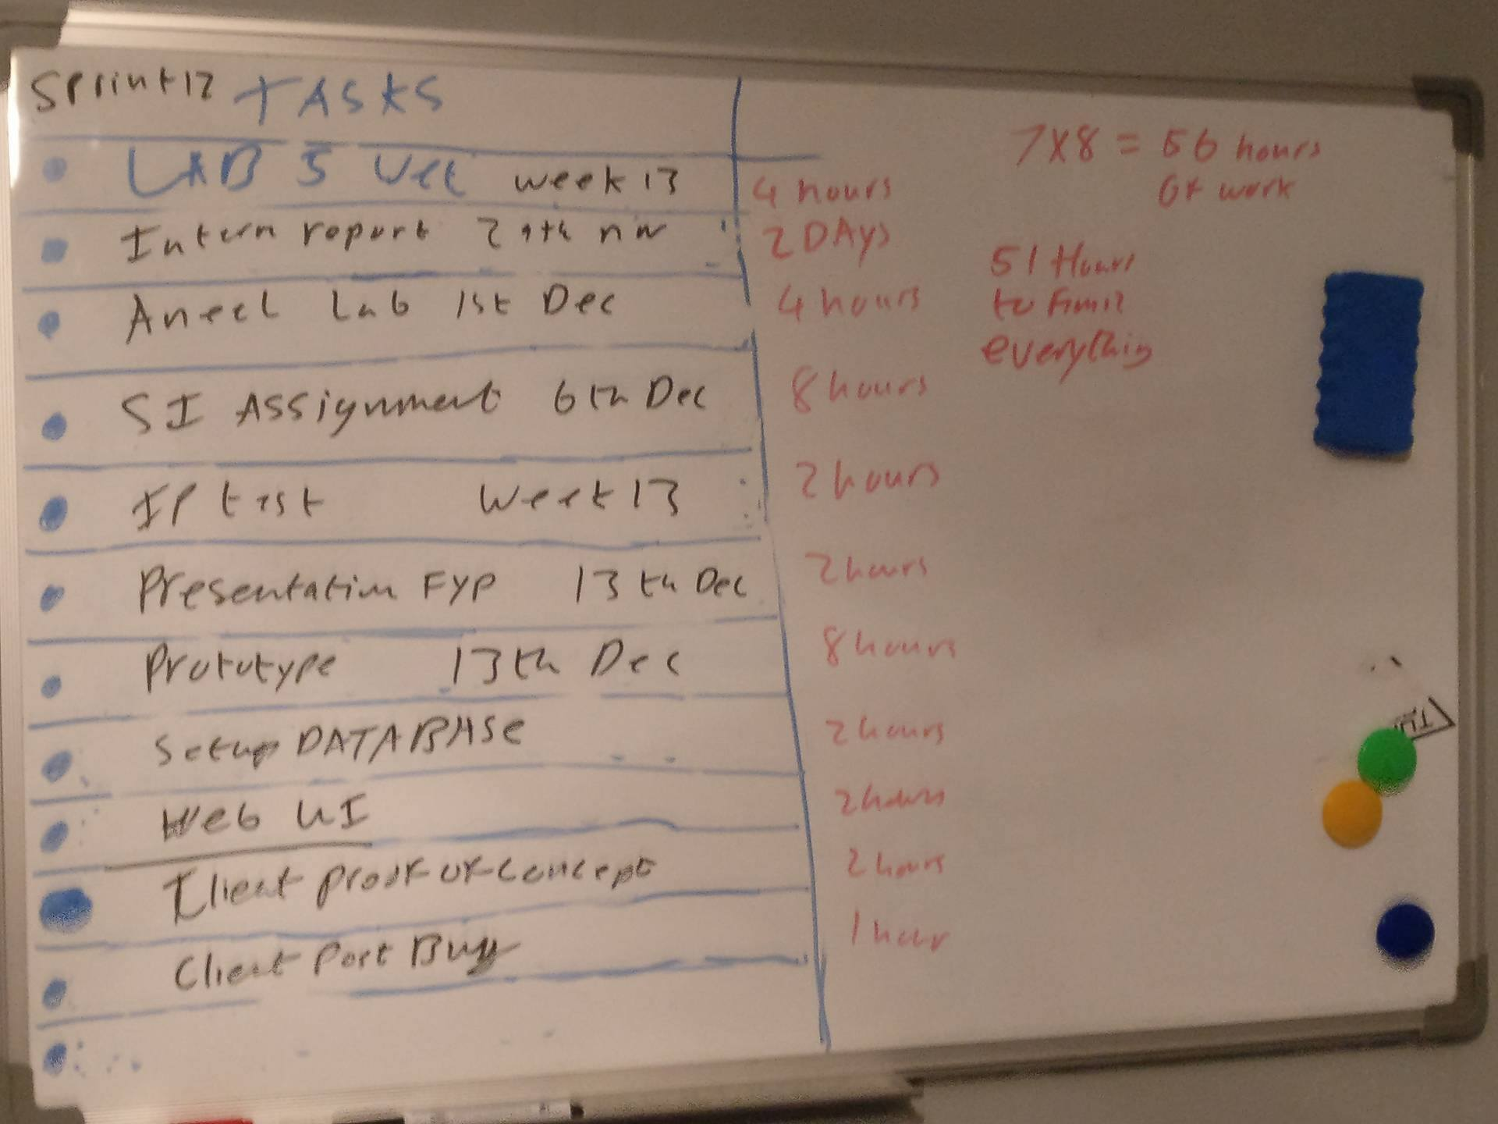

Figure 5 Week 12 sprint

# Design

## Technical architecture diagram:

## low level view.jpg

## Figure 6 low level diagram of architecture

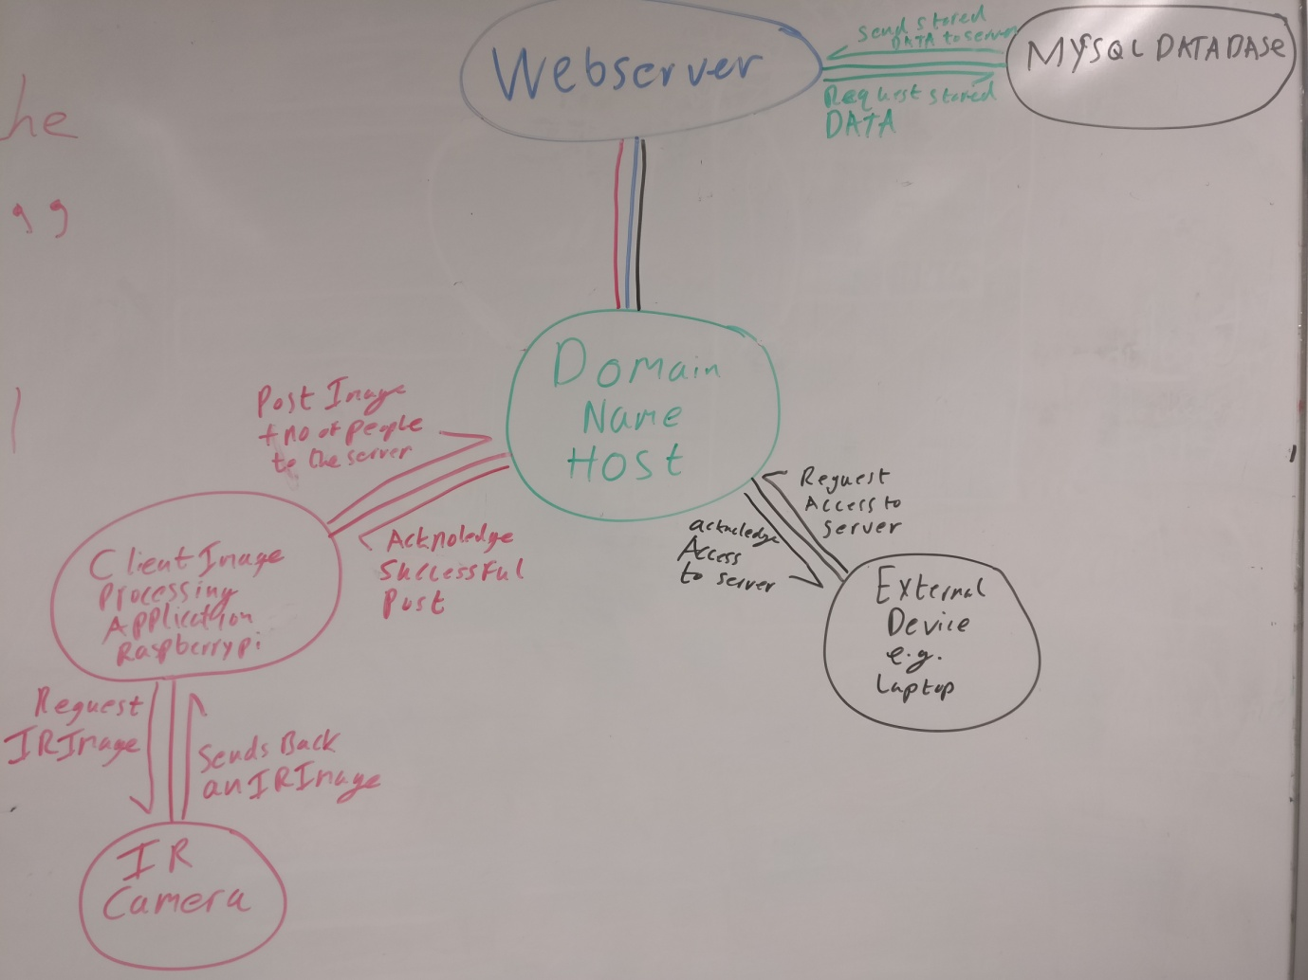

## Figure 7 More detail into the architecture Other design documents

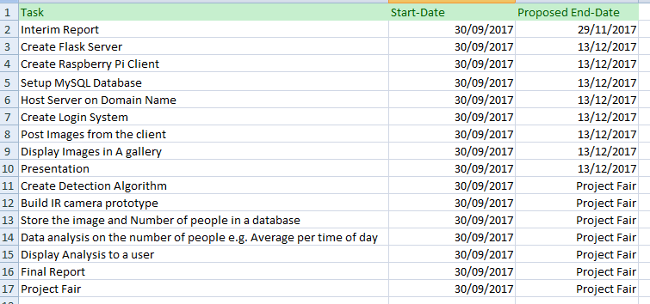

Figure 8 Gantt chart

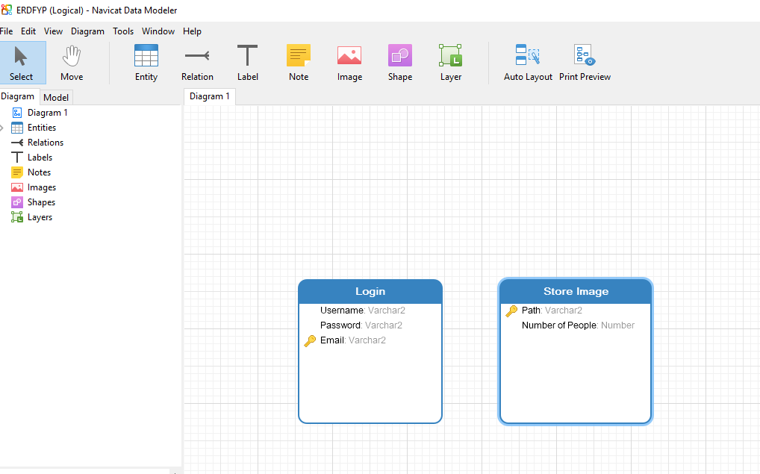

Figure 9 MYSQL ERD

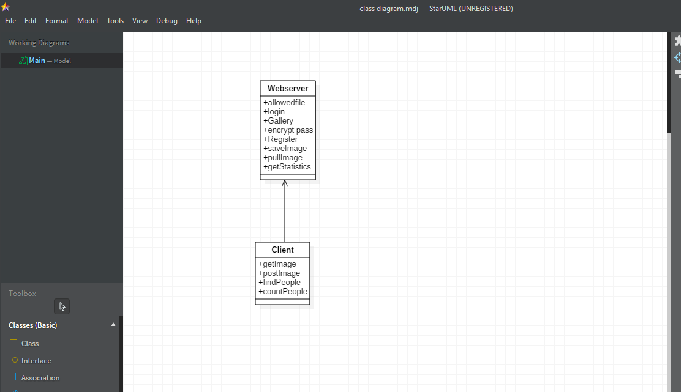

Figure 10 Class Diagram

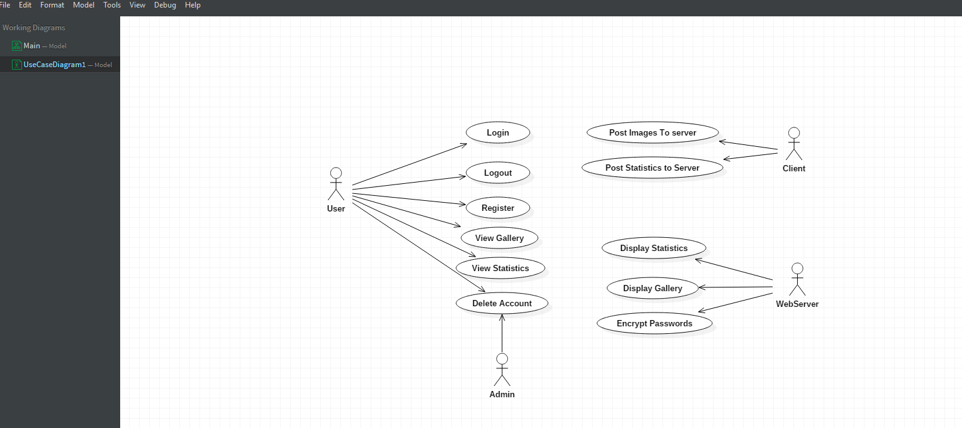

Figure 11 Use Case

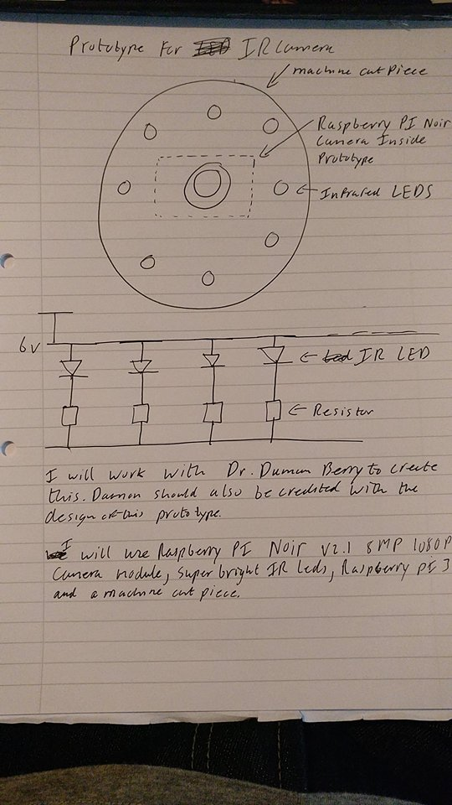

Figure 12 Prototype Camera

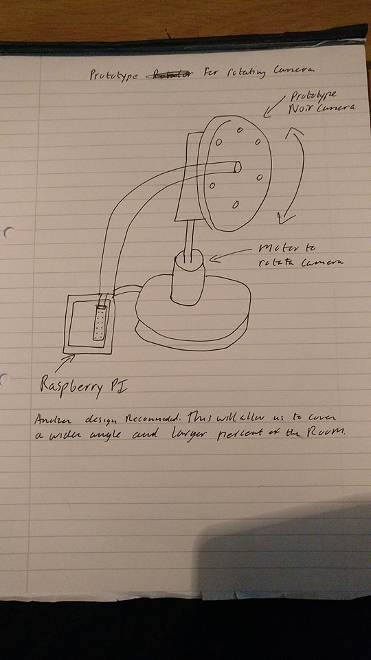

Figure 13 Prototype Motorised camera

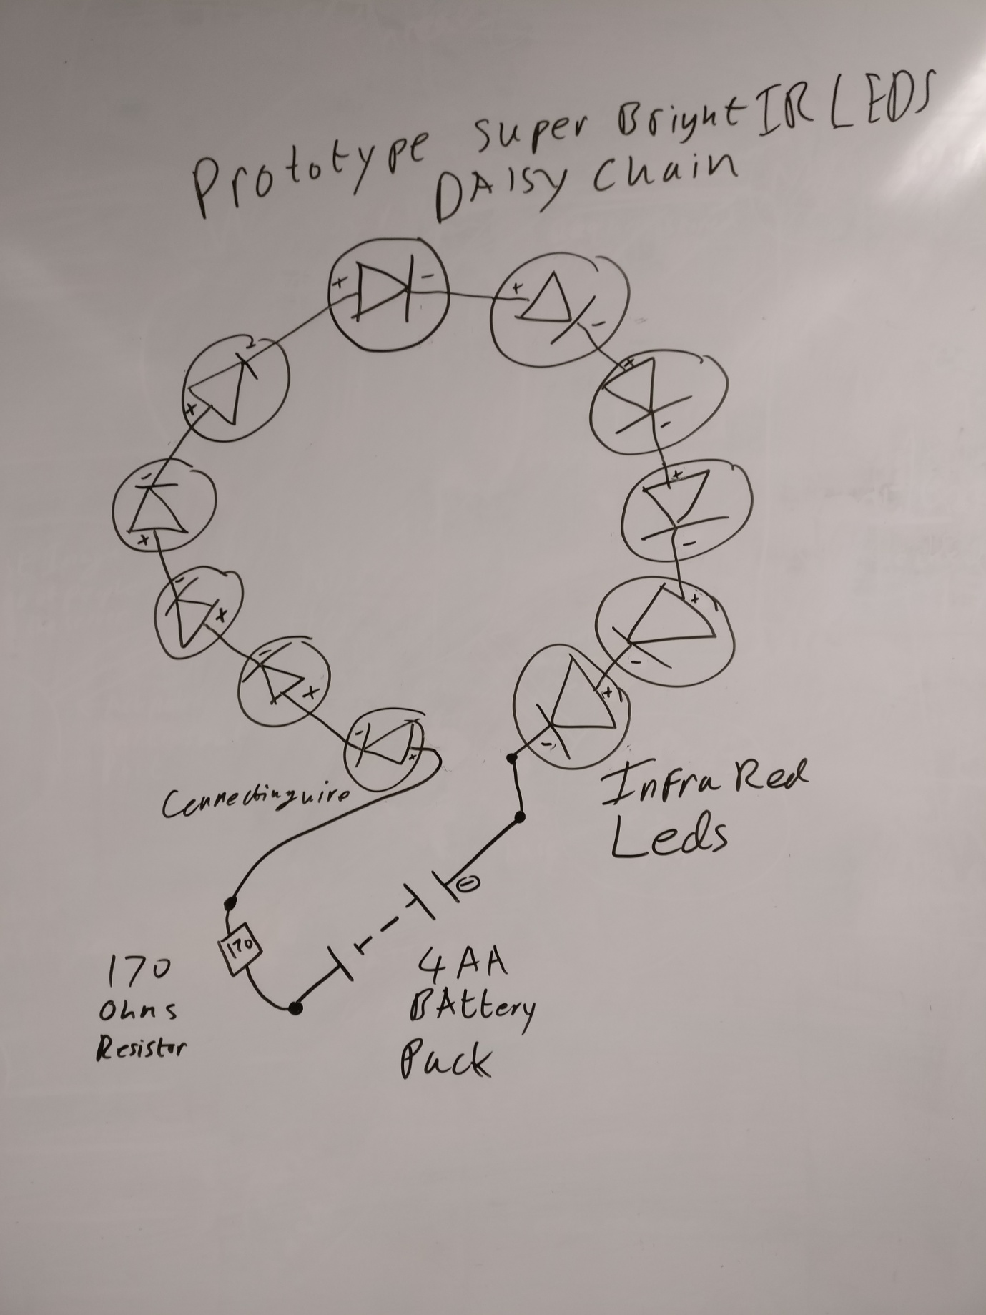

Figure 14 Daisy chain solution To infrared LEDS

# Prototyping and Development

6.1 Creating the prototype camera

The camera I am using for this project is the raspberry pi NoIR camera. The reason for choosing this camera is that it has no infrared filter attached. The lack of an IR filter allows the taking of lowlight and infrared images. For this camera to take infra red (IR) images, IR LEDS must be shined onto the target area.

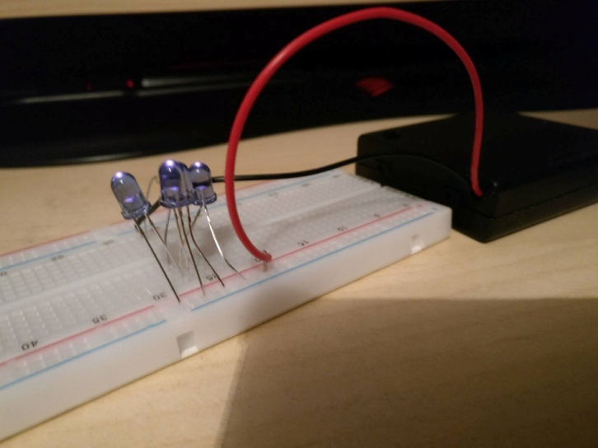

Figure 15 Breadboard Prototype

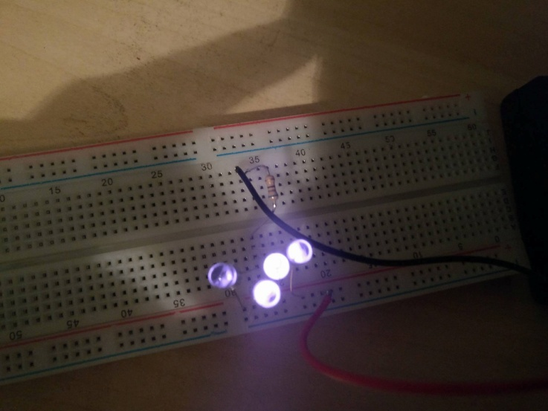

Figure 16 IR Leds

6.2 Creating the web server.

To create the web server the python flask framework was used. At first the web server was running off localhost on my home network. As of now it is being hosted on a domain name website using my home computers IP address. The web server will display three pages; these are the login, register and display image pages. The login and registration pages are straightforward a user enters their details into a form and the server stores them in a database, the server will retrieve them to compare login credentials. The display image page allows a client application to post an image to the server; the server will then store this image on the Hard disk drive of my home computer and save the path to the database.

6.3 Setting up the domain name and hosting.

To host my web server I used the site dynu.com and chose the domain name MichaelKanefyp, this is open to change but for now it's just a temporary name. To allow traffic to connect to the web server the home router needed to enable port forwarding on the address and port number. With port forwarding enabled the domain name was configured to mask my IP address with the domain name. There were some issues with this as the port number would have to be appended to the domain name. This was fixed by adding the port number to the masked domain name.

6.4 Creating the database.

The database is created with MYSQL and will have two tables. The first table is the login table; this table will store the username, email address, and the encrypted password for the user account. The primary key for this table will be the email address. The second table will be the store image table, this table will store the directory path to the image on the web server and will also store the number of people found in that image as an integer value. The primary key for this table will be the directory.

6.5 Creating the client.

The client is hosted on a raspberry pi and uses Python with OPENCV and Anaconda to create the image processing application. The client will threshold then segment the region of interest from the image, then using contours finds the person in the image. This will be a proof of concept and machine learning will be brought in later to enhance the process. The client uses an import called request to post the processed image to the web server.

# Testing

7.1 Testing Outputs

The first step I chose to take when testing was that the expected output where being returned to the server. What I mean by this is that if I posted an image to the web server I would expect to see that image on the web server. The same can be said about the database, The point of me doing this was to understand the flow of data between the applications and to make sure that they are connecting to the correct areas.

7.2 Regular Expressions and test functions

Now that I have tested that physical data is being sent to the server, I created functions such as the function allowed file. The purpose of this function is to only allow jpg files into the server. This puts a layer of security in case that if an entity can post to the web server, that the web server will only accept a jpg image. The login and registration page for the user will also be tested for SQL injections through the use of regular expressions. Regular expressions allow the program to disallow certain characters such as ">" from being used in a username or password.

7.3 Unit Testing

The purpose of a unit test is to ensure that the output of a program does not change as a programmer is making changes to the codebase. Unless it is intended for the output to change, Unit Tests are a great way to ensure continuity of the data sent from client to server, or from server to database.

7.4 Usability test

To test the usability of the system I intend to get friends, family and people I do not know to test the system. This will take the form of a heuristic evaluation of the system.

# Issues and risks

8.1 Prototype camera

The prototype camera designed to take the IR photos did not arrive on time. This has stalled my work on the algorithm for person detection. I contacted the company, who posted my piece of equipment, and they said “on this occasion our postal service has failed you and we will be sending you out a replacement part. Please contact us if you do receive your first package.” The package has arrived since the message was sent and I hope to begin construction of the prototype before or after Christmas. It is regrettable that it will not be complete for the presentation.

8.2 Security

The web server currently has no security, my goal for after Christmas is to encrypt the user passwords and store them in the database and to create security for SQL injections. I propose to use an encryption algorithm to encrypt the passwords, and to use regular expressions to prevent the use of SQL injections on the server. I will also need to setup sessions so a user who isn’t logged in can’t piggyback off the current users session.

8.3 Person Detection using Infra Red

From the research I have done so far I am worried that the IR camera may not be able to detect people at its current state. The project using spectroscopy to find people uses a 6 band camera to find a person, while I am using a lone infrared camera with IR led’s. I hope to solve this problem by finishing the prototype and getting to test it with real world examples.

8.4 Posting Error Raspberry pi

There is a small error with the raspberry pi where the images being returned to the web server are unusable. Currently working on a fix to the problem but it may be a problem with the format they are saved in.

# Plan and future work

9.1 Create the prototype Infrared camera

The work to be completed for the prototype camera is to daisy chain the infrared LEDS together, connect them to a low voltage resistor to increase the light intensity, then connect them to a battery pack to power the prototype. Once the basic shell is completed the idea is to laser cut a piece of metal to hold the prototype, this will keep the prototype held in place and opens it up to be used with a motor to rotate the camera.

9.2 Setup Security

The web server currently has no security installed, I would hope to setup and encryption algorithm to encrypt user passwords and store them in the database. Regular expressions will also be used to prevent SQL injections to the database. The prototype will also hopefully include SSH connections to both the server and client so public and private keys will need to be set up to ensure secure connections to the infrastructure.

9.3 Creating an algorithm to find locate people in a room

Currently all the algorithm will do is post an image to the web server with some slight modifications. The idea is to create an algorithm which will threshold the image, segment out a person, then use contours to count the number of people and return it as an integer value to the server. There will also be an aspect of machine learning involved as the application will need to understand what a person looks like.

9.4 Running analysis on database data

The number of people will be stored in the database with a date time stamp. The server will pull the data for each day and get the average number of people per time of day. This will give the user an idea of when a room will be free or when a person is usually in a room.

9.5 Usability testing

The web server will need a usability test to see how usable it is for a user. This will involve the use of Nielsen's heuristics and volunteers from family, friends, and people I don't know. They will test the interaction on the website and give feedback on what needs improvement and what they feel needs to be added.

9.6 Creating unit tests for the expected results from client, server and database

It will be important to have static unit tests where the result should always be the same. The code will change drastically as the project moves forward but as of now the output from each source should not change. So for future work unit tests will be created to make sure I keep on track with the work.

# Conclusions

To develop a finished prototype by the end of the semester will require a greater degree of effort and research, far more than I showed in this report. Focusing on my other module work has left me at a disadvantage for the interim report but I still have a presentable portion of work. In the next semester I hope to put more time and effort into the final year project while still focusing on my module work.

1. https://www.tutorialspoint.com/dip/
2. http://www.bogotobogo.com/python/OpenCV_Python/python_opencv3_Image_Non-local_Means_Denoising_Algorithm_Noise_Reduction.php
3. http://ivrl.epfl.ch/research/infrared/imaging
4. C. Fredembach and S. Süsstrunk, [Colouring the near infrared](http://infoscience.epfl.ch/record/129419/files/IR_colour.pdf), Proceedings of the IS&T 16th Color Imaging Conference, pp. 176-182, 2008.
5. http://ivrl.epfl.ch/research/infrared/imaging
6. https://pimylifeup.com/raspberry-pi-camera-vs-noir-camera/
7. https://www.cs.auckland.ac.nz/courses/compsci773s1c/lectures/ImageProcessing-html/topic3.htm
8. https://docs.opencv.org/trunk/d9/d61/tutorial_py_morphological_ops.html
9. http://citeseerx.ist.psu.edu/viewdoc/download?doi=10.1.1.389.6745&rep=rep1&type=pdf
10. https://docs.opencv.org/3.1.0/d4/d73/tutorial_py_contours_begin.html
11. http://citeseerx.ist.psu.edu/viewdoc/download?doi=10.1.1.389.6745&rep=rep1&type=pdf
12. https://karanjthakkar.wordpress.com/2012/11/21/what-is-opencv-opencv-vs-matlab/
13. <http://scrummethodology.com/>