User Manual

1: There are multiple ways to run the program, it can be opened in the MATLAB app designer or ran as an .exe file. However, the recommend way is to run the .exe.

2: To install the .exe file double click MyAppInstaller.exe.

3: Once installed run the MatlabMusicCreator.exe file.



4: Click a note on the top bar and then click the staff. The note should in the spot indicated by the blue dot.



5: To add sharps and flats to the music click the sharp and flat buttons on the top bar.



6: To stop adding sharps and flats click the sharp or flat button again. Please keep in mind that not all notes have a sharp or flat version of themselves due to there only being a half step in between them. Take for example E->F, if the user attempts to input E# or Fb the program will display the non-sharp or flat note instead.

7: To add rests click the rest button on the top bar, then click a note on the top bar with the same length as the desired rest.



For example, to input an eighth rest click rest and then click an eighth note. To Stop inputting rests, click the rest button on the top bar once again. To change the tempo, click and drag the tempo slider.

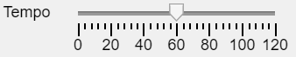

8: Before playing the music through the Arduino the Arduino first needs to be properly setup. Connect ground to one side of a piezo buzzer and the other side to digital port 5. 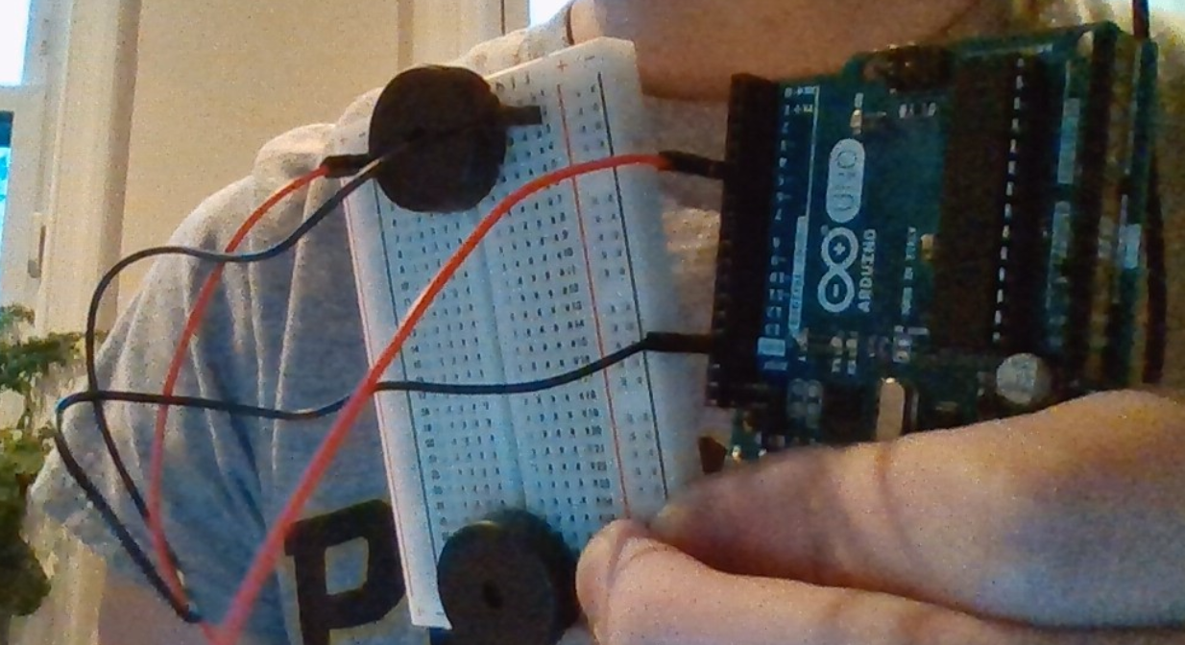

9: The connected the arduino board to your computer by using a USB A to USB B cable.

10: Play the music through the arduino by clicking the Play button in the top left hand corner and then click user created songs

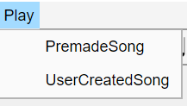

11: A pop up should then appear asking for the information of the arduino board. You an find the COM port information by looking inside device manger. Once the correct information is inputed click submit and the song should being playing after a few moments.

12: To play Premade songs follow the same process as outlined in the previous steps but instead of clicking UserCreatedSong click PremadeSong instead. If a user wants to test the piezo buzzer connecion click PremadeSongs and the click testing on the PopUpMenu.