Team 2 Final Project

Michael Knight, Alexandria Samson, Karene Matoka, Liberty Mudzingwa

12/14/2021

## Introduction

With the advent of the internet, there has been a shift on how and where people obtain news. Additionally, there is a growing trend of people getting news from social media platforms, which comes at the expense of credibility and correctness of the news reports on social media (Aldwairi & Alwahedi, 2018). Despite apparent evidence of inconsistencies in social media news reports, a huge number of internet users have made social media their primary source of daily global/local economic, political, or social news updates (Gottfried & Elisa, 2016).

This paper seeks to address the reason why people continue to frequently get their news from social networking sites despite the fact that they do not trust it. We have identified a few hypotheses that form the basis of our research question. Firstly, we will use the survey findings to show the lack of trust that people who obtain news from social media have towards family, friends, and news media in general. Additionally, we will show that the respondents who read the news for political reasons tend to only focus on either republican or democratic debates to enhance their political views. We also identify that respondents who approach social media news with a skeptical eye are more likely to fact check whatever they read on social platforms to verify its authenticity. Survey data also indicates that readers who diversify their sources of information on the subject of government and politics are more likely to engage and share their opinions with their family and friends.

##Literature Review Discussions and concerns of “fake news” intensified in the wake of the 2016 United States presidential election (Allcot & Gentzkow, 2017; Gottfried & Elisa, 2016). “Fake news” is defined by Allcot and Gentzkow (2017) as articles which are deliberately and factually incorrect and distributed with the intent to mislead readers. Scholars continue to explore and measure overall levels of trust in mainstream media and news sources across social media platforms. Research has shown a significant relationship between social media consumption and general mistrust in the news across all platforms (i.e., TV, radio, print, online, etc.) (Fletcher & Park, 2017; Kalogeropoulos, Udris, & Eisenegger, 2019; Park, Fisher, Flew, & Dulleck, 2020; Tsfati & Ariely, 2014). Specifically, consuming news through TV and print is associated with an increase in news media trust, while consuming news through online platforms is associated with a decrease in news media trust (Tsfati & Ariely, 2014).  
Park and colleagues (2020) suggest that mistrust is directly associated with overall skepticism and/or suspicion surrounding information that individuals engage with on social media. Therefore, mistrust in news can be defined as a “state where the news consumer is skeptical of the news source and defers the judgment (Park et al., 84, 2020). Millions of “fake news” articles circulated on Facebook in the 2016 election which heavily contributes to the massive decline in overall media trust (Allcot & Gentzkow, 2017). Additionally, the anti-media rhetoric from President Trump amplified public mistrust in mainstream media (Kalogeropoulos, Udris, & Eisenegger, 2019).

Social networking plays a significant role in the overall distribution and consumption of news around the world. In fact, research shows that 62% of adults in the United States get their news from social media (Gottfried & Elisa, 2016). Misinformation circulates on social media every single day and it can be challenging for readers to identify trustworthy news sources (Allcot & Gentzkow, 2017). Therefore, it is important to understand how social media use can impact how individuals seek out and understand information. There is minimal existing literature on how receiving the news through different methods is associated with trust in news. The current study seeks to fill this gap in the literature by identifying if there is a relationship between social media consumption and general mistrust in the news. In other words, our research question for this study is: how does social media use impact overall trust in news media? Based on the review of the existing literature, we hypothesize the following:

H1) People who get their news from social media feel that most people in society cannot be trusted (i.e., family, friends, & community).

H2) People who get their news from social media feel that most national news orgs cannot be trusted.

H3) People who do not trust the news they see online are more likely to fact check.

##Data Collection This study was conducted by researchers Gottfried and Shearer (2016) at the Pew Research Center. In order to conduct surveys, researchers created The American Trends Panel (ATP). This panel is made of randomly selected adults living in households throughout the United States. Participants were first contacted via phone from two national landlines and divide into two groups: Internet Users and Non-Internet Users. At the end of the phone call, each candidate was offered to join the panel. As a result, the Pew Research Center was able to recruit more than 5000 candidates (Gottfried & Shearer, 2016). The participants who were willing to provide their email address and self-identify as Internet users, were sent surveys directly through this means of communication. In contrast, participants who did not want to share their information were contacted and sent surveys by mail (Gottfried & Shearer, 2016).

Following the recruitment stage, participants received a welcome packet, a monetary incentive and future surveys invitations. The next step included making a few adjustments on ATP data such as population density which was adjusted to match the U.S. Decennial Census from 2010. The Pew Research Center also took into account the possible errors and bias as a result of the question wording and practical difficulties (Gottfried & Shearer, 2016). Overall, researchers had a response rate of more than 60% from both groups (Internet Users and Non-Internet participants). This study was centered around news and social media. This survey was made of multiple questions and each participant had to pick between 5 or 2 responses. The vast majority of variables obtained from this research were categorical (Gottfried & Shearer, 2016).

##Exploratory Data Analysis

knitr::opts_chunk$set(echo = TRUE)  
library(haven)  
library(tidyverse)

## ── Attaching packages ─────────────────────────────────────── tidyverse 1.3.1 ──

## ✔ ggplot2 3.3.5 ✔ purrr 0.3.4  
## ✔ tibble 3.1.6 ✔ dplyr 1.0.8  
## ✔ tidyr 1.2.0 ✔ stringr 1.4.0  
## ✔ readr 2.1.2 ✔ forcats 0.5.1

## ── Conflicts ────────────────────────────────────────── tidyverse_conflicts() ──  
## ✖ dplyr::filter() masks stats::filter()  
## ✖ dplyr::lag() masks stats::lag()

library(Hmisc)

## Loading required package: lattice

## Loading required package: survival

## Loading required package: Formula

##   
## Attaching package: 'Hmisc'

## The following objects are masked from 'package:dplyr':  
##   
## src, summarize

## The following objects are masked from 'package:base':  
##   
## format.pval, units

library(dplyr)  
library(tidyverse)

atp_as_factor <- read_sav("./Datasets/ATP W14.sav",   
 user_na = TRUE) %>%  
 as_factor()  
  
atp_as_factor

## # A tibble: 4,654 × 190  
## QKEY NEW_Device_Type_W14 LANG_W14 LOCALRATING_W14 LOCALIMPACT_W14 LIVE3_W14  
## <dbl> <fct> <fct> <fct> <fct> <fct>   
## 1 100197 Tablet English Good A small impact 10-25 mi…  
## 2 100260 Tablet English Good A moderate imp… Less tha…  
## 3 100314 Desktop English Good A moderate imp… More tha…  
## 4 100363 Desktop English Good A moderate imp… 26-50 mi…  
## 5 100446 Desktop English Excellent A moderate imp… 51-100 m…  
## 6 100514 Desktop English Excellent A big impact More tha…  
## 7 100588 Mobile phone English Only Fair A small impact 26-50 mi…  
## 8 100598 Desktop English Excellent A big impact More tha…  
## 9 100734 Desktop English Excellent A big impact More tha…  
## 10 100803 Desktop English Excellent A big impact 51-100 m…  
## # … with 4,644 more rows, and 184 more variables: WORKCLOSE_W14 <fct>,  
## # NEIGHBORS_W14 <fct>, COMATTACH_W14 <fct>, SOCTRUST_W14 <fct>,  
## # COMTRUST_W14 <fct>, NEWS_LEVELA_W14 <fct>, NEWS_LEVELB_W14 <fct>,  
## # NEWS_LEVELC_W14 <fct>, NEWS_LEVELD_W14 <fct>, NEWS_TOPICA_W14 <fct>,  
## # NEWS_TOPICB_W14 <fct>, NEWS_TOPICC_W14 <fct>, NEWS_TOPICD_W14 <fct>,  
## # NEWS_TOPICE_W14 <fct>, NEWS_TOPICF_W14 <fct>, NEWS_TOPICG_W14 <fct>,  
## # NEWS_TOPICH_W14 <fct>, NEWS_DEVICEA_W14 <fct>, NEWS_DEVICEB_W14 <fct>, …

#View(atp_as_factor)  
  
labelsdf <- setNames(stack(lapply(atp_as_factor, label))[2:1], c("Varcode", "Variables"))  
#View(labelsdf)

## Rename The Columns We will be Observing

##Define our variables (in a table)

## var_names  
## 1 News_Preference  
## 2 Trust_in_Others  
## 3 Trust_in_social_media_news  
## 4 Fact_Check  
## 5 How_often_social_media_for_news  
## 6 Trust_in_natl_news_orgs  
## questions_asked  
## 1 Which of the following would you say you prefer for getting news?  
## 2 Generally speaking, would you say that most people can be trusted or that you can't be too careful in dealing with people?  
## 3 How much, if at all, do you trust the information you get from Social networking sites, such as Facebook and Twitter?  
## 4 When you are online and come across information in a news story that you think is inaccurate, how often do you take it upon yourself to figure out whether it is accurate?  
## 5 How often do you get news from a social networking site?  
## 6 How much, if at all, do you trust the information you get from National news organizations?  
## answers  
## 1 TV, Radio, Newspaper, Social Media, News Site/App  
## 2 Can't be too careful (0), Most people can be trusted (1)  
## 3 Not at all (0), Not too much (1), Some (2), A lot (3)  
## 4 Never (0), Hardly ever (1), Sometimes (2), Often (3)  
## 5 Never (0), Hardly ever (1), Sometimes (2), Often (3)  
## 6 Not at all (0), Not too much (1), Some (2), A lot (3)

# The hypotheses for this research are:

## Hypothesis 1. People who get their news from social media feel that most people in general cannot be trusted.

## Hypothesis 2: People who get their news from social media feel that most national news orgs cannot be trusted.

### Hypothesis 1 pt 2: News_Preference vs. Trust_in_Others

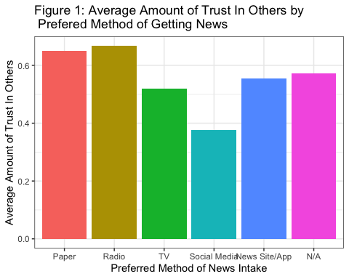

According to Figure 1, the group with the least average amount of trust in others (measured from 0 to 1, with 0 being “Can’t be too careful” and 1 being “Most people can be trusted”) was the group whose preferred method of news intake was social media. The survey questions which measure these variables were: Which of the following would you say you prefer for getting news? and “Generally speaking, would you say that most people can be trusted or that you can’t be too careful in dealing with people?”.

### Hypothesis 1 pt 2: How_often_social_media_for_news vs. Trust_in_Others

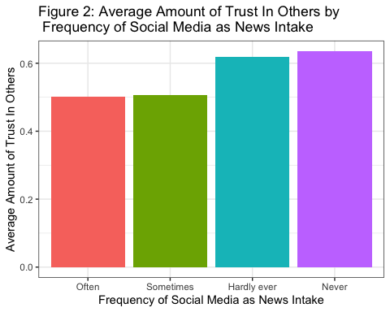

Figure 2 shows that the group with the least average amount of trust in others (measured from 0 to 1, with 0 being “Can’t be too careful” and 1 being “Most people can be trusted”) was the group whose frequency of social media intake was the most frequent (i.e., often). In fact, it is easily observable that there is a direct linear correlation with frequency of social media as news intake and average amount of trust in others. The survey questions which were asked to measure these variables were: “Which of the following would you say you prefer for getting news?” and “Generally speaking, would you say that most people can be trusted or that you can’t be too careful in dealing with people?”.

## Hypothesis 2: People who get their news from social media feel that most national news orgs cannot be trusted.

### Hypothesis 2 pt 1: News_Preference vs. Trust_in_natl_news_orgs

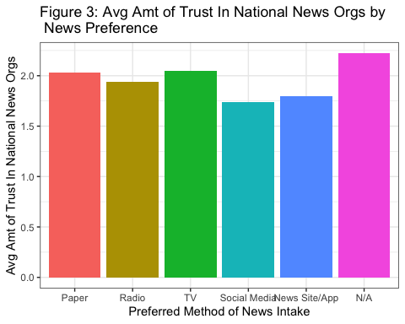

According to Figure 3, the group with the least average amount of trust in National News Organizations (measured from 0 to 3, with 0 being “Not at all”, 1 being “Not too much”, 2 being “Some”, and 3 being “A lot”) was the group whose preferred method of intake was social media. The survey questions which were asked to measure these variables were: “Which of the following would you say you prefer for getting news?” and “How much, if at all, do you trust the information you get from National news organizations?”.

### Hypothesis 2 pt 2

How_often_social_media_for_news vs. Trust_in_natl_news_orgs 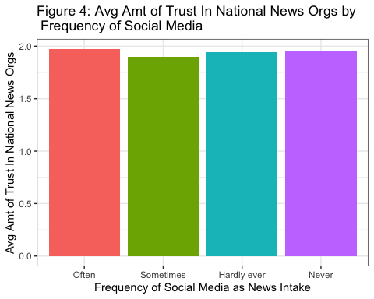

Figure 4 shows that the group with the least average amount of trust in National News Organizations (measured from 0 to 3, with 0 being “Not at all”, 1 being “Not too much”, 2 being “Some”, and 3 being “A lot”) was the group whose frequency of social media intake was the most frequent. The survey questions asked to measure these variables were: “Which of the following would you say you prefer for getting news?”and “How much, if at all, do you trust the information you get from National news organizations?”.

### Hypothesis 3

People who do not trust the news they see online are more likely to fact check. Trust_in_social_media_news vs. Fact_Check 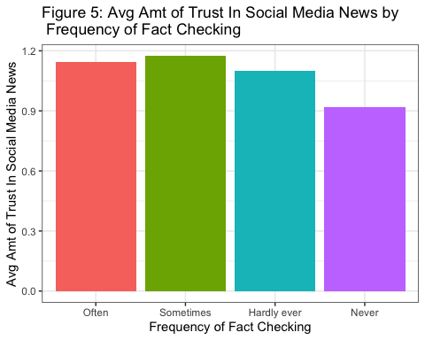

The results in Figure 5 contradict our initial hypothesis. For the most part, the more people trusted social media news, the more they fact checked. Furthermore, Figure 5 shows that the groups with higher average amounts of trust in social media news (measured from 0 to 3, with 0 being “Not at all”, 1 being “Not too much”, 2 being “Some”, and 3 being “A lot”) tended to more frequently fact check their news. The survey questions asked to measure these variables were: “When you are online and come across information in a news story that you think is inaccurate, how often do you take it upon yourself to figure out whether it is accurate?” and “How much, if at all, do you trust the information you get from social media news?”

#install.packages("tidyverse")  
#install.packages("haven")  
#install.packages("gtsummary")  
#install.packages("arules")   
  
library(gtsummary)  
library(tidyverse)  
library(haven)  
library(arules)

Trust_data<-read.csv("./datasets/Trust_data.csv")

# The Chi-Square test for independence

**Dependence on Social Media Trust and Fact-Checking**

* We seek to know if there exists a link between the social media news readers’ level of trust and doing fact-checking
* Ho: Trust on Social Media News and Fact-Checking is independent.
* Ha: Trust on Social Media News and Fact Checking is dependent.

**Making a subset of the Trust_data dataset with two variables needed for thee Chi-Square test.**

subset<-Trust_data[,c(3,2)]

**Running a Chi-Square test**

a<-table(subset$SM_NewsTrust,subset$AccuracyCheck)  
chisq <- chisq.test(a)  
chisq

##   
## Pearson's Chi-squared test with Yates' continuity correction  
##   
## data: a  
## X-squared = 4.243, df = 1, p-value = 0.03941

**Analysis from the output**

* This test is done at a 5% level of significance.
* Since the p-value is less that alpha, we can reject the null hypothesis. i.e, the trust on Social Media News and Fact Checking is dependent.

**Running Association Rules, we start by importing a binary dataset into our work environment**

Trust_data <- read.csv("./datasets/Trust_data.csv",header = TRUE)

**Converting our dataset into a binary format**

as.binary<-Trust_data>0.5

**The function that generates the set of association rules is “apriori”**

rules <- apriori(as.binary, parameter = list(supp=0.01, conf=0,minlen=2), appearance = list(lhs = "NoTrust_In_SM_News", default = "rhs"))  
#lhs = "NoTrust_In_SM_News",, appearance = list(default = "lhs", default = "rhs")

**The “inspect” function displays the rules**

rules.sorted <- sort(rules, by="supp")  
inspect(rules.sorted)

## lhs rhs support confidence coverage   
## [1] {NoTrust_In_SM_News} => {AccuracyCheck} 0.4980363 0.7925781 0.6283751  
## [2] {NoTrust_In_SM_News} => {TrustOnSociety} 0.3664703 0.5832031 0.6283751  
## [3] {NoTrust_In_SM_News} => {SM_NewsSource} 0.2221404 0.3535156 0.6283751  
## lift count  
## [1] 0.9874505 2029   
## [2] 1.0398116 1493   
## [3] 0.6461295 905

The above output indicates that there is 79% probability (confidence) that those with no trust on social news will Fact Check whatever they read. This is consistent with the below summary from Excel Pivot Table

##Data Driven Hypotheses The results from our analysis confirm our first two hypotheses. First, we hypothesized that people who get their news from social media feel that most people in society cannot be trusted (i.e., family, friends, & community). The results from our study support this claim, showing that individuals who get their news from social media have a greater overall trust for people in society. Second, we hypothesized that people who get their news from social media feel that most national news organizations cannot be trusted. The results from our analysis supports this claim, showing that individuals who get their news from social media have a decreased trust in national news organizations compared to individuals who get their news through other means (i.e., print, radio, television, news websites, etc).

The results from our analysis reject our third hypotheses. Based on the review of the literature and findings from our first two hypotheses, we suspected that individuals who were mistrusting of social networking websites would be more likely to fact check the news they consumed on social media. However, we found that an increase in trust in social media news is associated with an increase in fact checking. Therefore, our new data driven hypothesis would be thhat individuals who trust social media news are more likely to fact check. This was an interesting finding and future research ought to look further into the relationship between trust and fact checking.

## Discussion/Conclusion

The spread of misinformation can mislead the public to believing information which is not factually credible or supported by evidence. This includes information about national elections, climate change, global pandemics, and so much more. Therefore, the current study is important in understanding how social media news consumption can impact overall trust in news media and members of society as a whole. Our main findings show that people who prefer to get their news on social media have the least amount of trust in others compared to those who prefer to get their news through other means. This finding is consistent with previous literature which have identified a significant relationship between social media consumption and general mistrust in the news across all platforms (i.e., print, radio, television, news websites, etc) (Fletcher & Park, 2017; Kalogeropoulos, Udris, & Eisenegger, 2019; Park, Fisher, Flew, & Dulleck, 2020; Tsfati & Ariely, 2014).Additionally, fact checking is an indication of general mistrust in the news (Allcot & Gentzkow, 2017). Therefore, it is not surprising that 79% of individuals that do not trust news obtained from social media platforms fact check whatever they read. However, existing research suggests that most people are bias in their fact checking process (Shin & Thorson, 2017).Therefore, future research is needed on the relationship between fact checking and general mistrust in news platforms.

##References Allcott, & Gentzkow, M. (2017). Social Media and Fake News in the 2016 Election. The Journal of Economic Perspectives, 31(2), 211–235. Ceron. (2015). Internet, News, and Political Trust: The Difference Between Social Media and Online Media Outlets. Journal of Computer-Mediated Communication, 20(5), 487–503. Fletcher, R., & Park, S. (2017). The impact of trust in the news media on online news consumption and participation. Digital Journalism, 5(10), 1281–1299 Gottfried, J., & Elisa, S. (2016). News Use across Social Media Platforms 2016. Pew Research Center, May 26. <https://www.pewresearch.org/journalism/2016/05/26/news-use-across-social-media-platforms-2016/> Kalogeropoulos, Suiter, J., Udris, L., & Eisenegger, M. (2019). News Media Trust and News Consumption: Factors Related to Trust in News in 35 Countries. International Journal of Communication (Online), 3672–3693. Park, Fisher, C., Flew, T., & Dulleck, U. (2020). Global Mistrust in News: The Impact of Social Media on Trust. International Journal on Media Management (Saint Gall, Switzerland), 22(2), 83–96. Shin, J., & Thorson, K. (2017). Partisan Selective Sharing: The Biased Diffusion of Fact-Checking Messages on Social Media. Journal of Communication, 67(2), 233–255. Tsfati, Y., & Ariely, G. (2014). Individual and contextual correlates of trust in media across 44 countries. Communication Research, 41(6), 760–782.