Michael Kohronas

10/9/2023

1. Power on VM

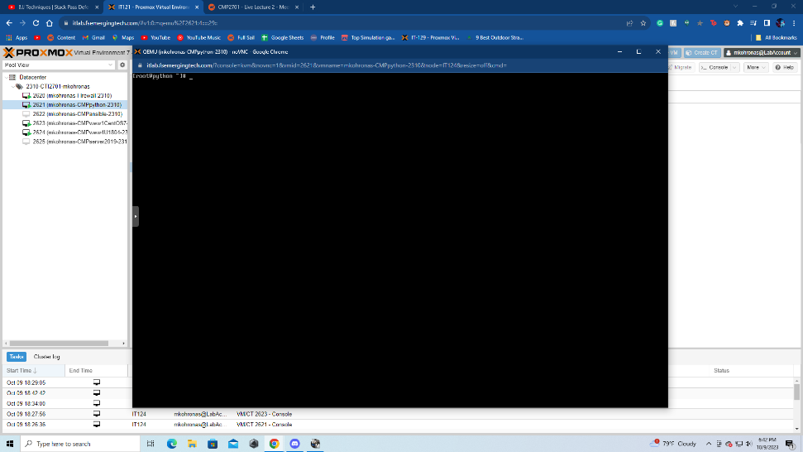

1. Add the EPEL repository.

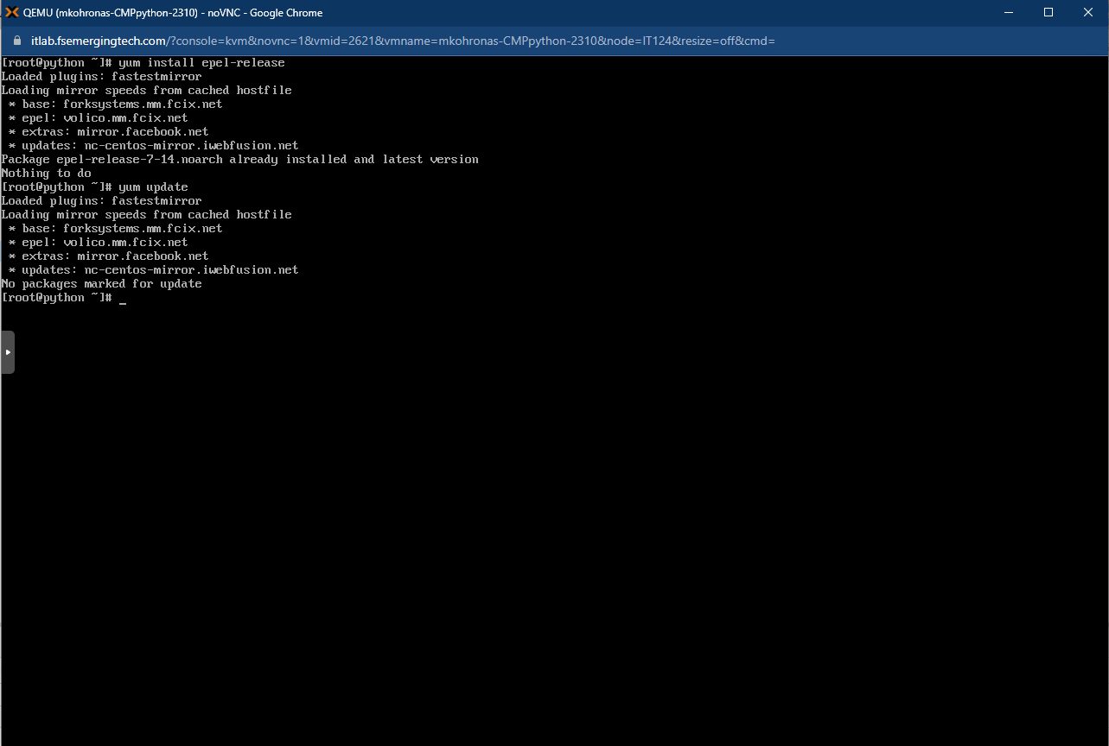

1. Install SQL database software (MariaDB)

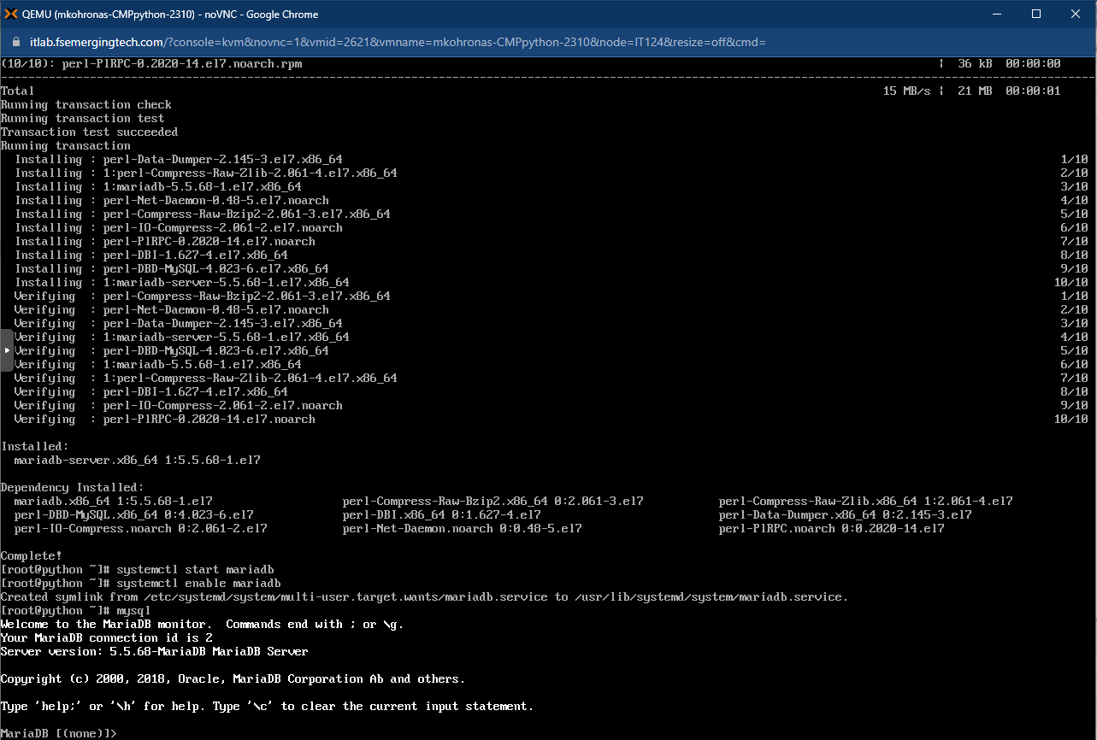

1. Type exit to leave the SQL console.

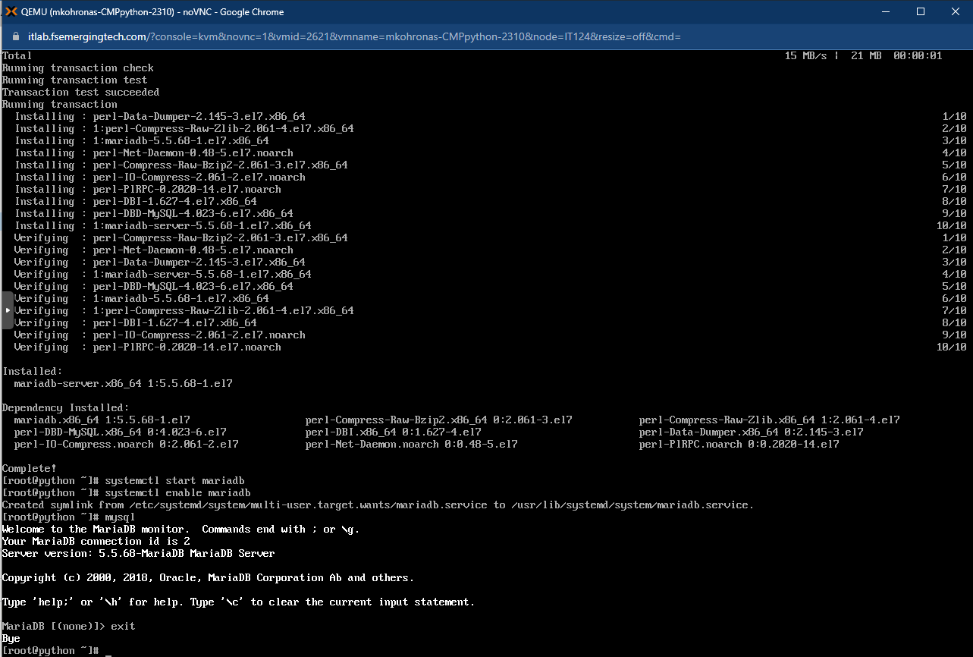

1. Install the MySQL-connector-python.

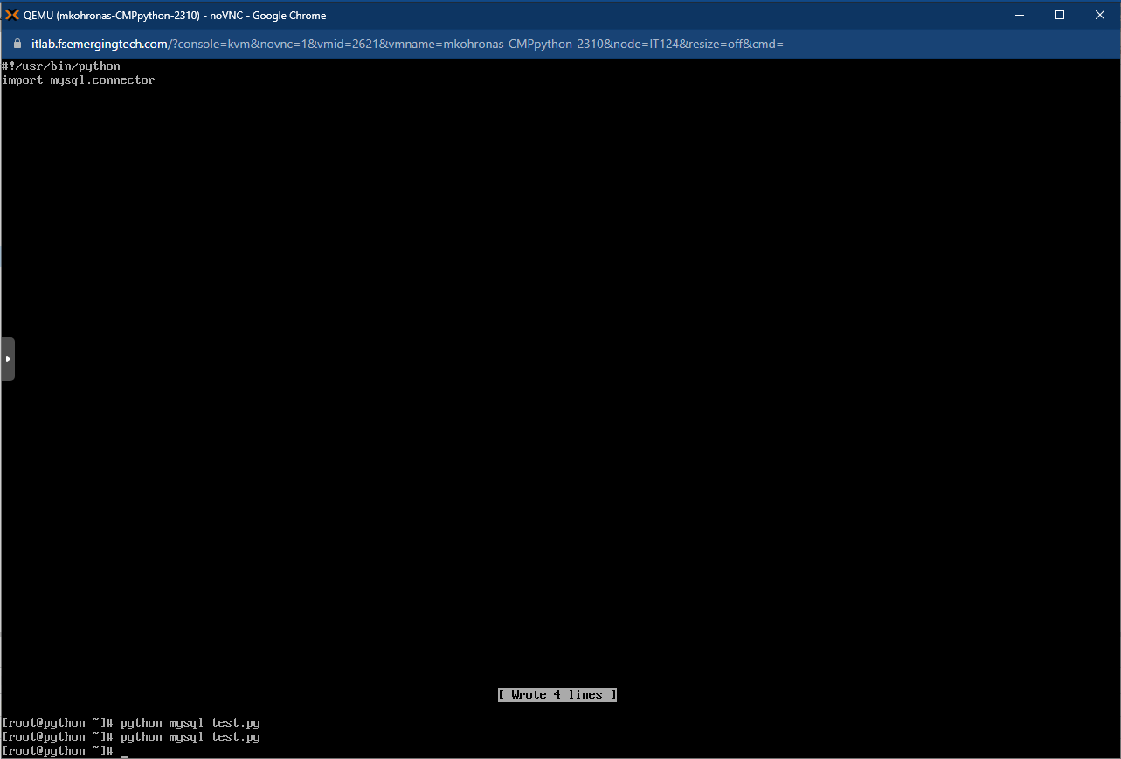

1. Create a python script which creates a new database

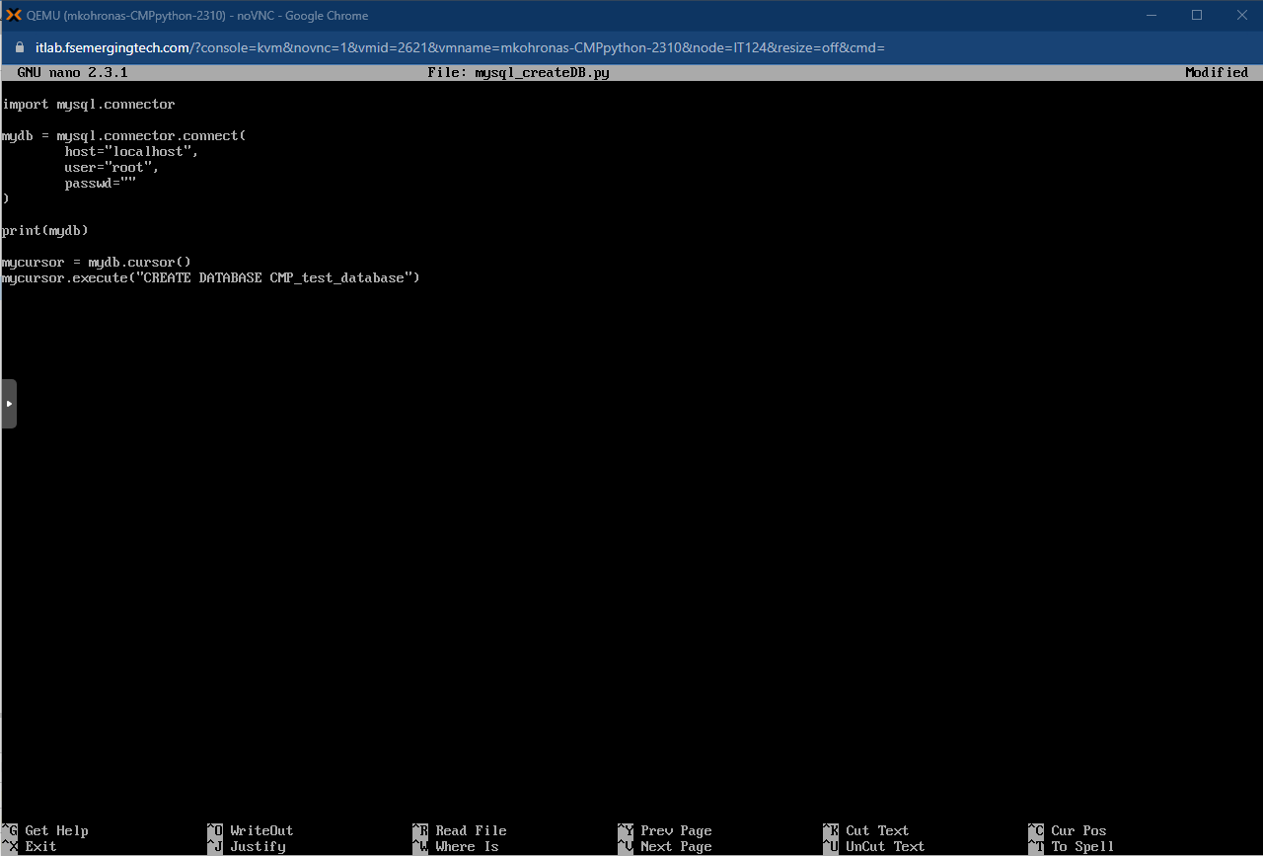

1. Run the python Script.

1. Login to MySQL as root and show databases. Then create a python script that can show databases for you.

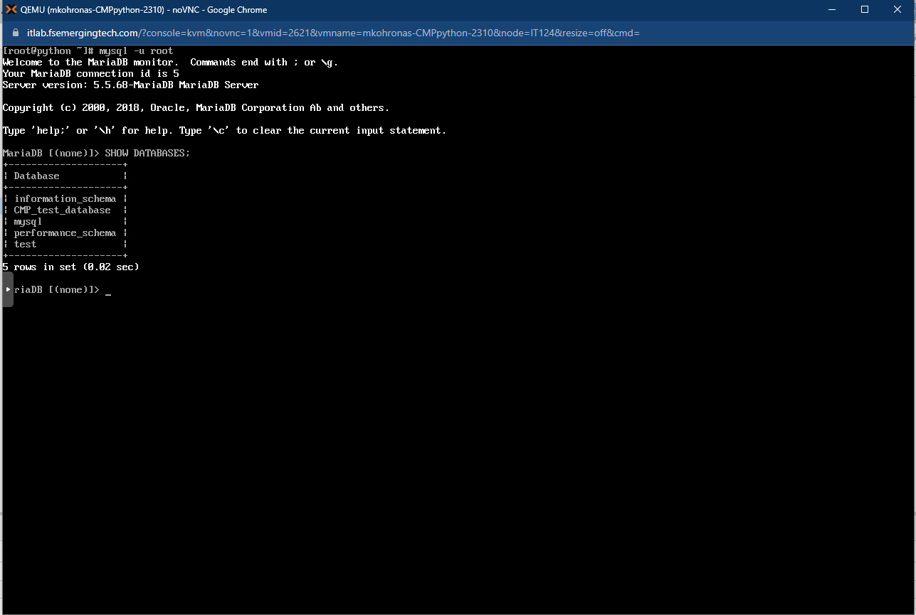

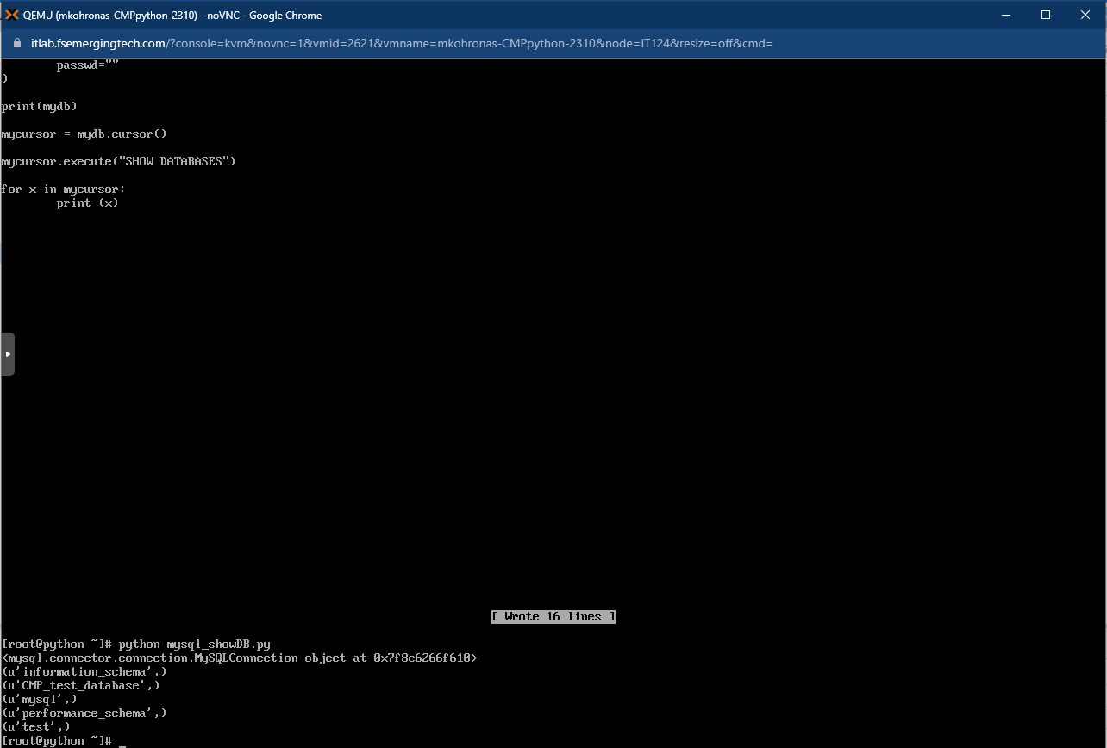

1. Create a snapshot of the virtual machine.

