# Testing

# Department

# Adding department name

# 

Figure 1 Adding a new department name

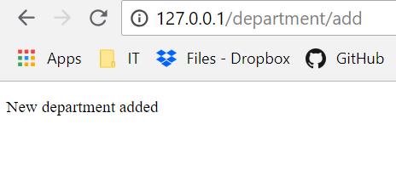

Figure 2 Confirmation message

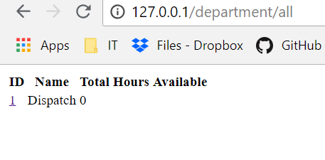

Figure 3 New department added

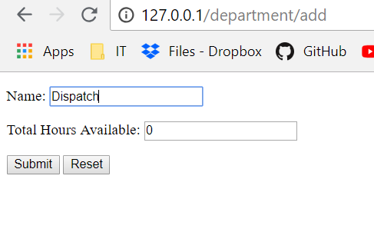

Figure 4 Adding the second department with the same name



Figure 5 Confirmation message

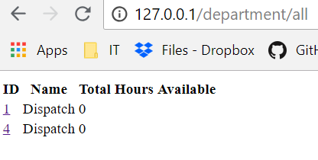

Figure 6 Error second department with the same name added

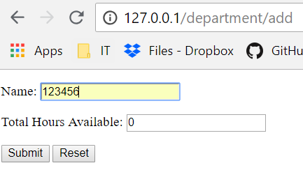

Figure 7 Adding integer as a department name



Figure 8 Confirmation message

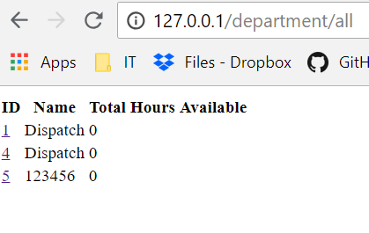

Figure 9 Error integer added as a department name

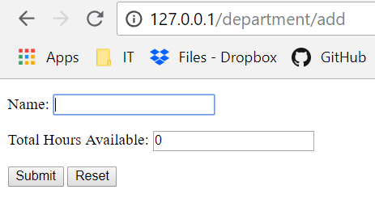

Figure 10 Empty filed used as a department name



Figure 11 Confirmation message

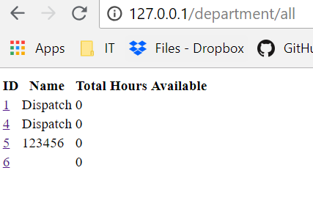

Figure 12 Error empty filed added to the department's list

# Adding Total Hours Available in the department

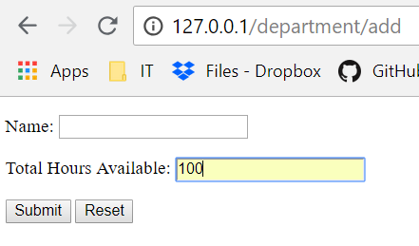

Figure 13 Adding total hour available in the department

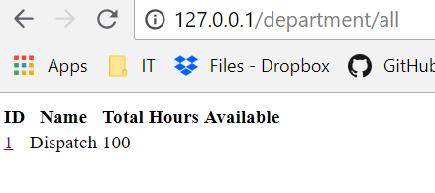

Figure 14 Hours available added to the department

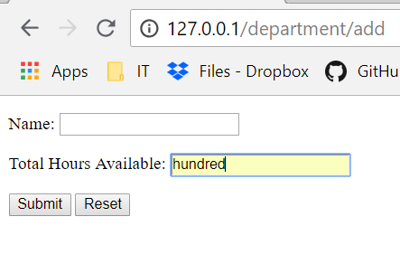

Figure 15 Using string as an hour available

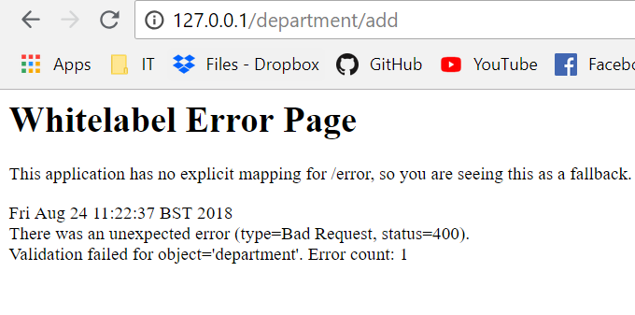

Figure 16 Error appear

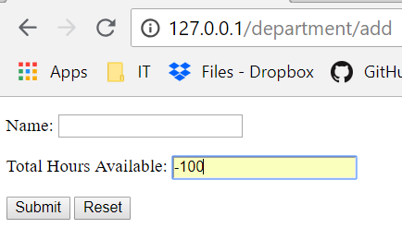

Figure 17 Adding negative integer

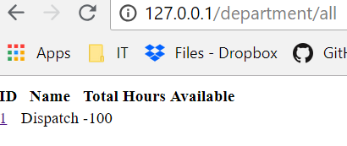

Figure 18 Error negative integer added

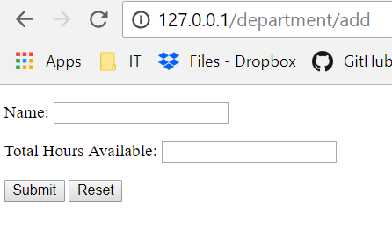

Figure 19 Using the empty field as an hour available

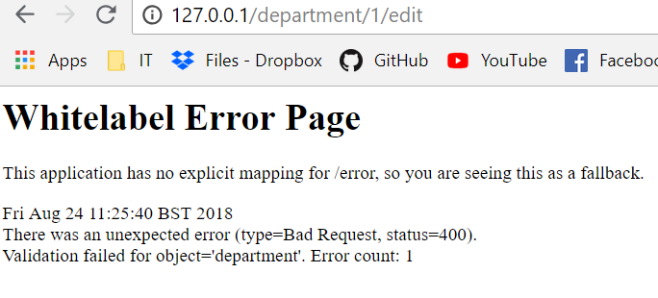

Figure 20 Error appear

# Editing department name

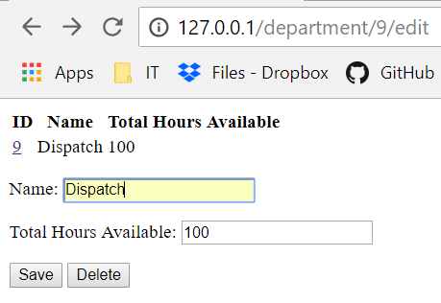

Figure 21 Changing department name for already existing

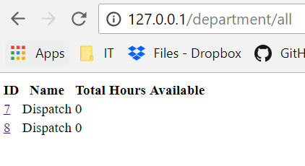

Figure 22 Error name changed

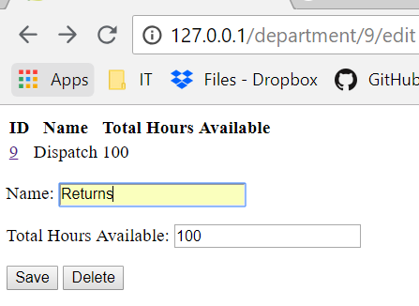

Figure 23 Changing department name

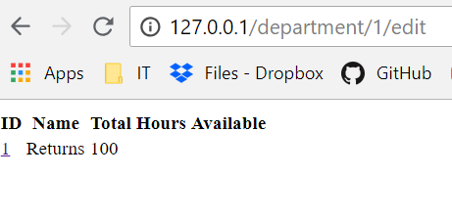

Figure 24 Name changed

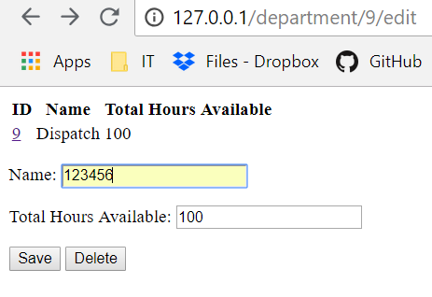

Figure 25 Changing department name for an integer

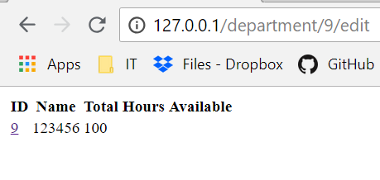

Figure 26 Error name changed for an integer

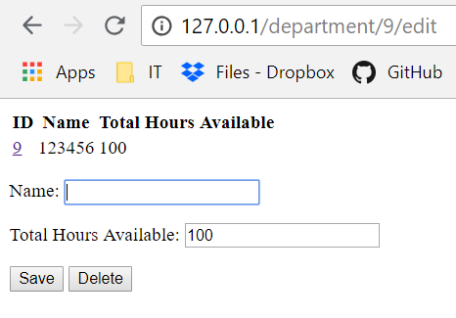

Figure 27 changing department name for an empty field

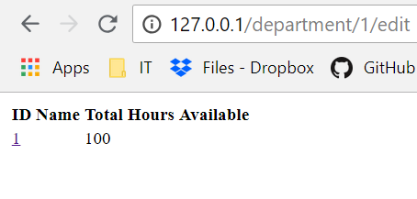

Figure 28 Error name changed for an empty field

# Adding Total Hours Available in the department

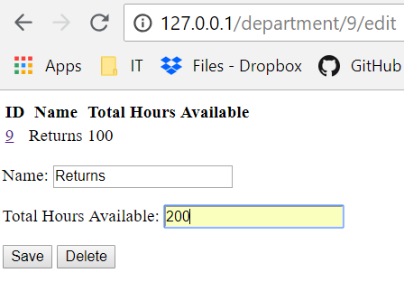

Figure 29 Editing hours available

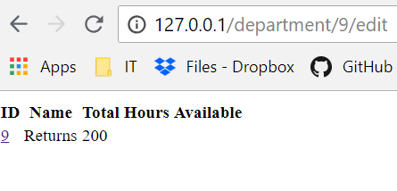

Figure 30 Hours changed

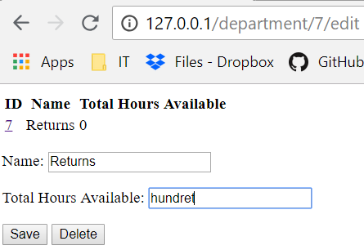

Figure 31 Changing hours on to string

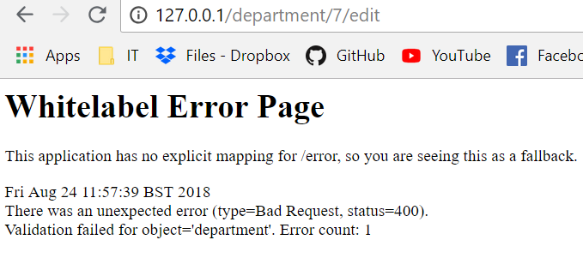

Figure 32 Error appeared

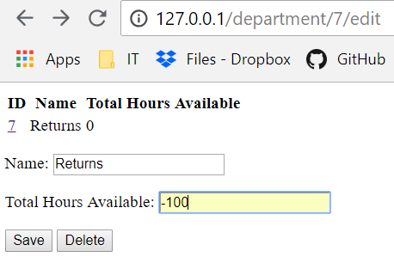

Figure 33 Changing hours for a negative integer

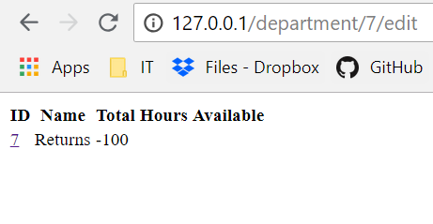

Figure 34 Error hours changed

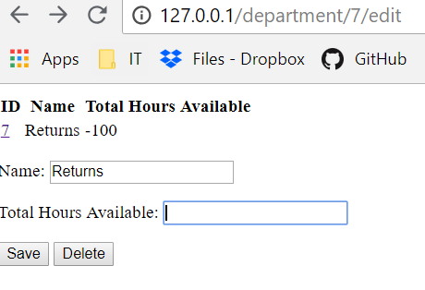

Figure 35 Changing hours for the empty field

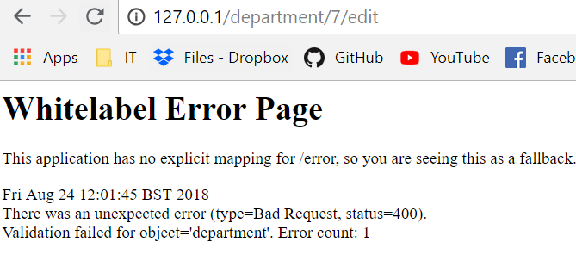

Figure 36 Error appeared

# Employee

# Adding employee name

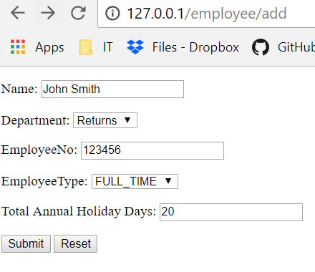

Figure 37 Adding Employee name

# 

Figure 38 Confirmation message appeared

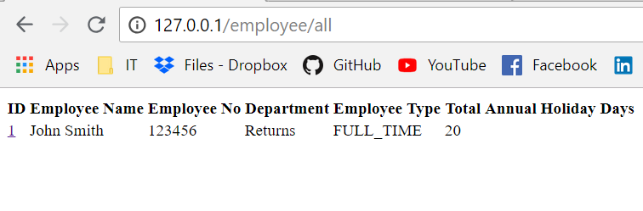

Figure 39 employee added to the list

# 

Figure 40 Confirmation message appeared

# 

Figure 41 Adding employee with same name added

# 

Figure 42 Employee with the same name added

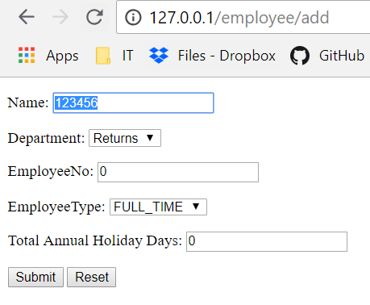

Figure 43 Adding integer as an employee name

# 

Figure 44 Confirmation message appeared

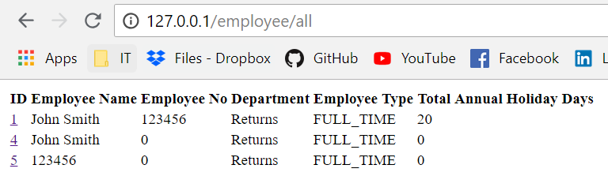

Figure 45 Error integer added to the employee list

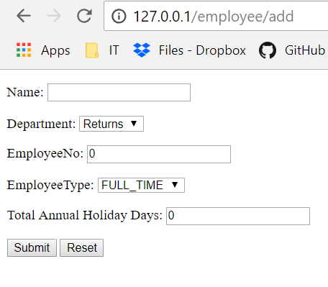

Figure 46 Adding an empty field to the employee list

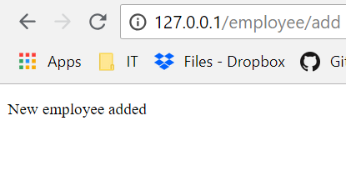

Figure 47 Confirmation message appeared

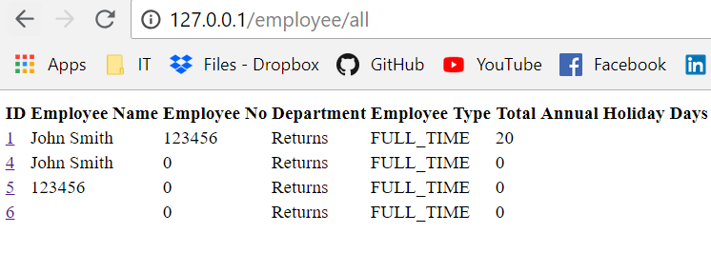

Figure 48 Error empty field added to the employee list

# Selecting department

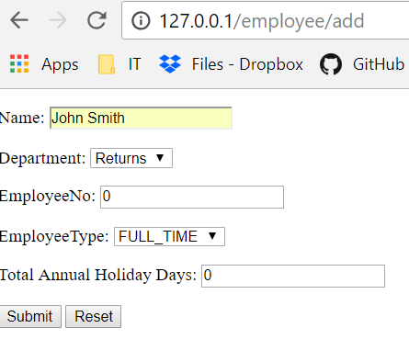

Figure 49 Selecting department for the employee



Figure 50 Confirmation message appeared

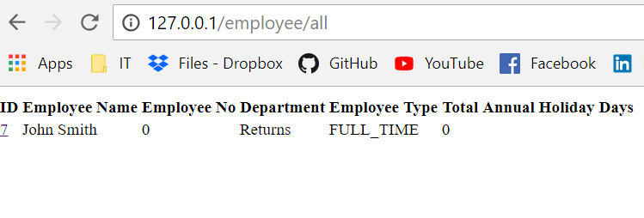

Figure 51 Return department selected for the employee

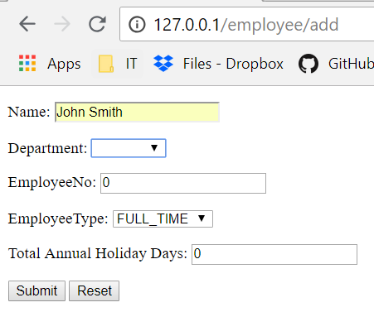

Figure 52 Selecting an empty filed as a department



Figure 53 Confirmation message appeared

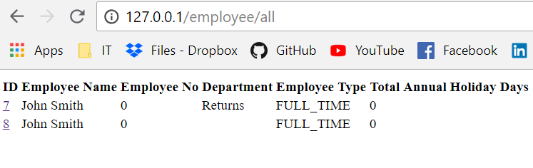

Figure 54 Error empty field selected for the employee department

# Adding employee number

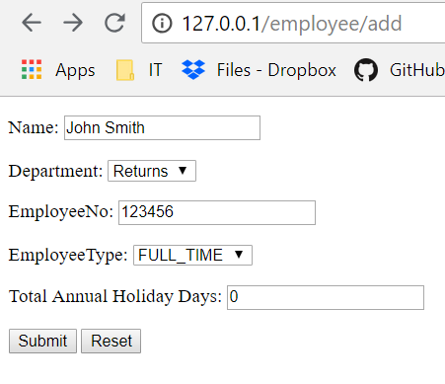

Figure 55 Adding employee number



Figure 56 Confirmation message appeared

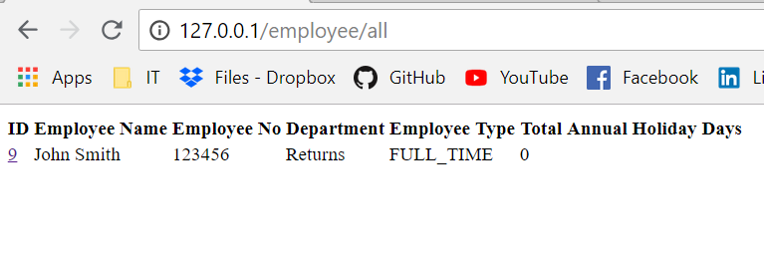

Figure 57 Employee number added

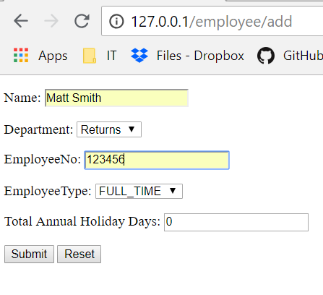

Figure 58 Adding the same employee number to the different employee



Figure 59 Confirmation message appeared

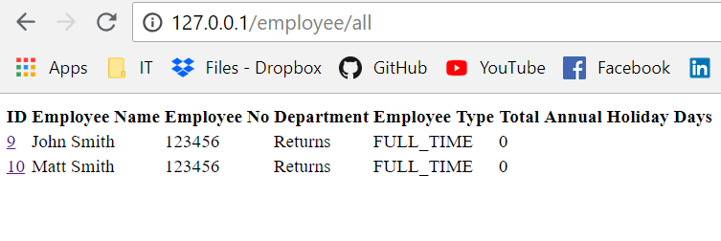

Figure 60 Error same number added to the different employee

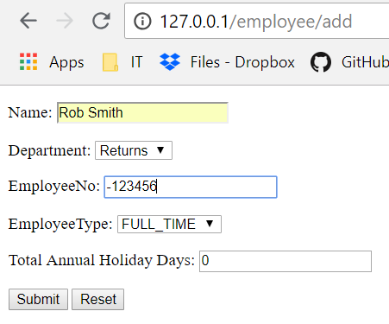

Figure 61 Adding a negative integer as an employee number



Figure 62 Confirmation message appeared

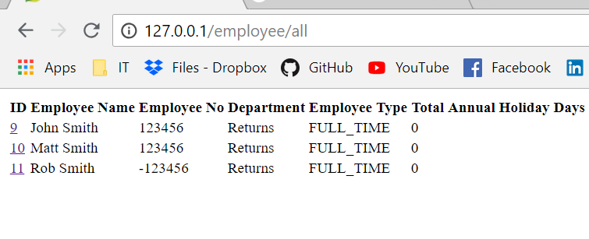

Figure 63 Error negative integer added to the list

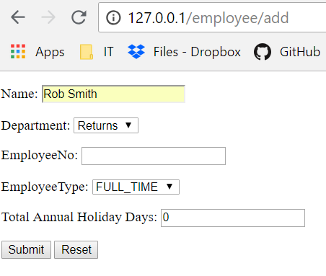

Figure 64 Selecting an empty field for the employee number

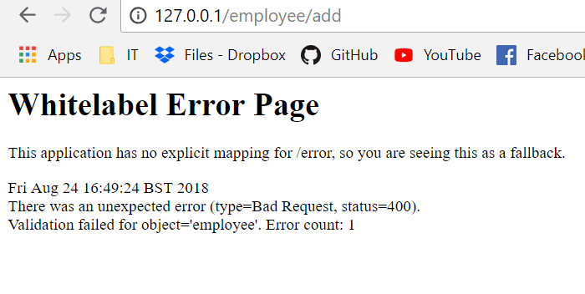

Figure 65 Error appeared

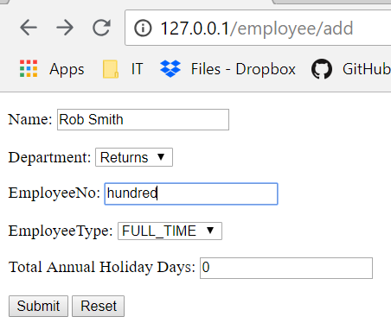

Figure 66 Selecting a string as an employee number

# Selecting employee type

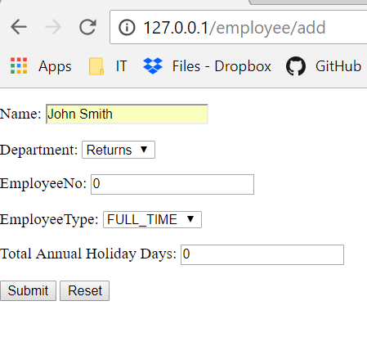

Figure 67 Selecting Full time as an employee type



Figure 68 Confirmation message appeared

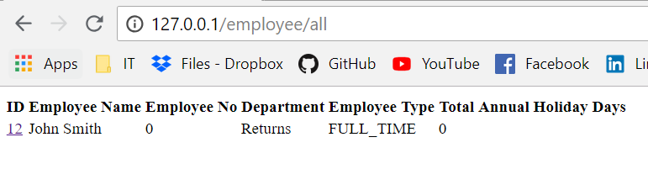

Figure 69 Employee type selected

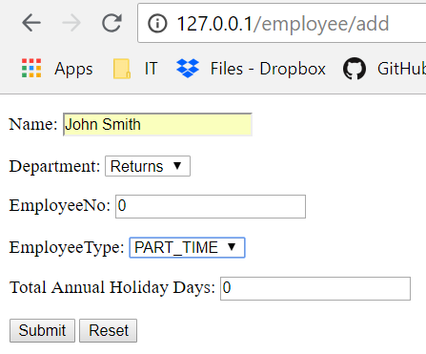

Figure 70 Selecting part-time for the employee type



Figure 71 Confirmation message appeared

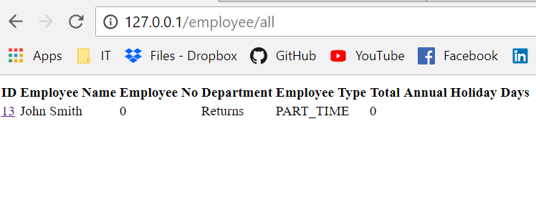

Figure 72 Part-time selected for the employee type

# Adding total annual holiday days

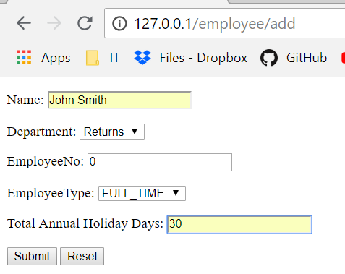

Figure 73 Adding total annual holiday days to the employee



Figure 74 Confirmation message appeared

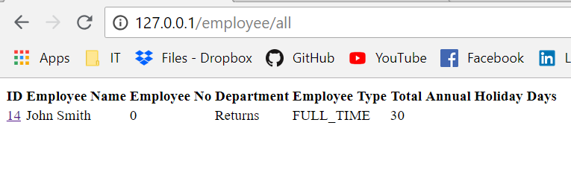

Figure 75 Total Annual Holiday Days added

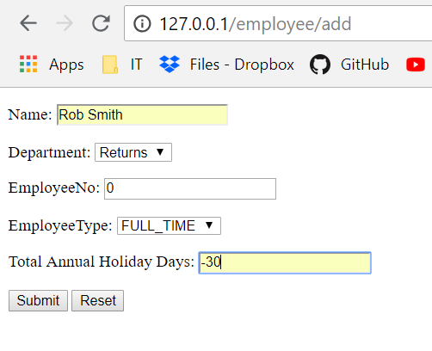

Figure 76 Adding a negative integer as a total annual holiday day

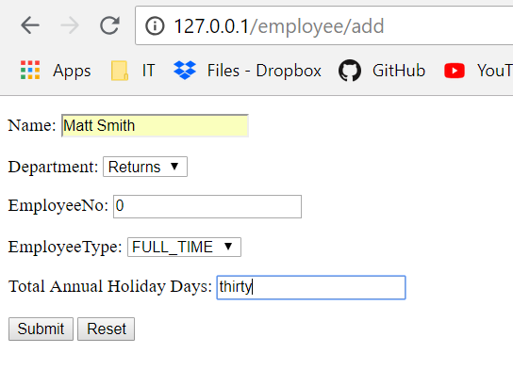

Figure 77 Adding string as a total annual holiday day



Figure 78 Error appear

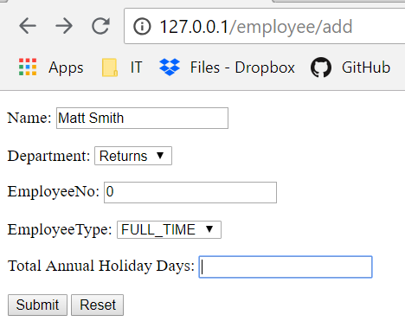

Figure 79 Adding empty field as a total annual holiday day



Figure 80 Error appeared

# Editing employee name

# 

Figure 81 Changing employee name

# 

Figure 82 Employee name changed

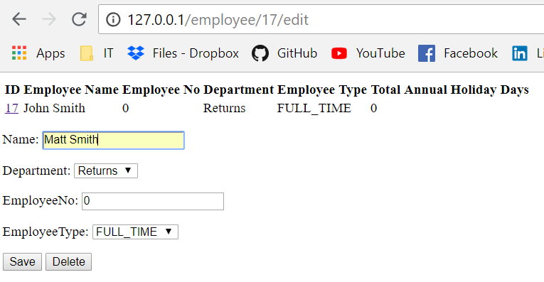

Figure 83 Changing name for already existing one in the list

# 

Figure 84 Error name changed

# 

Figure 85 Editing name for the integer

# 

Figure 86 Error name changed for integer

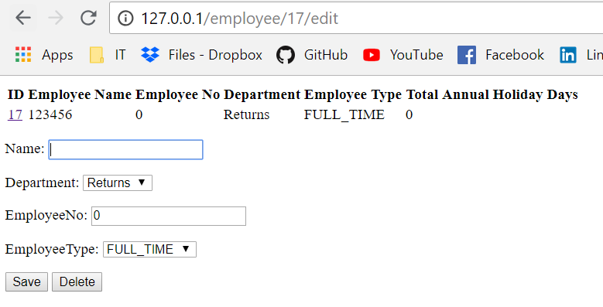

Figure 87 Changing name for the empty field

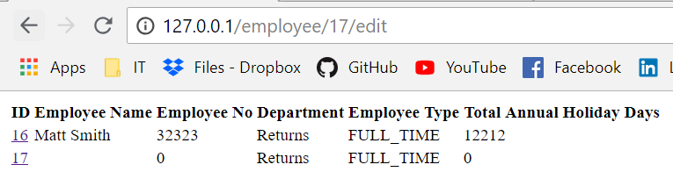

Figure 88 Error name changed for the empty string

# Editing department for the employee

# 

Figure 89 Changing department for the employee

# 

Figure 90 Error appear department doesn’t change

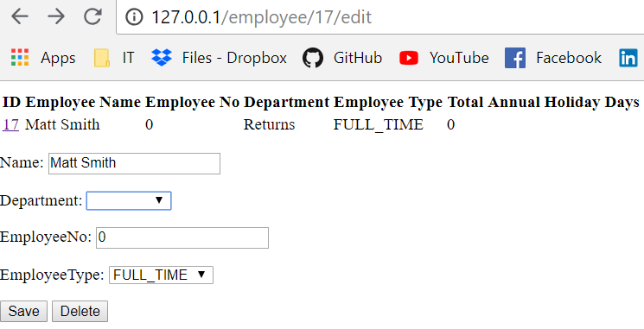

Figure 91 Changing department for the empty field

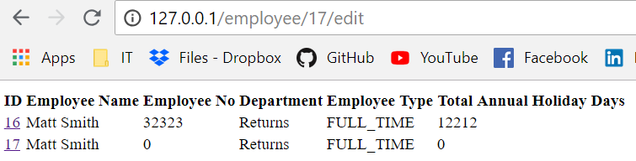

Figure 92 Error appear department doesn’t change

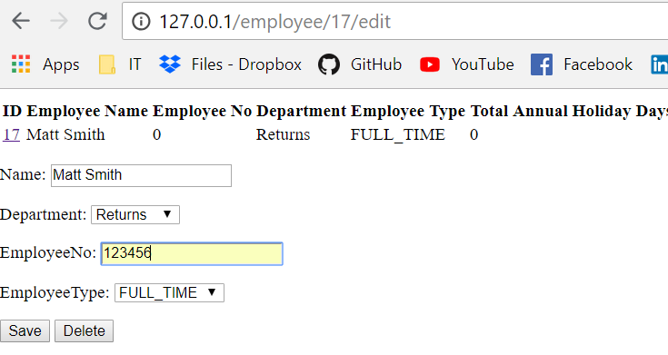

Figure 93 Changing employee number

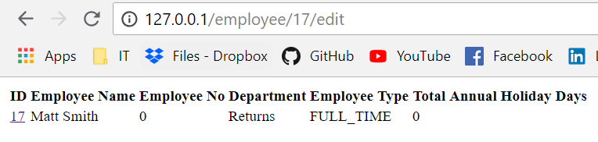

Figure 94 Error employee number doesn't change

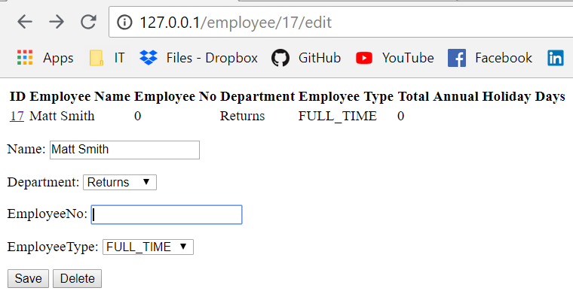

Figure 95 Changing employee number for empty field



Figure 96 Error appeared

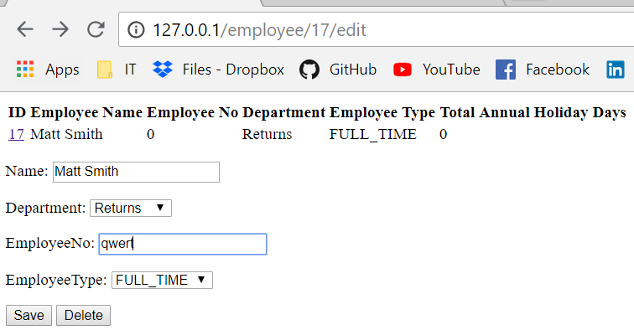

Figure 97 Changing employee number for string



Figure 98 Error appeared

# Editing employee type

# 

Figure 99 Changing employee type for Part-time

# 

Figure 100 Error employee type doesn’t change

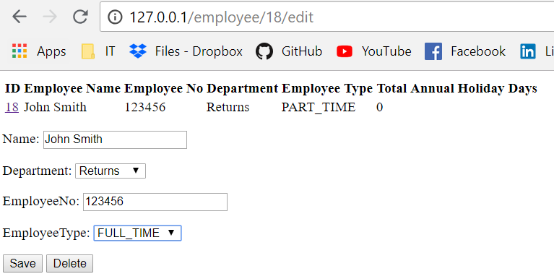

Figure 101 Changing employee type to full time

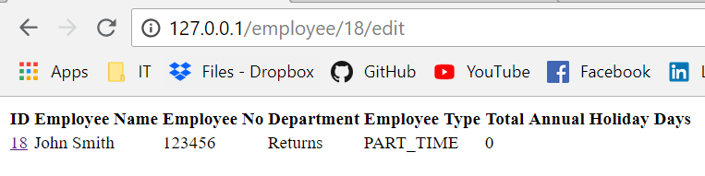

Figure 102 Error department type doesn’t change

# Holiday

# Selecting employee for the holiday

# 

Figure 103 Adding employee for the holiday

# 

Figure 104 Confirmation massage appeared

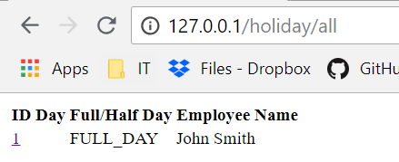

Figure 105 Employee added to the holiday

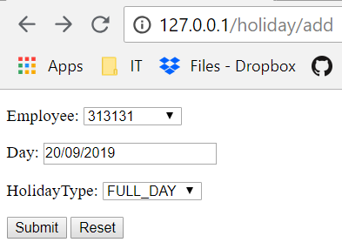

Figure 106 Adding integer as an employee name

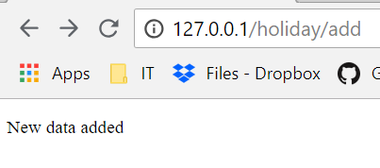

Figure 107 Confirmation message appeared

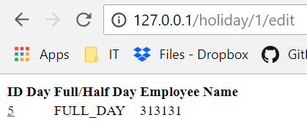

Figure 108 Error employee name added as an integer

# Selecting a day for the holiday

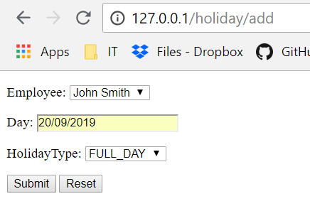

Figure 109 Adding day for the holiday



Figure 110 Confirmation message appeared

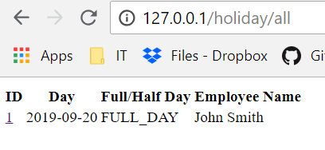

Figure 111 Day added to the holiday

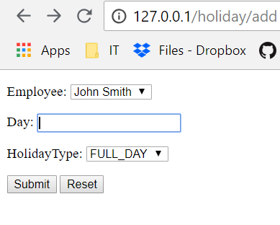

Figure 12 Adding empty filed as a holiday day



Figure 13 Confirmation message appeared

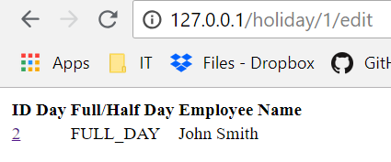

Figure 14 Error empty filed added as a holiday day

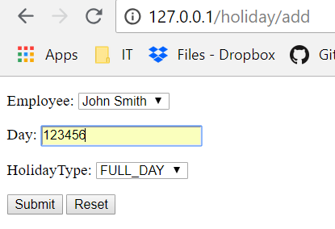

Figure 115 Adding integer as a holiday day



Figure 116 Confirmation message appeared

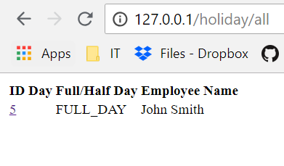

Figure 117 Error empty field added to the holiday day

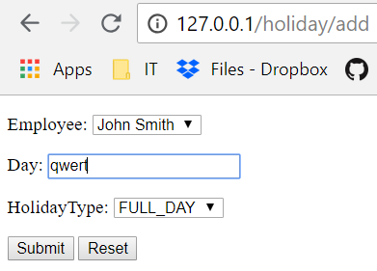

Figure 118 Adding string as a holiday day



Figure 119 Confirmation message appeared



Figure 120 Error empty field added to the holiday day

# Selecting holiday type

# 

Figure 121 Adding full day as a holiday type

# 

Figure 122 Confirmation message appeared

# 

Figure 123 Full day added as a holiday type

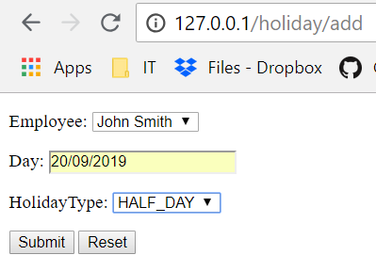

Figure 124 Adding half day as a holiday type



Figure 125 Confirmation message appeared

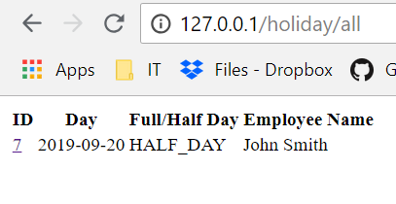

Figure 126 Half day selected as a holiday type

# Editing holiday day

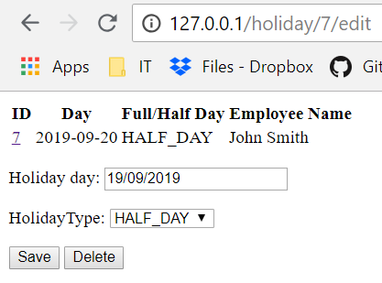

Figure 127 Changing holiday day

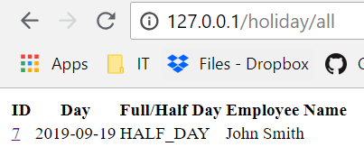

Figure 128 Holiday data changed

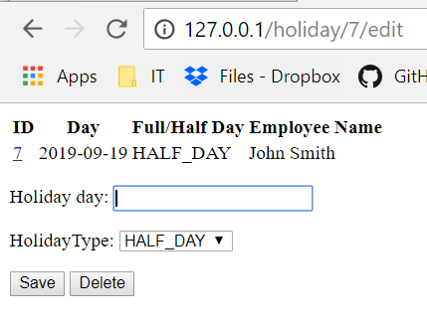

Figure 129 Changing holiday day for the empty field

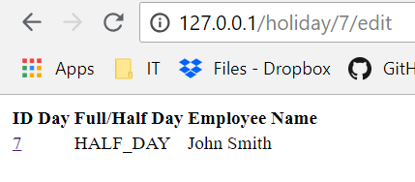

Figure 130 Error holiday day changed for the empty field

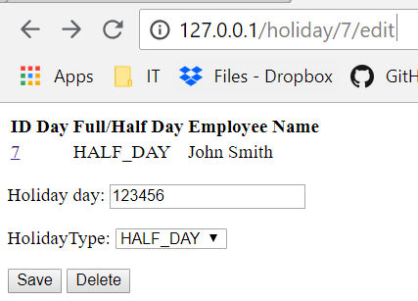

Figure 131 Changing holiday day for the integer



Figure 132 Error holiday day appeared as an empty field

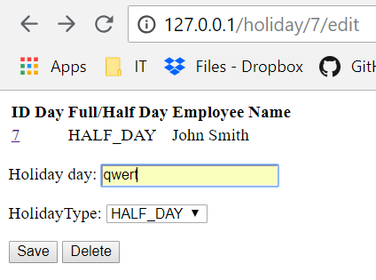

Figure 133 Changing holiday day for the string



Figure 134 Error holiday day appeared as an empty field

# Editing holiday type

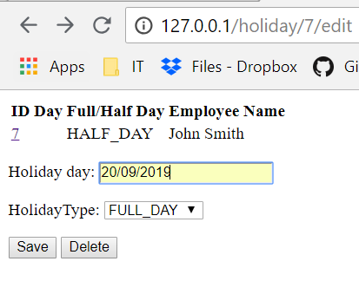

Figure 135 Changing holiday type for the full day

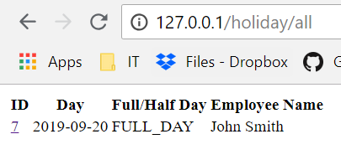

Figure 136 Holiday type changed

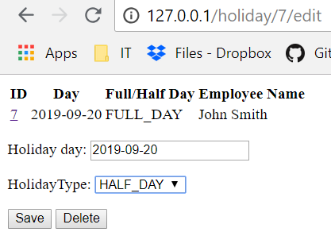

Figure 137 Changing holiday type for the half day

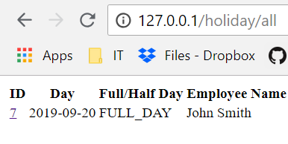

Figure 138 Holiday type changed for the full day

# Training

# Adding training name

# 

Figure 139 Adding training name

# 

Figure 140 confirmation message appeared

# 

Figure 141 Name to the training added

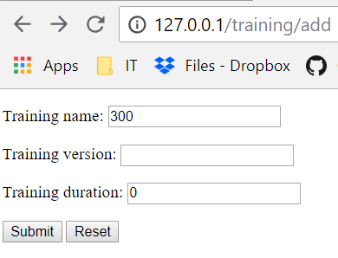

Figure 142 Adding integer as a training name

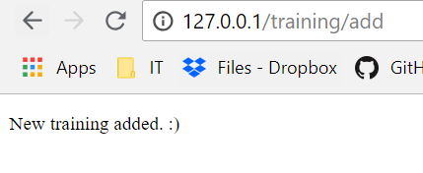

Figure 143 Confirmation message appeared

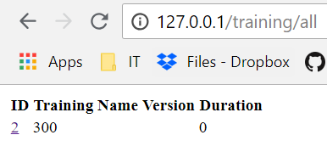

Figure 144 Error integer added as a training name

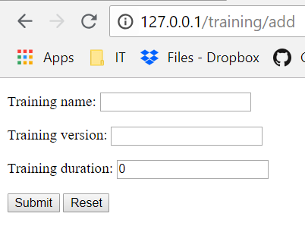

Figure 145 Adding empty filed as an integer



Figure 146 Confirmation message appeared

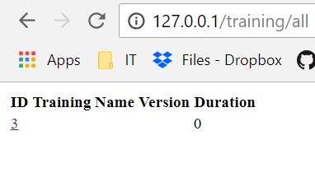

Figure 147 Error empty string added as a training name

# Adding training version

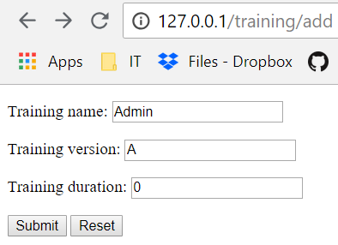

Figure 148 Adding training version



Figure 149 Confirmation message appeared

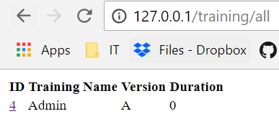

Figure 150 Version added to the training

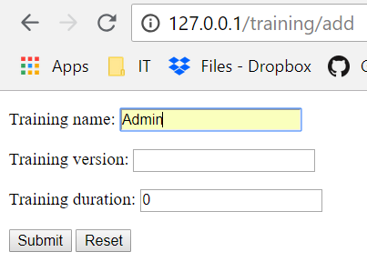

Figure 151 Adding empty field as a training version

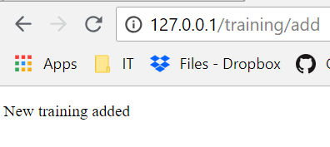

Figure 152 Confirmation message appeared

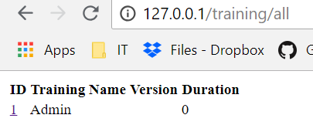

Figure 153 Error empty field added as a training version

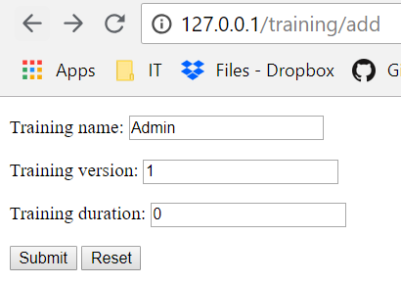

Figure 154 Adding integer as a training version



Figure 155 Confirmation message appeared

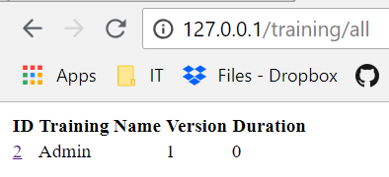

Figure 156 Integer added as a training version

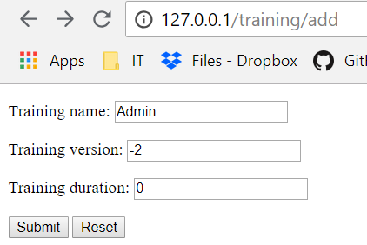

Figure 157 Adding a negative integer as a training version



Figure 158 Confirmation message appeared

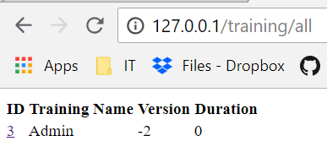

Figure 159 Error negative integer appeared as a training version

# Adding training duration

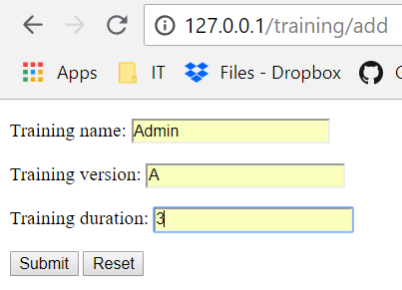

Figure 160 adding duration to the training



Figure 161 Confirmation message appeared

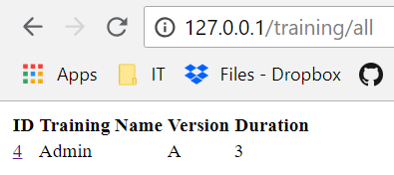

Figure 162 Duration added to the training

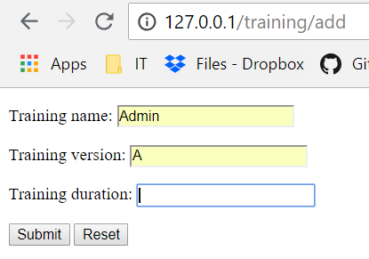

Figure 163 Adding empty field as a training duration

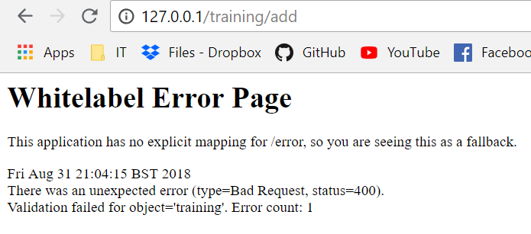

Figure 164 Error appeared

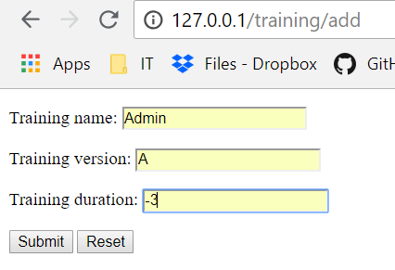

Figure 165 adding negative integer as a training duration



Figure 166 Confirmation message appeared

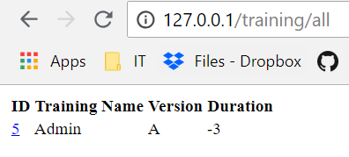

Figure 167 Error negative integer added as a training duration

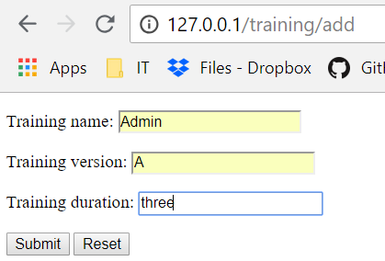

Figure 168 Adding string as training duration

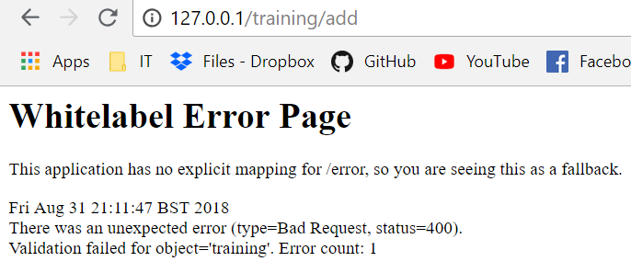

Figure 169 Error appeared

# Editing training name

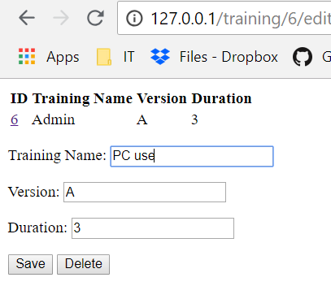

Figure 170 Changing training name

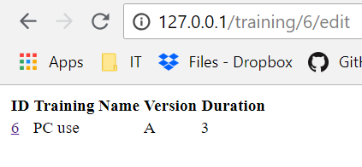

Figure 171 Training name changed

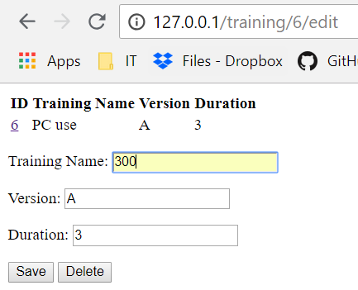

Figure 172 Changing training name to the integer

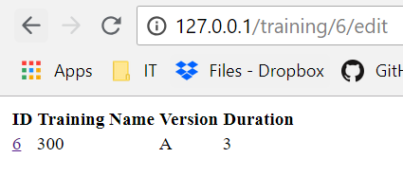

Figure 173 Error training name changed for the integer

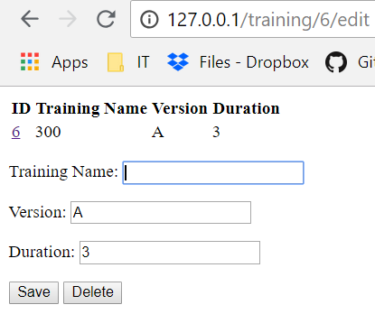

Figure 174 Changing training name for the empty string

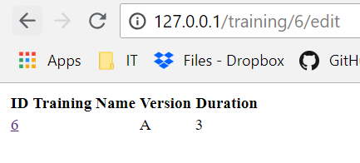

Figure 175 Error training name changed for the empty field

# Editing training version

# 

Figure 176 Changing training version

# 

Figure 177 Training version changed

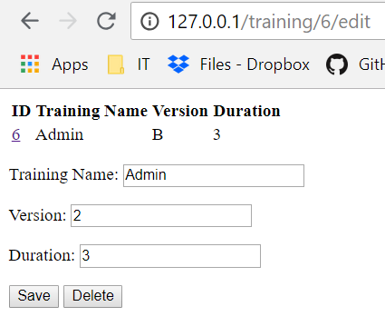

Figure 178 Changing training version for the integer

# 

Figure 179 training version changed for the integer

# 

Figure 180 Changing training version for the negative integer

# 

Figure 181 Error training version changed for the negative integer

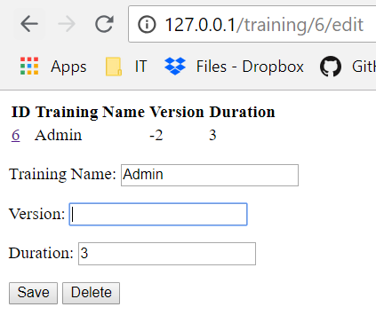

Figure 182 Changing training version for the empty field

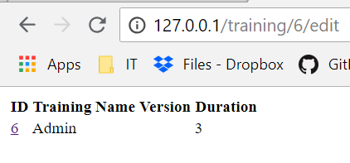

Figure 183 Error training version changed for the empty string

# Editing training duration

# 

Figure 184 Changing training duration

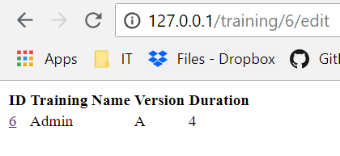

Figure 185 Training duration changed

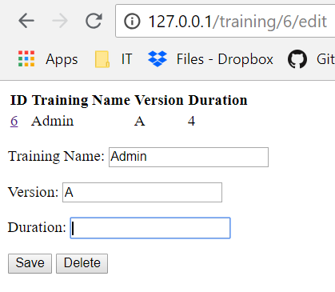

Figure 186 Changing training duration for the empty field

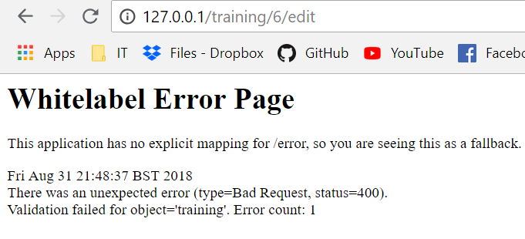

Figure 187 Error appeared

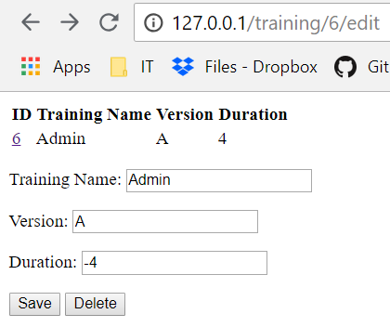

Figure 188 Changing training duration for the negative integer

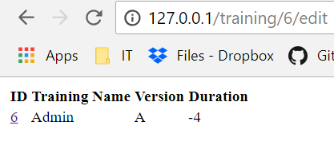

Figure 189 Error training duration changed for the negative integer

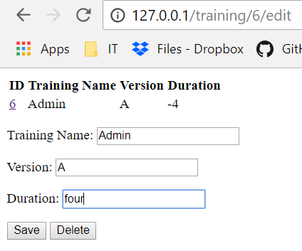

Figure 190 Changing training duration for the string



Figure 191 Error appear

# Training records

# Selecting employee for the training

# 

Figure 192 Adding employee for the training

# 

Figure 193 Confirmation message appeared

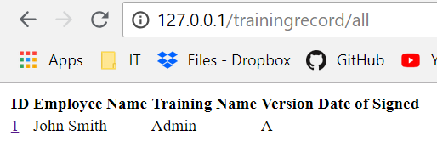

Figure 194 Training added to the employee

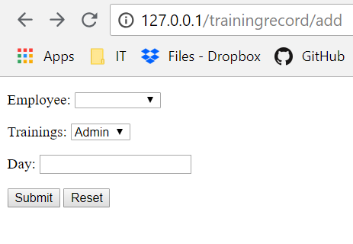

Figure 195 Selecting an empty field for the employee field

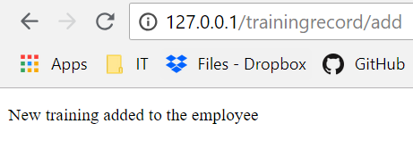

Figure 196 Confirmation message appeared

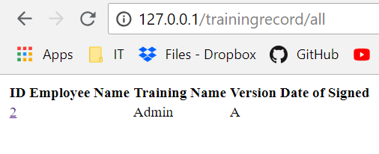

Figure 197 Error empty filed selected for the employee name

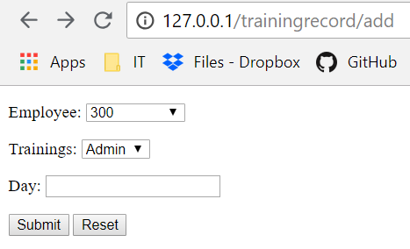

Figure 198 Adding integer as an employee name for the training



Figure 199 Confirmation message appeared

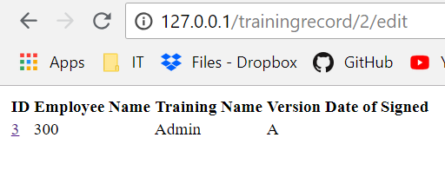

Figure 200 Empty field added as an employee name for the training

# Adding training name to the employee

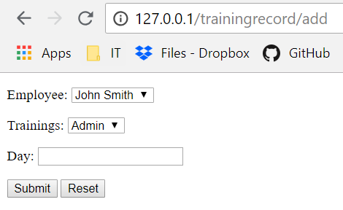

Figure 21 Selecting training name to the employee



Figure 202 Confirmation message appeared

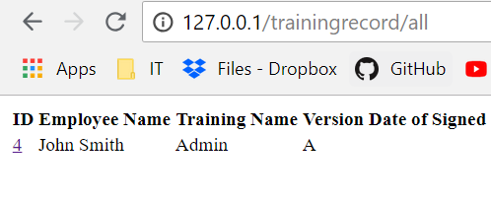

Figure 203 Training name added to the employee

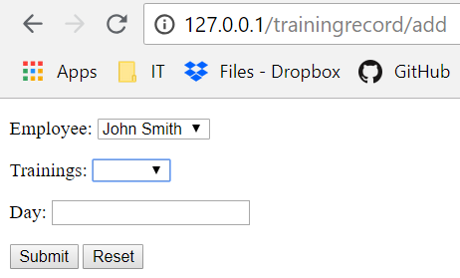

Figure 204 Selecting an empty field as a training name



Figure 205 Confirmation message appeared

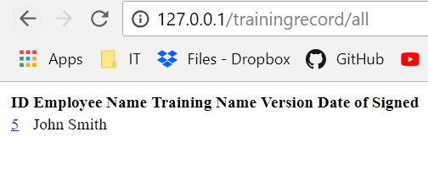

Figure 206 Error empty field selected for the training name

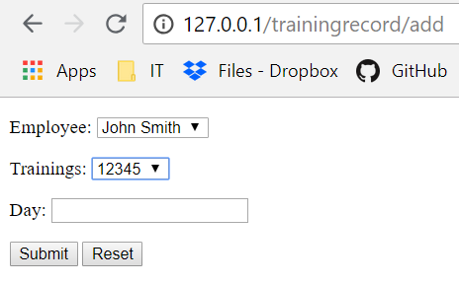

Figure 207 Selecting integer as a training name



Figure 208 Confirmation message appears

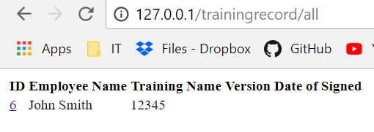

Figure 209 Error integer added as a training name

# Adding sign day to the training

# 

Figure 210 Selecting day for the training record

# 

Figure 211 Confirmation message appears

# 

Figure 212 Data added to the training record

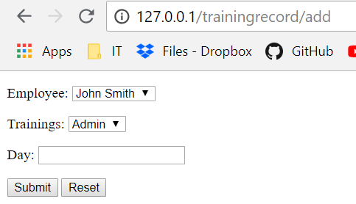

Figure 213 Selecting an empty field for the data



Figure 214 Confirmation message appeared

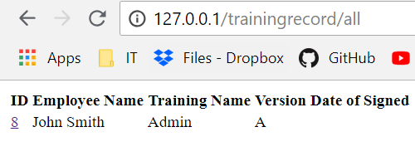

Figure 215 Error empty field added as a data

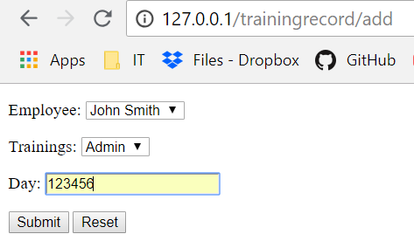

Figure 216 Adding string as a data

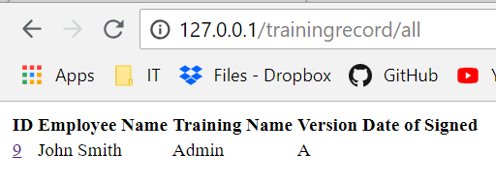

Figure 217 Error empty field as data appeared

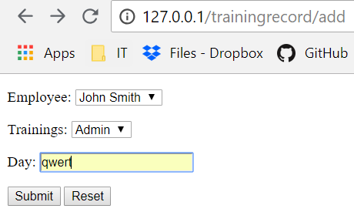

Figure 218 Adding string as a data



Figure 219 Empty field appear as a data

# Editing employee name

# 

Figure 220 Changing employee name

# 

Figure 221 Error can’t change employ name

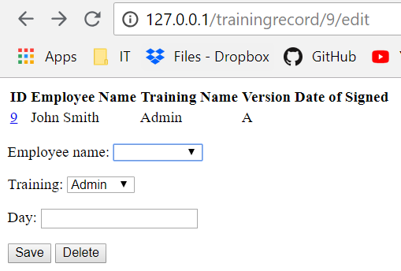

Figure 222 Changing employee name for the empty field

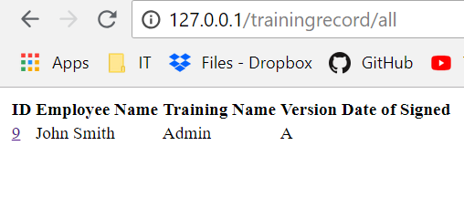

Figure 223 Can’t change an employee name

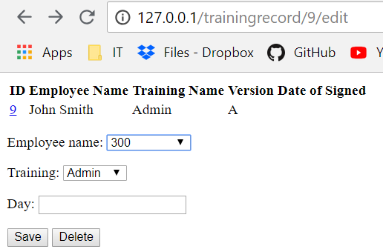

Figure 224 Changing employee name for the integer



Figure 225 Can't change employee name for the integer

# Editing training name

# 

Figure 226 Changing training name

# 

Figure 227 Training name changed

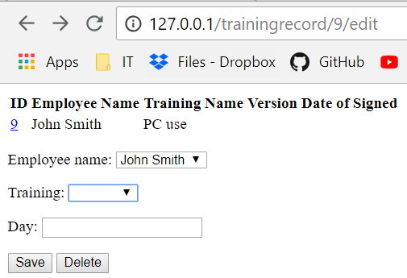

Figure 228 Changing training name for the empty field

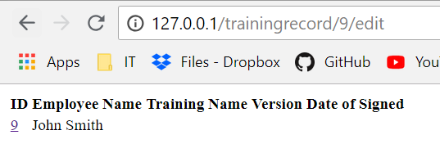

Figure 229 Error training name changed for the empty field

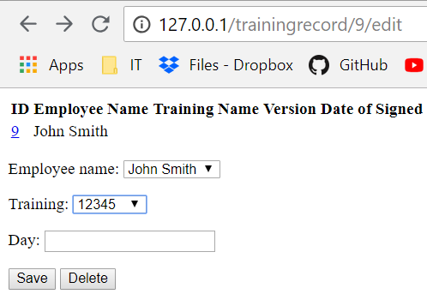

Figure 230 Changing training name for the integer

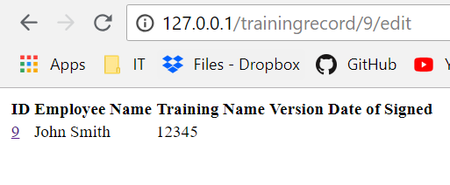

Figure 231 Error training name changed for the integer

# Editing data for signing training

# 

Figure 232 Changing data for signing training

# 

Figure 234 Data changed

# 

Figure 235 Changing data for the empty field

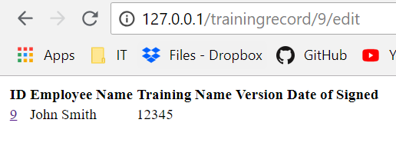

Figure 236 Error empty field appeared

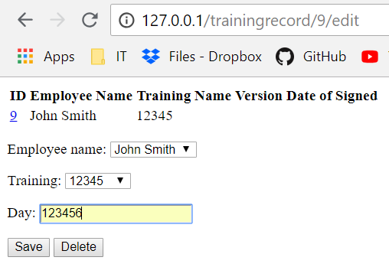

Figure 237 Changing data for the integer

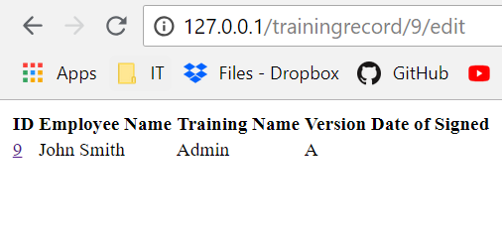

Figure 238 Error empty field appeared

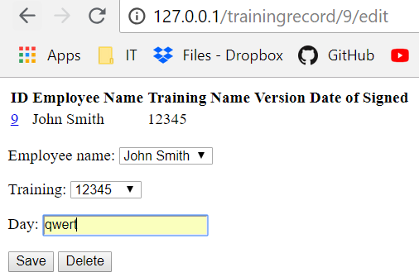

Figure 239 Changing data for the string



Figure 240 Error empty field appeared