Kaiyuan Chen
604838709
TA: Isha Verma
Lab 4
May 10, 2017

Machine Learning Opens Up New Ways to Help Disabled People

Machine learning is a field of Computer Science that trains software to extract mathematical model from images, sounds, languages without being explicitly programmed. It has become useful in many fields such as computer vision(CV), speech recognition and robotics. The article, Machine Learning Opens Up New Ways to Help Disabled People, by Tom Simonite introduces machine learning as a subset of Artificial Intelligence, developed by large companies such as Youtube, Facebook and IBM, opens up new ways to help disabled people with deafness and cognitive diseases.

First, YouTube has dedicated to helping people who are deaf and hard of hearing for the last decade. After launching automated captions years ago, it now owns more than 1 billion videos with automatic captions and the accuracy of this technology is around 97 percent, which is getting closer to that of human ears. Also, with the help of deep neural network model, YouTube’s sound effect caption system can identify and label [APPLAUSE], [MUSIC], later [KNOCK], [BARK] without manual input. These automated sound effect caption can be superposed to each other and translate sound effect to keywords effectively. For possible applications, I think this technology should focus more on optimizations on video content. For example, YouTube can train the algorithm to understand the content of video, so that people with visual diseases will have another way to understand the video. On the other hand, understanding the video will provide more accuracy on search results, advertising and recommendations with the help of machine learning. For example, maybe someday people can do research based on uploading a picture or typing a description rather than the exact matching words.

The passage also mentions Facebook’s application LeCun based on deep learning that can answer a series of questions on the content of photos. It can, according to MIT Technology Review, determine the subject of image, the subject’s action and color. The following picture is a screenshot of this application. The application uses computer vision, based on machine learning, to translate the picture’s objects and subjects to descriptive keywords. This will be greatly helpful to those who are visually impaired.
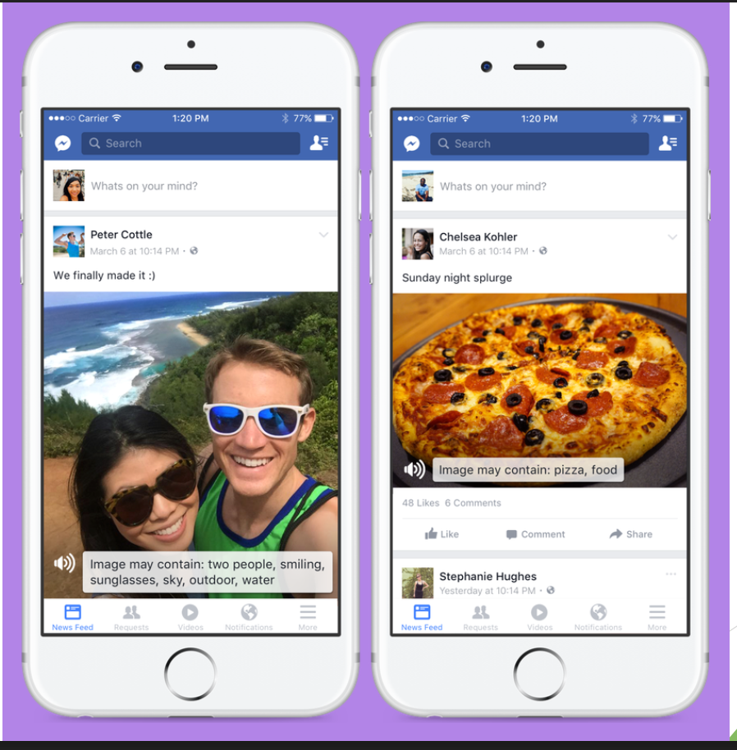
Computer Vision, or in this case, image recognition is always a big part of machine learning. What it does is transform a set of data, through trained algorithm, to a desired output. As Adam Geitgey ’s following demonstration:
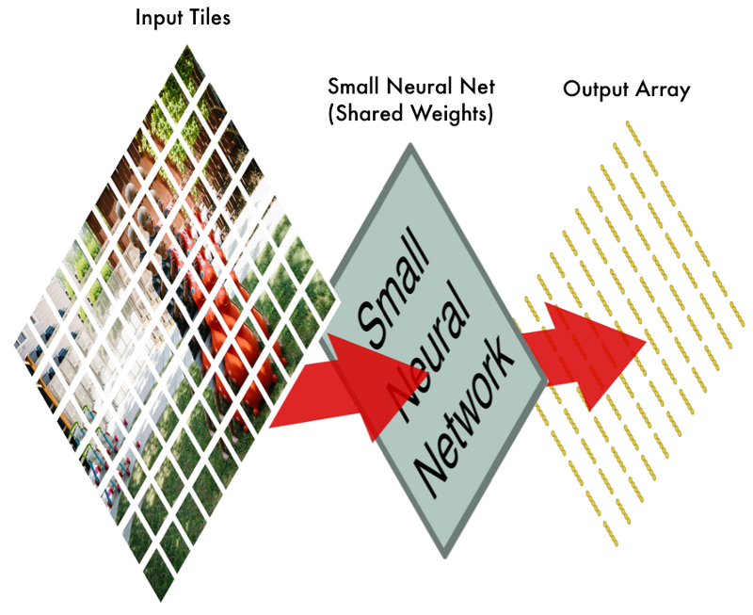
A picture can be separated apart as input tiles, then passed into small neural net and generate an output array that contains the result of machine learning analysis. As a result, the machine can “understand” the input tiles by comparing with its own trained set and tell what this image is about, an application that greatly helps disabilities to acquire information as much as we do.

To help those with reading or cognitive disabilities, researchers at IBM make a tool called Content Clarifier that can trim figures of speech like “raining cats and dogs” to plainer and shorter terms, as well as MIT is developing tools to translate administrative and educational documents for autistic high school students. The linguistic efforts are also applied by a text-simplifying project called EU project led by Ineke Schuurman, who believes the accessibility tools should help people from being left behind by society and communications. This project contains built-in apps that integrate with Gmail or Facebook that can simplify texts for people with intellectual disabilities. I think this application can be promising someday only if when the model is accurate enough, because some errors in some aspects, such as understanding the content of image, will not bring as many troubles as understanding the rules and communications correctly. Friends may deliver wrong message because of this software or the software gives the translation that no one can understand. This application might cause bring more troubles for others to use the words that the machine understands or the user to translate what the algorithm outputs. Hopefully with enough training and refined mathematical model, this project, or other similar projects, will help disabled people with cognitive diseases.

With the help of machine learning, these new tools developed by YouTube, Facebook and IBM are helping disabilities such as those who have visual or cognitive diseases. Although this is a new topic that no one had heard of it ten years ago, it will become an industry that compounds the knowledge of computer science, neuroscience and mathematics in near future.

Works Cited
Alpaydin, Ethem. Introduction to Machine Learning. Cambridge: MIT, 2014. Print.
Geitgey, Adam. "Machine Learning Is Fun! Part 3: Deep Learning and Convolutional Neural Networks." Medium. 13 June 2016. Web. 18 May 2017.
Simonite, Tom. "*Applause* YouTube's Caption Upgrade Shows How Machine Learning Is Helping the Disabled." MIT Technology Review. MIT Technology Review, 08 May 2017. Web. 11 May 2017.
Simonite, Tom. "Experimental Facebook App Can Answer Questions About the Content of Photos." MIT Technology Review. MIT Technology Review, 16 Mar. 2016. Web. 11 May 2017.
"Visualizing Sound Effects." YouTube Engineering and Developers Blog. 23 Mar. 2017. Web. 11 May 2017.

