The graph that I will be using to test each of the questions

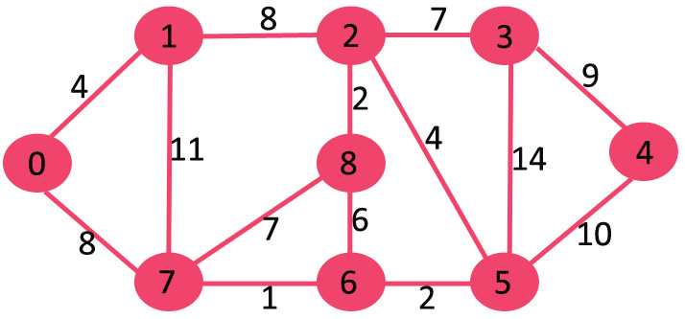

1.

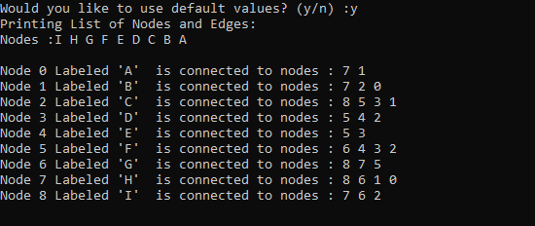

Source code will be the same for all questions and will be located at the bottom of this electronic packet. My representation of this class only allows for undirected graphs. To change to a directed graph, inside of the addEdge() function of the Graph class you can take out the second insert to only create a record from node1 to node2 with weight of the weight passed into the function.

2.

The two methods we talked about in class are the Breadth First Traversal and the Depth First Traversal. The Breadth First Traversal goes through the tree each “Row” at a time and checks each neighbor before traversing to the next level inside of the tree. Depth first does the opposite where it goes as far down the tree as it can until it reaches a leaf, then it will start back at the top and go down the next neighbor’s subtree.

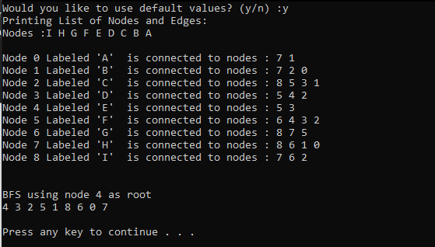

Source code will be located at the bottom of this packet.