**Introduction**

Backpropagation network is the most commonly used one of all kinds of neural networks, and that the multiple–layer BP network with a single hidden layer is most widely applied in practice.

The birth of BP network is due to the acquirement of the backpropagation algorithm. BP is a sort of supervised learning rule. Its base idea is as follows: the learning rule is provided with inputs x1 ,x2 $⋯$ xq , where q is the number of input/target pairs, to the network and the corresponding target outputs t1 ,t2 $⋯$ tq ,the aim of learning is to update network parameters including weights and offsets so as to minimize the mean square error calculated according to the error of target output and practical outputs y1 ,y2 $⋯$ yq .In fact, BP algorithm is an approximatively descent gradient optimization method ,by which training a network includes two steps at every iteration :the first is to send the inputs forward through the network ,and the second is to propagate backward the error signal defined later in this paper in order to adjust network parameters in every layer until the ultimate goal is attain.

**Methodology**

The experiment is initiated to build a model for a nonlinear system based on an improved BP algorithm for neural network.

In order to produce correct results by neural network itself, a training is needed. There are two major ways to train a network: supervised learning and unsupervised learning. Given the fact that our goal is to solve a kind of classification problem, and the samples are generated by a known formula, it is supervised learning that is more suitable.

There are 4 steps in the experiment:

1. Before we start to train the network, it is important to preprocess data. Because the range of the input data might be too large and it could cost too much time for training. Therefore, we need to map the input data to a smaller range, for example, from -1 to +1.
2. Next step is to build a feedforward neural network with MATLAB. A set of training data is generated by the following formula:

$$y\left(k\right)=\frac{29}{40}\sin\left(\frac{16u\left(k-1\right)+8y\left(k-1\right)}{3+4u{\left(k-1\right)}^{2}+4y{\left(k-1\right)}^{2}}\right)+\frac{2}{10}u\left(k-1\right)+\frac{2}{10}y\left(k-1\right)$$

where $u\left(k\right)$ is an input to the network and $y\left(k\right)$ is the corresponding target output. After obtaining 200 samples, 100 of them will be used as training samples while another 100 will be used to verify the performance of the network.

1. Training. The third step includes setting training parameters, choosing activation functions, and develop some algorithms.
2. Finally, the data gathered from step2 will be inputted to the network. Comparing the results with desired values, the accuracy of the network can be determined.

**Result**

A BP neural network with a single hidden layer and a sufficient number of nodes can approximate any kind of input / output mapping with arbitrary accuracy.

BP neural network’s learning method is training the connection weights with a set of training examples. This procedure includes two parts: forward and backward propagation. In forward propagation part, the neural network receives the input information from the training examples, then each hidden layer neurons calculates the input information and transmits the result to the output layer. If the result of the output layer is not consistent with the expected output in the training sample, the output layer will enter the reverse propagation process. At this time, the network will send the error signal back along the original path, and change each layer of neurons’ connection weight in accordance with certain principles. This process is repeated until the output of the forward propagation meets the error requirement.

It is very important to determine the number of hidden nodes. If the quantity is less, the network will not acquire enough information; while a large quantity will cause an increase of training time and a decline of generalization ability. Therefore, it is necessary to set a small number of nodes at first, and test the learning error, then gradually increase the number of nodes until the learning error is no longer obviously reduced.

Figure 1 and 2 shows the comparison of simulation results with the test sample from before and after training.

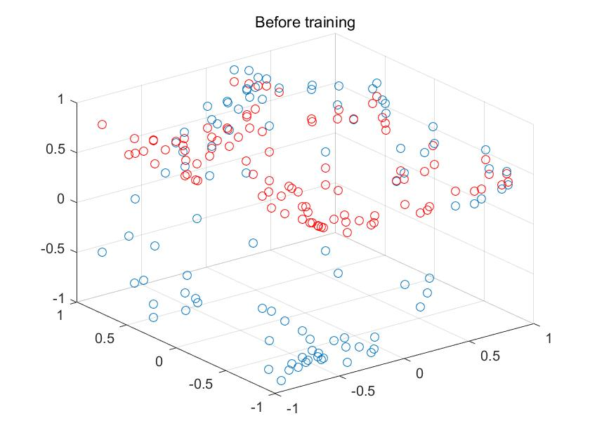

Fig. 1

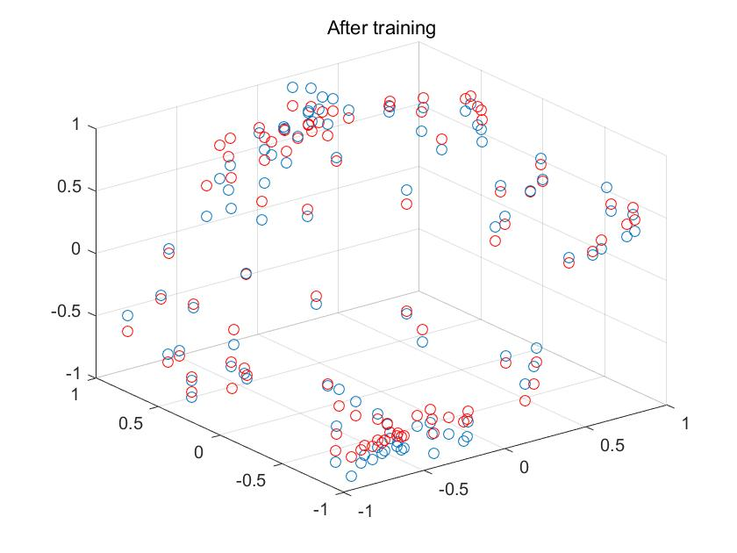

Fig. 2

The blue circle denotes the sample point, and the red circle denotes the simulation result. By comparison, we can clearly see that the network with training achieves a better approximation effect.