Spatiotemporal Variation of Adult C. californicus Shell Allometry

Malloy and Ul-Hasan and Lewis et al

Apr 9, 2019

Last edited [Sabah Ul-Hasan]: April 9, 2019

<https://github.com/MichaelMalloy/C_californicus_Morphology>

Contributors of data by order of contribution: MM, SUH, CAO, SC Contributors of code by order of contribution: SUH, LL, MM

SuppTabs 2-4 Data, post-processing: Raw -> Clean -> SoCal Lines 22 - 144 Figure 1a-b Map of C. californicus range Lines 146 - 260 Figure 2b Shell allometry (shell manual) Lines 262 - 302 Supp Fig 1 Correlates for shell collection bias Lines 304 - 331 Figure 3 Bergmann’s rule: Morphology ~ temperature Lines 333 - Figure 4 Major factors ~ Morphology (SoCal) Lines

Overview of data and post-processing

###### Upload data ######  
# install.packages("RCurl")  
library("RCurl") # package needed for downloading data from Github repo

## Warning: package 'RCurl' was built under R version 3.5.2

## Loading required package: bitops

# packageVersion("RCurl") # v1.95.4.12   
  
Raw <- read.csv(text=getURL("https://raw.githubusercontent.com/MichaelMalloy/C_californicus_Morphology/master/SupplementalTable2_Data-Raw.csv"))   
  
# Ensure blanks are read as NAs  
###### Upload data ######  
  
  
###### Data structure ######  
str(Raw) # Quick view of RawData

## 'data.frame': 2996 obs. of 52 variables:  
## $ Specimen_Number : int 1 2 3 4 5 6 7 8 9 10 ...  
## $ Collection : Factor w/ 9 levels "ANSP","CAS","iNat",..: 1 1 1 1 1 1 1 1 1 1 ...  
## $ Lot_Number : Factor w/ 390 levels "1 atm Gland",..: 219 219 219 219 376 376 376 376 376 376 ...  
## $ Collector : Factor w/ 114 levels "alex_bairstow",..: 72 72 72 72 99 99 99 99 99 99 ...  
## $ Ecoregion : Factor w/ 2 levels "Northern California",..: 2 2 2 2 2 2 2 2 2 2 ...  
## $ County : Factor w/ 10 levels "Baja California",..: 5 5 5 5 2 2 2 2 2 2 ...  
## $ Land_Category : Factor w/ 3 levels "Coastal","Island",..: 1 1 1 1 1 1 1 1 1 1 ...  
## $ Location : Factor w/ 20 levels "ANA","BS","CAT",..: 14 14 14 14 4 4 4 4 4 4 ...  
## $ Site : Factor w/ 151 levels "All Saints Bay",..: 76 76 76 76 149 149 149 149 149 149 ...  
## $ SoCal_Group : Factor w/ 8 levels "CAT","Los Angeles",..: 4 4 4 4 2 2 2 2 2 2 ...  
## $ Island_Size : Factor w/ 3 levels "Large","Medium",..: NA NA NA NA NA NA NA NA NA NA ...  
## $ Latitude : num 32.7 32.7 32.7 32.7 33.7 ...  
## $ Longitude : num -117 -117 -117 -117 -118 ...  
## $ Epoch : Factor w/ 4 levels "Anthropocene",..: 1 1 1 1 1 1 1 1 1 1 ...  
## $ Formation : Factor w/ 19 levels "12th Terrace",..: NA NA NA NA NA NA NA NA NA NA ...  
## $ Decade : int 1950 1950 1950 1950 1970 1970 1970 1970 1970 1970 ...  
## $ Year : int 1951 1951 1951 1951 1973 1973 1973 1973 1973 1973 ...  
## $ Season : Factor w/ 4 levels "Fall","Spring",..: 1 1 1 1 4 4 4 4 4 4 ...  
## $ Month : int 11 11 11 11 2 2 2 2 2 2 ...  
## $ Mean_SST : num 16.2 16.2 16.2 16.2 15.2 ...  
## $ Mean_SST_Sdev : num 1.63 1.63 1.63 1.63 1.25 ...  
## $ Length_mm : num 22.3 25.21 25.23 28.6 8.33 ...  
## $ Width_mm : num 12.47 14.24 14.66 16.35 4.47 ...  
## $ Globosity_WoverL : num 0.56 0.57 0.58 0.57 0.54 0.57 0.6 0.58 0.56 0.61 ...  
## $ Aperture_mm : num 3.14 3.38 3.51 3.69 0.71 0.82 1.63 1.64 1.81 2.46 ...  
## $ Thickness_mm : num 0.32 0.41 0.45 0.34 0.23 0.15 0.44 0.37 0.51 0.33 ...  
## $ Habitat : Factor w/ 4 levels "algae forest",..: NA NA NA NA NA NA NA NA NA NA ...  
## $ Depth : Factor w/ 3 levels "deep","intertidal",..: NA NA NA NA NA NA NA NA NA NA ...  
## $ BRY : int 0 0 0 0 0 0 0 0 0 0 ...  
## $ BAR : int 0 0 0 0 0 0 0 0 0 0 ...  
## $ LMP : int 0 0 0 0 0 0 0 0 0 0 ...  
## $ TWS : int 0 0 0 0 0 0 0 0 0 0 ...  
## $ COR : int 0 0 0 0 0 0 0 0 0 0 ...  
## $ ALG : int 0 0 0 0 0 0 0 0 0 0 ...  
## $ SCR : int 0 1 0 0 0 0 0 0 0 0 ...  
## $ BOR_TAP : int 0 0 0 0 0 0 0 0 0 0 ...  
## $ BOR_STR : int 0 0 0 0 0 0 0 0 0 0 ...  
## $ BOR_INC : int 0 0 0 0 0 0 0 0 0 0 ...  
## $ mean_pvolc3 : num 128 128 128 128 NA ...  
## $ sd_pvolc3 : num 231 231 231 231 NA ...  
## $ zooplankton_n_points_used: int 484 484 484 484 NA NA NA NA NA NA ...  
## $ zooplankton_mean_distance: num 2.95 2.95 2.95 2.95 NA ...  
## $ fish_total_catch_wt_kg : num NA NA NA NA NA NA NA NA NA NA ...  
## $ fish_cpue_kg_per_ha_der : num NA NA NA NA NA NA NA NA NA NA ...  
## $ sd_total_catch_wt_kg : num NA NA NA NA NA NA NA NA NA NA ...  
## $ sd_cpue_kg_per_ha_der : num NA NA NA NA NA NA NA NA NA NA ...  
## $ fish_n_points_used : int NA NA NA NA NA NA NA NA NA NA ...  
## $ fish_mean_distance : num NA NA NA NA NA NA NA NA NA NA ...  
## $ Population_Density : num 13.6 13.6 13.6 13.6 1708.3 ...  
## $ Population_Density_NoBaja: num 13.6 13.6 13.6 13.6 1708.3 ...  
## $ MPA : Factor w/ 2 levels "no","yes": 1 1 1 1 1 1 1 1 1 1 ...  
## $ Image_url : Factor w/ 99 levels "https://static.inaturalist.org/photos/10375087/medium.jpg?1505096528",..: NA NA NA NA NA NA NA NA NA NA ...

# Plots of shell morphology measurements as a point of reference for outliers   
morphos = c("Globosity_WoverL", "Length_mm", "Width_mm", "Aperture_mm", "Thickness_mm")   
  
# install.packages("PerformanceAnalytics")  
library("PerformanceAnalytics") # Need package for correlation charts

## Loading required package: xts

## Loading required package: zoo

##   
## Attaching package: 'zoo'

## The following objects are masked from 'package:base':  
##   
## as.Date, as.Date.numeric

##   
## Attaching package: 'PerformanceAnalytics'

## The following object is masked from 'package:graphics':  
##   
## legend

# packageVersion("PerformanceAnalytics") # v1.5.2  
  
# install.packages("tidyverse")  
library("tidyverse") # Need package pipes ( %>% or "then" )

## ── Attaching packages ────────────────────────────────── tidyverse 1.2.1 ──

## ✔ ggplot2 3.1.0 ✔ purrr 0.3.0   
## ✔ tibble 2.0.1 ✔ dplyr 0.8.0.1  
## ✔ tidyr 0.8.3 ✔ stringr 1.4.0   
## ✔ readr 1.3.1 ✔ forcats 0.3.0

## Warning: package 'tibble' was built under R version 3.5.2

## Warning: package 'tidyr' was built under R version 3.5.2

## Warning: package 'purrr' was built under R version 3.5.2

## Warning: package 'dplyr' was built under R version 3.5.2

## Warning: package 'stringr' was built under R version 3.5.2

## ── Conflicts ───────────────────────────────────── tidyverse_conflicts() ──  
## ✖ tidyr::complete() masks RCurl::complete()  
## ✖ dplyr::filter() masks stats::filter()  
## ✖ dplyr::first() masks xts::first()  
## ✖ dplyr::lag() masks stats::lag()  
## ✖ dplyr::last() masks xts::last()

# packageVersion("tidyverse") # v1.2.1  
   
chart.Correlation(Raw %>% select(morphos)) # we can see outliers here

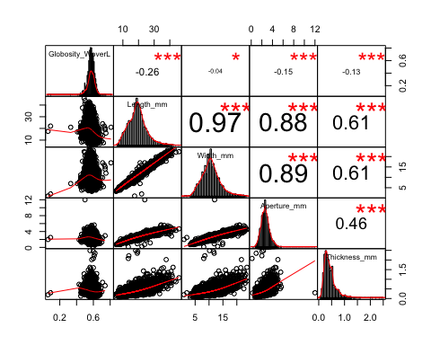

###### Data structure ######  
  
  
###### Clean-up ######  
# Subset for shells without aperture / thickness (iNat will be included)  
Raw_globoshells = subset(Raw, is.na(Raw$Thickness_mm))  
Raw_iNat = subset(Raw, Raw$Collection=="iNat") # 99 specifically from iNat  
  
# Filter outliers (min and max values identified by viewing Raw)  
# Confirmed outliers from operator error (measuring or datasheet input)  
Clean_OutliersRemoved = Raw %>% # 2996 obs   
 filter(Thickness_mm < 2) %>% # low thickness  
 filter(!(Width_mm < 15 & Thickness_mm > 2)) %>% # too thick for width  
 filter(Aperture_mm < 6) %>% # small aperture  
 filter(!(Length_mm > 20 & Aperture_mm <2)) %>% # aperture too small for length  
 rbind(Raw_globoshells) %>% # adds 775 shells back in *length that's above the threshold?  
 filter(Width_mm > 2) %>% # too narrow (note this gets rid of iNat)  
 rbind(Raw_iNat) %>% # add iNat back in  
 filter(Globosity_WoverL > 0.42 & Globosity_WoverL < 0.71 ) %>%   
 data.frame # ensure it's a data frame  
# Remove 25 shells from Pliocene (too old, few)  
Clean_OutliersRemoved=subset(Clean_OutliersRemoved, !Epoch=="Pliocene")  
  
# 50 shells of original 2996 removed (2946 obs)  
length(Raw %>% filter(Thickness_mm >= 2) %>% .$Specimen_Number)

## [1] 6

paste(length(Raw$Specimen_Number)-length(Clean_OutliersRemoved$Specimen_Number), "removed of", length(Raw$Specimen_Number), "shells")

## [1] "50 removed of 2996 shells"

# Ensure updated Clean dataset has 3 or more specimens per lot  
Clean = Clean_OutliersRemoved %>%   
 group_by(Lot_Number) %>%   
 mutate(Specimens_per_Lot = length((Lot_Number))) %>%  
 ungroup %>%   
 filter(Specimens_per_Lot > 2 | Collection == "iNat") # keep catalogs with > 2 in lot and iNat (1 per 'lot')  
  
# 61 shells of original 2996 removed, 11 from Clean_OutliersRemoved (2935 obs)  
paste(length(Raw$Specimen_Number)-length(Clean$Specimen_Number), "removed of", length(Raw$Specimen_Number), "shells")

## [1] "61 removed of 2996 shells"

# Validation check for NA values for final data set  
cat("\n\n",  
 sum(is.na(Clean$Globosity_WoverL)), "have no globosity ratio,\n", # 0  
 sum(is.na(Clean$Width_mm)), "have no width measurement,\n", # 99 [iNat]  
 sum(is.na(Clean$Length_mm)), "have no length measurement,\n", # 99 [iNat]  
 sum(is.na(Clean$Thickness_mm)), "have no thickness measurement,\n", # 742 = 99 [iNat] + 338 PR + 273 Pleisto  
 sum(is.na(Clean$Aperture_mm)), "have no aperture measurement" ) # 742 = 99 [iNat] + 338 PR + 273 Pleisto

##   
##   
## 0 have no globosity ratio,  
## 99 have no width measurement,  
## 99 have no length measurement,  
## 742 have no thickness measurement,  
## 742 have no aperture measurement

# Order the data  
Clean %>% group_by(Lot_Number) %>% summarise(N = length(Specimen_Number))

## # A tibble: 379 x 2  
## Lot_Number N  
## <fct> <int>  
## 1 1 atm Gland 5  
## 2 100 PSI Gland 5  
## 3 100023 10  
## 4 10032.43 4  
## 5 10035.15 3  
## 6 10130.21 31  
## 7 10167.44 8  
## 8 10307939 1  
## 9 10341412 1  
## 10 105150 10  
## # … with 369 more rows

Clean %>% group_by(Epoch) %>% summarise(N = length(Specimen_Number))

## # A tibble: 3 x 2  
## Epoch N  
## <fct> <int>  
## 1 Anthropocene 1492  
## 2 Holocene 1138  
## 3 Pleistocene 305

# Re-do of correlation chart  
chart.Correlation(Clean %>% select(morphos)) # much improved

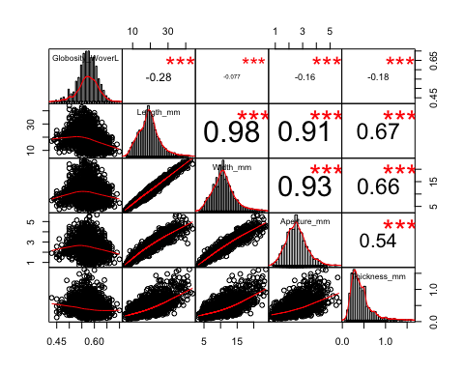

# Parameters for SoCal points  
counties = c("Sonoma", "San Mateo", "Monterey", "San Luis Obispo", "Santa Barbara", "Ventura", "Los Angeles", "Orange", "San Diego", "Baja California")  
Raw$County = factor(Raw$County, levels=counties) # order counties  
  
socal = c("Santa Barbara", "Ventura", "Los Angeles", "Orange", "San Diego")  
Clean_SoCal = Clean %>% filter(County %in% socal) # 2597 obs for SoCal   
  
socal_locations = c("SB", "NLA", "LA", "SLA", "SD", "ANA", "SCZI", "SRI", "SMI", "CAT", "SBI", "SNI", "SCI") # socal location order  
Clean_SoCal$Location = factor(Clean_SoCal$Location, levels=socal_locations) # order   
  
# Distribution of shells by county  
Clean_SoCal %>% group_by(County) %>% summarise(N = length(Epoch)) %>% data.frame

## County N  
## 1 Los Angeles 1363  
## 2 Orange 280  
## 3 San Diego 526  
## 4 Santa Barbara 345  
## 5 Ventura 83

# Check correlation for SoCal subset  
chart.Correlation(Clean_SoCal %>% select(morphos)) # Also looks good

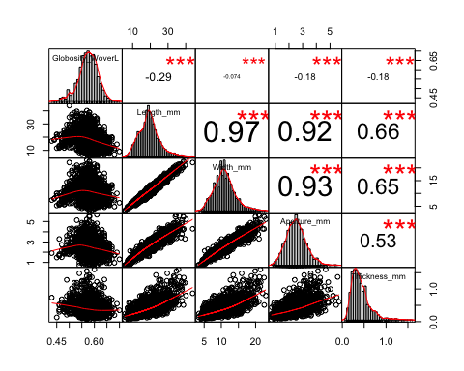

###### Clean-up ######  
  
  
###### Save cleaned-up data for downstream visualization and analysis ######  
  
# Data structure for Clean and SoCal subset  
sort(unique(Clean$Collection)) # Unique collections: 9

## [1] ANSP CAS iNat LACM-M LACM-M-IP MCZ PR   
## [8] SBNHM SIO   
## Levels: ANSP CAS iNat LACM-M LACM-M-IP MCZ PR SBNHM SIO

sort(unique(Clean$Catalog)) # Unique lots: 379

## Warning: Unknown or uninitialised column: 'Catalog'.

## NULL

sort(unique(Clean$County)) # Unique counties: 10

## [1] Baja California Los Angeles Monterey Orange   
## [5] San Diego San Luis Obispo San Mateo Santa Barbara   
## [9] Sonoma Ventura   
## 10 Levels: Baja California Los Angeles Monterey Orange ... Ventura

sort(unique(Clean$Location)) # Unique locations: 20

## [1] ANA BS CAT LA MB MO NBC NLA SB SBC SBI SCI SCZI SD   
## [15] SLA SM SMI SNI SO SRI   
## 20 Levels: ANA BS CAT LA MB MO NBC NLA SB SBC SBI SCI SCZI SD SLA ... SRI

sort(unique(Clean$Land_Category)) # Unique location types: 3

## [1] Coastal Island Open   
## Levels: Coastal Island Open

sort(unique(Clean$Habitat)) # Unique habitats: 4

## [1] algae forest gravel   
## [3] rocky reef or intertidal sand   
## Levels: algae forest gravel rocky reef or intertidal sand

sort(unique(Clean$Depth)) # Unique depths: 3

## [1] deep intertidal subtidal   
## Levels: deep intertidal subtidal

sort(unique(Clean_SoCal$Collection)) # Unique collections: 9

## [1] ANSP CAS iNat LACM-M LACM-M-IP MCZ PR   
## [8] SBNHM SIO   
## Levels: ANSP CAS iNat LACM-M LACM-M-IP MCZ PR SBNHM SIO

sort(unique(Clean_SoCal$Catalog)) # Unique lots: 333

## Warning: Unknown or uninitialised column: 'Catalog'.

## NULL

sort(unique(Clean_SoCal$County)) # Unique counties: 5

## [1] Los Angeles Orange San Diego Santa Barbara Ventura   
## 10 Levels: Baja California Los Angeles Monterey Orange ... Ventura

sort(unique(Clean_SoCal$Location)) # Unique locations: 13

## [1] SB NLA LA SLA SD ANA SCZI SRI SMI CAT SBI SNI SCI   
## Levels: SB NLA LA SLA SD ANA SCZI SRI SMI CAT SBI SNI SCI

write.csv(Clean, file = "SupplementalTable3_Data-Clean.csv")  
write.csv(Clean_SoCal, file = "SupplementalTable4_Data-SoCal.csv")   
# Validation check   
Clean <- read.csv(text=getURL("https://raw.githubusercontent.com/MichaelMalloy/C_californicus_Morphology/master/SupplementalTable3_Data-Clean.csv"))   
Clean_SoCal <- read.csv(text=getURL("https://raw.githubusercontent.com/MichaelMalloy/C_californicus_Morphology/master/SupplementalTable4_Data-SoCal.csv"))   
  
###### Save cleaned-up data for downstream visualization and analysis ######

Figure 1a-b: Maps of shell locations (Clean and SoCal Data)

# install.packages("ggplot2")  
library("ggplot2")  
# packageVersion("ggplot2") # v3.1.0.9000  
# devtools::install_github("dkahle/ggmap")   
library("ggmap")

## Google's Terms of Service: https://cloud.google.com/maps-platform/terms/.

## Please cite ggmap if you use it! See citation("ggmap") for details.

# packageVersion("ggmap") # v3.0.0.900  
# install.packages("rgdal")  
library("rgdal")

## Loading required package: sp

## rgdal: version: 1.3-6, (SVN revision 773)  
## Geospatial Data Abstraction Library extensions to R successfully loaded  
## Loaded GDAL runtime: GDAL 2.1.3, released 2017/20/01  
## Path to GDAL shared files: /Library/Frameworks/R.framework/Versions/3.5/Resources/library/rgdal/gdal  
## GDAL binary built with GEOS: FALSE   
## Loaded PROJ.4 runtime: Rel. 4.9.3, 15 August 2016, [PJ_VERSION: 493]  
## Path to PROJ.4 shared files: /Library/Frameworks/R.framework/Versions/3.5/Resources/library/rgdal/proj  
## Linking to sp version: 1.3-1

# packageVersion("rgdal") # v1.3.6  
  
# This code is personalized by account and only runs if you have a key  
# Instructions:https://github.com/dkahle/ggmap  
# Visit your personal Google Maps Platform to retrieve key if you have one  
# ggmap::register_google(key = " ")   
  
# Create parameters and background maps for Clean and Clean_SoCal  
# Parameters for All points  
# Subset data by Epoch to color code points  
Anthro = subset(Clean, Epoch=="Anthropocene") # 1492  
Holo = subset(Clean, Epoch=="Holocene") # 1138  
Pleisto = subset(Clean, Epoch=="Pleistocene") # 305  
  
All_bbox <- make_bbox(lat = Latitude, lon = Longitude, data = Clean)  
All_bbox

## left bottom right top   
## -122.9015 25.8435 -114.7285 38.7465

# left bottom right top   
# -122.9015 25.8435 -114.7285 38.7465   
  
# Load polygons for ecoregions and call them after downloaded in your folder  
# shape files from http://www.marineregions.org/  
NC_poly=readOGR( "northern_ecoregions" , layer="ecoregions")

## OGR data source with driver: ESRI Shapefile   
## Source: "/Users/sul-hasan/Desktop/Manuscripts_Done-or-Submitted/Morphology_JofMolluscanStudies/Apr9-2019/northern_ecoregions", layer: "ecoregions"  
## with 1 features  
## It has 6 fields

SCB_poly=readOGR( "southern_ecoregions" , layer="ecoregions")

## OGR data source with driver: ESRI Shapefile   
## Source: "/Users/sul-hasan/Desktop/Manuscripts_Done-or-Submitted/Morphology_JofMolluscanStudies/Apr9-2019/southern_ecoregions", layer: "ecoregions"  
## with 1 features  
## It has 6 fields

MT_poly=readOGR( "magdaelena_ecoregions" , layer="ecoregions")

## OGR data source with driver: ESRI Shapefile   
## Source: "/Users/sul-hasan/Desktop/Manuscripts_Done-or-Submitted/Morphology_JofMolluscanStudies/Apr9-2019/magdaelena_ecoregions", layer: "ecoregions"  
## with 1 features  
## It has 6 fields

All=get_map(location=c(-125,20,-105,40), # adjust to include regions  
 zoom = 5,   
 maptype = "terrain")

## Bounding box given to Google - spatial extent only approximate.

## Source : https://maps.googleapis.com/maps/api/staticmap?center=30,-115&zoom=5&size=640x640&scale=2&maptype=terrain&language=en-EN&key=xxx-y1EWLUZ90AD0k6wTMZk

SoCal_bbox = make_bbox(lat = Latitude, lon = Longitude, data = Clean_SoCal)  
SoCal_bbox

## left bottom right top   
## -120.6685 32.4635 -116.9615 34.5865

# left bottom right top   
# -120.6695 32.4425 -116.9405 34.5875   
  
SoCal=get_map(location=c(-121,32,-116.5,35),   
 zoom = 7,   
 maptype = "terrain")

## Bounding box given to Google - spatial extent only approximate.

## Source : https://maps.googleapis.com/maps/api/staticmap?center=33.5,-118.75&zoom=7&size=640x640&scale=2&maptype=terrain&language=en-EN&key=xxx-y1EWLUZ90AD0k6wTMZk

# Figure 1a  
SoCal_box = data.frame(x=c(-121,-121,-116.5,-116.5,-121),   
 y=c(35,32,32,35,35)) # create box for zoom of SoCal  
  
Clean_map = ggmap(All) +  
 geom_polygon(data = NC_poly, aes(x = long, y = lat),  
 fill = "white", alpha = 0.5) + # white  
 geom_polygon(data = SCB_poly, aes(x = long, y = lat),  
 fill = "blue", alpha = 0.3) + # blue  
 geom_polygon(data = MT_poly, aes(x = long, y = lat),  
 fill = "#666666", alpha = 0.5) + # grey  
 stat_density_2d(data = Clean, # density  
 aes(x = Longitude,  
 y = Latitude,  
 fill = stat(level)),  
 alpha = .25,  
 bins = 250,  
 geom = "polygon") +  
 scale_fill_gradientn(colors = "black") + # color fill, orange  
 geom_point(data = Anthro, aes(x = Longitude, y = Latitude),   
 color = "#FC4E07",  
 size = 1) + # aqua  
 geom_point(data = Holo, aes(x = Longitude,y = Latitude),   
 color = "#E7B800",   
 size = 1) + # seagreen  
 geom_point(data = Pleisto, aes(x = Longitude, y = Latitude),   
 color = "#00AFBB",  
 size = 1) + # blue   
 geom_path(data=SoCal_box, aes(x,y), color="black", lwd=1) + # insert box  
 labs(x="Longitude", y="Latitude")

## Regions defined for each Polygons

## Regions defined for each Polygons  
## Regions defined for each Polygons

Clean_map

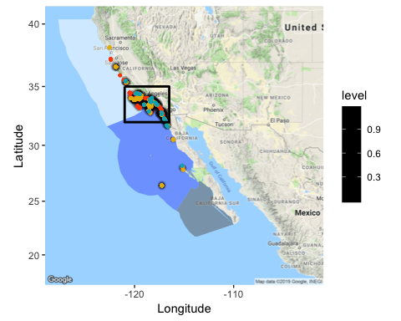

ggsave("Figure1a_Data-Clean_Map.png", dpi = 800)

## Saving 5 x 4 in image

# Figure 1b  
Anthro_SoCal = subset(Clean_SoCal, Epoch=="Anthropocene") # 1366  
Holo_SoCal = subset(Clean_SoCal, Epoch=="Holocene") # 1020  
Pleisto_SoCal = subset(Clean_SoCal, Epoch=="Pleistocene") # 211  
  
CleanSoCal_map = ggmap(SoCal) +  
 geom_polygon(data = NC_poly, aes(x = long, y = lat),  
 fill = "white", alpha = 0.5) + # white  
 geom_polygon(data = SCB_poly, aes(x = long, y = lat),  
 fill = "blue", alpha = 0.3) + # blue  
 stat_density_2d(data = Clean_SoCal, # density  
 aes(x = Longitude,  
 y = Latitude,  
 fill = stat(level)),  
 alpha = .35,  
 bins = 250,  
 geom = "polygon") +  
 scale_fill_gradientn(colors = "black") + # color fill, orange  
 geom_point(data = Anthro_SoCal, aes(x = Longitude, y = Latitude),   
 color = "#FC4E07",  
 size = 2) +   
 geom_point(data = Holo_SoCal, aes(x = Longitude,y = Latitude),   
 color = "#E7B800",   
 size = 2) +   
 geom_point(data = Pleisto_SoCal, aes(x = Longitude, y = Latitude),   
 color = "#00AFBB",  
 size = 2) +   
 geom_path(data=SoCal_box, aes(x,y), color="black", lwd=1) + # insert box  
 labs(x="Longitude", y="Latitude")

## Regions defined for each Polygons  
## Regions defined for each Polygons

CleanSoCal_map

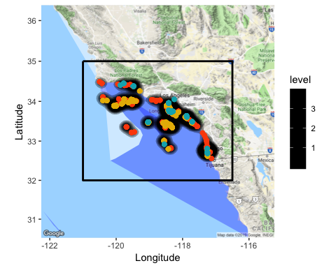

ggsave("Figure1b_Data-Clean-SoCal_Map.png", dpi = 800)

## Saving 5 x 4 in image

Figure 2b: Allometry - shell shape vs size (Clean)

# install.packages("GGally")  
library(GGally)

##   
## Attaching package: 'GGally'

## The following object is masked from 'package:dplyr':  
##   
## nasa

# packageVersion("GGally") # v1.4.0  
# install.packages("ggplot2")  
library(ggplot2)  
# packageVersion("ggplot2") # v3.1.0  
  
# Create a function for including linear regression line  
my_fn <- function(data, mapping, ...){  
 p <- ggplot(data = data, mapping = mapping) +   
 geom_point() +   
 geom_smooth(method=lm, color="black", ...)   
 p  
}  
  
# Subset data  
Fig2 = Clean[,c("Epoch", "Globosity_WoverL", "Length_mm", "Width_mm", "Mean_SST")]   
# Rename columns  
names(Fig2) = c("Epoch", "Globosity", "Length", "Width", "Mean SST")   
# Create figure (automatically excludes NAs)  
Fig2_chart = ggpairs(Fig2, aes(color = Epoch, alpha = 0.85), lower = list(continuous = my_fn), upper = list(continuous = wrap("cor", size = 4.25)))  
# Change colors manually with a loop through each plot  
for(i in 1:Fig2_chart$nrow) {  
 for(j in 1:Fig2_chart$ncol){  
 Fig2_chart[i,j] <- Fig2_chart[i,j] +   
 scale_fill_manual(values=c("#FC4E07", "#E7B800", "#00AFBB")) +  
 scale_color_manual(values=c("#FC4E07", "#E7B800", "#00AFBB"))   
 }  
}

## Warning in (function (data, mapping, alignPercent = 0.6, method =  
## "pearson", : Removed 99 rows containing missing values

## Warning in (function (data, mapping, alignPercent = 0.6, method =  
## "pearson", : Removed 99 rows containing missing values

## Warning in (function (data, mapping, alignPercent = 0.6, method =  
## "pearson", : Removed 99 rows containing missing values

## Warning in (function (data, mapping, alignPercent = 0.6, method =  
## "pearson", : Removed 99 rows containing missing values

## Warning in (function (data, mapping, alignPercent = 0.6, method =  
## "pearson", : Removed 99 rows containing missing values

Fig2_chart +   
 theme_classic() # theme for figure

## Warning: Removed 99 rows containing non-finite values (stat_boxplot).

## Warning: Removed 99 rows containing non-finite values (stat_boxplot).

## `stat_bin()` using `bins = 30`. Pick better value with `binwidth`.

## `stat_bin()` using `bins = 30`. Pick better value with `binwidth`.

## Warning: Removed 99 rows containing non-finite values (stat_bin).

## Warning: Removed 99 rows containing non-finite values (stat_smooth).

## Warning: Removed 99 rows containing missing values (geom_point).

## Warning: Removed 99 rows containing non-finite values (stat_density).

## `stat_bin()` using `bins = 30`. Pick better value with `binwidth`.

## Warning: Removed 99 rows containing non-finite values (stat_bin).

## Warning: Removed 99 rows containing non-finite values (stat_smooth).

## Warning: Removed 99 rows containing missing values (geom_point).

## Warning: Removed 99 rows containing non-finite values (stat_smooth).

## Warning: Removed 99 rows containing missing values (geom_point).

## Warning: Removed 99 rows containing non-finite values (stat_density).

## `stat_bin()` using `bins = 30`. Pick better value with `binwidth`.

## Warning: Removed 99 rows containing non-finite values (stat_smooth).

## Warning: Removed 99 rows containing missing values (geom_point).

## Warning: Removed 99 rows containing non-finite values (stat_smooth).

## Warning: Removed 99 rows containing missing values (geom_point).

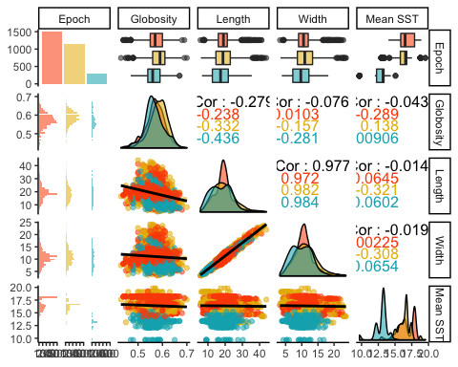

ggsave("Figure2b_Data-Clean_Shell-Allometry.png", dpi = 800)

## Saving 5 x 4 in image

## Warning: Removed 99 rows containing non-finite values (stat_boxplot).

## Warning: Removed 99 rows containing non-finite values (stat_boxplot).

## `stat_bin()` using `bins = 30`. Pick better value with `binwidth`.  
## `stat_bin()` using `bins = 30`. Pick better value with `binwidth`.

## Warning: Removed 99 rows containing non-finite values (stat_bin).

## Warning: Removed 99 rows containing non-finite values (stat_smooth).

## Warning: Removed 99 rows containing missing values (geom_point).

## Warning: Removed 99 rows containing non-finite values (stat_density).

## `stat_bin()` using `bins = 30`. Pick better value with `binwidth`.

## Warning: Removed 99 rows containing non-finite values (stat_bin).

## Warning: Removed 99 rows containing non-finite values (stat_smooth).

## Warning: Removed 99 rows containing missing values (geom_point).

## Warning: Removed 99 rows containing non-finite values (stat_smooth).

## Warning: Removed 99 rows containing missing values (geom_point).

## Warning: Removed 99 rows containing non-finite values (stat_density).

## `stat_bin()` using `bins = 30`. Pick better value with `binwidth`.

## Warning: Removed 99 rows containing non-finite values (stat_smooth).

## Warning: Removed 99 rows containing missing values (geom_point).

## Warning: Removed 99 rows containing non-finite values (stat_smooth).

## Warning: Removed 99 rows containing missing values (geom_point).

# Length = Width, globosity independent of length and width  
# size = length=width, aperture and thickness are neglible as dependent on size (see categories)  
# shape = globosity

Supplemental Figure 1: Cc shell morphology ~ batch effect (Clean)

SuppFig1 = Clean[,c("Collection", "Lot_Number", "Specimens_per_Lot", "Collector", "Globosity_WoverL", "Length_mm", "Width_mm", "Aperture_mm", "Thickness_mm", "Epoch")]   
# Rename columns  
names(SuppFig1) = c("Coll", "Lot", "Specimens", "Collector", "Globosity", "Length", "Width", "Aperture", "Thickness", "Epoch")   
  
# Assign variables as numeric such that they are viewed as continuous  
SuppFig1 = transform(SuppFig1,   
 Coll = as.numeric(Coll),   
 Lot = as.numeric(Lot),  
 Specimens = as.numeric(Specimens),  
 Collector = as.numeric(Collector),  
 Globosity = as.numeric(Globosity),  
 Length = as.numeric(Length),  
 Width = as.numeric(Width),  
 Aperture = as.numeric(Aperture),  
 Thickness = as.numeric(Thickness),   
 Epoch = as.numeric(Epoch))  
  
SuppFig1 = ggcorr(SuppFig1, geom = "blank", label = TRUE, hjust = 0.75, size = 3) +  
 geom_point(size = 10, aes(color = coefficient > 0, alpha = abs(coefficient) > 0.5)) +  
 scale_alpha_manual(values = c("TRUE" = 0.25, "FALSE" = 0)) +  
 guides(color = FALSE, alpha = FALSE)  
SuppFig1

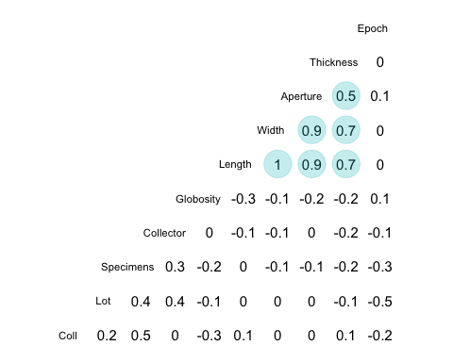

ggsave("SupplementalFigure1_Clean-Data_Batch-Effect.png", dpi = 800)

## Saving 5 x 4 in image

Figure 3: Relationship between shell morphology and temperature (Clean)

Clean_Length = Clean[!is.na(Clean$Length_mm), ] # remove rows with NAs [iNat]  
Clean_Shape = Clean[!is.na(Clean$Globosity_WoverL), ]  
  
################################################  
# STATISTICS  
### Distribution of data  
hist(Clean_Length$Length_mm) # fairly normal

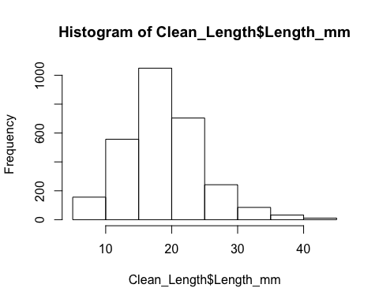

hist(Clean_Length$Mean_SST) # slightly skewed

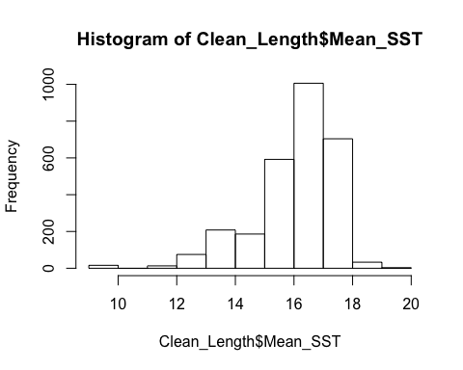

### Parametric (assumes normality)  
# linear model (1st order polynomial)? No  
x = lm(Length_mm~Mean_SST, Clean_Length)  
shapiro.test(residuals(x)) # W = 0.97431, p-value < 2.2e-16

##   
## Shapiro-Wilk normality test  
##   
## data: residuals(x)  
## W = 0.97431, p-value < 2.2e-16

# p needs to be over 0.05  
plot(x) # shows residuals, qqplot not great

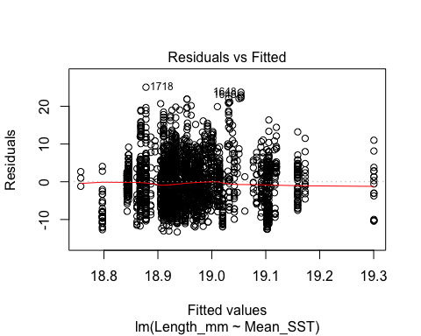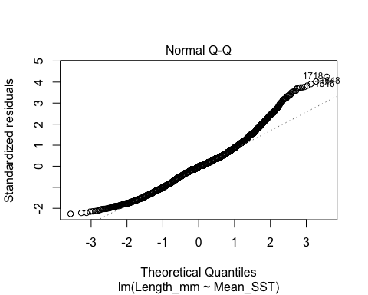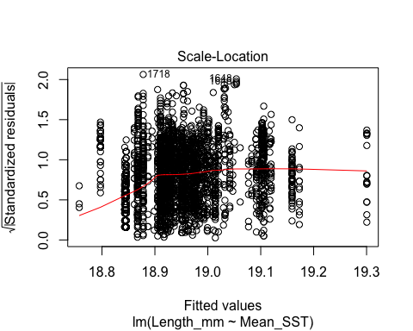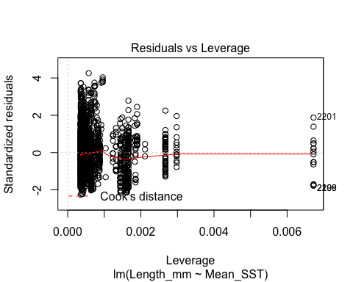

# nonlinear models  
# logarithmic model? No (about the same as before)  
ya = lm(Length_mm~log(Mean_SST), Clean_Length) # log transform   
shapiro.test(residuals(ya)) # W = 0.9742, p-value < 2.2e-16

##   
## Shapiro-Wilk normality test  
##   
## data: residuals(ya)  
## W = 0.9742, p-value < 2.2e-16

plot(ya)

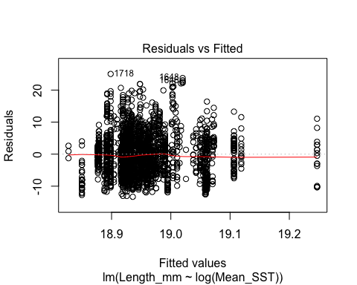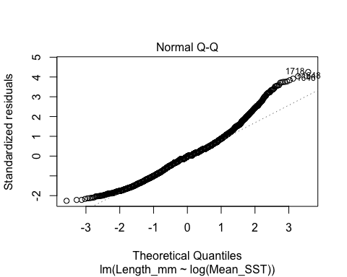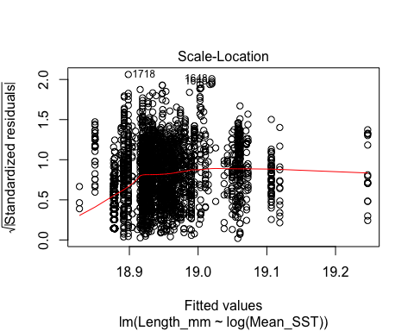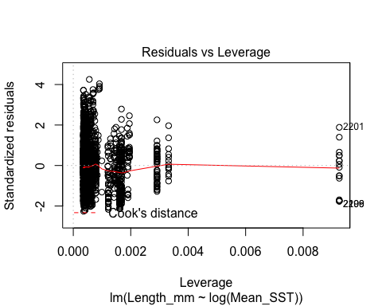

# log-log model? No (looks decent)  
yb = lm(log(Length_mm)~log(Mean_SST), Clean_Length)   
shapiro.test(residuals(yb)) # W = 0.98499, p-value < 2.2e-16

##   
## Shapiro-Wilk normality test  
##   
## data: residuals(yb)  
## W = 0.98499, p-value < 2.2e-16

plot(yb)

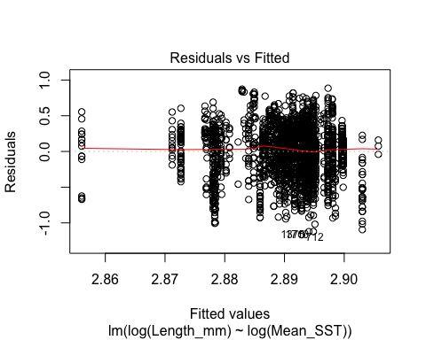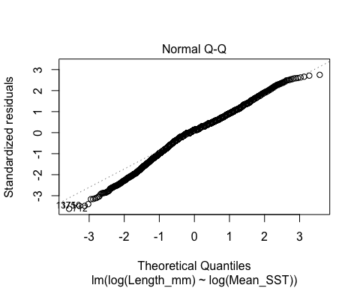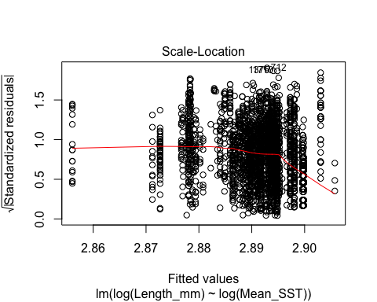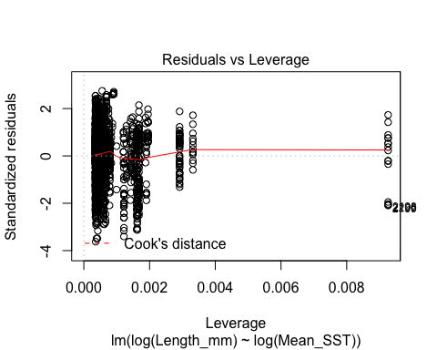

# 2nd order polynomial model? No  
z = lm(Length_mm~poly(Mean_SST,2), Clean_Length)  
shapiro.test(residuals(z)) # W = 0.97539, p-value < 2.2e-16

##   
## Shapiro-Wilk normality test  
##   
## data: residuals(z)  
## W = 0.97539, p-value < 2.2e-16

plot(z)

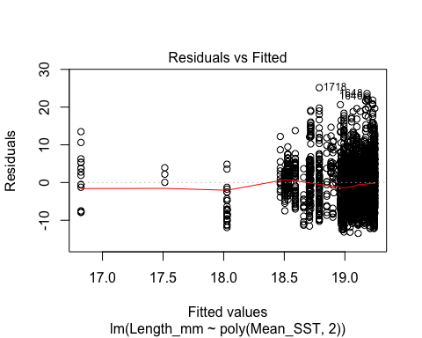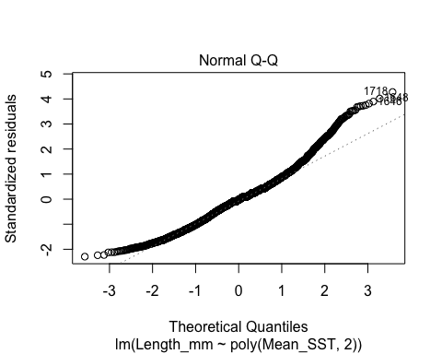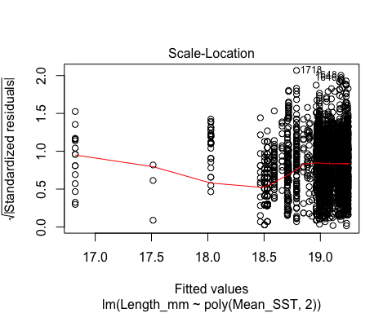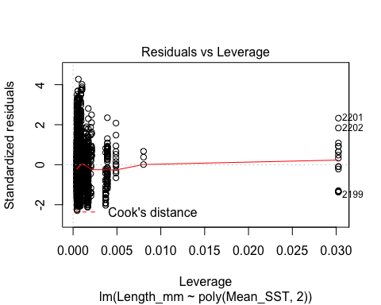

summary(x) # r^2 = -0.0001501

##   
## Call:  
## lm(formula = Length_mm ~ Mean_SST, data = Clean_Length)  
##   
## Residuals:  
## Min 1Q Median 3Q Max   
## -13.3159 -3.9427 -0.1087 3.0693 25.0521   
##   
## Coefficients:  
## Estimate Std. Error t value Pr(>|t|)   
## (Intercept) 19.83457 1.17968 16.814 <2e-16 ***  
## Mean_SST -0.05518 0.07280 -0.758 0.449   
## ---  
## Signif. codes: 0 '***' 0.001 '**' 0.01 '*' 0.05 '.' 0.1 ' ' 1  
##   
## Residual standard error: 5.887 on 2834 degrees of freedom  
## Multiple R-squared: 0.0002027, Adjusted R-squared: -0.0001501   
## F-statistic: 0.5746 on 1 and 2834 DF, p-value: 0.4485

summary(ya) # r^2 = -0.0002482

##   
## Call:  
## lm(formula = Length_mm ~ log(Mean_SST), data = Clean_Length)  
##   
## Residuals:  
## Min 1Q Median 3Q Max   
## -13.3158 -3.9325 -0.1142 3.0661 25.0316   
##   
## Coefficients:  
## Estimate Std. Error t value Pr(>|t|)   
## (Intercept) 20.6037 3.0501 6.755 1.73e-11 ***  
## log(Mean_SST) -0.5978 1.0980 -0.544 0.586   
## ---  
## Signif. codes: 0 '***' 0.001 '**' 0.01 '*' 0.05 '.' 0.1 ' ' 1  
##   
## Residual standard error: 5.887 on 2834 degrees of freedom  
## Multiple R-squared: 0.0001046, Adjusted R-squared: -0.0002483   
## F-statistic: 0.2964 on 1 and 2834 DF, p-value: 0.5862

summary(yb) # r^2 = 0.0001369

##   
## Call:  
## lm(formula = log(Length_mm) ~ log(Mean_SST), data = Clean_Length)  
##   
## Residuals:  
## Min 1Q Median 3Q Max   
## -1.1665 -0.1836 0.0433 0.1956 0.8853   
##   
## Coefficients:  
## Estimate Std. Error t value Pr(>|t|)   
## (Intercept) 2.69542 0.16684 16.156 <2e-16 ***  
## log(Mean_SST) 0.07076 0.06006 1.178 0.239   
## ---  
## Signif. codes: 0 '***' 0.001 '**' 0.01 '*' 0.05 '.' 0.1 ' ' 1  
##   
## Residual standard error: 0.322 on 2834 degrees of freedom  
## Multiple R-squared: 0.0004896, Adjusted R-squared: 0.0001369   
## F-statistic: 1.388 on 1 and 2834 DF, p-value: 0.2388

summary(z) # r^2 = 0.002156 (best, but not by a lot...)

##   
## Call:  
## lm(formula = Length_mm ~ poly(Mean_SST, 2), data = Clean_Length)  
##   
## Residuals:  
## Min 1Q Median 3Q Max   
## -13.4895 -4.0518 -0.1517 3.0831 25.1416   
##   
## Coefficients:  
## Estimate Std. Error t value Pr(>|t|)   
## (Intercept) 18.9443 0.1104 171.571 < 2e-16 ***  
## poly(Mean_SST, 2)1 -4.4623 5.8802 -0.759 0.44799   
## poly(Mean_SST, 2)2 -16.1555 5.8802 -2.747 0.00604 **   
## ---  
## Signif. codes: 0 '***' 0.001 '**' 0.01 '*' 0.05 '.' 0.1 ' ' 1  
##   
## Residual standard error: 5.88 on 2833 degrees of freedom  
## Multiple R-squared: 0.00286, Adjusted R-squared: 0.002156   
## F-statistic: 4.062 on 2 and 2833 DF, p-value: 0.01731

# 2nd order (z) didn't pass Shapiro's test (log-log), qqplots look bad  
  
### Non-parametric (assumes non-normal, but weaker statistic)  
cor.test(Clean_Length$Length_mm, Clean_Length$Mean_SST, method = "spearman")

## Warning in cor.test.default(Clean_Length$Length_mm,  
## Clean_Length$Mean_SST, : Cannot compute exact p-value with ties

##   
## Spearman's rank correlation rho  
##   
## data: Clean_Length$Length_mm and Clean_Length$Mean_SST  
## S = 3.883e+09, p-value = 0.2544  
## alternative hypothesis: true rho is not equal to 0  
## sample estimates:  
## rho   
## -0.02140846

# S = 3885200000, p-value = 0.2418, rho = -0.02198427 ('r^2')  
# p value needs to be less than 0.05 to be significant  
# data is linear  
  
cor.test(Clean_Shape$Globosity_WoverL, Clean_Shape$Mean_SST, method = "spearman")

## Warning in cor.test.default(Clean_Shape$Globosity_WoverL,  
## Clean_Shape$Mean_SST, : Cannot compute exact p-value with ties

##   
## Spearman's rank correlation rho  
##   
## data: Clean_Shape$Globosity_WoverL and Clean_Shape$Mean_SST  
## S = 4451700000, p-value = 0.002214  
## alternative hypothesis: true rho is not equal to 0  
## sample estimates:  
## rho   
## -0.05646121

# S = 4451700000, p-value = 0.002214, rho = -0.05646121   
# data is not linear, but relationship to temperature is significant  
  
################################################  
  
locations = c("SM", "MB", "MO", "BS", "SO", "SB", "NLA", "LA", "SLA", "SD", "NBC", "SBC", "ANA","SCZI","SRI","SMI","SCI","SNI","SBI","CAT")  
# Coastal "SM", "MB", "MO", "BS", "SO", "SB", "NLA", "LA", "SLA", "SD", "NBC", "SBC"  
# Northern islands (marine sanctuary) "ANA","SCZI","SRI","SMI"  
# Southern islands "SCI","SNI","SBI","CAT"  
Clean$Location = factor(Clean$Location, levels=locations) # order locations  
  
Figure3a = ggplot(data = Clean,   
 aes(x = Latitude, y = Mean_SST,  
 color = Epoch)) +  
 scale_color_manual(values=c("#FC4E07", "#E7B800", "#00AFBB")) +  
 annotate("rect",ymin=-Inf,ymax=Inf,xmin=32.56,xmax=34.49, # adjust by transformation  
 alpha=0.3, fill="red") + # shade square  
 geom_point() +  
 geom_smooth() + # default of 95% confidence  
 geom_smooth(method = lm, color = "black") + # 95% confidence  
 theme(axis.line = element_line(colour = "black", size = 0.25)) +  
 labs(x="Latitude", y="Mean SST")  
Figure3a +  
 theme_classic()

## `geom_smooth()` using method = 'gam' and formula 'y ~ s(x, bs = "cs")'

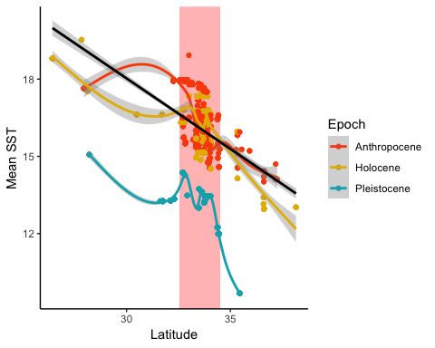

ggsave("Figure3a_Data-Clean_Latitude-MeanSST.png", dpi = 800)

## Saving 5 x 4 in image  
## `geom_smooth()` using method = 'gam' and formula 'y ~ s(x, bs = "cs")'

Figure3b = ggplot(data = Clean,   
 aes(x = Mean_SST, y = Globosity_WoverL,  
 color = Epoch)) +  
 scale_color_manual(values=c("#FC4E07", "#E7B800", "#00AFBB")) +  
 geom_point() +  
 geom_smooth() + # default of 95% confidence  
 geom_smooth(method = lm, color = "black") + # 95% confidence  
 theme(axis.line = element_line(colour = "black", size = 0.25)) +  
 labs(x="Mean SST", y="Shape")  
Figure3b +  
 theme_classic()

## `geom_smooth()` using method = 'gam' and formula 'y ~ s(x, bs = "cs")'

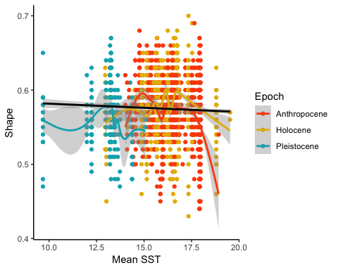

ggsave("Figure3b_Data-Clean_SST-Shape.png", dpi = 800)

## Saving 5 x 4 in image  
## `geom_smooth()` using method = 'gam' and formula 'y ~ s(x, bs = "cs")'

Figure3c = ggplot(data = Clean,   
 aes(x = Mean_SST, y = Length_mm,  
 color = Epoch)) +  
 scale_color_manual(values=c("#FC4E07", "#E7B800", "#00AFBB")) +  
 geom_point() +  
 geom_smooth() + # default of 95% confidence  
 geom_smooth(method = lm, color = "black") + # 95% confidence  
 theme(axis.line = element_line(colour = "black", size = 0.25)) +  
 labs(x="Mean SST", y="Size")  
Figure3c +  
 theme_classic()

## `geom_smooth()` using method = 'gam' and formula 'y ~ s(x, bs = "cs")'

## Warning: Removed 99 rows containing non-finite values (stat_smooth).

## Warning: Removed 99 rows containing non-finite values (stat_smooth).

## Warning: Removed 99 rows containing missing values (geom_point).

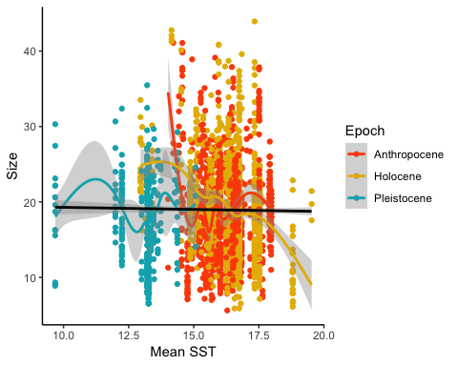

ggsave("Figure3c_Data-Clean_SST-Size.png", dpi = 800)

## Saving 5 x 4 in image  
## `geom_smooth()` using method = 'gam' and formula 'y ~ s(x, bs = "cs")'

## Warning: Removed 99 rows containing non-finite values (stat_smooth).

## Warning: Removed 99 rows containing non-finite values (stat_smooth).

## Warning: Removed 99 rows containing missing values (geom_point).

Figure 4: Relationship between shell morphology and other factors (SoCal)

# install.packages("corrr")  
library(corrr)

## Warning: package 'corrr' was built under R version 3.5.2

# packageVersion("corrr") # v0.3.1  
  
# Subset SoCal by Epoch  
Fig4a = Pleisto_SoCal[,c("Ecoregion", "Location", "Latitude", "Mean_SST", "Globosity_WoverL", "Length_mm")] # No Land Category, Decade, or Population  
Fig4b = Holo_SoCal[,c("Ecoregion", "Land_Category", "Location", "Latitude", "Decade", "Mean_SST", "Globosity_WoverL", "Length_mm", "Population_Density_NoBaja")]   
Fig4c = Anthro_SoCal[,c("Ecoregion", "Land_Category", "Location", "Latitude", "Decade", "Mean_SST", "Globosity_WoverL", "Length_mm", "Population_Density_NoBaja")]   
  
# Rename columns  
names(Fig4a) = c("Ecoregion", "Location", "Latitude", "SST", "Shape", "Size")   
names(Fig4b) = c("Ecoregion", "Landscape", "Location", "Latitude", "Decade", "SST", "Shape", "Size", "Humans")   
names(Fig4c) = c("Ecoregion", "Landscape", "Location", "Latitude", "Decade", "SST", "Shape", "Size", "Humans")   
  
# Assign variables as numeric such that they are viewed as continuous  
Fig4a_Pleisto = transform(Fig4a,   
 Ecoregion = as.numeric(Ecoregion),   
 Location = as.numeric(Location),  
 Latitude = as.numeric(Latitude),  
 SST = as.numeric(SST),  
 Shape = as.numeric(Shape),  
 Size = as.numeric(Size))  
Fig4b_Holo = transform(Fig4b,   
 Ecoregion = as.numeric(Ecoregion),   
 Landscape = as.numeric(Landscape),  
 Location = as.numeric(Location),  
 Latitude = as.numeric(Latitude),  
 Decade = as.numeric(Decade),  
 SST = as.numeric(SST),  
 Shape = as.numeric(Shape),  
 Size = as.numeric(Size),  
 Humans = as.numeric(Humans))  
Fig4c_Anthro = transform(Fig4c,   
 Ecoregion = as.numeric(Ecoregion),   
 Landscape = as.numeric(Landscape),  
 Location = as.numeric(Location),  
 Latitude = as.numeric(Latitude),  
 Decade = as.numeric(Decade),  
 SST = as.numeric(SST),  
 Shape = as.numeric(Shape),  
 Size = as.numeric(Size),  
 Humans = as.numeric(Humans))  
  
# Produce networks and supporting correlations  
Fig4a_Pleisto %>% correlate() %>% network_plot(min_cor=0.5)

##   
## Correlation method: 'pearson'  
## Missing treated using: 'pairwise.complete.obs'

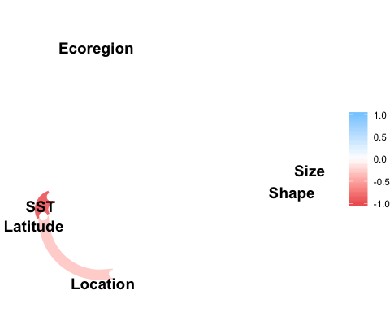

ggsave("Figure4ai_Clean_SoCal-Data_Pleistocene-Network.png", dpi = 800)

## Saving 5 x 4 in image

Fig4aii = ggcorr(Fig4a_Pleisto, geom = "blank", label = TRUE, hjust = 0.75, size = 3) +  
 geom_point(size = 10, aes(color = coefficient > 0, alpha = abs(coefficient) > 0.5)) +  
 scale_alpha_manual(values = c("TRUE" = 0.25, "FALSE" = 0)) +  
 guides(color = FALSE, alpha = FALSE)  
Fig4aii

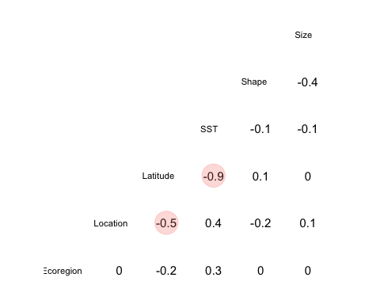

ggsave("Figure4aii_Clean_SoCal-Data_Pleistocene-Chart.png", dpi = 800)

## Saving 5 x 4 in image

Fig4b_Holo %>% correlate() %>% network_plot(min_cor=0.5)

##   
## Correlation method: 'pearson'  
## Missing treated using: 'pairwise.complete.obs'

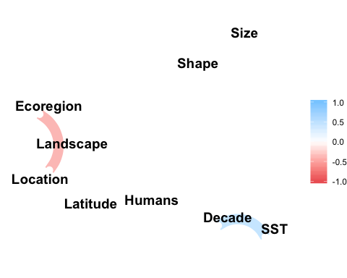

ggsave("Figure4bi_Clean_SoCal-Data_Holocene-Network.png", dpi = 800)

## Saving 5 x 4 in image

Fig4bii = ggcorr(Fig4b_Holo, geom = "blank", label = TRUE, hjust = 0.75, size = 3) +  
 geom_point(size = 10, aes(color = coefficient > 0, alpha = abs(coefficient) > 0.5)) +  
 scale_alpha_manual(values = c("TRUE" = 0.25, "FALSE" = 0)) +  
 guides(color = FALSE, alpha = FALSE)  
Fig4bii

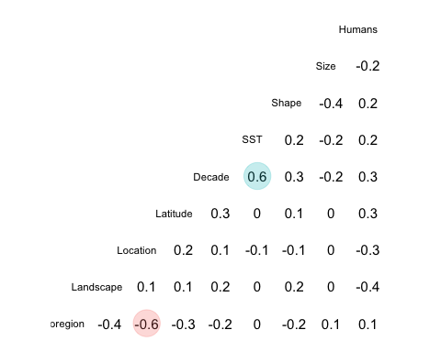

ggsave("Figure4bii_Clean_SoCal-Data_Holocene-Chart.png", dpi = 800)

## Saving 5 x 4 in image

Fig4c_Anthro %>% correlate() %>% network_plot(min_cor=0.5)

##   
## Correlation method: 'pearson'  
## Missing treated using: 'pairwise.complete.obs'

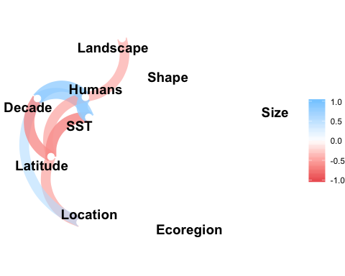

ggsave("Figure4ci_Clean_SoCal-Data_Anthropocene-Network.png", dpi = 800)

## Saving 5 x 4 in image

Fig4cii = ggcorr(Fig4c_Anthro, geom = "blank", label = TRUE, hjust = 0.75, size = 3) +  
 geom_point(size = 10, aes(color = coefficient > 0, alpha = abs(coefficient) > 0.5)) +  
 scale_alpha_manual(values = c("TRUE" = 0.25, "FALSE" = 0)) +  
 guides(color = FALSE, alpha = FALSE)  
Fig4cii

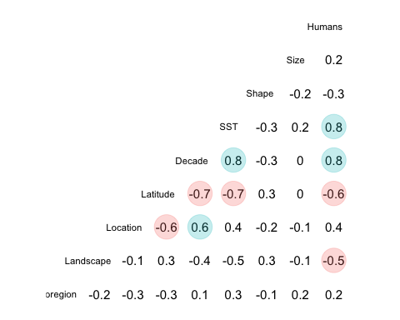

ggsave("Figure4cii_Clean_SoCal-Data_Anthropocene-Chart.png", dpi = 800)

## Saving 5 x 4 in image