SMC Print Relay (1.0.05)
Penetration Test
Retest Report

Inovalon, Inc.
V1.0
07/23/2026

Table Of Contents

Table Of Contents 1
EXECUTIVE SUMMARY 1
REMEDIATIONS VERIFIED 2
FINDINGS REMAINING 5
CONCLUSION 9
1. Token Introspection Does Not Verify Token Active State (Residual of Finding 1) - Low 6
7. End-of-Life and Outdated Components Processing Untrusted Input - Medium 7
9. Unsigned Application Binaries and Installer - Low 8
10. Over-Permissive HTTP URL ACL Reservation (Everyone) - Low 8
11. Local Persistence and Configuration Hygiene - Info 8

EXECUTIVE SUMMARY
Inovalon OST performed a remediation retest of SMC Print Relay following the penetration test documented in the original report (assessment conducted 06/10-14/2026). This retest evaluated installer build v1.0.0.7 (DesktopPrintRelayService.Host.exe, DesktopPrintRelayInstaller.msi, and setup.exe, dated 07/21/2026), compared against the originally assessed v1.0.05 (host binary v1.0.0.5). The retest was conducted on 07/23/2026.
As in the original engagement, all verification was performed statically against the application binary. The MSI payload was extracted, the host assembly was decompiled from IL, Authenticode signatures were verified, and the versions of the bundled components were inspected. Each of the eleven original findings was re-checked against the specific code or configuration pattern documented in its original write-up.
Of the eleven findings, six are fully remediated, two are partially remediated, and three remain open. Most importantly, the end-to-end remote attack chain formed by the four High-severity findings has been broken. The delivery vector (Finding 4, permissive CORS) and all three authentication bypasses (Findings 1, 2, and 3) are closed, so an unauthenticated web page can no longer drive the relay to print. Because the print, routing-map, and read endpoints now all require a validated token, the two Medium unauthenticated-access findings (5 and 6) and the SSRF (Finding 8) are closed as well.
RETEST STATUS SUMMARY
Finding | Original Severity | Retest Status
1. Authentication Bypass via Attacker-Controlled Token Introspection URL | High | Partially Fixed
2. Authentication Bypass via Attacker-Controlled OpenID Connect Discovery (B2C Validation Path) | High | Fixed
3. Missing Authorization on the PrintPdf Endpoint | High | Fixed
4. Overly Permissive CORS Policy Enabling Cross-Site Exploitation | High | Fixed
5. Unauthenticated Modification of the Print-Routing Map | Medium | Fixed
6. Unauthenticated Information Disclosure via Printer Enumeration | Medium | Fixed
7. End-of-Life and Outdated Components Processing Untrusted Input | Medium | Partially Fixed
8. Constrained Server-Side Request Forgery via X-ProviderValidationUrl | Low | Fixed
9. Unsigned Application Binaries and Installer | Low | Not Fixed
10. Over-Permissive HTTP URL ACL Reservation (Everyone) | Low | Not Fixed
11. Local Persistence and Configuration Hygiene | Info | Not Fixed
REMAINING RISK
After remediation the residual risk is limited to lower-severity items. None of them, individually, permits an unauthenticated remote attacker to print or to read data cross-origin. The remaining severity tally is:
Critical: 0
High: 0
Medium: 1
Low: 3
Informational: 1

REMEDIATIONS VERIFIED
The following remediations were confirmed present in the v1.0.0.7 application binary. Findings marked Partially Fixed have a residual item carried forward to “Findings Remaining.”
FINDING 1 — ATTACKER-CONTROLLED TOKEN INTROSPECTION URL (PARTIALLY FIXED)
Remediation applied: the service now validates the provider URL before use. A new IsProviderUrlTrusted() method requires the URL to be HTTPS and its host to appear in a hardcoded allowlist of Inovalon Okta hosts (inovalonone.okta.com and the oktapreview.com dev/qa/uat hosts). The original “any URL containing the substring okta” check no longer grants trust on its own, so a request whose X-ProviderValidationUrl points to an attacker-controlled host is rejected before any outbound call. Residual: the introspection response is still accepted on the absence of an error field rather than on active == true (see Findings Remaining).
Evidence — decompiled from the v1.0.0.7 binary:
// PrintController.IsUserTokenValid — now gated before any outbound call
if (!IsProviderUrlTrusted(providerValidationUrl))
return false; // reject attacker-supplied hosts
// PrintController.IsProviderUrlTrusted
if (!result.Scheme.Equals("https", StringComparison.OrdinalIgnoreCase))
return false;
string host = result.Host;
if (_allowedB2CProviderHosts.Contains(host)) return true;
if (_allowedOktaProviderHosts.Contains(host)) return true;
return false;
// Static allowlist (PrintController static constructor)
_allowedOktaProviderHosts = { "inovalonone.okta.com",
"inovalonone{dev,qa,uat}.oktapreview.com" };
FINDING 2 — ATTACKER-CONTROLLED OIDC DISCOVERY / B2C PATH (FIXED)
Remediation applied: the B2C validation path (IsB2CTokenValid) is now reachable only through the same IsProviderUrlTrusted() gate, which pins the discovery URL host to Inovalon B2C hosts (sso.inovalon.com and the dev/qa/uat equivalents). The attacker can no longer host the OpenID Connect discovery document or the signing keys used to validate the token, so a token signed with attacker-published keys is rejected.
Evidence — decompiled from the v1.0.0.7 binary:
// The B2C path is reached ONLY after the host-pinning gate:
if (!IsProviderUrlTrusted(providerValidationUrl)) // host must be a pinned Inovalon host
return false;
...
return await IsB2CTokenValid(providerValidationUrl, accessToken, clientSecretJwt);
// Static allowlist (PrintController static constructor)
_allowedB2CProviderHosts = { "sso.inovalon.com", "sso-dev.inovalon.com",
"sso-qa.inovalon.com", "sso-uat.inovalon.com" };
FINDING 3 — MISSING AUTHORIZATION ON PRINTPDF (FIXED)
Remediation applied: PrintPdf now calls IsUserTokenValid() and returns HTTP 401 (“Authorization failed”) when validation fails, matching its sibling print endpoints. The previously unauthenticated /printers/{printDocType}/print/pdf path now enforces the same token validation as the other print endpoints.
Evidence — decompiled from the v1.0.0.7 binary:
// PrintController.PrintPdf (POST /printers/{printDocType}/print/pdf)
if (!(await IsUserTokenValid(providerValidationUrl, accessToken, clientSecretJwt)))
{
return new UnauthorizedObjectResult(new { message = "Authorization failed" });
}
// ...reached only with a valid token:
PdfPrinting.PrintPdf(content, printQueueName, documentName, 1, showPrintDialog);
FINDING 4 — OVERLY PERMISSIVE CORS POLICY (FIXED)
Remediation applied: the global CORS policy no longer calls AllowAnyOrigin() or AllowAnyHeader(). It now uses WithOrigins() against an explicit allowlist of Inovalon HTTPS origins together with a fixed set of allowed request headers. No wildcard-origin (AllowAnyOrigin/SetIsOriginAllowed) or AllowAnyHeader pattern remains, so cross-origin requests from sites outside the allowlist are not granted access.
Evidence — decompiled from the v1.0.0.7 binary:
// Startup.ConfigureServices — CORS policy (no AllowAnyOrigin/AllowAnyHeader)
builder.WithOrigins(Program.Settings.AllowedOrigins); // explicit allowlist
builder.WithMethods("GET", "POST", "OPTIONS");
builder.WithHeaders("x-accesstoken", "x-clientsecretjwt",
"x-providervalidationurl", "x-document-name", "x-show-print-dialog",
"x-xsrf-token", "content-type");
// AppSettingsLoader.defaultAllowedOrigins — 20 pinned HTTPS origins (excerpt)
// https://foundation.smc-qual.gcp.inovalon.global
// https://admin.smc-qual.gcp.inovalon.global ...
FINDING 5 — UNAUTHENTICATED PRINT-ROUTING MAP MODIFICATION (FIXED)
Remediation applied: SetPrintDocTypeMap and SetPrintDocTypeMaps now route through a central ValidateAuthHeaders() gate that enforces IsUserTokenValid() and returns 401 on failure, so an unauthenticated request to change or delete a routing map is rejected. Note: the input allowlisting and change auditing recommended in the original report were not implemented; only the authentication gap was closed.
Evidence — decompiled from the v1.0.0.7 binary:
// PrintController.SetPrintDocTypeMap
IActionResult actionResult =
await ValidateAuthHeaders(providerValidationUrl, accessToken, clientSecretJwt);
if (actionResult != null) return actionResult; // 401 when the token is invalid
// ...reached only when authorized:
WritePrintDocTypeMapSettings(dictionary); // persists the routing map
FINDING 6 — UNAUTHENTICATED PRINTER ENUMERATION (FIXED)
Remediation applied: all read endpoints (printer names, detail, status, doc-type maps, and ping) now route through ValidateAuthHeaders() and IsUserTokenValid() and return 401 without a valid token. Note: the detailed printer object is still returned in full; the DTO field-minimization recommended in the original report was not implemented.
Evidence — decompiled from the v1.0.0.7 binary:
// Every read endpoint (GetPrinterNames, GetPrintersDetail, Ping, ...) begins with:
IActionResult actionResult =
await ValidateAuthHeaders(providerValidationUrl, accessToken, clientSecretJwt);
if (actionResult != null) return actionResult;
// ValidateAuthHeaders enforces the token itself:
if (!(await IsUserTokenValid(providerValidationUrl, accessToken, clientSecretJwt)))
return new UnauthorizedObjectResult(new { message = "Authorization failed" });
FINDING 7 — END-OF-LIFE AND OUTDATED COMPONENTS (PARTIALLY FIXED)
Remediation applied: Newtonsoft.Json was upgraded from 11.0.2 to 13.0.4, Kestrel was patch-bumped from 2.2.0.18316 to 2.3.11.26141, and the target framework moved from .NET Framework 4.8 to 4.8.1. Residual: the application still runs the end-of-life ASP.NET Core 2.x line and Aspose.PDF remains at the 2020-era 20.10 release (see Findings Remaining).
Evidence — decompiled from the v1.0.0.7 binary:
// Component versions extracted from the v1.0.0.7 installer payload
Newtonsoft.Json.dll 13.0.4 (was 11.0.2) upgraded
Microsoft.AspNetCore.Server.Kestrel.Core.dll 2.3.11.26141 (was 2.2.0.18316)
Target framework (exe.config) .NETFramework v4.8.1 (was 4.8)
Aspose.PDF.dll 20.10.0.0 (2020) UNCHANGED
Startup: SetCompatibilityVersion(CompatibilityVersion.Version_2_2) // still 2.x
FINDING 8 — CONSTRAINED SSRF VIA X-PROVIDERVALIDATIONURL (FIXED)
Remediation applied: because the outbound validation request is now constrained by IsProviderUrlTrusted() to the pinned Okta hosts, the destination is no longer influenced by the caller. The relay can no longer be steered to make outbound requests to an arbitrary attacker-supplied host.
Evidence — decompiled from the v1.0.0.7 binary:
// The outbound introspection request is built only after host pinning:
if (!IsProviderUrlTrusted(providerValidationUrl)) // HTTPS + pinned host required
return false;
...
client.BaseAddress = new Uri(uri.Scheme + "://" + uri.Host); // host is now trusted
// the destination can no longer be an attacker-supplied host.

FINDINGS REMAINING
The following items remain open after remediation and are carried forward for a future fix. Severities reflect the residual risk in the v1.0.0.7 build.
1. Token Introspection Does Not Verify Token Active State (Residual of Finding 1) - Low | Low

Summary
The attacker-controlled-URL portion of Finding 1 has been remediated — the provider URL is now host-pinned. One weakness in the token-introspection path remains: the response is treated as valid whenever the “error” field is absent, and the introspection “active” claim is never checked (the OktaIntrospectResponse.Active property exists but is unused). Against the real, now-pinned Okta endpoint, a token that Okta reports as inactive or expired (a response of {"active": false} with no error field) would still be accepted as valid. Because the endpoint is now the genuine Okta tenant rather than an attacker server, exploitability is far narrower than the original finding, so the residual is rated Low.

Evidence
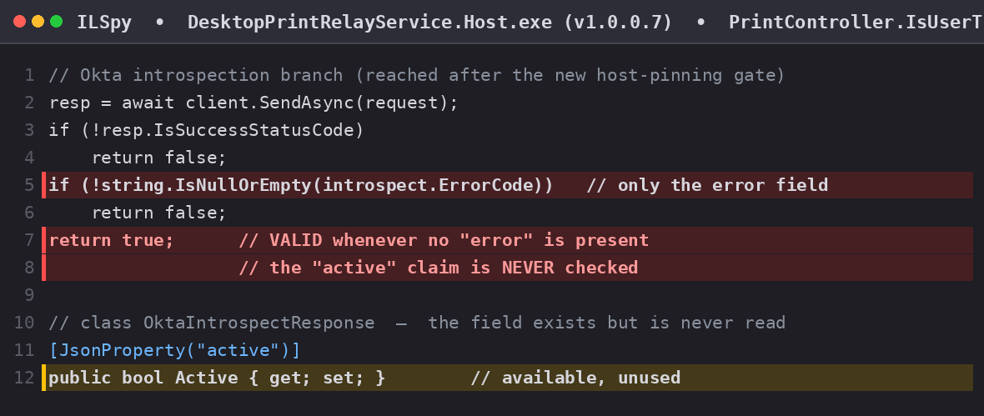
Figure — IsUserTokenValid accepts the token whenever no “error” field is present; the introspection “active” claim is never evaluated (OktaIntrospectResponse.Active is unused).

Remediation
Treat the token as valid only when the introspection response explicitly contains active == true; treat any non-200 status, parse error, or missing “active” field as invalid (deny-by-default). Preferably, replace the network introspection call with local JWT validation against the pinned tenant JWKS.
7. End-of-Life and Outdated Components Processing Untrusted Input - Medium | Medium

Summary
Although Newtonsoft.Json was upgraded and Kestrel patch-bumped, the application still runs on the end-of-life ASP.NET Core 2.x line (Startup pins CompatibilityVersion.Version_2_2) hosted on .NET Framework 4.8.1, and it was not re-platformed to a supported .NET LTS. More significantly, Aspose.PDF remains at version 20.10 (a 2020 build; “Copyright 2003-2020”), and attacker-supplied PDF bytes are still parsed in-process by this dated engine with no sandbox or size limit. Mitigating factor: because Finding 3 is now fixed, a PDF can no longer reach this parser without a valid token, reducing the exposure to authenticated callers.

Evidence
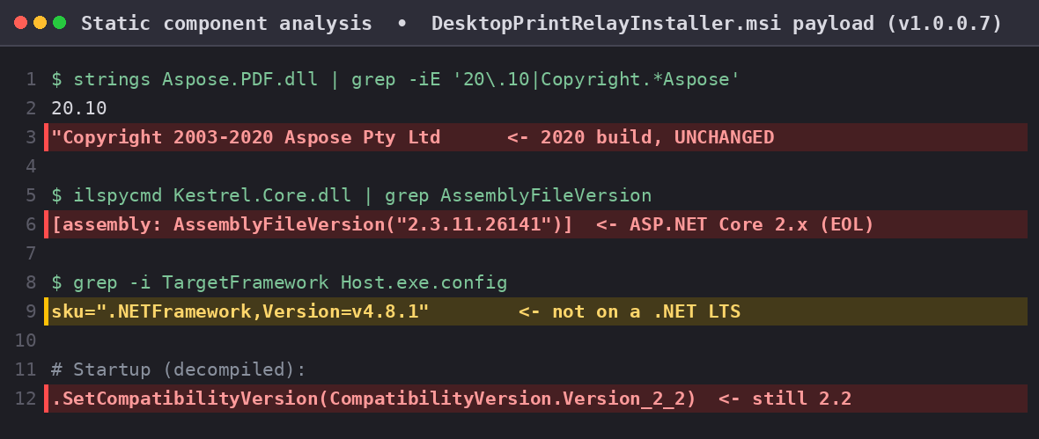
Figure — Static analysis of the v1.0.0.7 payload: Aspose.PDF is still 20.10 (2020), Kestrel / ASP.NET Core remain on the 2.x end-of-life line, and the host targets .NET Framework 4.8.1 rather than a supported .NET LTS.

Remediation
- Re-platform onto a supported .NET LTS (e.g. .NET 8) and replace the ASP.NET Core 2.2 packages with current equivalents.
- Upgrade Aspose.PDF to a current supported release.
- Enforce a maximum PDF size and parse untrusted PDFs in a separate low-privilege, sandboxed process.
- Add dependency scanning (e.g. dotnet list package --vulnerable) to CI to prevent regression.
9. Unsigned Application Binaries and Installer - Low | Low

Summary
setup.exe, DesktopPrintRelayInstaller.msi, and DesktopPrintRelayService.Host.exe remain unsigned. The executables contain no Authenticode certificate table (PE Security directory size 0) and the MSI contains no digital-signature stream. There is no cryptographic assurance of the software’s authenticity or integrity, and publisher-based allow-listing controls cannot be applied. No change from the original assessment.

Remediation
Authenticode-sign both executables and the MSI with an organization (preferably EV) code-signing certificate, add a trusted timestamp so signatures remain valid after the certificate expires, and enforce publisher rules so only signed, known-publisher builds run.
10. Over-Permissive HTTP URL ACL Reservation (Everyone) - Low | Low

Summary
During startup the application still executes netsh http add urlacl url=http://<hostname>:<port>/ user=everyone (Utils.RegisterServiceUrl), granting the Everyone group the right to reserve the HTTP URL namespace. The listener binds to loopback via Kestrel, so the reservation is largely vestigial, but granting the namespace to Everyone remains poor hygiene. Unchanged from the original assessment.

Remediation
Remove the netsh urlacl step. If a reservation is genuinely required, scope it to the specific low-privilege service account instead of Everyone, and continue binding only to 127.0.0.1.
11. Local Persistence and Configuration Hygiene - Info | Info

Summary
Configuration defaults are unchanged. With SecureVersion=False (the shipped default), the autostart entry and configuration are read from the per-user HKCU hive, which is writable by the logged-in standard user; RunAtStartup is True and EnableLog is True. AppSettingsLoader reads the listening port and the CORS origin allowlist from HKCU before HKLM, leaving them user-writable. None of these is directly exploitable for privilege escalation, but collectively they widen local tamperability and create the possibility of sensitive data appearing in log files.

Remediation
Where feasible, store autostart and configuration under a machine-protected location (HKLM with administrator-only ACLs), ship a secure default for SecureVersion, and ensure logs exclude PHI and secrets, are access-controlled, and are rotated per policy.

CONCLUSION
The critical remote attack chain identified in the original assessment has been remediated in build v1.0.0.7: the CORS delivery vector and all three authentication bypasses are closed, and the associated unauthenticated print, routing-map, and enumeration paths now require a validated token. The remaining work for a clean retest is limited to lower-severity hardening: enforce active == true in the Okta introspection path (Finding 1); re-platform off end-of-life ASP.NET Core 2.x and upgrade or sandbox Aspose.PDF (Finding 7); Authenticode-sign all artifacts (Finding 9); remove the Everyone URL ACL (Finding 10); and harden the HKCU-based configuration and persistence defaults (Finding 11). Inovalon OST recommends addressing these items and confirming them in a follow-up verification.

