test-jwks.vigilanzportal.com
JWKS Endpoint
Penetration Test
Report

Inovalon, Inc.
V 1.0
07/23/2026

Table Of Contents

Table Of Contents 1
EXECUTIVE SUMMARY 2
Engagement Scope 3
TIMELINE 4
TECHNICAL FINDINGS OVERVIEW 4
F-001 — Host Header Not Validated (Virtual Host Confusion Exposes Raw Backend Origin) - Medium 5
F-002 — HTTP TRACE Method Enabled on the Raw IIS Origin - Low 7
F-003 — Server Header Discloses Backend Technology on Protocol-Level Errors - Low 8
F-004 — Publicly-Cached JWKS Response Has No Vary Header - Low 10
F-005 — Security Response Headers (Including HSTS) Absent on 404 Responses From Unmatched Paths - Low 11
Additional Testing Performed and Positive Security Controls Observed - Informational 13

EXECUTIVE SUMMARY

The Inovalon Offensive Security Team, hereby known as Inovalon (OST), was engaged to conduct a web application penetration test of test-jwks.vigilanzportal.com, a JSON Web Key Set (JWKS) hosting and health-check service. This engagement was designed to provide the development team insight into the potential security risks posed by the service. The assessment was conducted on 07/23/2026. This report contains confidential information about the state of the application’s security controls.
Inovalon’s security team worked with the development team to define the scope of the engagement. Because this service exposes no login or authentication surface, the engagement was explicitly scoped as a fully unauthenticated, black-box assessment — no credentials exist for, or were used against, this application. Inovalon OST developed a hybrid methodology that combines both an objective and systematic approach designed to identify the real-world risk to the test-jwks.vigilanzportal.com service. During the initial phase of the assessment, a scoping meeting was conducted in which the goals of the assessment were agreed upon by both teams. These goals included the following:
- Identify vectors that could allow unauthorized write or overwrite of the published JSON Web Key Set
- Identify vectors that could expose private key material or other sensitive data via the JWKS or health endpoints
- Provide remediation instructions for any deficiencies discovered
During the assessment, Inovalon OST identified configuration and defense-in-depth gaps that could:
- Allow an external party to reach a raw, unhardened default backend origin sitting behind the same infrastructure as the application, by supplying a non-matching Host header
- Reduce the consistency of the platform’s otherwise strong security-header and cache-control posture on response paths that fall outside the application’s matched routes
Inovalon OST encourages the leadership team to look over the findings laid forth in this report and identify a viable strategy for implementing a remediation.

The findings and recommendations resulting from the assessment are included in the “Technical Findings Overview.” This report is intended solely for the information and use of developers and Inovalon.
Inovalon OST identified:
SEVERITY SUMMARY

Critical: 0
High: 0
Moderate: 1
Low: 4
Informational: 1

Engagement Scope
The engagement was conducted 07/23/2026 as a single-day, fully unauthenticated black-box assessment. The engagement’s scope included an application penetration test of the test-jwks.vigilanzportal.com JWKS (JSON Web Key Set) hosting and health-check service.

APPLICATION URLS
The following URLs were used during the duration of testing:

https://test-jwks.vigilanzportal.com/
https://test-jwks.vigilanzportal.com/jwks.json
https://test-jwks.vigilanzportal.com/health
https://test-jwks.vigilanzportal.com/.well-known/jwks.json

USER TEST ACCOUNT
No user credentials or test accounts were provided for, or used during, this engagement. This was a fully unauthenticated, black-box assessment against the application’s public JWKS and health-check endpoints only; there is no login or authentication surface in scope for this service.

TIMELINE
07/23/2026

TECHNICAL FINDINGS OVERVIEW
Critical High Medium Low Informational
0 | 0 | 1 | 4 | 1

For detailed information about all areas of risk identified during this assessment, reference the respective technical findings that are documented within this document. The following discusses the summary details of the assessment. Based on the results of the assessment, Inovalon OST identified the following vulnerabilities within test-jwks.vigilanzportal.com:

The following security issues were identified during the engagement.
Finding Name | Risk | Estimated Level of Effort
F-001 — Host Header Not Validated (Virtual Host Confusion Exposes Raw Backend Origin) - Medium | Medium | Low
F-002 — HTTP TRACE Method Enabled on the Raw IIS Origin - Low | Low | Low
F-003 — Server Header Discloses Backend Technology on Protocol-Level Errors - Low | Low | Low
F-004 — Publicly-Cached JWKS Response Has No Vary Header - Low | Low | Low
F-005 — Security Response Headers (Including HSTS) Absent on 404 Responses From Unmatched Paths - Low | Low | Low

F-001 — Host Header Not Validated (Virtual Host Confusion Exposes Raw Backend Origin) - Medium | Medium

Summary
Unauthenticated requests to test-jwks.vigilanzportal.com that include an arbitrary or non-matching Host header (for example, “Host: internal-admin.vigilanzportal.com”, “Host: localhost”, “Host: 127.0.0.1”, or a random subdomain) are not rejected and are not consistently routed to the intended application. Instead, the request falls through to a raw, default IIS origin on the same backend infrastructure, which serves the stock “IIS Windows Server” welcome page (HTTP 200) for the root path, discloses a “Server: Microsoft-IIS/10.0” header, and omits the full set of security headers (Content-Security-Policy, Strict-Transport-Security, X-Frame-Options, X-Content-Type-Options, Referrer-Policy, X-Robots-Tag) that are otherwise consistently applied by the properly-routed application. A systematic test of 24 distinct Host header values (plausible subdomains, generic placeholder hostnames, and the bare backend IP address) confirmed this fallback behavior is not specific to any particular Host value — any non-matching Host header reaches the same raw origin — though in every case tested it terminated at the same static placeholder page rather than exposing a different, distinct application.
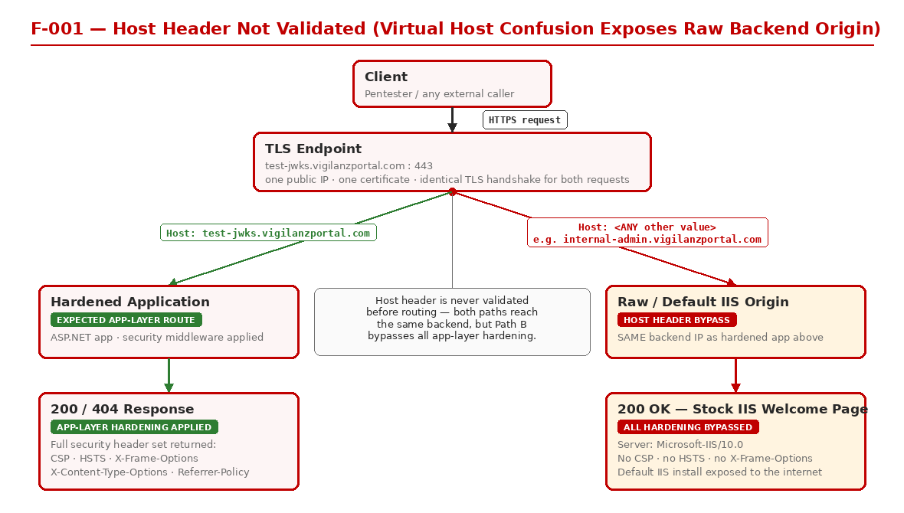
Figure 1: Host Header Routing — One TLS Endpoint, Two Divergent Backend Paths

EVIDENCE
Baseline (correct Host header):
curl -s -D - https://test-jwks.vigilanzportal.com/.well-known/jwks.json
→ HTTP/2 200, full security header set present (content-security-policy, strict-transport-security, x-frame-options, x-content-type-options, referrer-policy, x-robots-tag), no Server header
curl -s -D - https://test-jwks.vigilanzportal.com/
→ HTTP/2 404, empty body, no Server header
Spoofed Host header:
curl -s -D - -H "Host: internal-admin.vigilanzportal.com" https://test-jwks.vigilanzportal.com/
→ HTTP/2 200
server: Microsoft-IIS/10.0
content-type: text/html
last-modified: Thu, 07 Mar 2024 21:28:17 GMT
etag: "bcc07e5ed670da1:0"
content-length: 703
[body: stock IIS Windows Server welcome page referencing iisstart.png]
This exact response (same Content-Length 703, same ETag, same MD5 checksum of the body) was reproduced identically across all 24 tested Host values, including: www., admin., api., internal., staging., dev., portal., auth., sso., id., idp., keys., jwks., qa., uat., test., vpn., myshare., print., relay. (all under vigilanzportal.com), the bare apex domain, “Host: DefaultAppPool”, “Host: WIN-TEST”, and the bare backend IP address.
This finding was independently re-verified live on two separate occasions with identical results both times.

REMEDIATION
Configure the front-end/reverse-proxy layer or IIS site bindings to validate the incoming Host header against an explicit allow-list containing only “test-jwks.vigilanzportal.com”, and reject (HTTP 400, or a connection reset) any request whose Host header does not match — rather than allowing it to fall through to a default/catch-all site binding. If a default IIS site is not required for legitimate purposes, it should be removed or bound only to a loopback/internal-only interface so it cannot be reached via external Host-header manipulation. This is a web-server/reverse-proxy configuration change and should require low remediation effort.

REFERENCES
OWASP Web Security Testing Guide — WSTG-CONF-04 (Test HTTP Methods) and virtual-host testing guidance; CWE-346 (Origin Validation Error).

F-002 — HTTP TRACE Method Enabled on the Raw IIS Origin - Low | Low

Summary
The raw/default IIS origin reachable via the Host-header issue described in F-001 advertises the HTTP TRACE method as allowed (alongside OPTIONS, GET, HEAD, and POST) in its OPTIONS response. TRACE was not actively invoked during this assessment (no exploitation was attempted), but its presence confirms this fallback IIS binding is running an unhardened default configuration rather than the same hardened surface as the main application, which does not expose this behavior at all. Disabling TRACE (and TRACK) is a standard web-server hardening baseline (referenced in CIS and OWASP guidance) independent of whether a specific exploitation technique (e.g., historical Cross-Site Tracing/XST issues in certain legacy browser plugin contexts) currently applies.
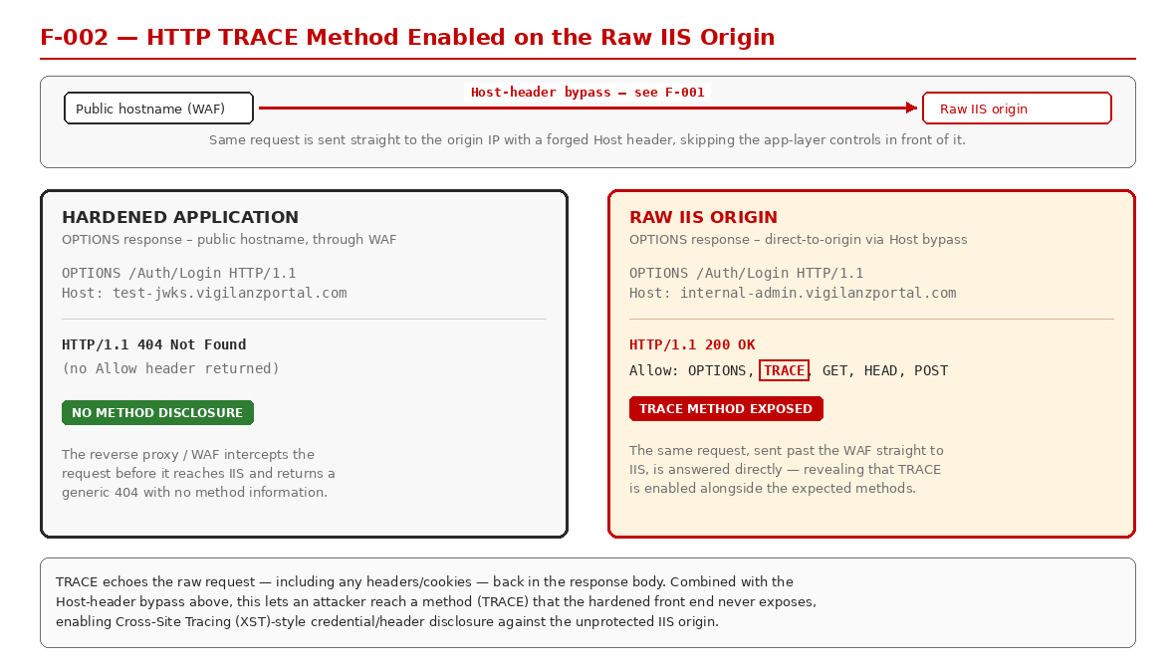
Figure 2: TRACE Method Exposed on the Raw IIS Origin (Hardened App vs. Raw Origin)

EVIDENCE
curl -i -X OPTIONS https://test-jwks.vigilanzportal.com/ -H "Host: internal-admin.vigilanzportal.com"
→ HTTP/2 200
allow: OPTIONS, TRACE, GET, HEAD, POST
public: OPTIONS, TRACE, GET, HEAD, POST
server: Microsoft-IIS/10.0
content-length: 0
By contrast, the same OPTIONS request sent with the correct Host header returns HTTP 404 with no Allow/Public header disclosed at all — the hardened application surface does not expose method enumeration.
Independently re-verified live on two separate occasions with identical results both times.

REMEDIATION
Disable the TRACE and TRACK HTTP methods at the IIS/web-server level (e.g. via a web.config <security><requestFiltering><verbs> deny rule, or an equivalent URL Rewrite module outbound/inbound rule) across all site bindings, including the default/fallback binding identified in F-001. Low remediation effort.

REFERENCES
OWASP Web Security Testing Guide — WSTG-CONF-06 (Test HTTP Methods); CWE-16 (Configuration).

F-003 — Server Header Discloses Backend Technology on Protocol-Level Errors - Low | Low

Summary
Normal HTTP 200 and 404 responses from the application (both /health and /.well-known/jwks.json) never include a Server header — this appears to be deliberately stripped by a front-end layer, consistent with the otherwise strong security header hygiene observed elsewhere on the properly-routed application. However, a raw HTTP protocol-level error — specifically an HTTP 411 “Length Required” response, triggered by sending a request with no Content-Length on a method that requires a body — is generated at the underlying HTTP.sys/kernel-driver level before it reaches that front-end header-scrubbing layer, and this response discloses “Server: Microsoft-HTTPAPI/2.0”. This confirms the origin’s underlying stack (Windows/IIS via HTTP.sys) and represents a minor inconsistency: a header-scrubbing control that is otherwise consistently applied does not cover protocol-level error paths.
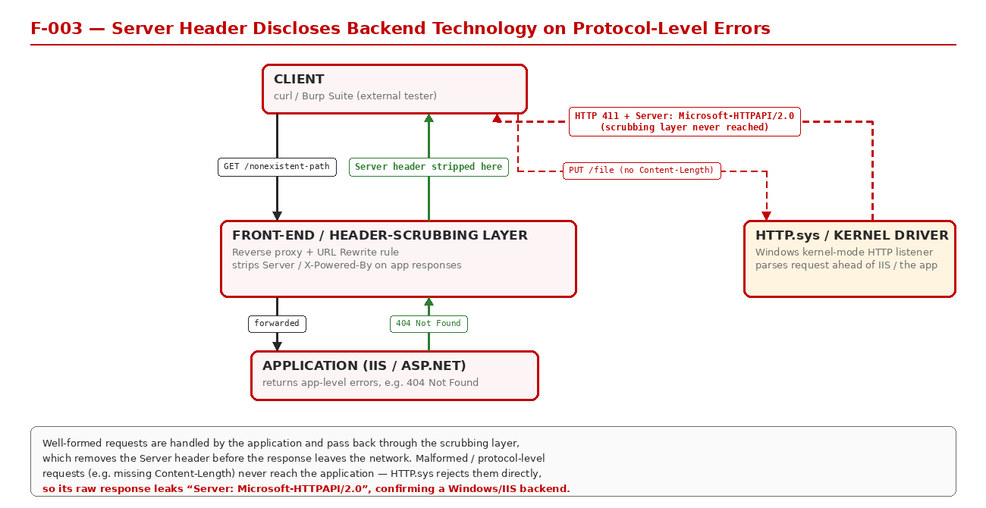
Figure 3: Malformed-Request Path Bypasses the Header-Scrubbing Layer

EVIDENCE
curl -X PUT https://test-jwks.vigilanzportal.com/health [no request body / no Content-Length]
→ HTTP/2 411
server: Microsoft-HTTPAPI/2.0
body: "HTTP Error 411. The request must be chunked or have a content length."
Identical behavior was reproduced against /.well-known/jwks.json. By contrast, normal GET 200 responses, and 404 responses returned for other tampered methods (PUT-with-body, DELETE, PATCH, TRACE), never include a Server header.
Independently re-verified live on two separate occasions with identical results both times.

REMEDIATION
Configure IIS/HTTP.sys to suppress the Server header on all responses, including protocol-level errors generated before requests reach the application or front-end layer (e.g. via the removeServerHeader setting available in IIS 10 and later, applied at the correct binding/site level so it also covers the fallback default site from F-001). Low remediation effort.

REFERENCES
OWASP Web Security Testing Guide — WSTG-INFO-02 (Fingerprint Web Server); CWE-200 (Exposure of Sensitive Information to an Unauthorized Actor).

F-004 — Publicly-Cached JWKS Response Has No Vary Header - Low | Low

Summary
The JWKS endpoint (/.well-known/jwks.json) is served with “Cache-Control: public, max-age=86400” (a 24-hour public caching directive) but never returns a Vary header, and no Age or X-Cache/CDN cache-status header is exposed either. Testing confirmed that none of the header-based inputs evaluated (Origin, X-Forwarded-Host, X-Forwarded-Proto, X-Original-URL, X-Rewrite-URL) currently have any effect on the response content, so there is no actively exploitable cache-poisoning vector today. However, in the absence of a Vary header, if any future change to the application introduces header-dependent response behavior (for example, content negotiation, locale-specific responses, or a debug/preview flag read from a header), it would be immediately poisonable at scale given the 24-hour public cache lifetime, since a caching layer in front of the origin would have no way to know it must treat those header variants as distinct cache entries.
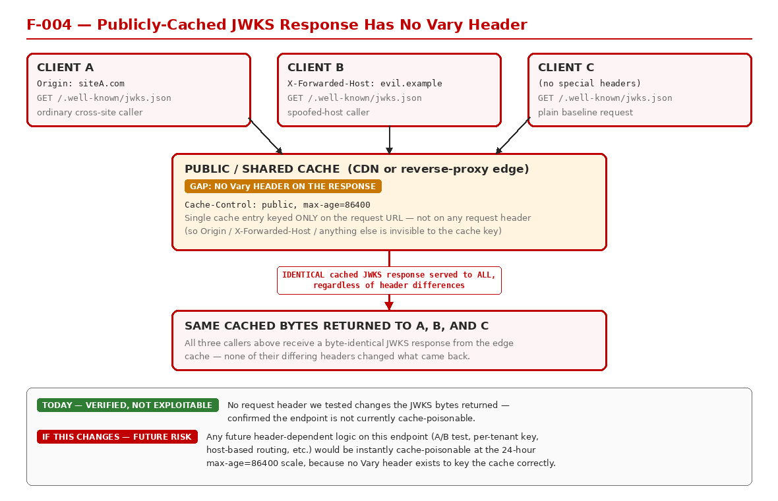
Figure 4: Shared Public Cache Returns Identical JWKS Bytes Regardless of Request Headers

EVIDENCE
curl -s -D - https://test-jwks.vigilanzportal.com/.well-known/jwks.json
→ cache-control: public, max-age=86400
content-length: 998
[no Vary header, no Age header, no X-Cache/CDN cache-status header present]
Repeat requests carrying Origin, X-Forwarded-Host, X-Forwarded-Proto, X-Original-URL, and X-Rewrite-URL headers all returned a byte-identical response (same Content-Length, same body hash), confirming no currently-unkeyed input alters the cached representation.
Independently re-verified live on two separate occasions with identical results both times.

REMEDIATION
As a forward-looking hardening measure, explicitly set an appropriate Vary header on this response (at minimum “Vary: Accept-Encoding” as a baseline) so that any header-dependent behavior introduced in the future is automatically cache-safe, rather than requiring a follow-up fix to be applied reactively once such behavior is added. Low remediation effort.

REFERENCES
RFC 7234 (HTTP/1.1 Caching), Section 4.1 (Vary); OWASP guidance on web cache deception and cache poisoning.

F-005 — Security Response Headers (Including HSTS) Absent on 404 Responses From Unmatched Paths - Low | Low

Summary
The application applies a full, consistent security header set (Content-Security-Policy, Strict-Transport-Security, X-Content-Type-Options, X-Frame-Options, Referrer-Policy, X-Robots-Tag) on its two functioning HTTP 200 routes (/health and /.well-known/jwks.json), but HTTP 404 responses returned for unmatched or mistyped paths — including the bare root path “/”, the path “/jwks.json” without the required “.well-known” prefix, and notably the exact typo’d path (“.well-know/jwks.json”, missing the final “n”) listed in the engagement’s own scope document — return only a bare “date” header, with none of those protections present. This indicates the security headers are applied by application-level middleware only on matched routes, rather than being applied globally at the front-end/edge layer. Impact is low: Strict-Transport-Security is still correctly enforced on the routes that actually serve content, and any browser session that has previously loaded a 200 response from this origin will already have HSTS cached for the whole origin regardless of what an individual 404 response includes. This is best characterized as a consistency/defense-in-depth gap rather than an independently exploitable weakness.
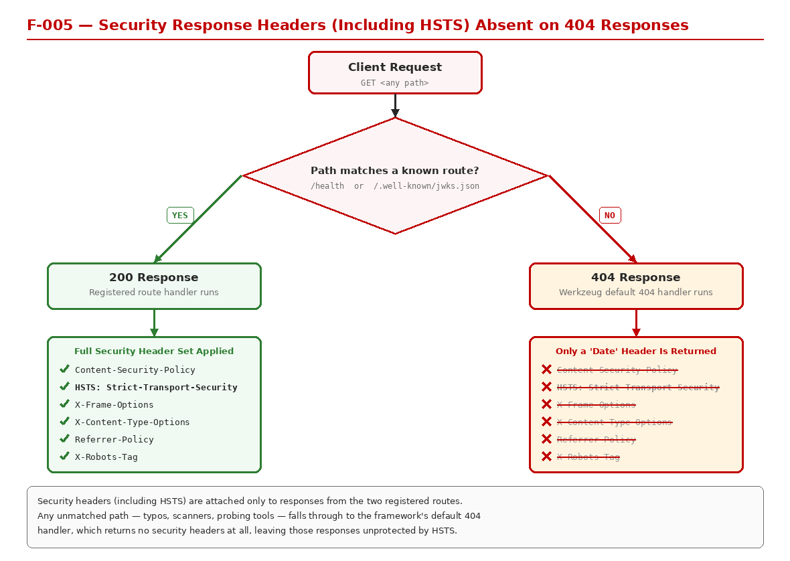
Figure 5: Security Headers Applied Only on Matched Routes, Absent on Default 404

EVIDENCE
curl -s -D - https://test-jwks.vigilanzportal.com/ → HTTP/2 404, only a "date" header present
curl -s -D - https://test-jwks.vigilanzportal.com/jwks.json → HTTP/2 404, only a "date" header present
Compare to:
curl -s -D - https://test-jwks.vigilanzportal.com/health → HTTP/2 200, full security header set
curl -s -D - https://test-jwks.vigilanzportal.com/.well-known/jwks.json → HTTP/2 200, full security header set
Independently re-verified live on two separate occasions with identical results both times.

REMEDIATION
Apply the same baseline security header set globally — at the front-end/edge/reverse-proxy layer, or via response-header middleware applied ahead of routing — to ALL responses regardless of HTTP status code or route match, rather than only on successfully-matched application routes. Low remediation effort.

REFERENCES
OWASP Secure Headers Project; CWE-16 (Configuration).

Additional Testing Performed and Positive Security Controls Observed - Info | Info

Summary
In addition to the findings above, the following areas were assessed and found to be correctly implemented or not exploitable. These are documented for completeness and to demonstrate the depth of testing performed; no remediation is required for any item below.

EVIDENCE
- Unauthenticated write/overwrite of the JWKS was directly tested: a canary key was submitted via POST, and every state-changing HTTP method tested (POST, PUT, DELETE, PATCH, TRACE) was rejected; a follow-up GET confirmed the canary key never appeared in the published key set.
- The JWKS contains only standard, well-formed public-key material (kty, use, alg, kid, crv, x, y fields per RFC 7517/7518) across all 4 EC P-384 signing keys — no private key material (“d”) or unexpected/internal fields were present on any key.
- All “kid” values are high-entropy 256-bit tokens with no discernible sequence, timestamp, hostname, or username pattern when decoded.
- No parameter pollution or header-based response variance was observed on the JWKS endpoint; any non-empty query string on that path fails closed with HTTP 404.
- Repeated fetches of the JWKS returned byte-identical content on every request — no canary/debug key or race-condition inconsistency was observed. The endpoint is actively protected by a request-rate limiter (HTTP 429 with a Retry-After header), a working control against high-volume automated probing.
- No ETag or Last-Modified header is disclosed on the JWKS response, so no internal file path, build timestamp, or key-rotation-cadence information is leaked via caching headers.
- TLS 1.0 and TLS 1.1 are correctly rejected by the server; only TLS 1.2 and TLS 1.3 are negotiated, both using strong, forward-secret AEAD cipher suites. A broad weak-cipher probe (LOW/EXPORT/anonymous/null-cipher suites) was rejected by the server.
- The TLS certificate chain is complete and currently valid (DigiCert-issued, correct Subject Alternative Names, valid through February 2027). HTTP Strict Transport Security is present with a one-year max-age and includeSubDomains directive (though without the optional “preload” token).
- Plain HTTP (port 80) is consistently unreachable — verified across 6 separate connection attempts using two different methods — so no unencrypted transport path exists for this application.
- Requests for files with a “.config” extension return a distinguishable IIS-generated 404 response (versus the application’s blank 404 for other paths), which confirms the backend is a Windows/IIS stack but does not disclose any file contents — IIS correctly blocks access to this file extension by default.
- The classic IIS 8.3 short-filename (“tilde”) disclosure technique was directly tested against this target and confirmed not exploitable — no differential response was observed that would indicate genuine short-filename enumeration.
- WebDAV is not enabled, and directory browsing/listing is not enabled, on either the main application or the raw IIS origin referenced in finding F-001.

REMEDIATION
N/A — no remediation is required for the items above; they are documented to demonstrate testing coverage and depth.

REFERENCES
OWASP Web Security Testing Guide; RFC 7517/7518 (JSON Web Key); RFC 8446 (TLS 1.3).

