SMC Print Relay (1.0.05)
Penetration Test
Report

Inovalon, Inc.
V 1.2
06/10-14/26

Table Of Contents

Table Of Contents 1
EXECUTIVE SUMMARY 2
Engagement Scope 4
TIMELINE 5
TECHNICAL FINDINGS OVERVIEW 5
1. Authentication Bypass via Attacker-Controlled Token Introspection URL - High 15
2. Authentication Bypass via Attacker-Controlled OpenID Connect Discovery (B2C Validation Path) - High 18
3. Missing Authorization on the PrintPdf Endpoint - High 22
4. Overly Permissive CORS Policy Enabling Cross-Site Exploitation - High 27
5. Unauthenticated Modification of the Print-Routing Map - Medium 31
6. Unauthenticated Information Disclosure via Printer Enumeration - Medium 34
7. End-of-Life and Outdated Components Processing Untrusted Input - Medium 37
8. Constrained Server-Side Request Forgery via X-ProviderValidationUrl - Low 41
9. Unsigned Application Binaries and Installer - Low 43
10. Over-Permissive HTTP URL ACL Reservation (Everyone) - Low 45
11. Local Persistence and Configuration Hygiene - Info 46

EXECUTIVE SUMMARY

The Inovalon Offensive Security Team, hereby known as Inovalon (OST), was engaged by
Inovalon’s leadership team to conduct a web application penetration test on the SMC Print Relay (1.0.05). This engagement was designed to provide the development team an insight into the potential security risks posed by using the application. The assessment was conducted 06/10-14/26. This report contains confidential information about the state of the application’s security controls.
Inovalon’s security team worked with the development team to define the scope of the engagement. To this end, Inovalon OST developed a hybrid methodology that combines both an objective and systematic approach designed to identify the real-world risk to the SMC Print Relay (1.0.05). During the initial phase of the assessment, a scoping meeting was conducted in which the goals of the assessment were agreed upon by both teams. These goals included the following:
- Identify vectors that can result in the theft of customer data
- Identify vectors that can result in the escalation of user privileges
- Provide remediation instructions for any deficiencies discovered
During the assessment, Inovalon OST was able to successfully identify security issues that could:
- Enable malicious users to attack and compromise other users
- Enable malicious users to leverage misconfigured controls to harvest sensitive data of other customers
Inovalon OST encourages the leadership team to look over the findings laid forth in this report and identify a viable strategy for implementing a remediation.

The findings and recommendations resulting from the assessment are included in the “Technical Findings Overview.” This report is intended solely for the information and use of developers and Inovalon.
Inovalon OST identified:
SEVERITY SUMMARY

Critical: 0
High: 4
Moderate: 3
Low: 3
THE BIGGER PICTURE: COMBINED ATTACK CHAIN
The four High-severity findings are not independent issues — they form a single end-to-end attack chain. A permissive cross-origin policy (F4) makes the loopback service reachable from any web page, turning a local-only weakness into a remote, click-driven attack. From there, the attacker needs only ONE of three independent authentication bypasses — F3 (an endpoint with no validation at all), F1 (an attacker-controlled token check), or F2 (a B2C path that trusts attacker-hosted keys) — to have a document accepted for printing. Unauthenticated reconnaissance (M6) supplies the target list, and the same access enables print-routing tampering (M5) as an alternative payload.

Remediation implication: because the three bypasses are an OR (any one is sufficient), fixing only one accomplishes nothing while the others remain. Closing the chain requires fixing the delivery vector (F4) AND every authentication bypass (F1, F2, F3) — ideally by routing all print endpoints through one shared, correctly-implemented authorization gate.
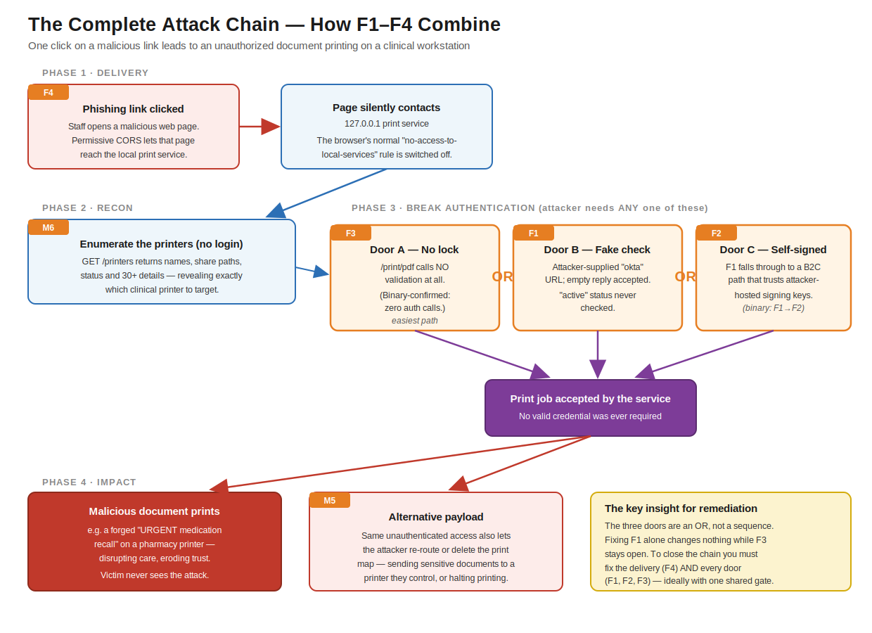
Figure A — The complete attack chain. Delivery (F4) → optional recon (M6) → any one of three authentication bypasses (F3 / F1 / F2) → unauthorized printing, with routing-map tampering (M5) as an alternative payload. All relationships verified against the application binary.

Engagement Scope
The engagement was conducted 06/10-14/26. The engagement’s scope included an application penetration test of the SMC Print Relay (1.0.05).

APPLICATION URL
The following URL was used for web printing only during the duration of testing:

https://foundation.smc-qual.gcp.inovalon.global/

USER TEST ACCOUNT
The following test accounts were provided and used throughout the engagement:

Username | Role
EMD.teamthunders@inovalon.com
EMD.teamspartans@inovalon.com

TIMELINE
06/10-14/26

TECHNICAL FINDINGS OVERVIEW
Critical High Medium Low Informational
0 | 4 | 3 | 3 | 1

For detailed information about all areas of risk identified during this assessment, reference the respective technical findings that are documented within this document. The following discusses the summary details of the assessment. Based on the results of the assessment, Inovalon OST identified the following vulnerabilities within SMC Print Relay (1.0.05):

The following security issues were identified during the engagement.
Finding Name | Risk | Estimated Level of Effort
1. Authentication Bypass via Attacker-Controlled Token Introspection URL | High | Medium
2. Authentication Bypass via Attacker-Controlled OpenID Connect Discovery (B2C Validation Path) | High | Medium
3. Missing Authorization on the PrintPdf Endpoint | High | Low
4. Overly Permissive CORS Policy Enabling Cross-Site Exploitation | High | Low
5. Unauthenticated Modification of the Print-Routing Map | Medium | Low
6. Unauthenticated Information Disclosure via Printer Enumeration | Medium | Medium
7. End-of-Life and Outdated Components Processing Untrusted Input | Medium | High
8. Constrained Server-Side Request Forgery via X-ProviderValidationUrl | Low | Low
9. Unsigned Application Binaries and Installer | Low | Medium
10. Over-Permissive HTTP URL ACL Reservation (Everyone) | Low | Low
11. Local Persistence and Configuration Hygiene | Info | Medium

Visual Attack Walkthrough
SMC Print Relay v1.0.05 — How the High-Severity Findings Combine
A step-by-step visual companion to the penetration test report

This document explains the attack visually, one step at a time. It is built to be read in order: we start with how the system is meant to work, mark where it fails, take each High-severity finding on its own, and then assemble them into the single end-to-end attack. Every technical detail shown here was verified against the actual application binary.

How to use it: if you are presenting, walk the pictures in sequence — each one assumes the previous. The captions and the short text blocks are written so you can narrate directly from them.

Step 1 — The Baseline: How It Should Work
Before you can see what is broken, you need the picture of what 'working' looks like. The relay is a small program on the workstation that bridges the web application to the printers. To print, the web app sends the relay a request containing the document and a login token. The relay's most important job is to validate that token before it prints. Hold onto that single idea — every finding is a deviation from this baseline.
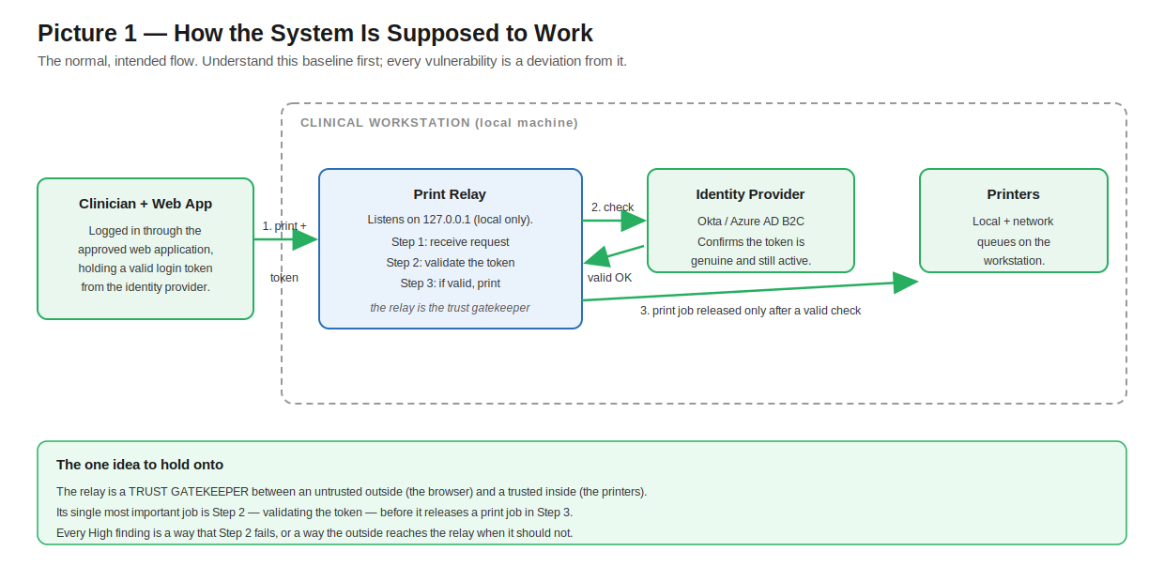
Picture 1 — The intended flow. The relay validates the token (Step 2) before releasing any print job (Step 3).

Step 2 — The Attack Surface: Where It Fails
Now the same system, marked with its four defects. Notice the shape of the problem: one defect (F4) is the way IN — it lets an outside web page reach a service that should only ever hear from the approved app. The other three (F1, F2, F3) are three separate ways PAST the token check. The attacker needs the way in, plus any one of the three ways past.
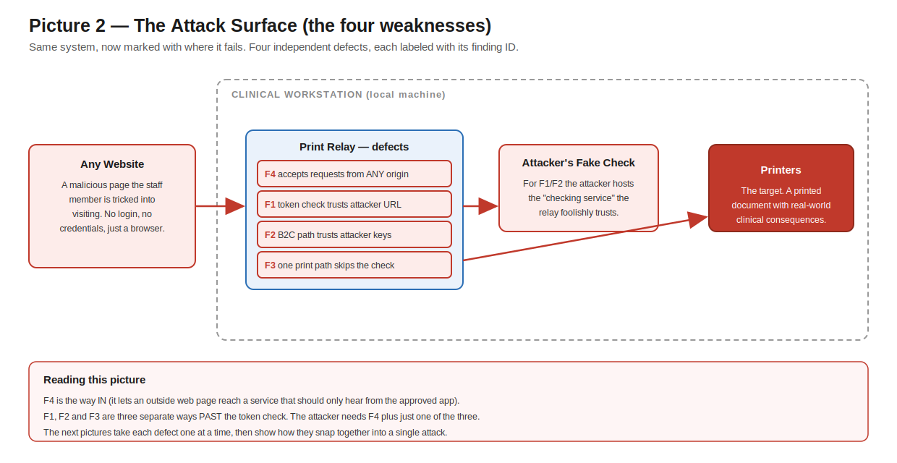
Picture 2 — Four independent defects. F4 is the delivery vector; F1/F2/F3 are three separate authentication bypasses.

Step 3 — F4: The Way In (Permissive CORS)
Start with F4, because it is what makes everything else remotely exploitable. A service that only listens on the local machine feels safe — but the user's browser is also on that machine. Normally a browser stops a random website from quietly talking to your local services. This relay overrides that protection and tells the browser 'any website may talk to me.' That is the difference between an attack someone must be physically inside to run, and one they can trigger by sending a staff member a link.
What the binary shows
- Startup.ConfigureServices registers a CORS policy calling AllowAnyOrigin() and AllowAnyHeader(), applied globally with UseCors.
- This is a configuration defect, not a coding bug — but it is the linchpin that turns local-only weaknesses into a remote attack.
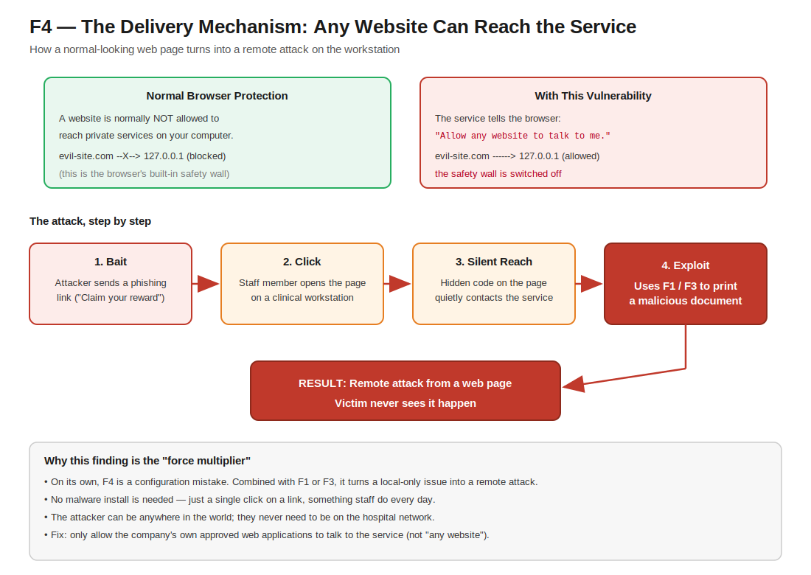
Picture 3 (F4) — Permissive CORS is the delivery mechanism: it lets a malicious web page reach the local print service through the victim’s own browser.

Step 4 — F3: The Door With No Lock (Missing Authorization)
Of the three ways past the token check, F3 is the simplest and the most serious, so we take it first. One of the relay's print paths performs no token validation at all. It checks only that certain headers are present — not that they are valid — and then prints. An attacker does not need any of the clever token trickery in F1 or F2; a plain request with junk headers prints.
What the binary shows
- PrintController.PrintPdf calls NONE of the validation methods — not validationForPrintPdf, not isUserTokenValid, not IsB2CTokenValid.
- By direct contrast, the sibling endpoint PrintPdfWithCopies DOES call validationForPrintPdf and isUserTokenValid. Same controller, inconsistent gating.
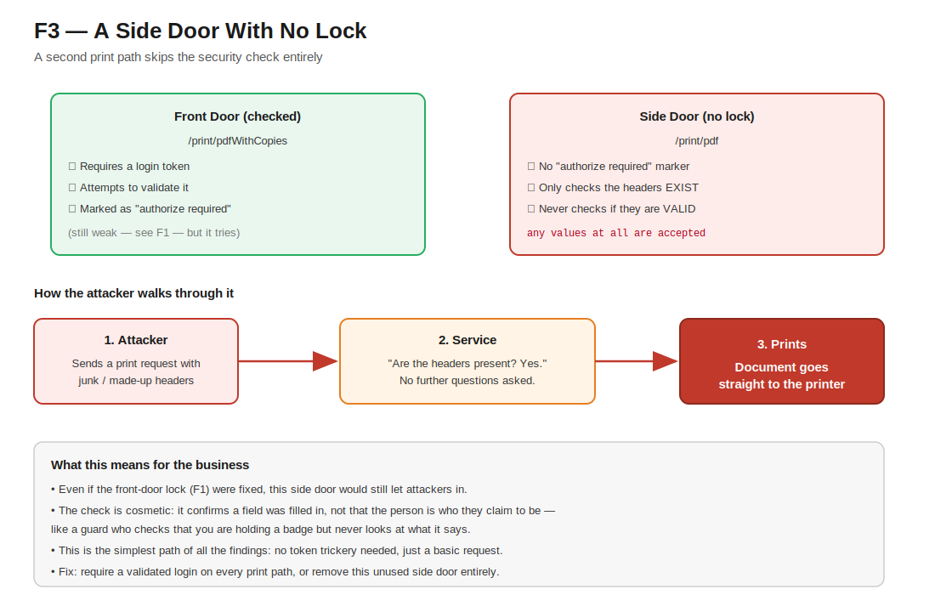
Picture 4 (F3) — A second print endpoint has no authorization check at all; it confirms a header was filled in, never that the caller is genuine.

Step 5 — F1: The Fake ID-Check (Attacker-Controlled Token Validation)
F1 is the most instructive bug in the whole report. The relay validates the login token by contacting a checking service whose address the attacker supplies, and then accepts the answer without really reading it. The only guard is a substring search for the text 'okta' in that attacker-supplied address. Worse, when the response comes back, the relay decides the token is valid as long as no error field is present — it never checks whether the token is actually active.
What the binary shows
- isUserTokenValid guards the attacker-supplied URL with only IndexOf("okta", ...) — any URL containing that text passes.
- Validity is decided by the absence of an ErrorCode field; the Active field is NEVER checked.
- The response object (OktaIntrospectResponse) literally has an Active property — they had the right field available and did not use it.
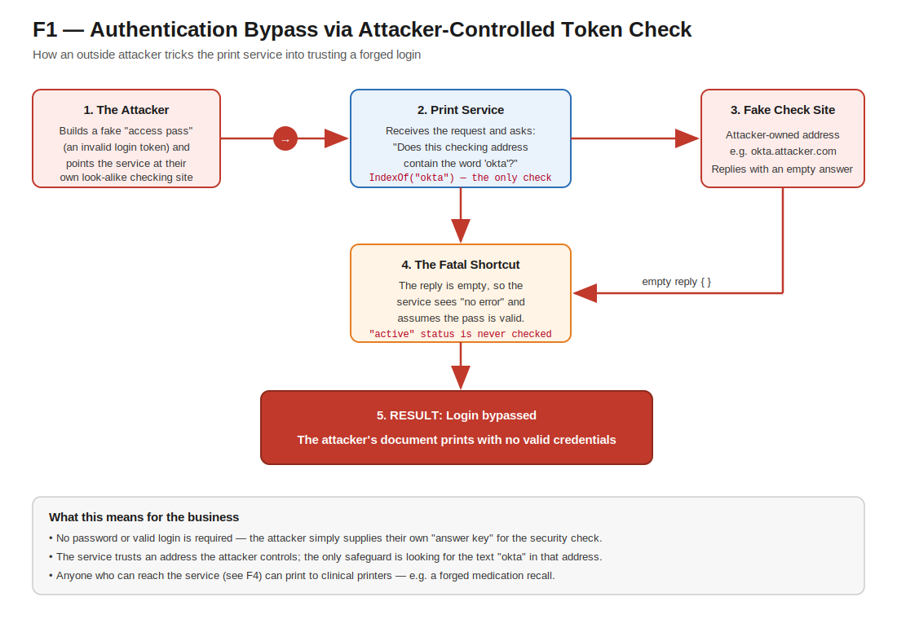
Picture 5 (F1) — The relay trusts an attacker-supplied “checking service” and accepts an empty reply as success, never verifying the token is active.

Step 6 — F2: The Self-Signed Pass (Attacker-Controlled Key Directory)
F2 is the same root mistake as F1, in a second code path. When the first check does not match, the relay falls through to a B2C validation path that derives its trust — the issuer and the signing keys — from input the attacker influences. If you control the directory that lists which signing keys are 'trusted,' you can list your own key and sign your own valid-looking pass. Because F1 and F2 share a cause and F1 leads directly into F2, they are fixed together as one change.
What the binary shows
- isUserTokenValid falls through to IsB2CTokenValid — the call is present in the binary, confirming the two-path design.
- The B2C path anchors trust to attacker-influenced input rather than to fixed, server-side configuration.
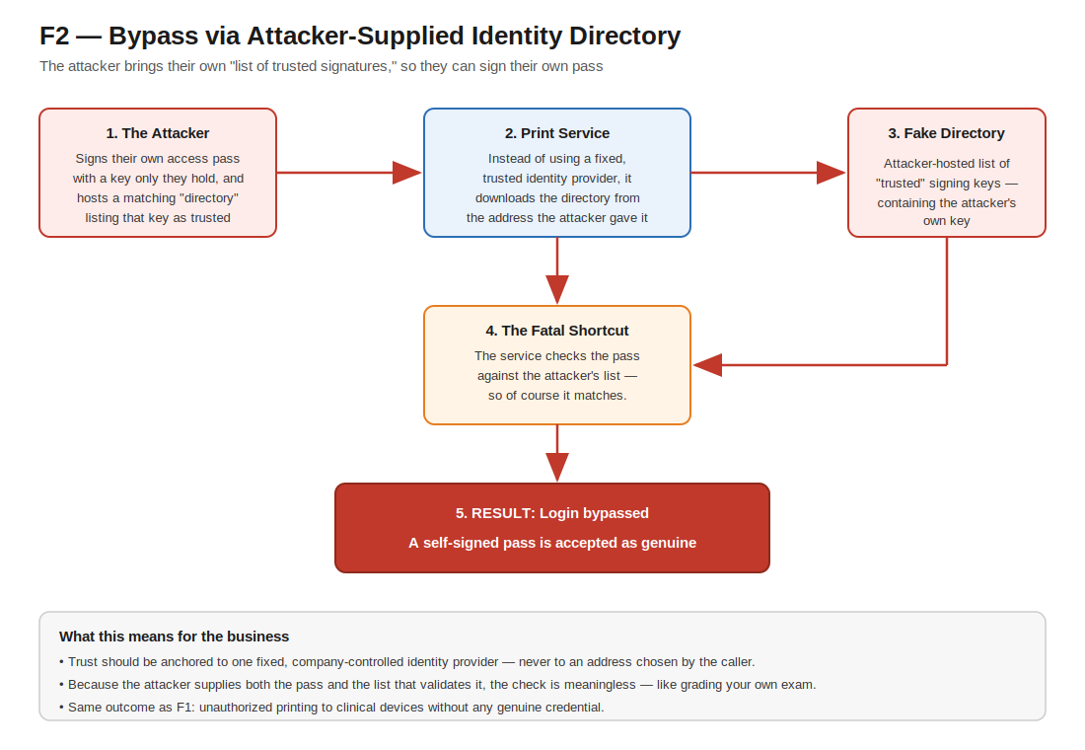
Picture 6 (F2) — A second validation path trusts an attacker-hosted directory of “trusted” keys, so the attacker can sign a pass that validates against their own key.

Step 7 — Putting It Together: The Complete Attack Chain
Individually, these are four defects. Together, they are one attack. This final picture assembles them in the order an attacker actually uses them. The most important thing to understand — and the thing that changes how the fix must be planned — is that the three authentication bypasses are joined by OR. The attacker needs only ONE of them. That means fixing F1 by itself accomplishes nothing while F3 stays open. To close the chain you must fix the delivery vector (F4) AND all three doors (F1, F2, F3) — ideally by routing every print path through one shared, correct authorization gate.

Picture 7 — The complete chain. Delivery (F4) → optional recon (M6) → ANY ONE of three bypasses (F3 / F1 / F2) → unauthorized printing, with routing-map tampering (M5) as an alternative payload.

The Four Sentences to Remember
If you take nothing else from these pictures, take these:
- F4 is the way in. Permissive CORS lets any website reach a service that should only hear from the approved app — turning a local issue into a remote, click-driven one.
- F3 is the door with no lock. One print path validates nothing; a plain request prints.
- F1 and F2 are broken ID-checks. The relay trusts a checking service, and the keys behind it, that the attacker controls — and never verifies the token is actually active.
- It is a chain joined by OR. Fixing one bypass changes nothing while another stays open; the delivery vector and all three doors must be fixed together.

Every detail in this walkthrough was verified against the application binary (DesktopPrintRelayService.Host.exe). For the full technical evidence, code locations, and step-by-step remediation, see the main penetration test report.

1. Authentication Bypass via Attacker-Controlled Token Introspection URL - High | High

Summary
Risk Rating: High | CVSS 3.1: 8.8 (AV:N/AC:L/PR:N/UI:R/S:C/C:L/I:H/A:L)
Affected component: DesktopPrintRelayService.Host.exe v1.0.0.5 — PrintController.isUserTokenValid; endpoints POST /printers/print/pdfWithCopies and POST /printers/{printDocType}/print/zpl
The relay validates the bearer token supplied by the calling web application by performing an OAuth2/Okta token-introspection call. The URL of that introspection endpoint is taken directly from the caller-supplied request header X-ProviderValidationUrl. The only validation performed on this attacker-controlled URL is a check that the literal substring "okta" appears in it. This is trivially satisfied by an attacker-hosted URL such as https://okta.attacker.example/introspect or https://evil.example/okta.
The defect is compounded by the success criteria. After issuing the request, the code deserializes the JSON response and treats the token as VALID whenever the response simply lacks an error field. It never checks that the introspection "active" claim is true, nor does it validate issuer, audience, client_id, or expiry. As a result, an attacker who stands up any HTTPS endpoint whose URL contains "okta" and returns a body with no error field (for example, an empty JSON object) will have any token value they supply accepted as valid.
Because the service applies a permissive Cross-Origin Resource Sharing policy (see related finding), this bypass is reachable cross-origin from any website the authenticated user visits; the loopback-bound listener is contacted from the victim's browser. The net effect is that the entire authorization model protecting document printing on the workstation can be defeated by an unauthenticated, remote attacker, allowing arbitrary content to be printed to the user's mapped printers.

EVIDENCE
Code Source Tracking
Binary File: DesktopPrintRelayService.Host.exe (v1.0.0.5)
File Location: C:\Program Files (x86)\Inovalon\DesktopPrintRelayInstaller\DesktopPrintRelayService.Host.exe
Namespace: ScriptMed.DesktopPrintRelayService
Class: PrintController
Method: isUserTokenValid()
Vulnerable Variable/String: providerValidationUrl (the "okta" substring check)
Source (where it comes from): HTTP Request Header: X-ProviderValidationUrl (attacker-supplied)
Vulnerable Code Pattern:
if (providerValidationUrl.IndexOf("okta", 5) < 0) return false;
Full Code Snippet (IL-reconstructed):
private bool isUserTokenValid(string providerValidationUrl, string accessToken, string clientSecretJwt)
{
// VULNERABLE: Only substring check for "okta"
if (providerValidationUrl.IndexOf("okta", 5) < 0)
return false;
var client = new HttpClient();
client.BaseAddress = new Uri(uri.Scheme + "://" + uri.Host); // host from header!
// ... POSTs token to attacker-supplied URL ...
var introspect = JsonConvert.DeserializeObject<OktaIntrospectResponse>(body);
// VULNERABLE: Never checks "active" claim!
return string.IsNullOrEmpty(introspect.ErrorCode);
}

Reconstructed logic of PrintController.isUserTokenValid (decompiled from IL):
Attack Path (Executive View)

Figure F1 — Attack path: the attacker supplies their own token-checking address; the service only looks for the word "okta" and treats an empty reply as success.

// providerValidationUrl, accessToken, clientSecretJwt all come straight from request headers
if (providerValidationUrl.IndexOf("okta", 5) < 0)
return false; // ONLY guard on the URL: must contain "okta"

var client = new HttpClient();
client.BaseAddress = new Uri(uri.Scheme + "://" + uri.Host); // host taken from the header
var req = new HttpRequestMessage(HttpMethod.Post, path);
req.Content = new FormUrlEncodedContent(new[]{
{"token", accessToken},
{"token_type_hint", "access_token"},
{"client_assertion", clientSecretJwt},
{"client_assertion_type", "urn:ietf:params:oauth:client-assertion-type:jwt-bearer"} });
var resp = await client.SendAsync(req);
var body = await resp.Content.ReadAsStringAsync();
var introspect = JsonConvert.DeserializeObject<OktaIntrospectResponse>(body);
return string.IsNullOrEmpty(introspect.ErrorCode); // VALID if no error field; never checks active==true

Proof-of-concept request (any token value is accepted when the attacker server returns {} ):

POST /printers/print/pdfWithCopies HTTP/1.1
Host: 127.0.0.1:<port>
Content-Type: application/json
X-ProviderValidationUrl: https://okta.attacker.example/introspect
X-AccessToken: anything
X-ClientSecretJwt: anything
X-Document-Name: poc

{ "Base64Content": "<base64 PDF>", "PrintDocType": "<mapped doc type>",
"PrinterSettings": { "Copies": 1 } }

REMEDIATION
Goal: make token validation depend only on server-side trust, never on caller-supplied input. Apply steps in order; each builds on the last.
Step 1. Move the validation endpoint to server-side configuration
- Add the Okta tenant and introspection/JWKS endpoints to appsettings.json (or environment variables) so they are fixed at deploy time.
- Delete the code that reads the destination from the X-ProviderValidationUrl request header.
appsettings.json
{
"Okta": {
"Issuer": "https://YOUR_TENANT.okta.com/oauth2/default",
"Audience": "api://print-relay",
"JwksUri": "https://YOUR_TENANT.okta.com/oauth2/default/v1/keys"
}
}
Step 2. Validate the token locally against the tenant JWKS
- Replace the network "introspection" call with standard JWT validation using the pinned issuer, audience, and signing keys.
- Reject the token if any check fails — signature, issuer, audience, or expiry.
var tv = new TokenValidationParameters {
ValidateIssuer = true, ValidIssuer = cfg["Okta:Issuer"],
ValidateAudience = true, ValidAudience = cfg["Okta:Audience"],
ValidateLifetime = true, ClockSkew = TimeSpan.FromMinutes(2),
ValidateIssuerSigningKey = true, IssuerSigningKeys = await GetOktaSigningKeysAsync()
};
var handler = new JwtSecurityTokenHandler();
var principal = handler.ValidateToken(accessToken, tv, out _); // throws if invalid
Step 3. If you must keep network introspection, verify the response correctly
- Treat the token as valid ONLY when the response body contains active == true.
- Treat any non-200 status, network error, parse error, or missing "active" field as INVALID (deny-by-default).
if (!resp.IsSuccessStatusCode) return false;
var doc = JsonConvert.DeserializeObject<IntrospectResponse>(body);
return doc != null && doc.Active == true; // not "no error" — must be explicitly active
Step 4. Pin outbound traffic to the tenant only
- Restrict egress so the relay can only reach the known Okta host(s), preventing any attacker-influenced destination.
✔ Verify: (1) a request with X-ProviderValidationUrl pointing to an attacker host is rejected; (2) a forged/empty token returns 401; (3) a genuine Okta token still prints; (4) an expired token is rejected.

REFERENCES
CWE-287: Improper Authentication — cwe.mitre.org/data/definitions/287.html
CWE-290: Authentication Bypass by Spoofing — cwe.mitre.org/data/definitions/290.html
OWASP Top 10 2021 A07: Identification and Authentication Failures — owasp.org/Top10/A07_2021-Identification_and_Authentication_Failures/
RFC 7662: OAuth 2.0 Token Introspection — datatracker.ietf.org/doc/html/rfc7662

2. Authentication Bypass via Attacker-Controlled OpenID Connect Discovery (B2C Validation Path) - High | High

Summary
Risk Rating: High | CVSS 3.1: 8.8 (AV:N/AC:L/PR:N/UI:R/S:C/C:L/I:H/A:L)
Affected component: PrintController.IsB2CTokenValid, reached from PrintController.isUserTokenValid — endpoints POST /printers/print/pdfWithCopies and POST /printers/{printDocType}/print/zpl
isUserTokenValid branches on the caller-supplied X-ProviderValidationUrl header. When the URL contains the substring “okta” (case-insensitive) it uses the token-introspection path described in Finding 1; otherwise it falls through to IsB2CTokenValid, which is itself a complete authentication bypass. Because the only condition for reaching this branch is the absence of “okta” in an attacker-controlled header, an attacker selects it at will.
IsB2CTokenValid derives its entire trust anchor from attacker-controlled input. It retrieves the OpenID Connect discovery document (issuer and JWKS signing keys) from the attacker-supplied URL, then sets ValidIssuer to the issuer that document declares, IssuerSigningKeys to that document’s keys, and ValidAudience to the attacker-supplied X-ClientSecretJwt header value. Although ValidateIssuer, ValidateAudience, ValidateIssuerSigningKey, and ValidateLifetime are all enabled, every value they are compared against is chosen by the attacker.
An attacker therefore signs a JWT with their own private key, publishes the matching public key in a JWKS referenced by their discovery document, sets the token’s aud to match the value they pass in X-ClientSecretJwt, and the relay accepts the token as authentic. This branch needs no “okta” trick and yields a cryptographically valid token, making it more reliable than the introspection bypass in Finding 1. Because the service applies a permissive Cross-Origin Resource Sharing policy (see related finding), the bypass is reachable cross-origin from any website the authenticated user visits; the loopback-bound listener is contacted from the victim’s browser.

EVIDENCE
Code Source Tracking
Binary File: DesktopPrintRelayService.Host.exe (v1.0.0.5)
File Location: C:\Program Files (x86)\Inovalon\DesktopPrintRelayInstaller\DesktopPrintRelayService.Host.exe
Namespace: ScriptMed.DesktopPrintRelayService
Class: PrintController
Method: IsB2CTokenValid()
Vulnerable Variable/String: b2cMetadataUrl / OpenID discovery document URL
Source (where it comes from): X-ProviderValidationUrl header → OpenID Connect discovery endpoint (attacker-supplied)
Vulnerable Code Pattern:
var metadata = client.GetStringAsync(b2cMetadataUrl).Result;
Full Code Snippet (IL-reconstructed):
private bool IsB2CTokenValid(string b2cMetadataUrl, string token)
{
// VULNERABLE: Fetches OpenID metadata from attacker-supplied URL
var metadata = client.GetStringAsync(b2cMetadataUrl).Result;
var jwkSet = JsonConvert.DeserializeObject<JwkSet>(metadata);
var handler = new JwtSecurityTokenHandler();
handler.ValidateToken(token, new TokenValidationParameters
{
// VULNERABLE: Uses signing keys from attacker's metadata
IssuerSigningKeyResolver = (t, st, kid, p) => jwkSet.Keys
});
}

Reconstructed logic of PrintController.IsB2CTokenValid (decompiled from IL):
Attack Path (Executive View)

Figure F2 — Attack path: the attacker hosts the very directory of "trusted" signing keys that the service uses to validate the attacker's own self-signed pass.

var config = await new ConfigurationManager<OpenIdConnectConfiguration>(
providerValidationUrl, // attacker-controlled discovery URL
new OpenIdConnectConfigurationRetriever()).GetConfigurationAsync();
var tvp = new TokenValidationParameters {
ValidateAudience = true,
ValidAudience = clientSecretJwt, // attacker-supplied header value
ValidateIssuer = true,
ValidIssuer = config.Issuer, // from the attacker’s discovery doc
ValidateIssuerSigningKey = true,
IssuerSigningKeys = config.SigningKeys, // from the attacker’s JWKS
ValidateLifetime = true,
ClockSkew = TimeSpan.Zero
};
new JwtSecurityTokenHandler().ValidateToken(accessToken, tvp, out SecurityToken validated);
return validated != null; // valid: attacker-signed token accepted

Proof-of-concept request (any non-“okta” URL routes to the B2C branch; the JWT is signed by the attacker and validates against the attacker’s own published keys):

POST /printers/print/pdfWithCopies HTTP/1.1
Host: 127.0.0.1:<port>
Content-Type: application/json
X-ProviderValidationUrl: https://evil.example/.well-known/openid-configuration
X-AccessToken: <JWT signed by attacker; iss matches discovery doc, aud=foo, valid exp>
X-ClientSecretJwt: foo
X-Document-Name: poc

{ "Base64Content": "<base64 PDF>", "PrintDocType": "<mapped doc type>",
"PrinterSettings": { "Copies": 1 } }

REMEDIATION
Goal: anchor B2C/OIDC trust to one fixed, company-controlled identity provider. Remediate together with Finding 1 so a single validation path protects every endpoint.
Step 1. Pin the OIDC authority server-side
- Configure the authority, issuer, JWKS URI, and expected audience from fixed server-side settings tied to your known B2C tenant.
- Remove all code that reads the discovery URL, issuer, keys, or audience from request headers.
appsettings.json
{
"AzureAdB2C": {
"Authority": "https://YOURTENANT.b2clogin.com/YOURTENANT.onmicrosoft.com/B2C_1_signin/v2.0",
"Audience": "api://print-relay"
}
}
Step 2. Use the framework OIDC validator, not a hand-rolled one
- Let the authentication middleware fetch and cache the signing keys from the pinned authority and validate tokens automatically.
services.AddAuthentication(JwtBearerDefaults.AuthenticationScheme)
.AddJwtBearer(o => {
o.Authority = cfg["AzureAdB2C:Authority"]; // keys fetched from here only
o.Audience = cfg["AzureAdB2C:Audience"];
o.TokenValidationParameters.ValidateLifetime = true;
});
Step 3. Set a fixed expected audience
- Validate the token aud claim against the relay’s own registered identifier — never a value supplied by the caller.
Step 4. Adopt deny-by-default
- Both branches of the old isUserTokenValid trusted a caller-controlled URL; ensure the single corrected path rejects anything it cannot positively validate.
✔ Verify: (1) a self-signed token with an attacker-hosted discovery/JWKS URL is rejected; (2) a token with the wrong audience is rejected; (3) a valid B2C token is accepted on every protected endpoint.

REFERENCES
CWE-287: Improper Authentication — cwe.mitre.org/data/definitions/287.html
CWE-290: Authentication Bypass by Spoofing — cwe.mitre.org/data/definitions/290.html
CWE-347: Improper Verification of Cryptographic Signature — cwe.mitre.org/data/definitions/347.html
OWASP Top 10 2021 A07: Identification and Authentication Failures — owasp.org/Top10/A07_2021-Identification_and_Authentication_Failures/

3. Missing Authorization on the PrintPdf Endpoint - High | High

Summary
Risk Rating: High | CVSS 3.1: 7.1 (AV:N/AC:L/PR:N/UI:R/S:U/C:N/I:H/A:L)
Affected component: PrintController.PrintPdf — endpoint POST /printers/{printDocType}/print/pdf
The PrintPdf action enforces no authorization whatsoever. It checks only that the three headers X-ProviderValidationUrl, X-AccessToken, and X-ClientSecretJwt are present and non-empty (any arbitrary value satisfies this) and that the supplied document type resolves to a known print queue. It then prints the supplied PDF. Unlike the sibling actions PrintPdfWithCopies and PrintZpl, it never calls the token validator at all.
Consequently, even without the validator weakness described in the Critical finding, this endpoint permits unauthenticated printing of arbitrary attacker-supplied PDF content to the workstation's mapped printers. Combined with the permissive CORS policy, it is exploitable as a drive-by from any website the user visits. The table below summarizes authorization enforcement across the controller's actions, illustrating the inconsistency.
Endpoint / action | Presence check | Token validated | Sensitive sink
POST /printers/{docType}/print/pdf (PrintPdf) | Yes | No | Prints PDF
POST /printers/print/pdfWithCopies | Yes | Yes (bypassable) | Prints PDF
POST /printers/{docType}/print/zpl | No | Yes (bypassable) | Raw ZPL to printer
* /printers/print-doc-type-map/... (SetPrintDocTypeMap) | No | No | Writes routing map
GET printer names / detail / status / maps | No | No | Information

EVIDENCE
Code Source Tracking
Binary File: DesktopPrintRelayService.Host.exe (v1.0.0.5)
File Location: C:\Program Files (x86)\Inovalon\DesktopPrintRelayInstaller\DesktopPrintRelayService.Host.exe
Namespace: ScriptMed.DesktopPrintRelayService
Class: PrintController
Method: PrintPdf() — POST /printers/{printDocType}/print/pdf
Vulnerable Variable/String: Missing [Authorize] attribute; presence-only IsNullOrEmpty header checks
Source (where it comes from): Headers X-ProviderValidationUrl / X-AccessToken / X-ClientSecretJwt (checked for presence, never validated)
Vulnerable Code Pattern:
if (IsNullOrEmpty(providerValidationUrl)) return BadRequest(...); // no isUserTokenValid call
Full Code Snippet (IL-reconstructed):
[HttpPost]
[Route("printers/{printDocType}/print/pdf")]
// MISSING: [Authorize] attribute!
public IActionResult PrintPdf(...)
{
// presence-only checks; NO call to isUserTokenValid anywhere in this action
if (IsNullOrEmpty(content)) return BadRequest("PDF bytes must be provided");
if (IsNullOrEmpty(providerValidationUrl)) return BadRequest("X-ProviderValidationUrl ...");
if (IsNullOrEmpty(accessToken)) return BadRequest("X-AccessToken ...");
if (IsNullOrEmpty(clientSecretJwt)) return BadRequest("X-ClientSecretJwt ...");
queue = GetPrintQueueForPrintDocType(printDocType);
PdfPrinting.PrintPdf(content, queue, documentName, ...); // prints, UNAUTHENTICATED!
}

Reconstructed control flow of the PrintPdf action (decompiled from IL):

// presence-only checks; NO call to isUserTokenValid anywhere in this action
if (IsNullOrEmpty(content)) return BadRequest("PDF bytes must be provided");
if (IsNullOrEmpty(providerValidationUrl)) return BadRequest("X-ProviderValidationUrl ...");
if (IsNullOrEmpty(accessToken)) return BadRequest("X-AccessToken ...");
if (IsNullOrEmpty(clientSecretJwt)) return BadRequest("X-ClientSecretJwt ...");
queue = GetPrintQueueForPrintDocType(printDocType);
if (IsNullOrEmpty(queue)) return BadRequest("Print Queue is not mapped ...");
if (IsNullOrEmpty(documentName)) return BadRequest("X-Document-Name ...");
PdfPrinting.PrintPdf(content, queue, documentName, ...); // <-- prints, unauthenticated

By contrast, PrintPdfWithCopies contains the guard: if (!await isUserTokenValid(...)) return Unauthorized("Authorization failed"); — confirming the omission in PrintPdf is an enforcement gap, not a design intent.
Attack Path (Executive View)

Figure F3 — Attack path: a second print endpoint has no authorization marker and only checks that headers exist, so any request prints.

REMEDIATION
Goal: ensure every print path enforces the same validated login. The fix is centralization, so no endpoint can be left unprotected.
Step 1. Add authentication/authorization middleware to the pipeline
- Register authentication and authorization in Startup and place the middleware before MVC so all controllers are covered.
public void Configure(IApplicationBuilder app, ...) {
app.UseRouting();
app.UseAuthentication(); // <-- add
app.UseAuthorization(); // <-- add
app.UseEndpoints(e => e.MapControllers());
}
Step 2. Require authorization by default, controller-wide
- Apply [Authorize] at the controller level (or a global fallback policy) so new actions are protected automatically rather than per-method.
[Authorize] // applies to ALL actions, including PrintPdf
[ApiController]
public class PrintController : ControllerBase { ... }
Step 3. Remove the cosmetic header-presence checks
- Delete the string.IsNullOrEmpty(...) header checks — they validate nothing. Authorization now happens in middleware using the corrected token validation from Finding 1.
// DELETE these lines from PrintPdf():
// if (string.IsNullOrEmpty(Request.Headers["X-AccessToken"])) return BadRequest();
// ...the [Authorize] attribute + middleware now enforce a real, validated identity.
Step 4. Set a deny-by-default fallback policy
- Configure a fallback authorization policy so any endpoint without an explicit policy still requires an authenticated user.
services.AddAuthorization(o =>
o.FallbackPolicy = new AuthorizationPolicyBuilder().RequireAuthenticatedUser().Build());
✔ Verify: (1) POST /printers/{docType}/print/pdf with junk headers returns 401, not 200; (2) the same request with a valid token still prints; (3) a newly added test endpoint is protected without extra code.

REFERENCES
CWE-862: Missing Authorization — cwe.mitre.org/data/definitions/862.html
CWE-306: Missing Authentication for Critical Function — cwe.mitre.org/data/definitions/306.html
OWASP Top 10 2021 A01: Broken Access Control — owasp.org/Top10/A01_2021-Broken_Access_Control/

4. Overly Permissive CORS Policy Enabling Cross-Site Exploitation - High | High

Summary
Risk Rating: High | CVSS 3.1: 6.5 (AV:N/AC:L/PR:N/UI:R/S:U/C:L/I:L/A:N)
Affected component: Startup.ConfigureServices — global CORS policy applied via UseCors to all endpoints
The Kestrel HTTP API applies a single CORS policy to every endpoint that calls AllowAnyOrigin() together with AllowAnyHeader() and the methods GET, POST, and OPTIONS. Because any origin is permitted and any request header is allowed, any website loaded in the user's browser can issue cross-origin requests to the relay — including preflighted requests carrying the custom X-AccessToken / X-ProviderValidationUrl / X-ClientSecretJwt headers — and read the responses.
This policy is the delivery mechanism that elevates the authentication-bypass and missing-authorization findings from local-only issues to browser-delivered, remotely exploitable ones. Independently, it exposes the response bodies of all unauthenticated GET endpoints (printer enumeration, status, doc-type maps) to any website. The listener itself binds to 127.0.0.1, which is good practice, but loopback binding does not mitigate a browser-based attacker; the malicious page simply targets http://127.0.0.1:<port>, and the port is discoverable via the unauthenticated GET endpoints.

EVIDENCE
Code Source Tracking
Binary File: DesktopPrintRelayService.Host.exe (v1.0.0.5)
File Location: C:\Program Files (x86)\Inovalon\DesktopPrintRelayInstaller\DesktopPrintRelayService.Host.exe
Namespace: ScriptMed.DesktopPrintRelayService
Class: Startup
Method: ConfigureServices() / Configure()
Vulnerable Variable/String: AllowAnyOrigin() + AllowAnyHeader(); methods limited to GET/POST/OPTIONS; applied via app.UseCors()
Source (where it comes from): ASP.NET Core CORS middleware configuration in Startup class
Vulnerable Code Pattern:
builder.AllowAnyOrigin().AllowAnyHeader().WithMethods("GET","POST","OPTIONS");
Full Code Snippet (IL-reconstructed):
// Startup.ConfigureServices() — CORS policy definition
services.AddCors(options =>
{
options.AddPolicy(POLICY_NAME, // policy name is defined as a constant builder =>
{
builder
.AllowAnyOrigin() // VULNERABLE: any website may call the relay
.AllowAnyHeader() // VULNERABLE: any header accepted
.WithMethods("GET", "POST", "OPTIONS");
});
});
// Startup.Configure() — policy applied globally
app.UseCors(POLICY_NAME); // affects every endpoint
// Note: no UseAuthentication()/UseAuthorization() middleware in the pipeline.
// Resulting response header: Access-Control-Allow-Origin: *

Reconstructed CORS policy builder (decompiled from IL, Startup.ConfigureServices):

services.AddCors(options => options.AddPolicy(CorsPolicyName, builder =>
{
builder.AllowAnyOrigin()
.WithMethods("GET", "POST", "OPTIONS")
.AllowAnyHeader();
}));
// Startup.Configure: app.UseCors(CorsPolicyName); app.UseMvc();
// Note: no UseAuthentication()/UseAuthorization() middleware in the pipeline.

Kestrel binding (decompiled): options.Listen(IPAddress.Loopback, int.Parse(Settings.Port)); — loopback only, but reachable cross-origin from the browser due to the policy above.
Attack Path (Executive View)

Figure F4 — Attack path: the permissive cross-origin policy lets any website reach the local service, turning F1/F3 into a remote, click-only attack.

REMEDIATION
Goal: allow only the company’s own approved web application(s) to call the service — never "any website".
Step 1. Replace AllowAnyOrigin with an explicit allowlist
- List only the exact HTTPS origin(s) of the ScriptMed web app that legitimately drive printing.
services.AddCors(o => o.AddPolicy("ScriptMedOnly", b => b
.WithOrigins("https://app.scriptmed.example") // exact origin(s) only
.WithMethods("GET", "POST")
.WithHeaders("Authorization", "Content-Type")));
Step 2. Apply the named policy (drop the permissive policy)
- Use the restrictive policy and place UseCors between routing and authorization.
app.UseRouting();
app.UseCors("ScriptMedOnly"); // replaces app.UseCors(POLICY_NAME)
app.UseAuthentication();
app.UseAuthorization();
Step 3. Add a request-authenticity control
- Because origin headers can be spoofed outside browsers, add a per-session shared secret or anti-CSRF handshake between the web app and the relay so origin alone is not the only gate.
Step 4. Never pair a wildcard origin with broad headers/methods
- Confirm no remaining policy combines AllowAnyOrigin with AllowAnyHeader.
✔ Verify: (1) a fetch() from an unlisted origin is blocked by the browser (no CORS headers returned); (2) the approved app still works; (3) the response no longer contains Access-Control-Allow-Origin: *.

REFERENCES
CWE-942: Permissive Cross-domain Policy with Untrusted Domains — cwe.mitre.org/data/definitions/942.html
CWE-346: Origin Validation Error — cwe.mitre.org/data/definitions/346.html
OWASP Top 10 2021 A05: Security Misconfiguration — owasp.org/Top10/A05_2021-Security_Misconfiguration/

5. Unauthenticated Modification of the Print-Routing Map - Medium | Medium

Summary
Risk Rating: Medium | CVSS 3.1: 5.0 (AV:N/AC:L/PR:N/UI:R/S:U/C:N/I:L/A:L)
Affected component: PrintController.SetPrintDocTypeMap — endpoints /printers/print-doc-type-map/{printDocType} and /printers/print-doc-type-map/{printDocType}/{printQueueName}
The endpoint that creates, updates, and deletes the mapping between document types and physical print queues performs no authentication or authorization. It reads the current map, applies the caller's change (including a DELETE operation), and persists the result to disk via File.WriteAllText. Any local process, or — via the permissive CORS policy — any website the user visits, can therefore remap a document type to a different local queue or delete mappings entirely.
The integrity and availability impact is meaningful: an attacker can cause documents of a given type to be routed to an unintended queue, or break printing for a document type by removing its mapping. In a specialty-pharmacy workflow this can misdirect or suppress the printing of sensitive material.

EVIDENCE
Code Source Tracking
Binary File: DesktopPrintRelayService.Host.exe (v1.0.0.5)
File Location: C:\Program Files (x86)\Inovalon\DesktopPrintRelayInstaller\DesktopPrintRelayService.Host.exe
Namespace: ScriptMed.DesktopPrintRelayService
Class: PrintController
Method: SetPrintDocTypeMap() — endpoints /printers/print-doc-type-maps (POST/DELETE)
Vulnerable Variable/String: No auth guard; direct File.WriteAllText to PrintDocTypeMapFilePath
Source (where it comes from): Request body + route (no isUserTokenValid / validationForPrintPdf call anywhere in the action)
Vulnerable Code Pattern:
WritePrintDocTypeMapSettings(map); // -> File.WriteAllText(PrintDocTypeMapFilePath, ...)
Full Code Snippet (IL-reconstructed):
// Reconstructed SetPrintDocTypeMap (decompiled from IL)
EnsurePrintDocTypeMapSettingsExist();
var map = ReadPrintDocTypeMapSettings();
if (verb == "DELETE") { /* remove mapping for printDocType */ }
else { /* add or update printDocType -> printQueueName */ }
WritePrintDocTypeMapSettings(map); // -> File.WriteAllText(PrintDocTypeMapFilePath, ...)
// VULNERABLE: No call to validationForPrintPdf or isUserTokenValid anywhere
// in this action. An unauthenticated caller can re-map any document type to
// any printer queue, or delete mappings to cause denial of service.

Reconstructed SetPrintDocTypeMap (decompiled from IL):

EnsurePrintDocTypeMapSettingsExist();
var map = ReadPrintDocTypeMapSettings();
if (verb == "DELETE") { /* remove mapping for printDocType */ }
else { /* add or update printDocType -> printQueueName */ }
WritePrintDocTypeMapSettings(map); // -> File.WriteAllText(PrintDocTypeMapFilePath, ...)
// No call to validationForPrintPdf or isUserTokenValid anywhere in this action.

Attack Path (Executive View)
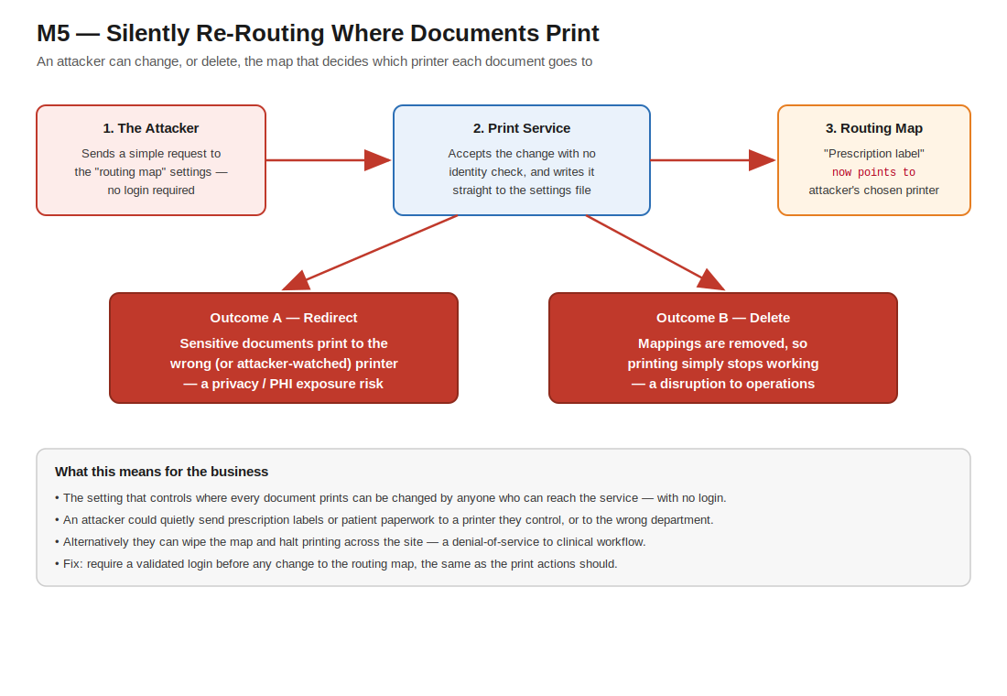
Figure M5 — Attack path: with no login required, an attacker rewrites or deletes the map that decides which printer each document type is sent to.

REMEDIATION
Goal: protect the routing map with the same validated login as printing, validate inputs, and record who changed what.
Step 1. Require authorization on the endpoint
- Ensure the corrected [Authorize] + middleware (Finding 3) covers SetPrintDocTypeMap and its DELETE path.
Step 2. Validate inputs against an allowlist
- Accept only known document types and existing, permitted queue names; reject anything else with 400.
if (!KnownDocTypes.Contains(printDocType)) return BadRequest("Unknown document type");
if (!InstalledQueues.Contains(printQueueName)) return BadRequest("Unknown print queue");
Step 3. Audit every change
- Log each create/update/delete with the authenticated principal, timestamp, old value, and new value.
logger.LogInformation("RoutingMap change by {User}: {DocType} {Old} -> {New} at {Time}",
User.Identity?.Name, printDocType, oldQueue, printQueueName, DateTimeOffset.UtcNow);
✔ Verify: (1) an unauthenticated map change returns 401; (2) an unknown queue name is rejected; (3) a valid change appears in the audit log with the user and timestamp.

REFERENCES
CWE-862: Missing Authorization — cwe.mitre.org/data/definitions/862.html
CWE-639: Authorization Bypass Through User-Controlled Key — cwe.mitre.org/data/definitions/639.html
OWASP Top 10 2021 A01: Broken Access Control — owasp.org/Top10/A01_2021-Broken_Access_Control/

6. Unauthenticated Information Disclosure via Printer Enumeration - Medium | Medium

Summary
Risk Rating: Medium | CVSS 3.1: 4.3 (AV:N/AC:L/PR:N/UI:R/S:U/C:L/I:N/A:N)
Affected component: PrintController read actions (GetPrinterNames, GetPrintersDetail, GetPrinterStatus, GetPrintQueueStatus, GetPrintDocTypeMaps, Ping)
All read-only endpoints require no authentication and, due to the permissive CORS policy, are readable cross-origin by any website. They disclose the workstation's installed printers and print queues, detailed per-printer status (a structure exposing more than thirty fields), and the document-type-to-queue mapping.
In a specialty-pharmacy environment, printer and queue names frequently encode site, department, floor, or device identifiers. Exposing this inventory to any website aids reconnaissance, fingerprinting of the workstation's role, and social-engineering, and confirms the presence and port of the relay to an attacker preparing the higher-severity attacks.

EVIDENCE
Code Source Tracking
Binary File: DesktopPrintRelayService.Host.exe (v1.0.0.5)
File Location: C:\Program Files (x86)\Inovalon\DesktopPrintRelayInstaller\DesktopPrintRelayService.Host.exe
Namespace: ScriptMed.DesktopPrintRelayService
Class: PrintController
Method: GetPrinterNames(), GetPrintersDetail(), GetPrintersStatus(), GetPrintDocTypeMaps(), Ping()
Vulnerable Variable/String: Read actions with no [Authorize]; exposed via permissive CORS
Source (where it comes from): GET routes /printers, /printers/detail, /printers/status, /printers/print-doc-type-maps, /ping
Vulnerable Code Pattern:
GET /printers -> GetPrinterNames // no auth, readable cross-origin
Full Code Snippet (IL-reconstructed):
// Unauthenticated GET endpoints (decompiled route templates and actions)
GET /printers -> GetPrinterNames
GET /printers/detail -> GetPrintersDetail
GET /printers/status -> GetPrintersStatus / GetPrinterStatus
GET /printers/print-doc-type-maps -> GetPrintDocTypeMaps
GET /ping -> Ping
// VULNERABLE: none of these actions carry [Authorize], and the permissive
// CORS policy (see F4) makes the responses readable cross-origin.
// Printer status object exposes: IsOffline, IsInError, IsOutOfPaper,
// IsPaperJammed, HasPaperProblem, NumberOfJobs, ShareName, fullName,
// ... (30+ fields) that leak site/department/host naming conventions.

Unauthenticated GET endpoints observed (decompiled route templates and actions):

GET /printers -> GetPrinterNames
GET /printers/detail -> GetPrintersDetail
GET /printers/status -> GetPrintersStatus / GetPrinterStatus
GET /printers/print-doc-type-maps -> GetPrintDocTypeMaps
GET /ping -> Ping
// Printer status object exposes: IsOffline, IsInError, IsOutOfPaper, IsPaperJammed,
// HasPaperProblem, NumberOfJobs, ShareName, fullName, ... (30+ fields)

Attack Path (Executive View)
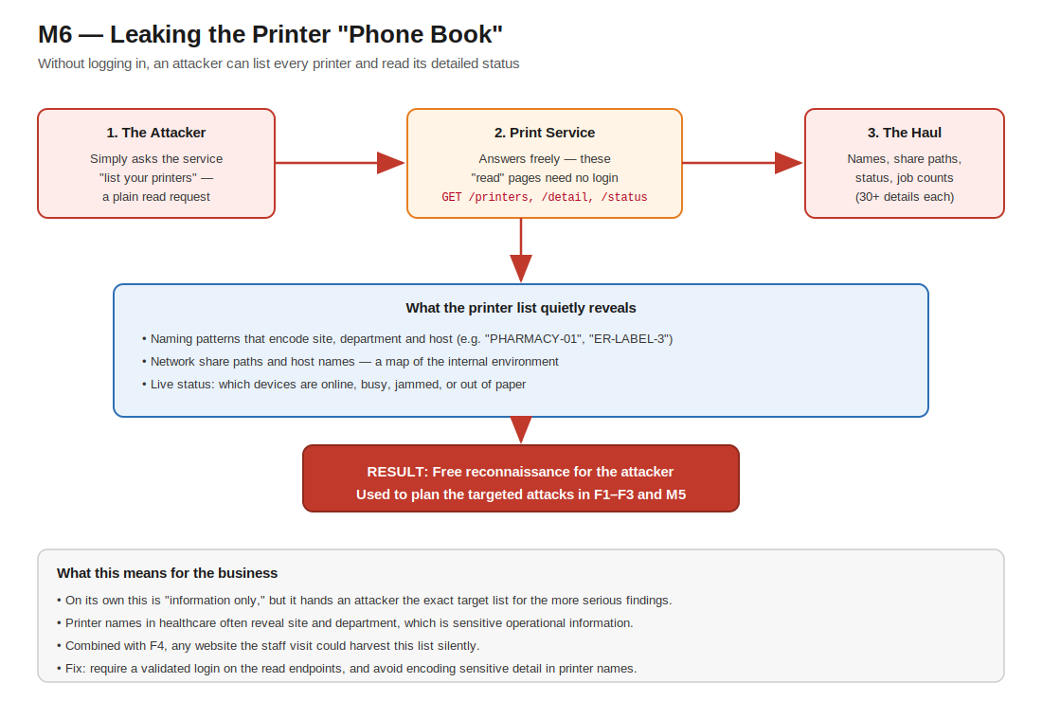
Figure M6 — Attack path: unauthenticated "read" endpoints hand an attacker the full printer list and detailed status, fueling reconnaissance for other findings.

REMEDIATION
Goal: stop unauthenticated reconnaissance by protecting the read endpoints and trimming what they expose.
Step 1. Authenticate the read endpoints too
- The controller-wide [Authorize] from Finding 3 already covers these; confirm GetPrinterNames, GetPrintersDetail, GetPrintersStatus, GetPrintDocTypeMaps and Ping all require a valid token (Ping may stay anonymous if it returns no data).
Step 2. Return only the fields the web app needs
- Project the printer objects to a minimal DTO; drop share names, host names, and internal identifiers.
return printers.Select(p => new PrinterDto {
DisplayName = p.FriendlyName, // no ShareName, no host/UNC paths
IsOnline = !p.IsOffline
});
Step 3. Restrict origins
- Apply the CORS allowlist from Finding 4 so responses are not readable by arbitrary sites.
Step 4. Avoid sensitive detail in printer names
- Where possible, rename queues so they do not encode site/department/host (e.g. avoid "PHARMACY-01-HOSTNAME").
✔ Verify: (1) GET /printers without a token returns 401; (2) the returned JSON no longer contains share names or host identifiers; (3) an unlisted website cannot read the response.

REFERENCES
CWE-200: Exposure of Sensitive Information to an Unauthorized Actor — cwe.mitre.org/data/definitions/200.html
CWE-306: Missing Authentication for Critical Function — cwe.mitre.org/data/definitions/306.html
OWASP Top 10 2021 A01: Broken Access Control — owasp.org/Top10/A01_2021-Broken_Access_Control/

7. End-of-Life and Outdated Components Processing Untrusted Input - Medium | Medium

Summary
Risk Rating: Medium | CVSS 3.1: 6.2 (AV:N/AC:L/PR:N/UI:R/S:U/C:L/I:L/A:H)
Affected components: ASP.NET Core 2.2 runtime, Aspose.PDF 20.10, Newtonsoft.Json 11.0.2, hosted on .NET Framework 4.8
The host ships and runs ASP.NET Core 2.2, which reached end of support in December 2019 and therefore receives no security patches. More significantly, fully attacker-controlled PDF bytes are parsed in-process by Aspose.PDF 20.10 (released October 2020) via PdfViewer.BindPdf, with no isolation or size limiting. Feeding untrusted input to a large, dated document-parsing engine exposes the workstation to memory-safety and availability risks (crash/denial of service, and potential code execution within the parser). Newtonsoft.Json 11.0.2 is likewise several years out of date.
This finding is a function of the runtime and dependency posture rather than a single code path; it compounds the impact of the printing findings because the same untrusted PDF that an attacker can submit unauthenticated is handed directly to the outdated parser.

EVIDENCE
Code Source Tracking
Binary File: DesktopPrintRelayService.Host.exe (v1.0.0.5) + bundled dependency assemblies
File Location: C:\Program Files (x86)\Inovalon\DesktopPrintRelayInstaller\ (assemblies alongside host .exe)
Namespace: ScriptMed.DesktopPrintRelayService (host) + third-party assemblies
Class: ASP.NET Core 2.2 runtime / Aspose.PDF / Newtonsoft.Json (dependency posture)
Method: PdfPrinting.PrintPdf() processes untrusted Base64 PDF via Aspose.PDF 20.10
Vulnerable Variable/String: Kestrel 2.2.0.18316 (EOL), Aspose.PDF 20.10.0.0 (2020), Newtonsoft.Json 11.0.2, .NET Framework 4.8
Source (where it comes from): Component versions extracted from the installer payload (MSI File table / assembly versions)
Vulnerable Code Pattern:
bytes = Convert.FromBase64String(base64); // fed to Aspose.PDF 20.10 (2020 build)
Full Code Snippet (IL-reconstructed):
// Component versions extracted from the installer payload (MSI File table)
Microsoft.AspNetCore.Server.Kestrel.Core.dll 2.2.0.18316 (ASP.NET Core 2.2 - EOL Dec 2019)
Aspose.PDF.dll 20.10.0.0 (~35 MB, released 2020-10)
Newtonsoft.Json.dll 11.0.2
Target framework (exe.config) .NETFramework v4.8
// Untrusted print path (decompiled, PdfPrinting.PrintPdf):
bytes = Convert.FromBase64String(base64); // attacker-controlled PDF bytes
// ... handed to Aspose.PDF 20.10 for rendering/printing ...
// VULNERABLE: an end-of-life runtime and a 2020-era PDF library parse
// attacker-supplied documents; no patches for known CVEs in these versions.

Component versions extracted from the installer payload (MSI File table / assembly versions):

Microsoft.AspNetCore.Server.Kestrel.Core.dll 2.2.0.18316 (ASP.NET Core 2.2 - EOL 2019-12-23)
Aspose.PDF.dll 20.10.0.0 (~35 MB, released 2020-10)
Newtonsoft.Json.dll 11.0.2
Target framework (exe.config) .NETFramework v4.8

Untrusted print path (decompiled, PdfPrinting.PrintPdf): bytes = Convert.FromBase64String(base64); stream = new MemoryStream(bytes); viewer.BindPdf(stream); viewer.PrintDocumentWithSettings(printerSettings); — no size cap, no sandbox.
Attack Path (Executive View)
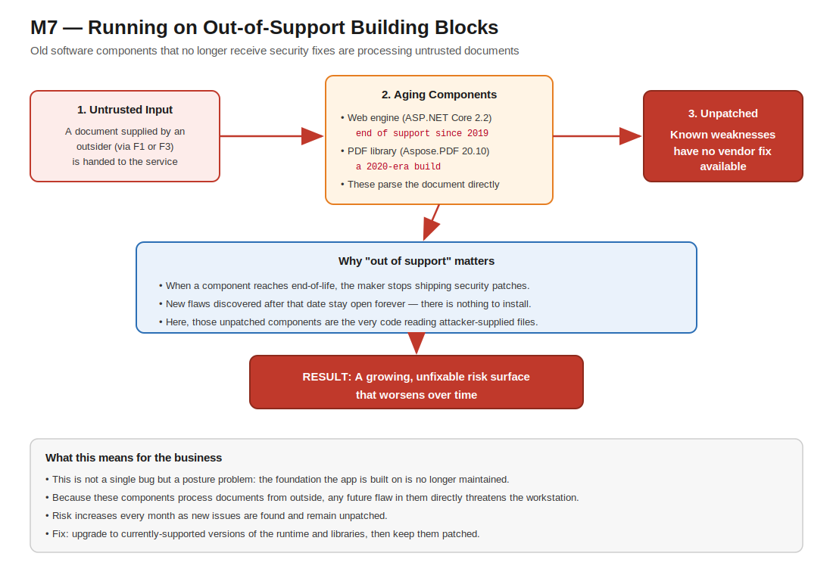
Figure M7 — Attack path: end-of-life runtime and a 2020-era PDF library — which no longer receive security fixes — parse attacker-supplied documents.

REMEDIATION
Goal: get back onto supported, patchable components and isolate untrusted PDF parsing. Plan as a short project, not a one-line change.
Step 1. Re-platform onto a supported .NET LTS release
- Target a supported LTS (e.g. .NET 8). Update the project file and replace ASP.NET Core 2.2 packages with current equivalents.
<!-- project.csproj -->
<TargetFramework>net8.0</TargetFramework>
<!-- remove Microsoft.AspNetCore.* 2.2.* package refs; use the in-box ASP.NET Core shared framework -->
Step 2. Upgrade the third-party libraries
- Move Aspose.PDF and Newtonsoft.Json to current supported versions; consider System.Text.Json where feasible.
dotnet add package Aspose.PDF # latest supported
dotnet add package Newtonsoft.Json # latest 13.x, or migrate to System.Text.Json
Step 3. Add dependency scanning to CI
- Fail the build on known-vulnerable packages so this posture cannot silently regress.
# CI step
dotnet list package --vulnerable --include-transitive
Step 4. Constrain and isolate PDF parsing
- Enforce a maximum PDF size, and render/parse untrusted PDFs in a separate low-privilege, sandboxed process so a parser compromise cannot reach the host.
if (pdfBytes.Length > MaxPdfBytes) return BadRequest("PDF too large");
// hand parsing to a sandboxed worker process / container with no network + least privilege
✔ Verify: (1) the app runs on the new runtime; (2) dependency scan reports no known-vulnerable packages; (3) an oversized PDF is rejected; (4) the parsing worker runs under a restricted account.

REFERENCES
.NET and .NET Core support policy — dotnet.microsoft.com/platform/support/policy/dotnet-core
CWE-1104: Use of Unmaintained Third Party Components — cwe.mitre.org/data/definitions/1104.html
CWE-20: Improper Input Validation — cwe.mitre.org/data/definitions/20.html

8. Constrained Server-Side Request Forgery via X-ProviderValidationUrl - Low | Low

Summary
Risk Rating: Low | CVSS 3.1: 3.5 (AV:N/AC:H/PR:N/UI:R/S:U/C:L/I:N/A:N)
Affected component: PrintController.isUserTokenValid outbound HTTP request
As part of token validation, the relay issues a server-side HTTP POST to the URL provided in the X-ProviderValidationUrl header. An attacker can therefore induce the workstation to make outbound POST requests to hosts and paths of their choosing, subject to the constraint that the URL must contain the substring "okta". The response success/error condition acts as a limited oracle.
Exploitability is constrained by the "okta" substring requirement and the absence of response reflection to the caller, which is why this is rated Low. It is nonetheless an attacker-influenced outbound request originating from inside the user's network and is fully remediated by the fix for the Critical finding.

EVIDENCE
Outbound request construction (decompiled, isUserTokenValid): client.BaseAddress = new Uri(scheme + "://" + host) where host derives from the attacker-supplied header; client.SendAsync(req) is then issued. See the Critical finding for the full reconstruction.

REMEDIATION
Goal: eliminate the caller-controlled destination so the relay cannot be steered to attacker infrastructure.
Step 1. Use a fixed, server-configured endpoint
- Apply the Finding 1 fix: the outbound validation target comes from configuration, never from request input.
Step 2. Enforce egress allowlisting
- At the host/network layer, permit outbound validation traffic only to the known Okta tenant host(s); deny all other egress from the service.
✔ Verify: (1) the service cannot make outbound requests to any host other than the configured Okta tenant; (2) supplying a different validation host has no effect on where the relay connects.

REFERENCES
CWE-918: Server-Side Request Forgery (SSRF) — cwe.mitre.org/data/definitions/918.html
OWASP Top 10 2021 A10: Server-Side Request Forgery — owasp.org/Top10/A10_2021-Server-Side_Request_Forgery_%28SSRF%29/

9. Unsigned Application Binaries and Installer - Low | Low

Summary
Risk Rating: Low | CVSS 3.1: 4.4 (AV:L/AC:L/PR:N/UI:R/S:U/C:N/I:H/A:N)
Affected components: setup.exe, DesktopPrintRelayInstaller.msi, DesktopPrintRelayService.Host.exe
None of the delivered artifacts is Authenticode-signed: the executables contain no certificate table and the MSI contains no digital-signature stream. Users and endpoint controls therefore have no cryptographic assurance of the software's authenticity or integrity. A tampered or trojanized build cannot be distinguished from a legitimate one, and publisher-based allow-listing controls (SmartScreen reputation, AppLocker/WDAC publisher rules) cannot be applied.

EVIDENCE
Signature verification performed during the assessment:

setup.exe PE Security directory size = 0 -> UNSIGNED
DesktopPrintRelayService.Host.exe PE Security directory size = 0 -> UNSIGNED
DesktopPrintRelayInstaller.msi no \x05DigitalSignature stream -> UNSIGNED

REMEDIATION
Goal: make build authenticity verifiable end-to-end so tampered or spoofed binaries are rejected.
Step 1. Authenticode-sign all artifacts
- Sign both executables and the MSI with an organization (preferably EV) code-signing certificate, and add a trusted timestamp so signatures remain valid after the cert expires.
signtool sign /fd SHA256 /tr http://timestamp.digicert.com /td SHA256 ^
/a DesktopPrintRelayService.Host.exe setup.exe DesktopPrintRelayInstaller.msi
Step 2. Verify on deployment
- Distribute through a trusted channel and enforce publisher rules so only signed, known-publisher builds run.
signtool verify /pa /all DesktopPrintRelayInstaller.msi
# plus AppLocker / WDAC publisher rule allowing only your signing identity
✔ Verify: (1) signtool verify succeeds on every artifact; (2) an unsigned or re-signed build is blocked by the publisher policy.

REFERENCES
CWE-347: Improper Verification of Cryptographic Signature — cwe.mitre.org/data/definitions/347.html
Authenticode code signing — learn.microsoft.com/windows-hardware/drivers/install/authenticode

10. Over-Permissive HTTP URL ACL Reservation (Everyone) - Low | Low

Summary
Risk Rating: Low | CVSS 3.1: 3.3 (AV:L/AC:L/PR:L/UI:N/S:U/C:N/I:L/A:L)
Affected component: Utils.RegisterServiceUrl (startup)
During startup the application executes netsh http add urlacl url=http://<hostname>:<port>/ user=everyone, granting the Everyone group the right to reserve and bind that HTTP URL namespace. While the relay's listener uses Kestrel sockets bound to loopback (so this http.sys reservation is largely vestigial today), granting the namespace to Everyone is poor hygiene: any local user may reserve the namespace, and were any http.sys-based listener introduced, it could enable local namespace hijacking or squatting.

EVIDENCE
Reconstructed Utils.RegisterServiceUrl (decompiled from IL):

url = "http://" + Dns.GetHostEntry("").HostName + ":" + port;
StartProcess("netsh", "http add urlacl url=" + url + " user=everyone");
// Listener actually binds via Kestrel: options.Listen(IPAddress.Loopback, port)

REMEDIATION
Goal: remove the over-broad http.sys reservation; Kestrel does not need it.
Step 1. Remove or scope the reservation
- Delete the netsh urlacl step. If a reservation is genuinely required, scope it to the specific low-privilege service account instead of Everyone.
netsh http delete urlacl url=http://+:PORT/
# if truly required, scope to the service account:
netsh http add urlacl url=http://127.0.0.1:PORT/ user="DOMAIN\svc-printrelay"
Step 2. Bind explicitly to loopback
- Continue binding only to 127.0.0.1 and document the intended listener model.
✔ Verify: (1) no urlacl entry grants Everyone; (2) the service still starts and listens on 127.0.0.1 only (netsh http show urlacl).

REFERENCES
CWE-732: Incorrect Permission Assignment for Critical Resource — cwe.mitre.org/data/definitions/732.html
UrlPrefix / URL ACL reservations — learn.microsoft.com/windows/win32/http/add-urlacl

11. Local Persistence and Configuration Hygiene - Info | Info

Summary
Risk Rating: Informational
Affected components: Run-key autostart, registry-sourced settings, application logging
The relay registers itself for automatic startup via the Windows Run key, and with the shipped default SecureVersion=False it reads its autostart entry and configuration from the per-user (HKCU) hive, which is writable by the logged-in standard user. The listening port is likewise sourced from user-writable settings. Verbose logging is enabled by default (EnableLog=True). None of these is directly exploitable for privilege escalation, but collectively they widen local tamperability and create the possibility of sensitive data appearing in log files.

EVIDENCE
Configuration defaults (exe.config userSettings) and registry selection (decompiled Utils.getRegistryKey):

RunAtStartup = True SecureVersion = False EnableLog = True
getRegistryKey(): SecureVersion ? HKLM\...\CurrentVersion\Run : HKCU\...\CurrentVersion\Run
AppSettingsLoader.Load(): Port read from registry (user-writable when SecureVersion=False)

REMEDIATION
Goal: tighten persistence and configuration hygiene so settings and logs cannot be abused or leaked.
Step 1. Protect configuration and persistence
- Where feasible, store autostart and configuration under a machine-protected location (HKLM with administrator-only ACLs) and ship a secure default for SecureVersion.
Step 2. Review log contents and retention
- Ensure logs exclude PHI and secrets, are access-controlled, and are rotated/retained per policy; confirm the existing log-purge behavior meets requirements.
✔ Verify: (1) configuration keys are not user-writable; (2) SecureVersion defaults to the hardened value; (3) sample logs contain no PHI or secrets and rotate as required.

REFERENCES
CWE-276: Incorrect Default Permissions — cwe.mitre.org/data/definitions/276.html
CWE-532: Insertion of Sensitive Information into Log File — cwe.mitre.org/data/definitions/532.html

