**Accomplishment Summary Report**

Prepare By: John Michael P. Masmela

May 1-15, 2023

May 1 2023

-Holiday

May 2 2023

**-Work Gobal:**

-Admin Page design progress 100%

-applicant remarks/status where in table remark as in interview and pass progress 100%

-admin add applicant where applicant doesn’t need to create account it is for those in face to face

May 3 2023

**-Job Access:**

Re editing Sign-up page progress 100%

Adding Applicant profile page progress 100%

**-Other:**

Creating two Dummy account in facebook

May 4 2023

**Both website:**

-Admin page include all pages design and function progress 100%

May 5 2023

-checking and debugging the website

-fixing all bug both in function and design

May 6 2023

-Absent

May 8 2023

-starting the design revision of employer dashboard and profile

May 9 2023

-Employer profile Page dashboard and profile progress 70%

May 10 2023

-manual of work global and website revision dashboard and profile progress 100%

May 11 2023

- work global manual On going 50%

-website revision 10%

May 12 2023

-Working on Work Global User Instruction Manual document (ongoing from 50% - 80%)

-Website debugging and design revisions 30%

May 13 2023

Website revision design and function employer dashboard design done

Username and password design done

User page design done

Still ongoing(30%-40%)

May 15 2023

-website design revision 45%

**New**

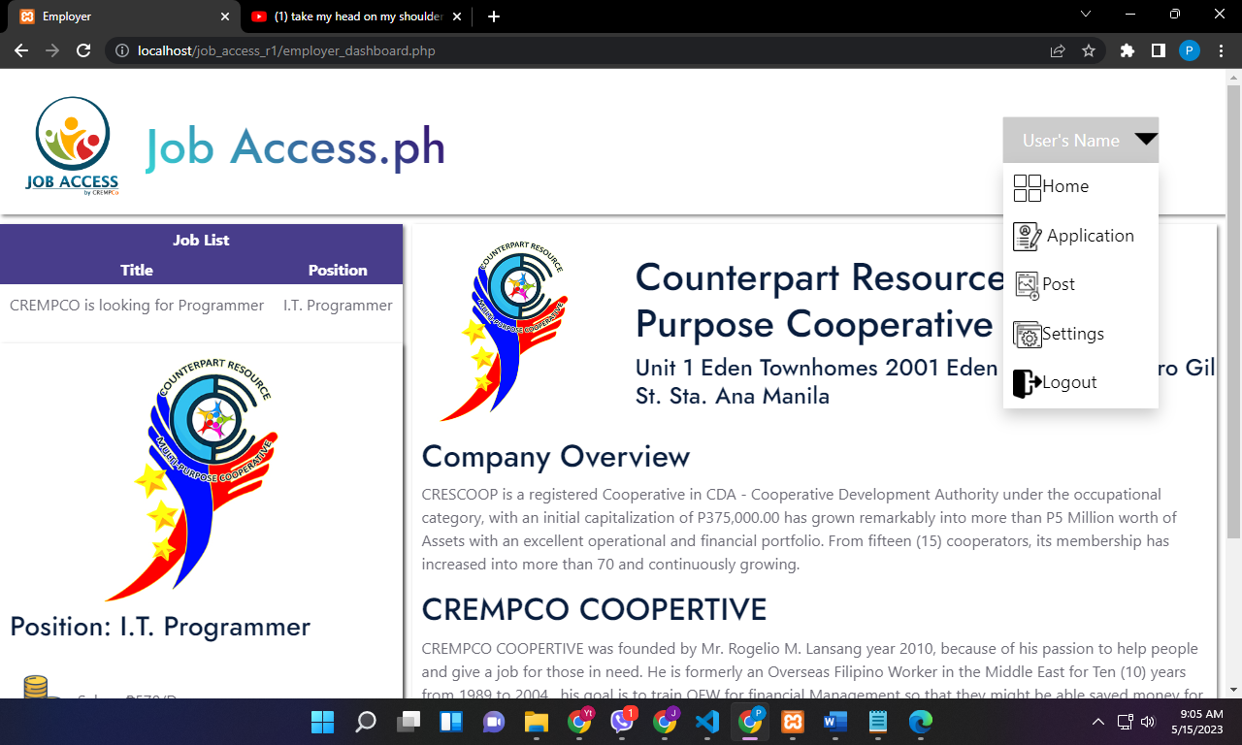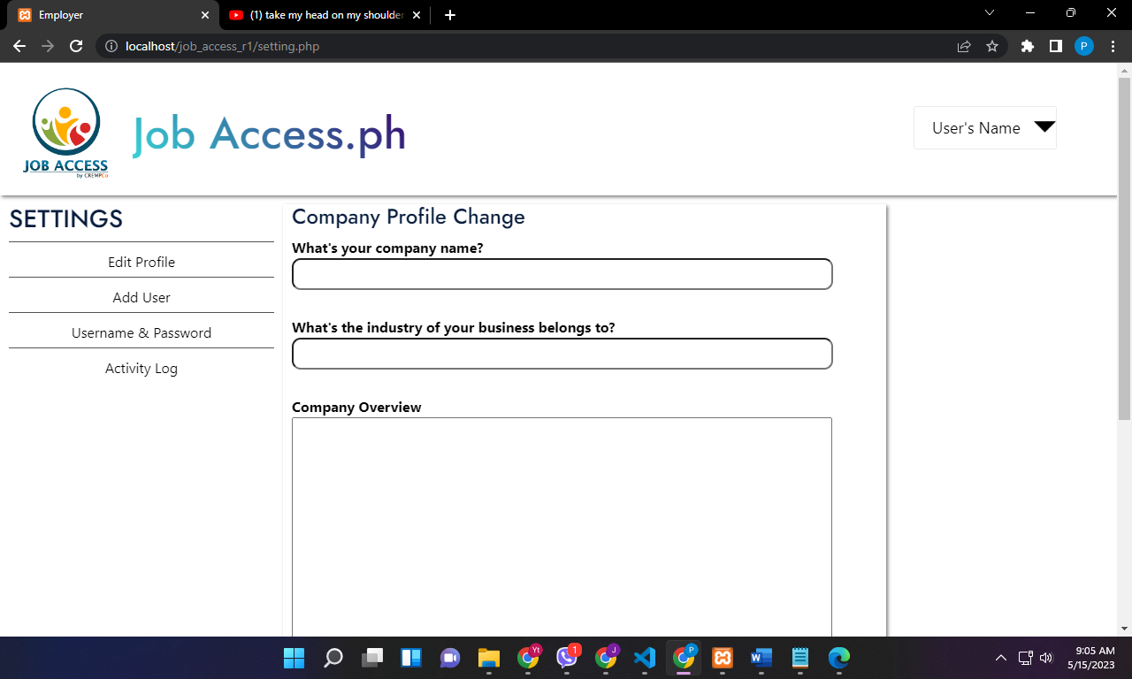

**Old**

