|  |  |
| --- | --- |
| **Michael M. Mitchell**  **(858) 842-0411** | **1431 Rainbow Ridge Ln.**  **Encinitas, CA 92024**  [**github.com/MichaelMitchellM**](https://github.com/MichaelMitchellM) |

**Education**

**UC San Diego** **Fall 2015 – Present**

Major: Mathematics-Computer Science (BS)

**MiraCosta Community College** **Fall 2012 – Spring 2015**

AA in Liberal Arts Emphasis in Math and Science 12-13-2014

Certificate of Achievement in IGETC (Honors) 12-13-2014

AA in Computer Science 05-22-2015

**Work Experience**

**Prizmiq -** Software Development Intern **Feb. 2015 – June 2015**

* Managed AWS EC2 instances
* Created a program to render a heatmap based on 3D analytics on a AWS GPU instance
* Made a server to take in a 3D model and generate and return a sprite.

**UC San Diego -** Upper Division Math Tutor **Aug. 2016 – Sept. 2016**

Tutored incoming transfer students in an upper division mathematics class centered around math proofs.

**Languages**

**Dw**

**Skills**

**Visual Studio, Entity Component System, Vulkan, OpenGL 3.3,**

**Git, Linux, WinApi, Networking, Parallel Programming/atomics**

**Awards**

**ACM International Collegiate Programming Contest (SoCal Regional)**

First Runner Up for Community Colleges (MCC Code Surfers) 2014

First Runner Up for Community Colleges (MCC Code Techs) 2013

**Projects**

**New Eden Map Viewer (Java/OpenGL) Fall 2013**

I built 3D intractable viewer for a map from the game EVE: Online. I used game developers publicly available database to generate a graph of all the star systems and the connections between the star systems. Using this graph, I implemented a path finding algorithm that finds the shortest path between any two systems and displays it on the 3D map.

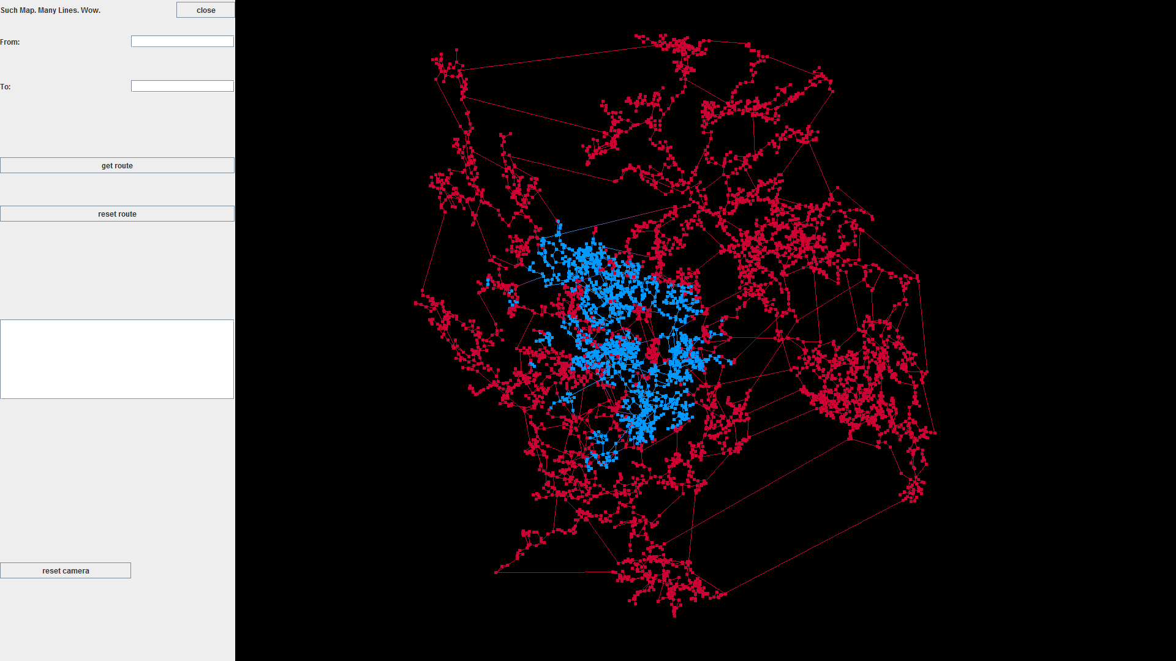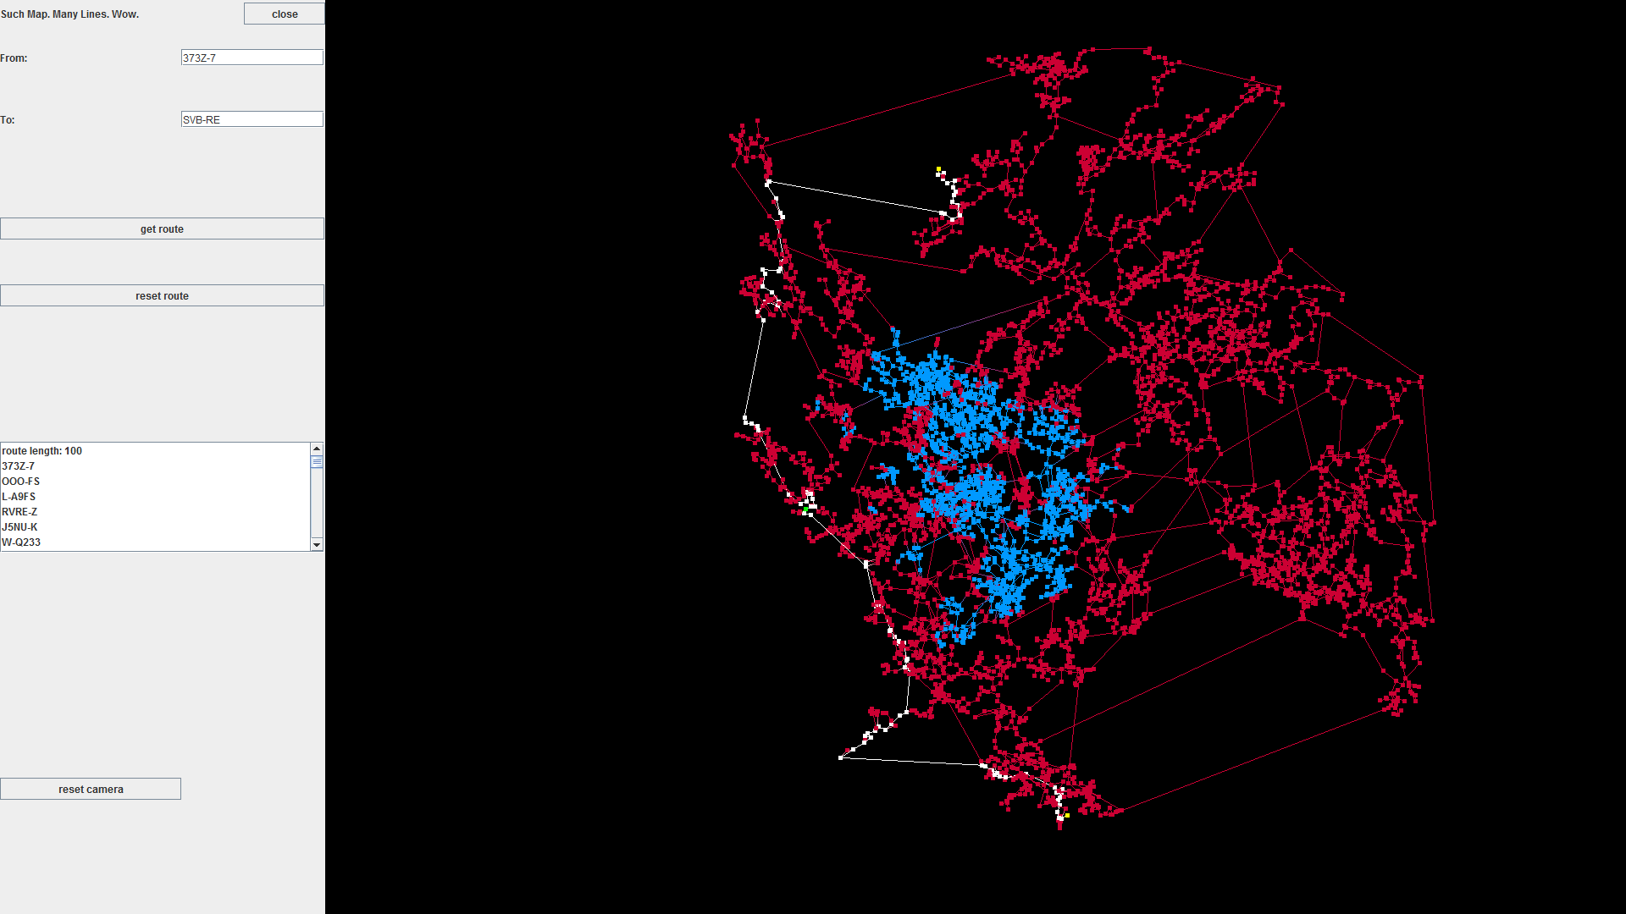

**Ray Tracer (C++) Fall 2014**

I built a C++ program that takes in a list of basic shapes and point lights and generates a color image based on their 3D locations and assigned colors. The program also uses the location and luminescence of the point lights to cast shadows and determine the intensity of the color on each rendered object.

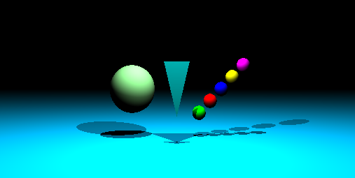

**3D Model Heat Map Server (C++11) Spring 2015**

At Prizmiq I was given a project to build a server that takes in a 3D model and a list of points that the model was viewed at. With this data I used an AWS EC2 g2.2xlarge instance to calculate with OpenGL how much each triangle in the model was viewed. I then took this data and generated a heat map texture that when applied to the original model shows how much each part of the model was looked at.

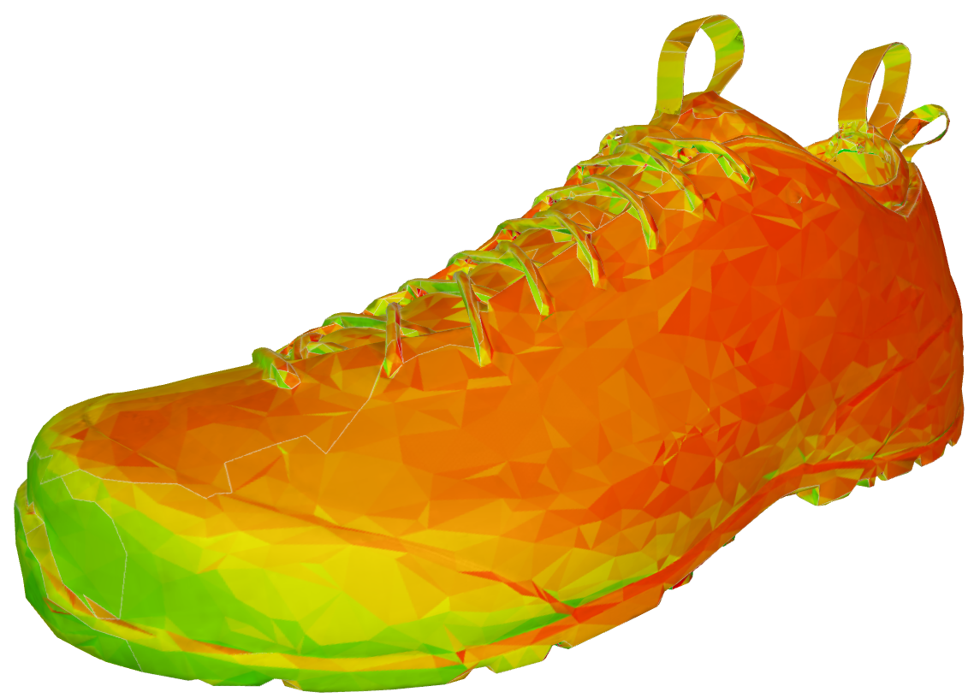

**Concurrent Queue (C++14) Spring 2015**

To practice concurrent programming, I attempted to implement a concurrent queue with the use of atomics. To make it a little more interesting I based my queue off an array instead of a linked list.

<github.com/MichaelMitchellM/AtomicQueue>

**Big Number (C++14) Summer 2015**

I implemented functions to add, subtract, multiply, and divide a 2048-bit unsigned integer. In addition, I used a primality test to determine if the number was likely a prime and if not find the next number that is a probable prime.

[github.com/MichaelMitchellM/BigNumber](https://github.com/MichaelMitchellM/BigNumber)