# Symmetric Key Encryption Assignment.

# Introduction.

An assignment was given where the goal was to:

1. Generate a symmetric key with OpenSSL (Use any of your favorite symmetric key algorithms).
2. Create a text file called BBIT4Exempt.txt.
3. Use the symmetric key to encrypt the message.
4. Use the same key to decrypt any message that was encrypted.

To achieve optimal results the following tools were used:

1. Kali Linux operating in vmware.
2. ChatGpt.

## Advanced Data Encryption (AES).

The first method used to do the data encryption using AES but is deprecated. To avoid this the command line suggested using -iter or -pbkdf2 would be better.

### Deprecated Method.

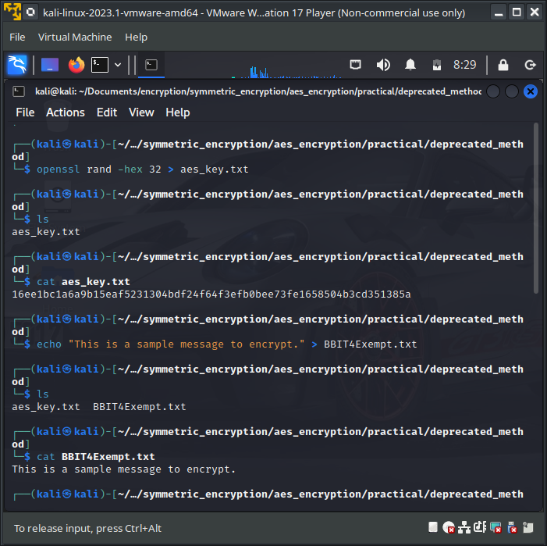

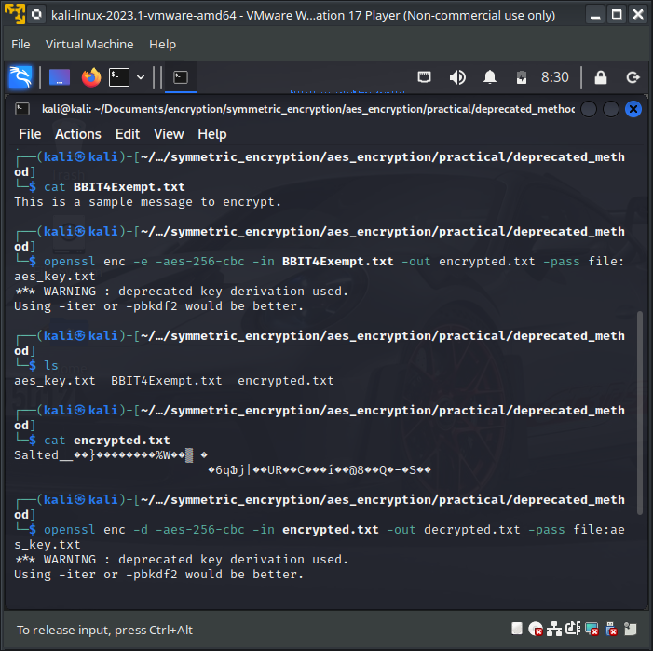

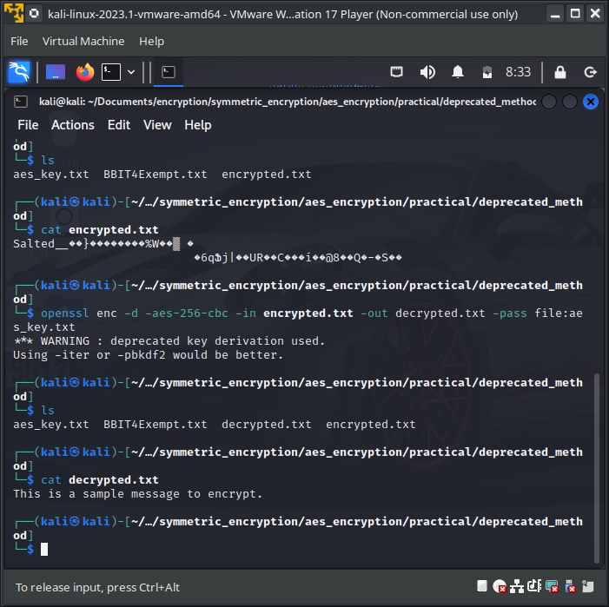

### 1.1. Using pbkdf2.

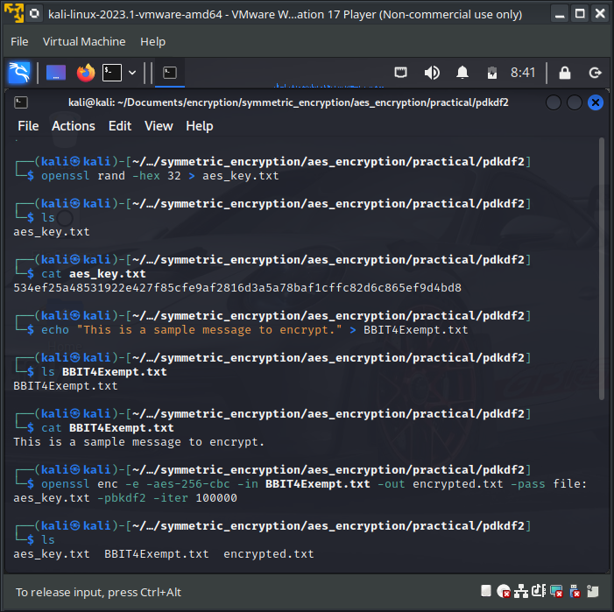

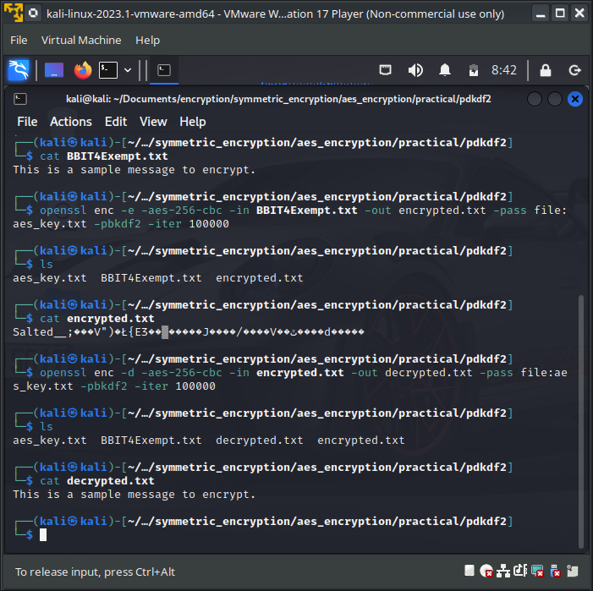

### 1.2. Using Iter.

