Junior Backend developer

- What to use
Go
PostgreSQL
Docker

To run your project use:
docker-compose -f docker-compose.yml up -d.
Run you project using default values, set in a configuration files,(including .env)

Task:
Implement authentification service. Service should provide four ending API points
- for a received couple tokens (access and refresh) for a user with an identifier (GUID)
set in a request parameter
- for a token updating
- getting current GUID of a user(route should be protected)
- de authentification (after this request with an access token, user should have a route to get his GUID and token update operation)

Requirements:

Requirements to an access token
1. token format – JWT
2. algorithm for a token – sha512
3. storing token in a database is strictly
prohibited

Requirement to a refresh token

1.token format – choose whatever you want
2.pass token only in a base64 format
3. store token in a database using bcrypt hash
4. protect token from repeated use
5. protect token from modifying it on a client side

Requirements to a refresh operation

1. Refresh operation can be implemented only with those pair of tokens, that were received together.

2. You need to prohibit token update operation when you change user-agent. After unsuccessful attempt, you need to de auhterise user.

3. When you try to update tokens, with a new IP, you need to send POST-request on a set webhook with an information about an attempt to use another IP. There is no need to prohibit operation

Result :
Provide a result with a github url

-have a docker file and docker compose
- write a swagger documentation

Dive into the details

Access token vs Refresh token

Access token :

Access tokens are used in token-based authentication to allow an application to access an API. The application receives an access token after a user successfully authenticates and authorizes access, then passes the access token as a credential when it calls the target API.

JWT access tokens

JSON Web Token (JWT) access tokens conform to the JWT standard and contain information about an entity in the form of claims. They are self-contained therefore it is not necessary for the recipient to call a server to validate the token.

Sample

This example shows the contents of an access token. Notice that the token only contains authorization information about the actions the application is allowed to perform at the API (such permissions are referred to as scopes).
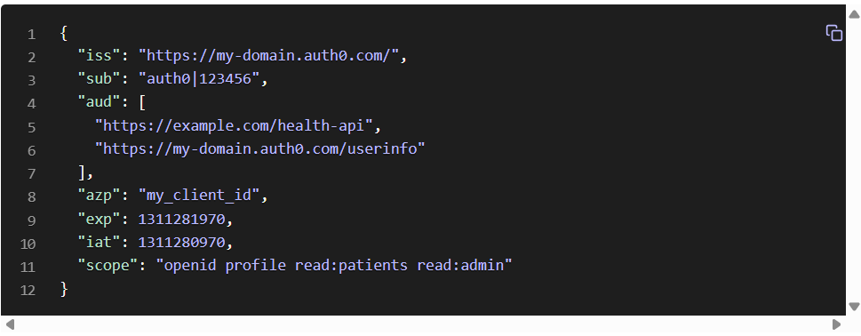
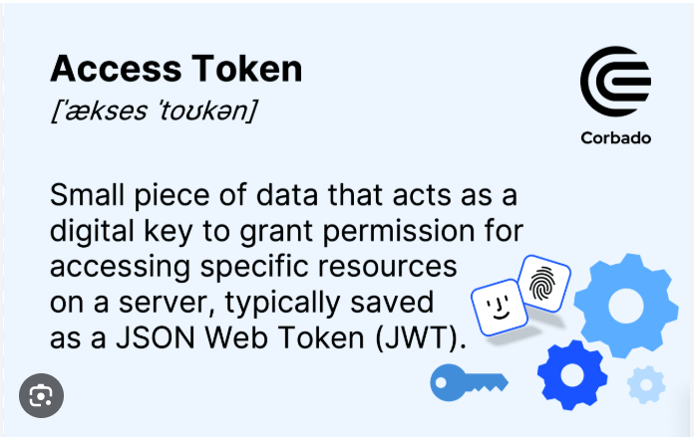

Access tokens: As mentioned, these tokens allow users access to certain resources. They often have a short lifespan (typically ranging from minutes to hours) to ensure security. Once expired, the user cannot access the resources until they obtain a new token.
- Refresh tokens: These tokens have a longer lifespan and are used to obtain new access tokens once the original ones expire. By using a refresh token, users don't have to re-enter their credentials, ensuring a smooth user experience.

Access tokens info
https://www.descope.com/learn/post/access-token

Refresh tokens

Tokens are pieces of data that carry just enough information to facilitate the process of determining a user's identity or authorizing a user to perform an action. All in all, tokens are artifacts that allow application systems to perform the authorization and authentication process.

As mentioned, for security purposes, access tokens may be valid for a short amount of time. Once they expire, client applications can use a refresh token to "refresh" the access token. That is, a refresh token is a credential artifact that lets a client application get new access tokens without having to ask the user to log in again.

https://auth0.com/blog/refresh-tokens-what-are-they-and-when-to-use-them/

Refresh token info

JWT(Jason web tokens)

JWT (short for JSON Web Token and pronounced “jot”) is an open standard used to create compact, self-contained tokens used for securely transmitting information between different applications or services. These tokens are typically used for authentication and authorization, as they can contain information that verifies the identity of a user, and their permissions.

Structure of a JWT

The three main components of a JWT are the:
- Header
- Payload
- Signature

The header is a JSON object that typically contains two properties: The type of token (JWT) and the encryption algorithm used (e.g., HMAC SHA256, RSA, etc).
Example of JSON header:
{
Open menu
"alg": "HS256",
"typ": "JWT"
}

The payload is another JSON object where all of the transmitted data lives. Also called a claim, this data typically contains user information (username, email address), session data (IP address, time or last login), or authorization permissions (roles or groups the user belongs to).
There are four types of claims:
- Commonly used: Registered and public
- Not commonly used: Private and custom
Example of JWT payload:
{
Open menu
"drn": "DS",
"exp": 1680902696,
"rexp": "2023-05-05T21:14:56Z"
}

https://www.descope.com/learn/post/jwt

Now learn a little bit about docker

Docker basic information

https://www.youtube.com/watch?v=Ud7Npgi6x8E&t=290s

Docker compose
https://www.youtube.com/watch?v=HGKfE-cn9y4

Implementing application:

https://www.youtube.com/watch?v=ma7rUS_vW9M

for now best implementation

additional stuff
https://medium.com/monstar-lab-bangladesh-engineering/jwt-auth-in-go-dde432440924
https://medium.com/monstar-lab-bangladesh-engineering/jwt-auth-in-go-part-2-refresh-tokens-d334777ca8a0

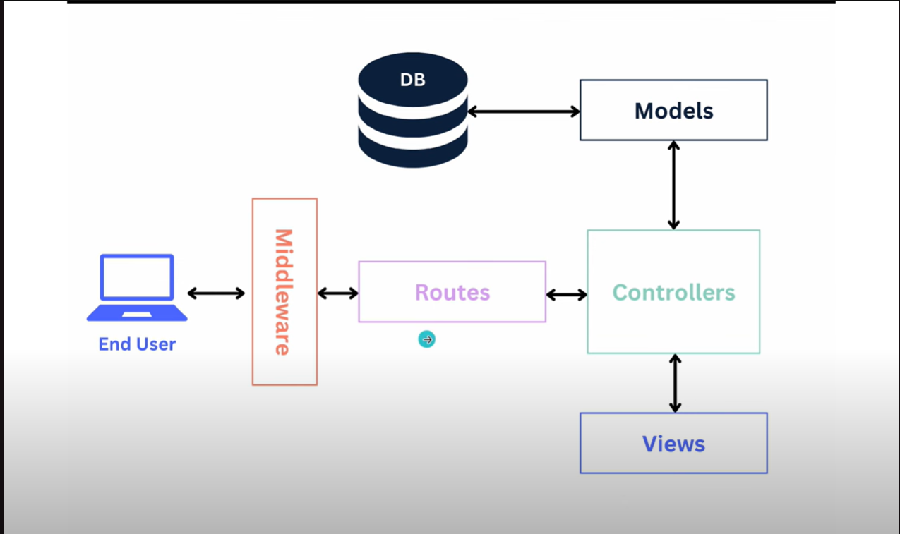

https://reliasoftware.com/blog/golang-jwt-authentication

protecting routes

https://iniakunhuda.medium.com/building-secure-jwt-authentication-in-go-with-postgresql-94b6724f9b75

for now best video there

https://www.youtube.com/watch?v=HtsEaKuYY2o&t=1686s

run only this

https://www.youtube.com/watch?v=ma7rUS_vW9M

