Michael Neas

CSE 2102

Professor: Therese Smith

Github.uconn.edu/mrn11001/OddJobs

**Test Driven Design, Structural models, and Behavioral models**

**Submit Screen Shots of the Following**

A. Produce your own screenshots of (1) test code, (2) test results and (3) development code as you go through three tests worth of test driven development.

Job Class

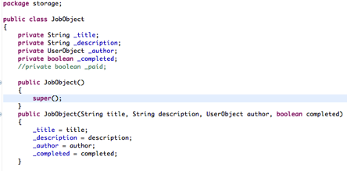

Karma Manipulation Class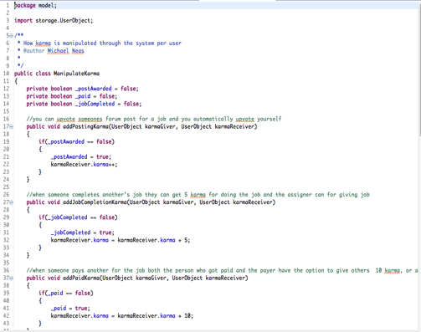

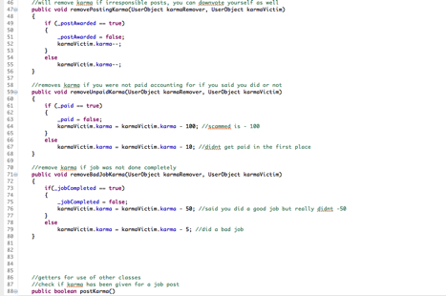

User Class

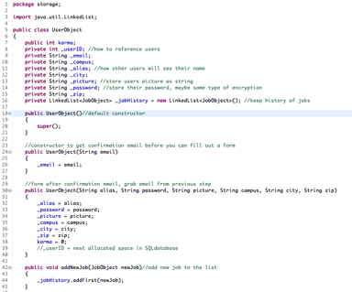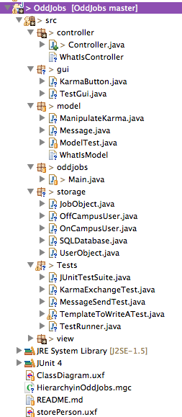

Testing Job, User, and manipulation classes

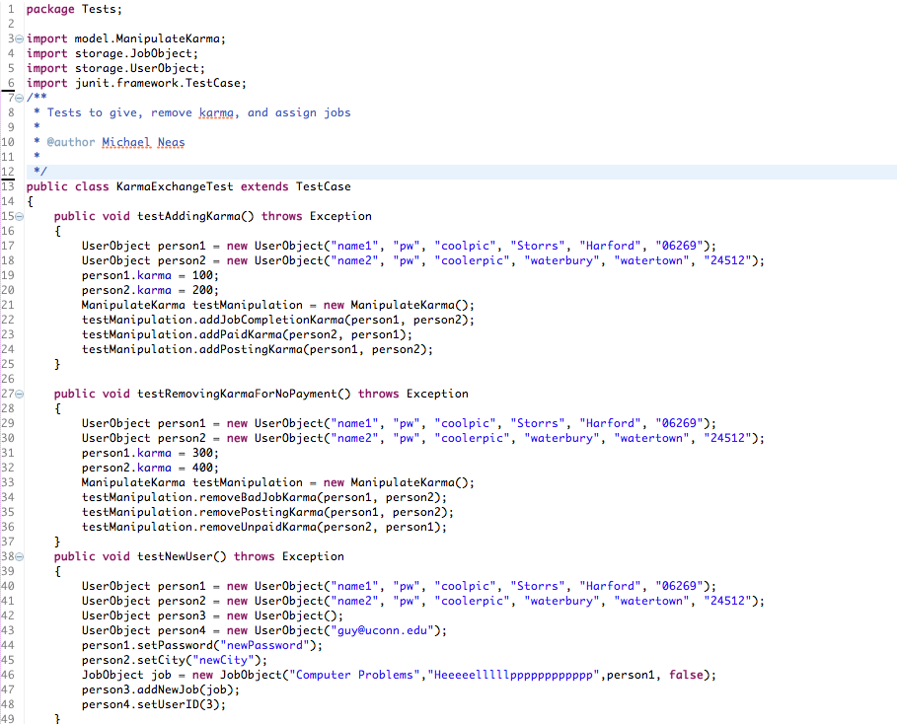

Outcomes

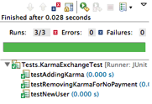Macintosh HD:Users:Neas:Desktop:Screen Shot 2015-02-25 at 6.28.41 PM.png 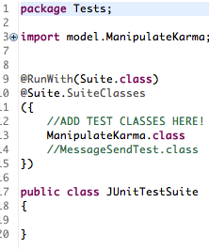

Tests From JUnit

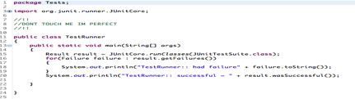

B. Use the X-Ray tool on your team's reference project.

Just a section of the System Complexity of Rapla

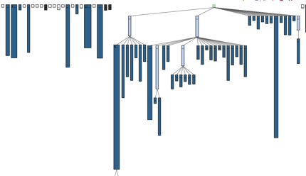

Package Dependency Structure of Rapla, focused on XML

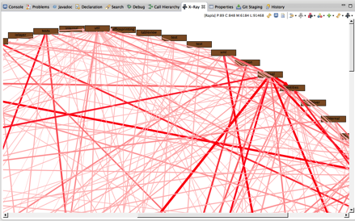

C. Apply the X-Ray tool to your own project.

We’re still in the early processes of development but this is my individual class and package dependency diagram from X-Ray from my tests.

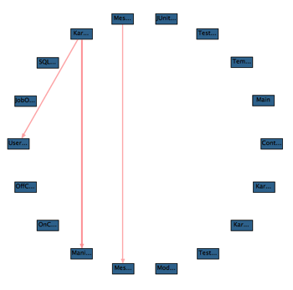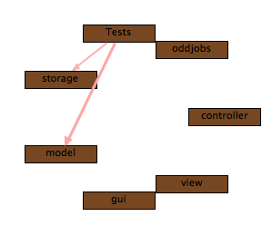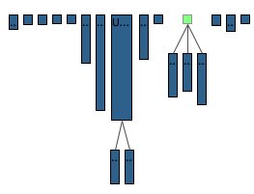

D. Use any of the UML class diagram tools to prepare UML generalization/specialization hierarchy models from your team's reference project.

This is a hierarchy of the AllocatableSelection class from Rapla, the class extends RaplaGUIComponent, which further extends RaplaComponent. Without this hierarchy, implementation of the other methods and classes derived from there would be much more difficult.

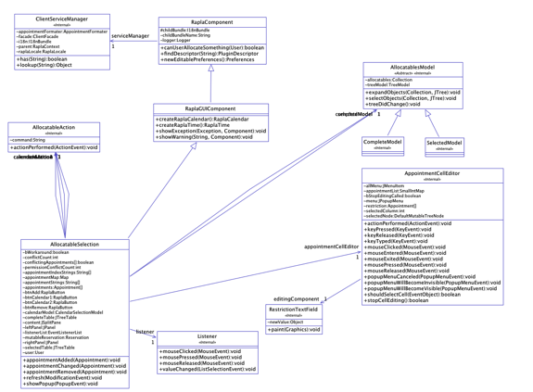

E. Apply this technique to your design-development project.

This is again the independent hierarchical class structure of my user class.

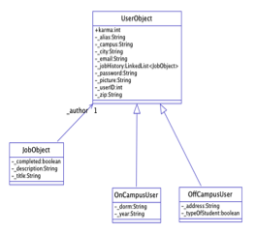

F. Use any of the UML sequence diagram tools to prepare UML sequence diagram (behavioral) models from your team's reference project.

Static Sequence diagram from Rapla where in the interactions are static based.

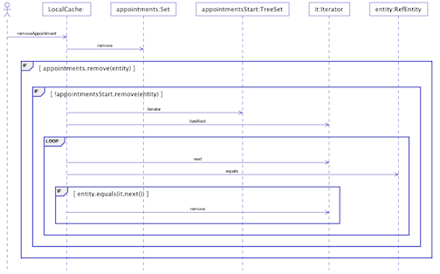

The interactions in the cache here are user dependent and rely on executable code.

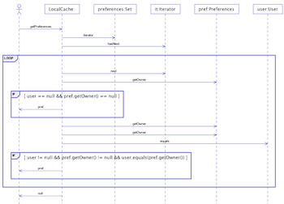

G. Apply this technique to your design-development project, to obtain static sequence diagrams, and, if SDK1.7 is available, also dynamic sequence diagrams.

Basic static sequence diagram since our program is in SDK 1.5, where a job is added to the list of jobs a user has done.

