Odd Jobs Official Document

Team: Mike, Joey, Akshara, Brianna

Requirements

Functional:

- login page/allow user to login

- just need email to contact, not shared with other users

- add user/create account

- allow user to post multiple jobs

- set job description, reward amount, date, etc.

- job listings page (can scroll through, sort by criteria, etc.)

- allow user to select a job and contact user through app

- payment in person/confirm, maybe integrate paypal into app

- messaging system for users?

- allow user to confirm that job has been completed, award karma

- allow worker to confirm payment (?), or pay upon completion

- update karma amounts on user profiles

- karma for paying

- karma for completing job

- allow users to update profile

- change password, profile picture, etc.

- take down job posting after user has confirmed completion/payment

Non-functional:

- response time → forum response

- nice design (minimalist/alluring)

- disclaimer page (we aren’t responsible for murders or muggings)

- self sustainability

- easy to use

**Project to build:** Android application for odd jobs.

Apprenticeship Project: Rapla ([Resource Scheduler](http://courses.engr.uconn.edu/moodle/pluginfile.php/227/mod_resource/content/1/instructorGuideCSE2102.pdf))

**Write a story of how the app will be used:**

Someone wants a odd job done, but they don’t have friends. So they’re trying to enlist some random stranger to do their work for them. They use an app to make an odd job posting in the area, offering imaginary internet points as a reward. Someone responds, finishes the job, and gets their imaginary, useless karma. The end.

As a college student with little financial support, I want an application that provides me with various work orders I can complete for cash.

As a college student who requires assistance to complete a job, I want an application that can tell thousands of reliable people that I will pay them to help me.

**Things to consider?**

- SEMAT cards and the software lifecycle process …

-Reward system in the 2.0 version =D

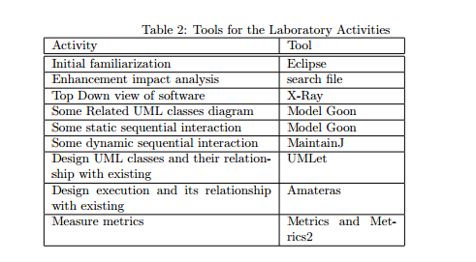

Model (guts/storing info), View (GUI), Controller (interaction)

**Sorting criteria**: academic, manual labor, technical, miscellaneous

- start by showing all categories, starting with most recent

- drop down menu to uncheck categories and limit searches

**COLOR SCHEME**

gray (background) - #666666

secondary gray - #cccccc (or at 50% opacity #50cccccc)

ice blue - #6699cc

white - #ffffff

<http://developer.android.com/guide/index.html>

**How to get the git stuff**

1. get the github link to our project, <https://github.uconn.edu/mrn11001/OddJobs/>
2. import as existing project in eclipse from git using that link
3. window → show view → git repository and history
4. in the repository you can push and pull the project as needed
5. If you’re joey make sure you have the JRE and JDK set up correctly

cPanel (go to http://campusoddjobs.com/oddjobs/old/)

Scroll to

Files>File Manager>public_html>oddjobs

for php stuff… register.php is from an awesome tutorial and it has tons of comments on how to properly make queries to store / check if something is in the database…

Scroll to

Databases>phpMyAdmin

to modify / add tables to the database and stuff. the php files refer to columns in a table… which is explained in great detail in register.php

And try to download android studio so you can pull the app and run it on your phones.. its a very rewarding method for debugging :D