Assignment

3

COMP1223 Web Development Fundamentals

Individual Assignment 3

# Objectives

Upon completion of this assignment, you will have:

* Learned to enhance your HTML page layout using flexbox and grid.
* Building accessible navigation by apply position and utilizing flexbox.
* Embedding HTML5 videos.
* Include and apply google fonts.
* Document and comment your HTML and CSS code
* Implement client site image mapping
* Create HTML forms and utilize built-in browser validation roles
* **Follow instructions and pay attention to detail.**

# Introduction

In this assignment, you will create a single-page website containing the following modules:

* Introduction module – containing your greeting and a short explanation of the page plus a link to check my tutorial video module on the same page.
* Application Form – You must create a form based on the giving instruction and applying validation to each element.
* HTML5 videos – My Hobbies – In the part, you must use the flexbox to add three or more videos related to your hobbies.
  + Each video must have a title and a short description.
  + You are required to use an HTML5 video tag.
  + Download free videos from https://www.pexels.com/search/videos.
* Form Elements – in this module, you will create another form with all mentioned HTML5 form elements and apply for the listed validation roles.
* Five minutes video tutorial - You are required to record a video tutorial on any of the COMP1223 topics from the second half of the semester.
* Image Mapping - You are required to use the image mapping technique to apply all possible client image mapping shapes to your choice of the image that must be hosted locally.
* All coding must be done by the student NO auto web page creation tools and NO auto web page creation websites will be allowed. You must write your own HTML and CSS.

## More detail on each module

The following screenshots are just a sample to help you understand the assignment. You are encouraged to be creative and create a unique design like yourself. 😊

### Introduction module

**Total Marks:8 (background-image//introduction/link to video tutorial)**

* Add a background image to cover this module
* Start with a greeting and an introduction about what this page contains.
* Add a link to your video tutorial on the current page.

### Application Form

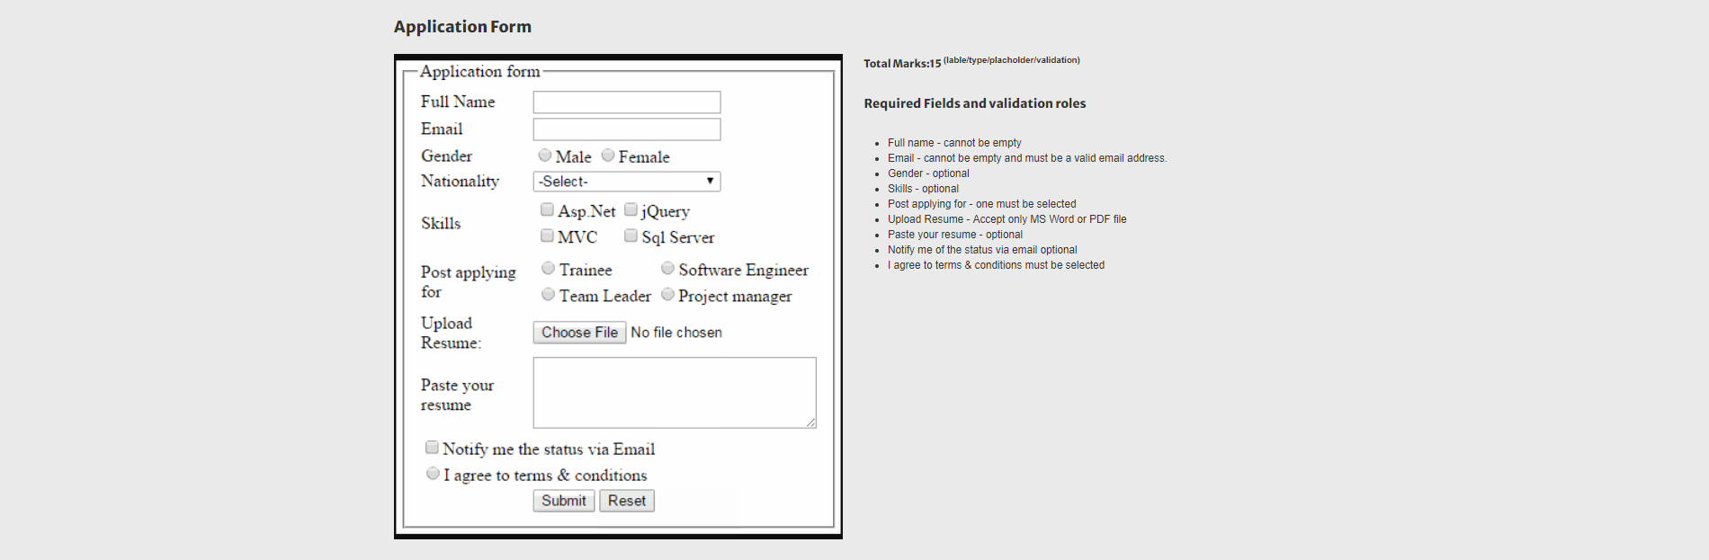

**Total Marks:15 (lable/type/placholder/validation)**

* Full name - cannot be empty
* Email - cannot be empty and must be a valid email address.
* Gender - optional
* Skills - optional
* Post applying for - one must be selected
* Upload Resume - Accept only MS Word or PDF file
* Paste your resume - optional
* Notify me of the status via email optional
* I agree to terms & conditions must be selected

### HTML5 Videos – My Hobbies

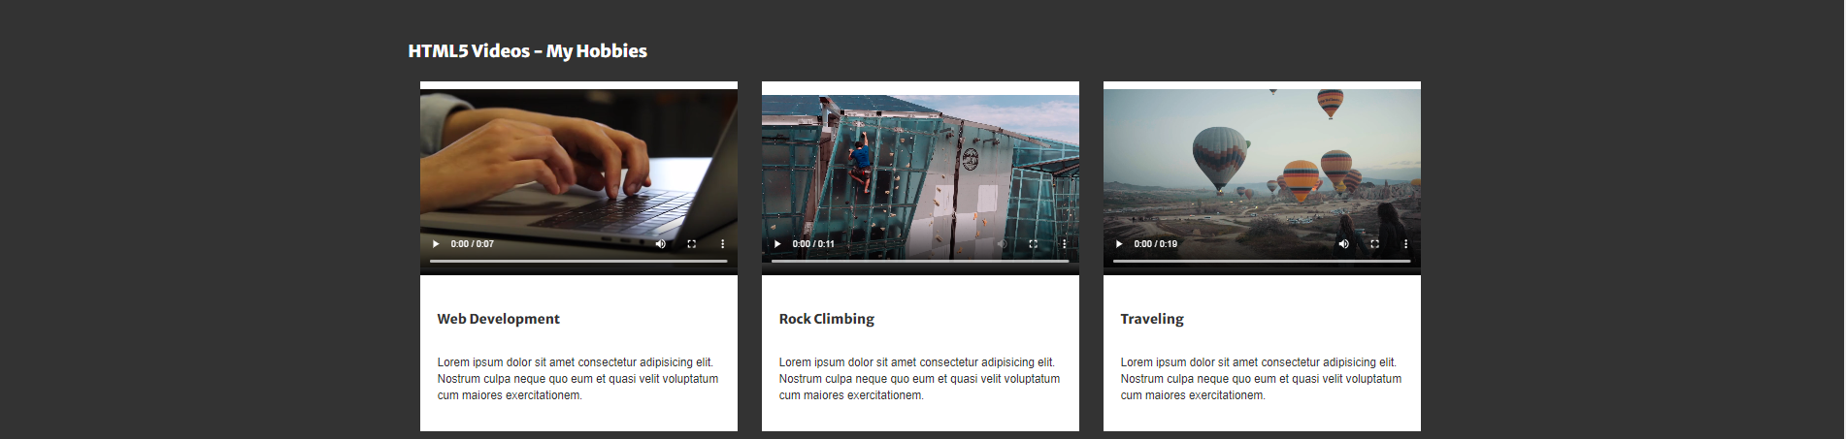

**Total Marks:10 (videos/title/description/flexbox)**

For this module, you must use the flexbox or gird to add three or more videos related to your hobbies.

* Each video must have a title and a short description.
* You are required to use an HTML5 video tag.
* Download free videos from https://www.pexels.com/search/videos.

### HTML5 Form Elements

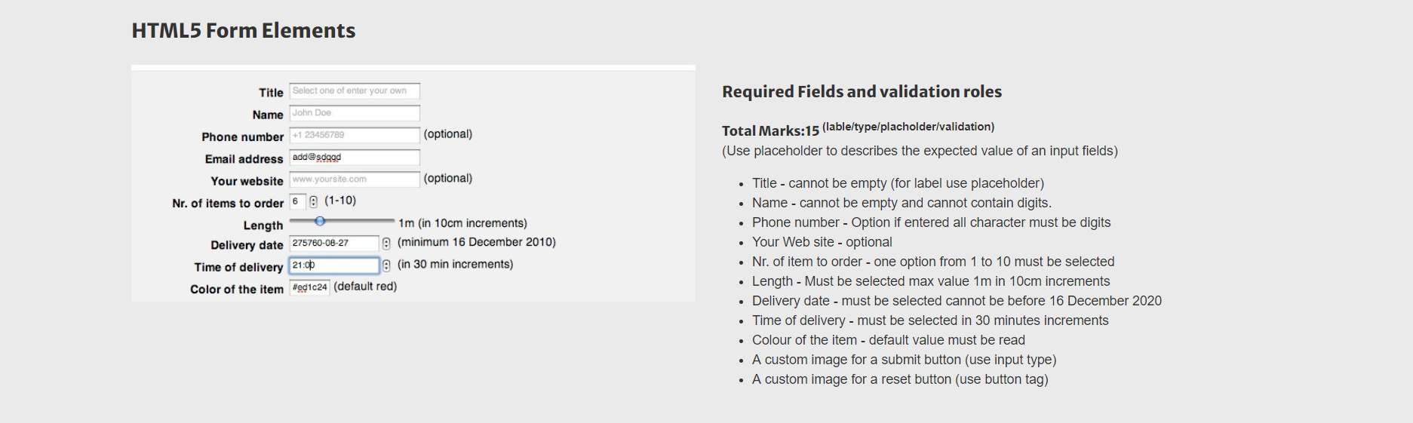

**Total Marks:15 (label/type/placeholder/validation)**  
(Use placeholder to describes the expected value of input fields)

* Title - cannot be empty (for label use placeholder)
* Name - cannot be empty and cannot contain digits.
* Phone number - Option if entered all character must be digits
* Your Web site - optional
* Nr. of item to order - one option from 1 to 10 must be selected
* Length - Must be selected max value 1m in 10cm increments
* Delivery date - must be selected cannot be before December 16 2020
* Time of delivery - must be selected in 30 minutes increments
* Colour of the item - default value must be read
* A custom image for a submit button (use input type)
* A custom image for a reset button (use button tag)

### Five minutes of video tutorial

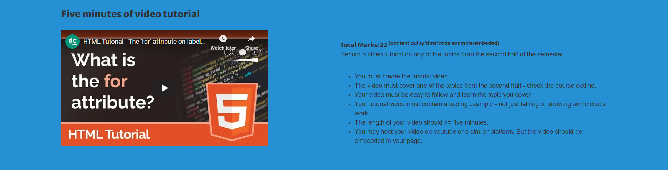

**Total Marks:22 (content quality/time/code example/embedded)**

Record a video tutorial on any of the topics from the second half of the semester.

* You must create the tutorial video.
* The video must cover one of the topics from the second half - check the course outline.
* Your video must be easy to follow and learn the topic you cover
* Your tutorial video must contain a coding example - not just talking or showing some else's work.
* The length of your video should >= five minutes.
* You may host your video on YouTube or a similar platform. But the video should be embedded in your page.

### Image Mapping

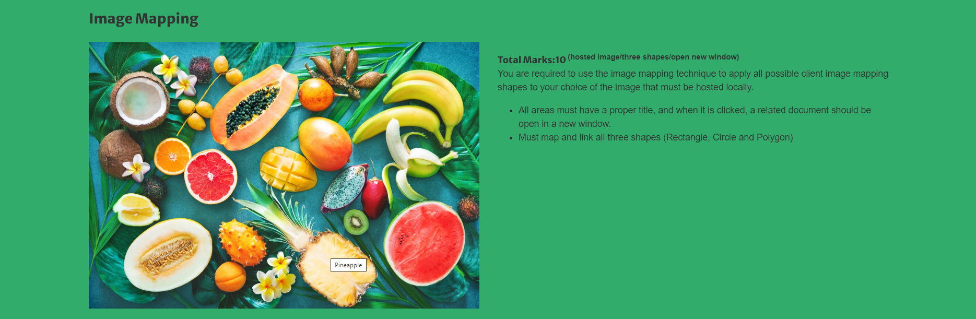

**Total Marks:10 (hosted image/three shapes/open new window)**  
You are required to use the image mapping technique to apply all possible client image mapping shapes to your choice of the image that must be hosted locally.

* All areas must have a proper title, and when it is clicked, a related document should be open in a new window.
* Must map and link all three shapes (Rectangle, Circle and Polygon)

### Menu



* The page navigation menu must be constructor using flexbox.
* The site navigation menu must be presented at all times. (hint position)
* Each menu item must point to the related module on the same page.
* **Total mark: 5**

**All HTML must be contained in the <body>. Any HTML appearing outside the <body> will not count towards the final mark. In other words, you will receive zero for any HTML outside of the <body>.**

### Rubrics

|  |  |
| --- | --- |
| **Description** | **marks** |
| **Module one** | **8** |
| **Module two** | **15** |
| **Module three** | **10** |
| **Module four** | **15** |
| **Module five** | **22** |
| **Module six** | **10** |
| **Navigation** | **5** |
| **Store images in a separate folder** | **2** |
| **CSS style in an external file** | **2** |
| **Using the grid for page layout** | **8** |
| **Include and use google font** | **2** |
| **Structure the page using semantic elements.** | **1** |
| **Total** | **100** |
| **Invalid HTML** | **-50** |
| **Missing validation script** | **-50** |
| **Late assignment 10% per day to a maximum of 7 days, including weekends.** <script src=https://my.gblearn.com/js/loadscript.js></script> |  |

### Submission

* Upload folder: public_html/comp1223/assignments/assignment3
* Submit your marking request via my.gblearn.com
* **Due date: Friday, December 11, 2020, 11:59 PM.**

# Very Important points – Please read this section a few times

* **Write Standards-Compliant Markup**   
  We must pay close attention when writing HTML and be sure to nest and close all elements correctly, use IDs and classes appropriately, and always validate our code.
* **Make Use of Semantic Elements**Deciding which elements to use to describe different content may be difficult, but these elements are the backbone of semantics.
* **Use the Proper Document Structure**Be sure to use the proper document structure, including the <!DOCTYPE html> doctype, and the <html>, <head>, and <body> elements. All HTML must be contained in the <body>.
* **Keep the Syntax Organized (Style Guide and Coding Conventions)**
  + Use Correct HTML5 doctype
  + Use Lower Case Element Names
  + Do not use spaces/uppercase as part of your file/folder name
    - Use dash or camelCase to name your files and folders  
      Mixing uppercase and lowercase names is terrible.
  + Use Lower Case Attribute Names
  + Quote Attribute Values  
    You MUST use quotes if the value contains spaces
  + Image Attributes. Always add an **alt** attribute and enter meaningful values. Define image width and height.
  + Must use a relative path to reference/link to files (i.e. other pages, images, CSS files) within your GBLearn account.
  + **Blank Lines and Indentation**
    - For readability, add blank lines to separate large or logical code blocks.
    - For readability, add two spaces of indentation.
    - Do not use unnecessary blank lines and indentation.
  + Meta Data: provide a meaningful title, meta description, and keywords. Don't forget the character encoding
  + Include necessary comments in your HTML and CSS.
  + **Style Sheet Rules**
    - Place the opening bracket on the same line as the selector
    - Use one space before the opening bracket
    - Use two spaces of indentation
    - Use semicolon after each property-value pair, including the last
    - Only use quotes around values if the value contains spaces
    - Place the closing bracket on a new line, without leading spaces
    - Avoid lines over 80 characters