# Section 1 - Executive Summary

The purpose of this assignment was to evaluate our understanding of databases. It was a valuable learning experience that allowed us to gain insight into what it is like to work in the database industry. We completed the assignment as a group, which gave us the chance to experience collaborating with others and using our different skills to work efficiently.

The case study for this assignment involved a company called Mike's Motorboats, which is a boat rental business serving local tourists. Customers can choose to rent boats for short or long periods of time. One major issue with Mike's Motorboats is that it uses a manual system for everything, including reservations, rentals, parts, maintenance, and service history. This manual system has several disadvantages, including a lack of security as paper documents can easily be lost or misplaced, a high cost due to the need for paper, files, and storage, and the difficulty and time-consuming process of modifying data. As the business grows, it will become increasingly difficult to keep up with a manual system.

This report consists of four sections. The first section provides an overview of the report and its contents. The second section presents different database designs based on a realistic scenario. The third section covers SQL implementations, a specialized language used for databases. The fourth section includes individual work by each group member, detailing their progress. Finally, there is an appendix with the individual entity relationship diagrams, logbooks, and full SQL code for each group member.

# Section 2: Database Design

## 2a - Top-Down ERD

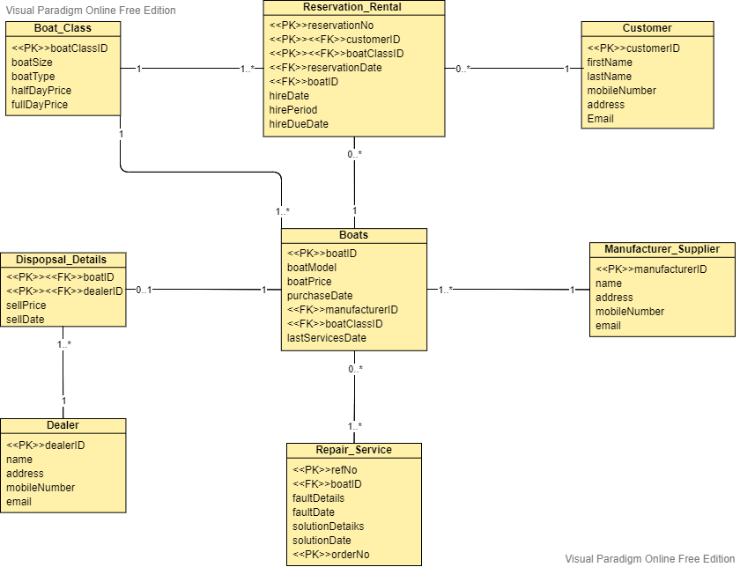

## 2b - Bottom-Up ERD

**Boat Record Normalisation**

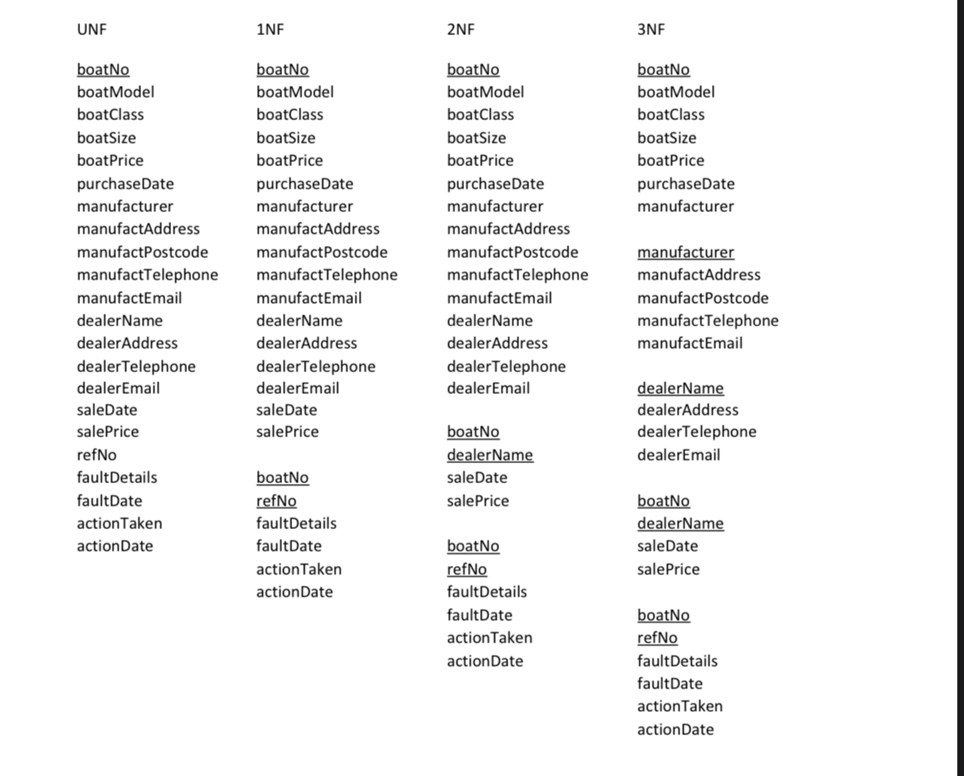

**Merged 3NFs from Normalisations and Bottom-Up Data Model**

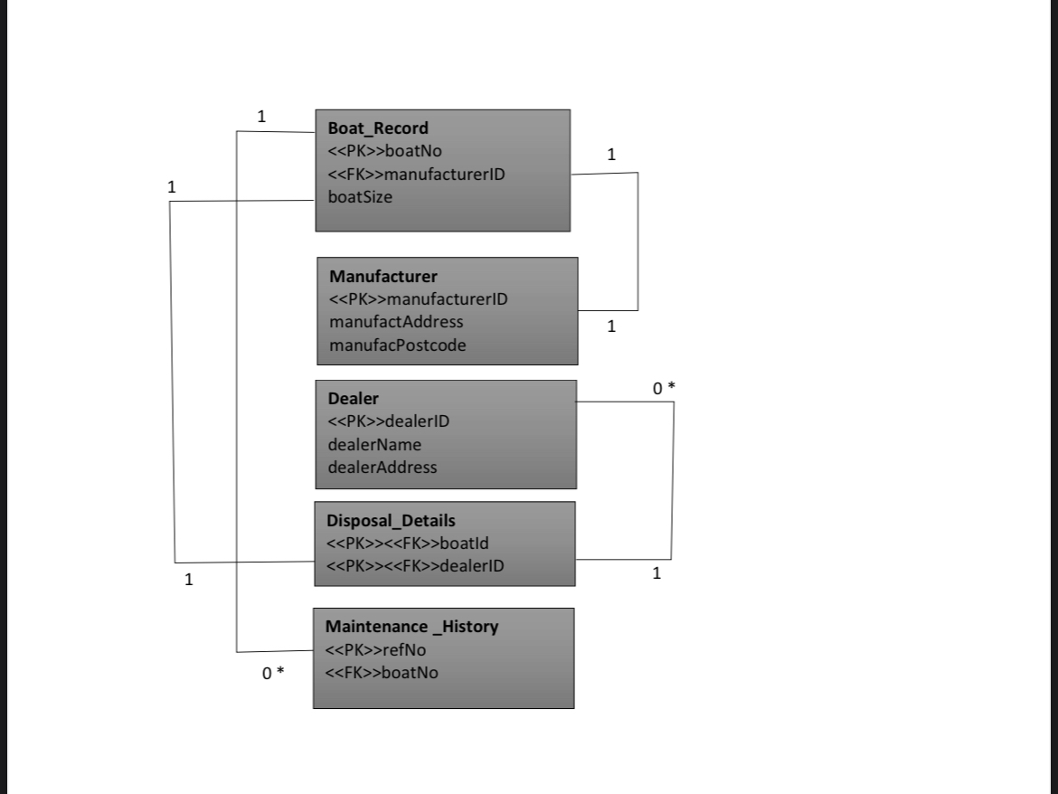

2c - Merge of Top Down and Bottom Up ERD’s

