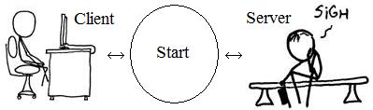

Name: Start

Actors: Client, Server
Precondition: None
Trigger: Some one desires to start the game
Main Flow:
- The server is started and program launched
- The client(s) are started and program launched
- Clients attempt to connect to server
- Server makes connections, remembering order that they were made
- Server assigns pieces based on connection order
- Server creates a board
- Server randomizes cards, keeps a room, weapon, and person card
- Server distributes other cards
- Server sends board to clients
- Server sends message to first connection beginning game play
Exceptional Flow: Network error or server error
Alternate Flow: Error, not enough players joined
Post-condition: Game play in progress
Author/Date: Green Team, September 29, 2008; revised October 6, 2008

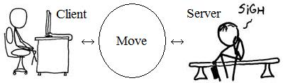

Name: Move
Actors: Server and Client
Precondition: Game play in progress, player’s turn
Trigger: Previous move over message received by server
Main Flow:
- Sever generates a random integer between 1 and 6
- Server computes all (out of a room, into a room, through passage, or along corridor) possible ending spaces from player’s current position
- Server sends client updated board and generated integer
- Client chooses end position
- Client sends position to server
- Server updates game board
- Server updates board for all players
Exceptional Flow: Network error
Alternate Flow: None
Post-condition: Turn continues (guess may be possible)(accuse may be possible)
Author/Date: Green Team, September 29, 2008; revised October 6, 2008

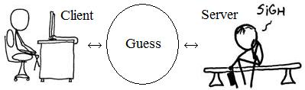

Name: Guess
Actors: Server and Client
Precondition: Player’s turn and located in a room that they haven’t guessed while being
in on this turn
Trigger: Player selects guess button
Main Flow:
- A form appears over the client GUI containing radio buttons for each player, room, and weapon
- Player selects a combo of one weapon, one player, and the current room is pre-selected and unchangeable
- Combination is sent to server
- Server moves guessed player’s piece to guessed room
- Server looks up player cards for first match in order of joining
- A player that has a match is queried to show the match or one if they have multiple
- That card is shown to guessing player along with which player had it
- All players notified of guess made, what the guess was and that it was disproved
Exceptional Flow: Network error
Alternate Flow: Server is unable to find a match among other players
- Message returned to guessing player that no match was found
- All players notified that a guess was made, what the guess was, and that it couldn’t be disproved
Post-condition: Game state is updated to reflect changes
Author/Date: Green Team September 29, 2008; revised October 6, 2008
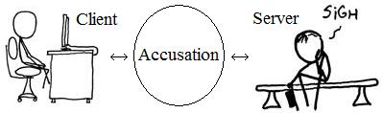

Name: Accusation
Actors: Server and Client
Precondition: Player’s turn
Trigger: Player selects accuse button
Main Flow:
- A form appears over the client GUI containing a radio buttons for each player, room, and weapon
- Player selects a combo of one weapon, one player, and one room
- Combination is sent to server
- Server verifies against saved cards
- Server updates game board for all player with game over message, player name has won
- Server closes connections to players
- Server resets itself, waits for connections
Exceptional Flow: Network error
Alternate Flow: Server finds the combo to not match.
- Player’s status is changed to show cards only status.
- Server sends message to players that this player made a wrong accusation, what it was, and that the player is out
Server finds the combo to not match and this is the last active player
- Server sends a message to all players telling them off
- Server closes connections to players
- Server resets itself
Post-condition: Game ends or next player’s turn, server get mad and game ends
Author/Date: Green Team, September 29, 2008; revised October 6, 2008

