Submission 1:

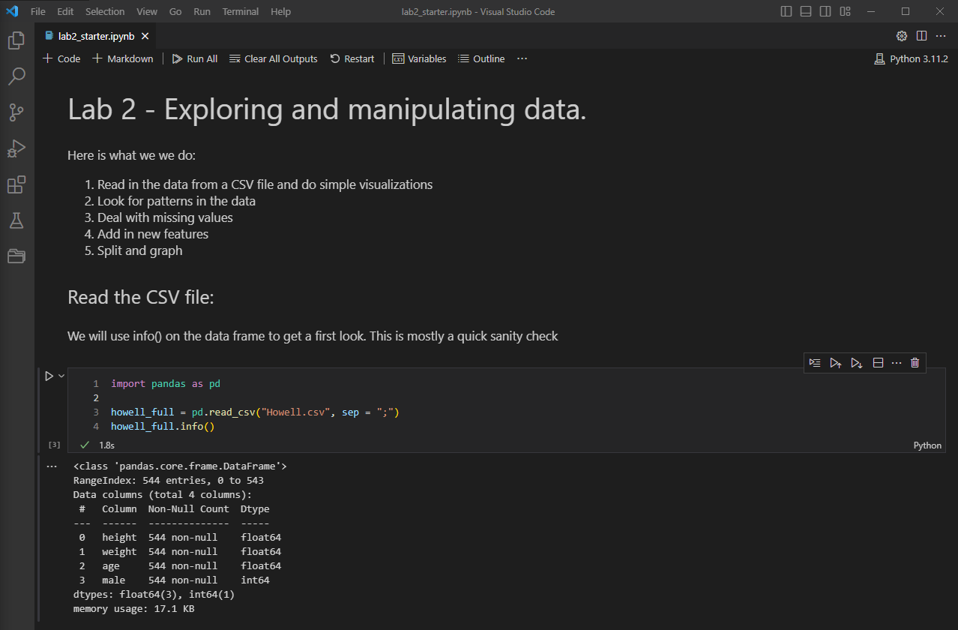

Submission 2:

1. How many data instances are there?
   * 544
2. How many features are there?
   * 4
3. What are the names?
   * Height, weight, age, and male.
4. Are there any missing values?
   * Does not appear to have any missing as we’ve got 544 non-null values for each segment.
5. Are there any non-numeric features?
   * No, all are numeric with one integer and 3 float data types.

Submission 3:

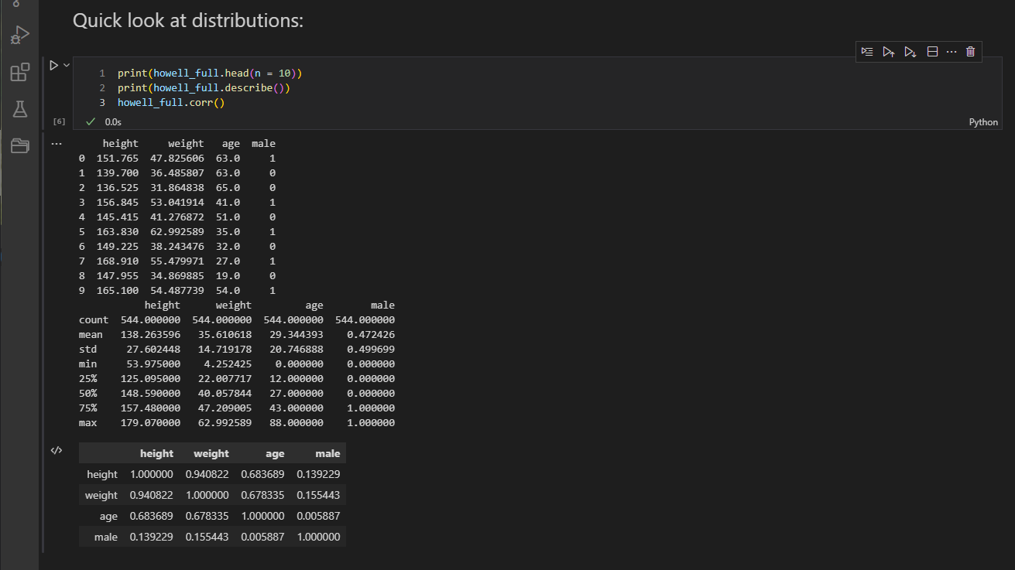

Submission 4:

1. Are the data instances sorted on any of the attributes?
   * Data appears to be completely random.
2. What are the units of height?
   * Float value is hopefully in centimeters.
3. What are the units of weight?
   * Float value in kilograms.
4. What are the minimum, median and max age?
   * 0, 27, 88
5. What two different features have the highest correlation?
   * Height and weight.

Submission 5:

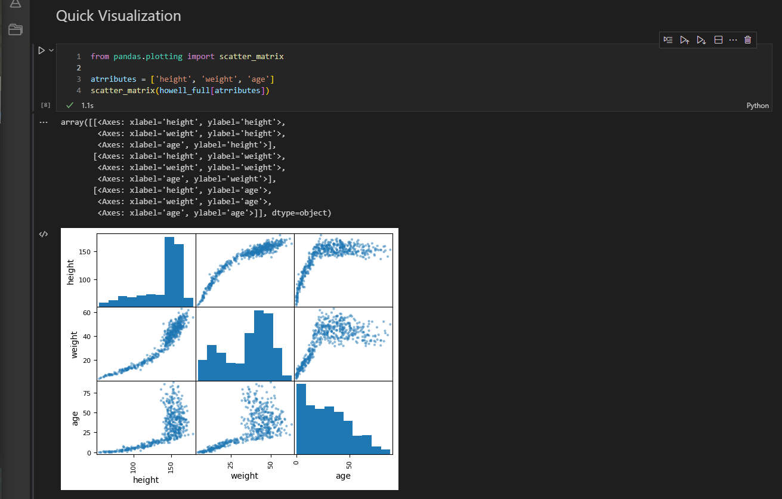

Submission 6:

1. Describe each distribution as skew, uniform, bimodal, or gaussian.
   * From left to right:
     + Height: Gaussian.
     + Weight: Bimodal.
     + Age: Skew.
2. Look at the age-weight scatter plot and explain the character of the graph.
   * There is a strong correlation at the start of the plot, where young kids are rather light and typically around the same size at certain ages. For this reason, we see very tight groupings. Once we reach a certain age, we lose all correlation leading to a very scattered grouping.
3. What does the age histogram tell us about this group of people?
   * This database contains less data on older individuals. The data also informs us that the correlation between height and weight is only present in younger individuals. At a certain point in age correlation drops.
4. How does the age histogram compare with that of people living in modern times?
   * We’re going to see more data on older individuals the more modern the data is.

Submission 7-1:

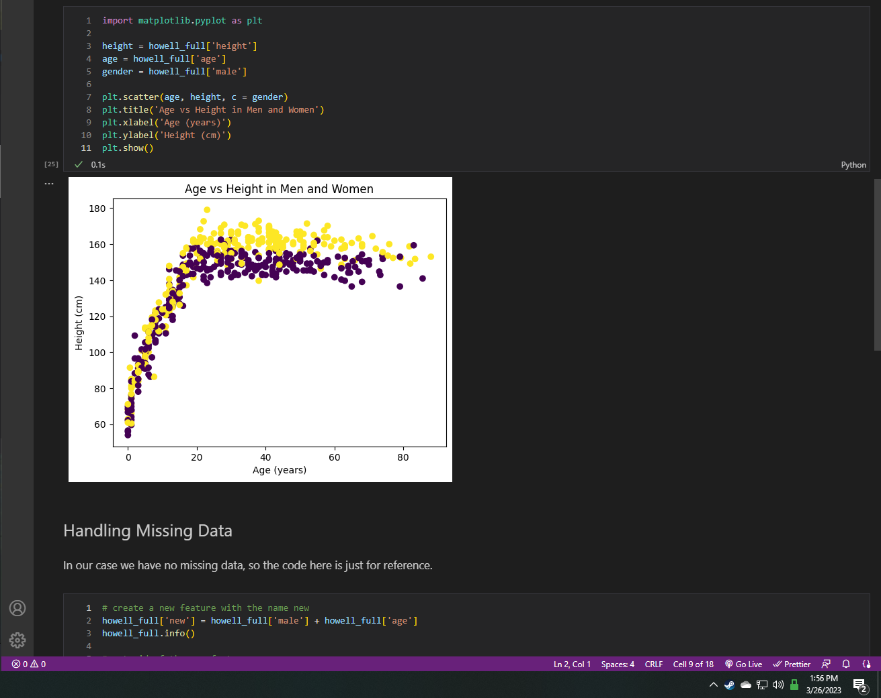

Submission 7-2:

* Age seems to begin diversifying after 20 years, around the 20-30 region.

Submission 8:

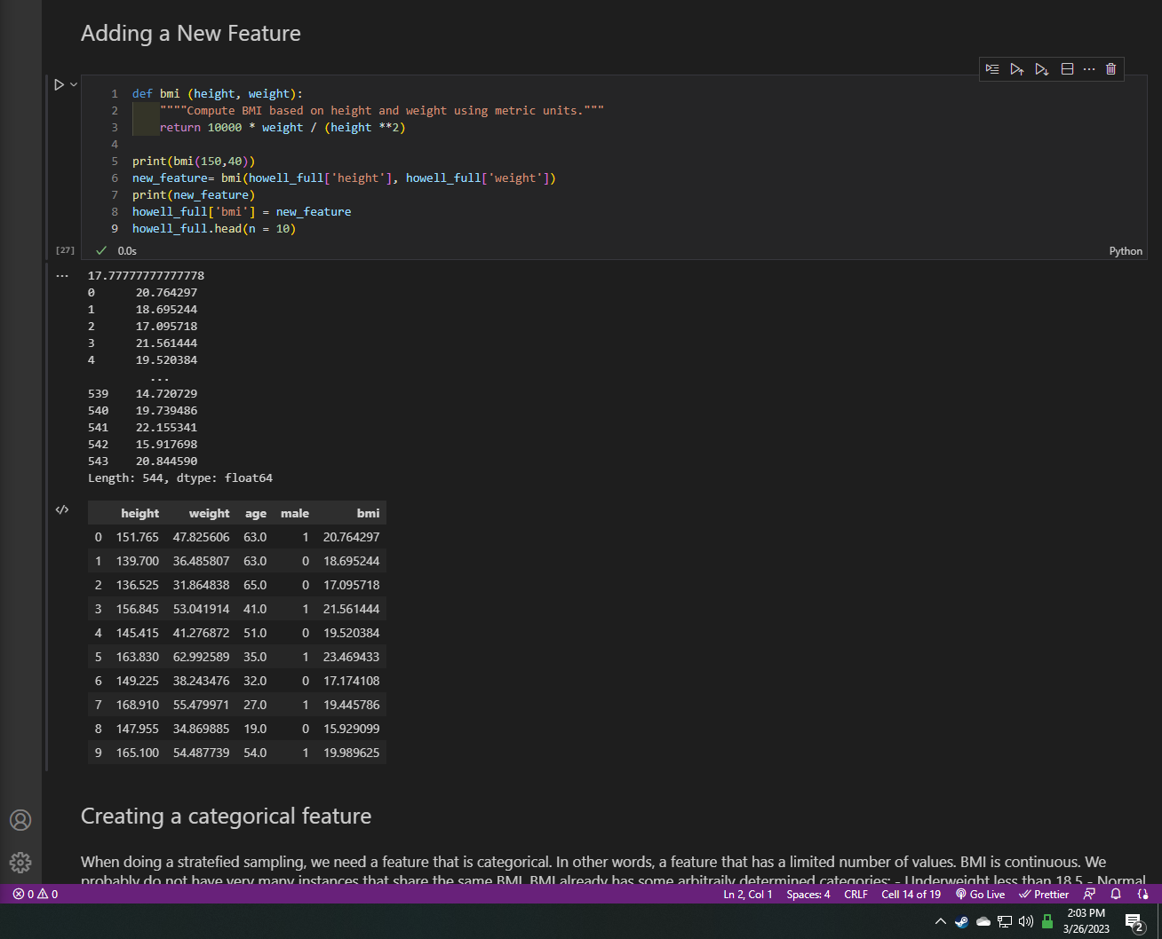

Submission 9:

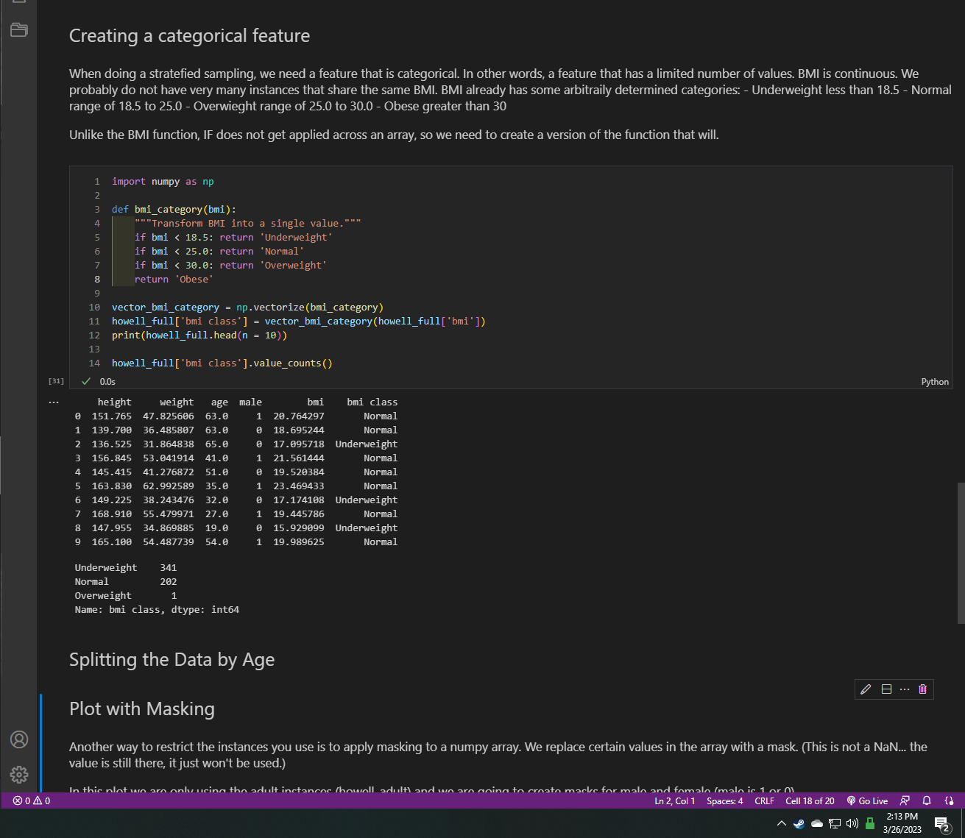

Submission 10:

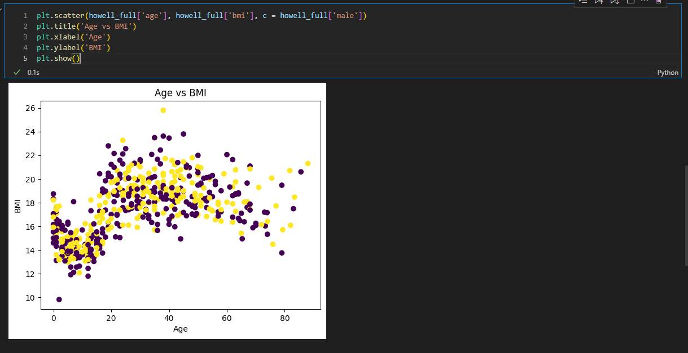

Submission 11:

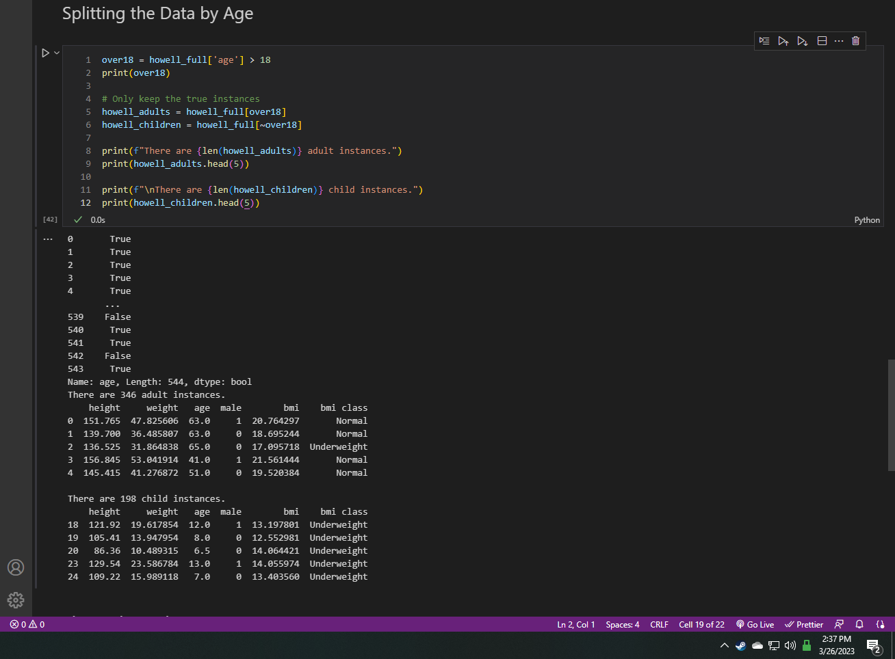

Submission 12:

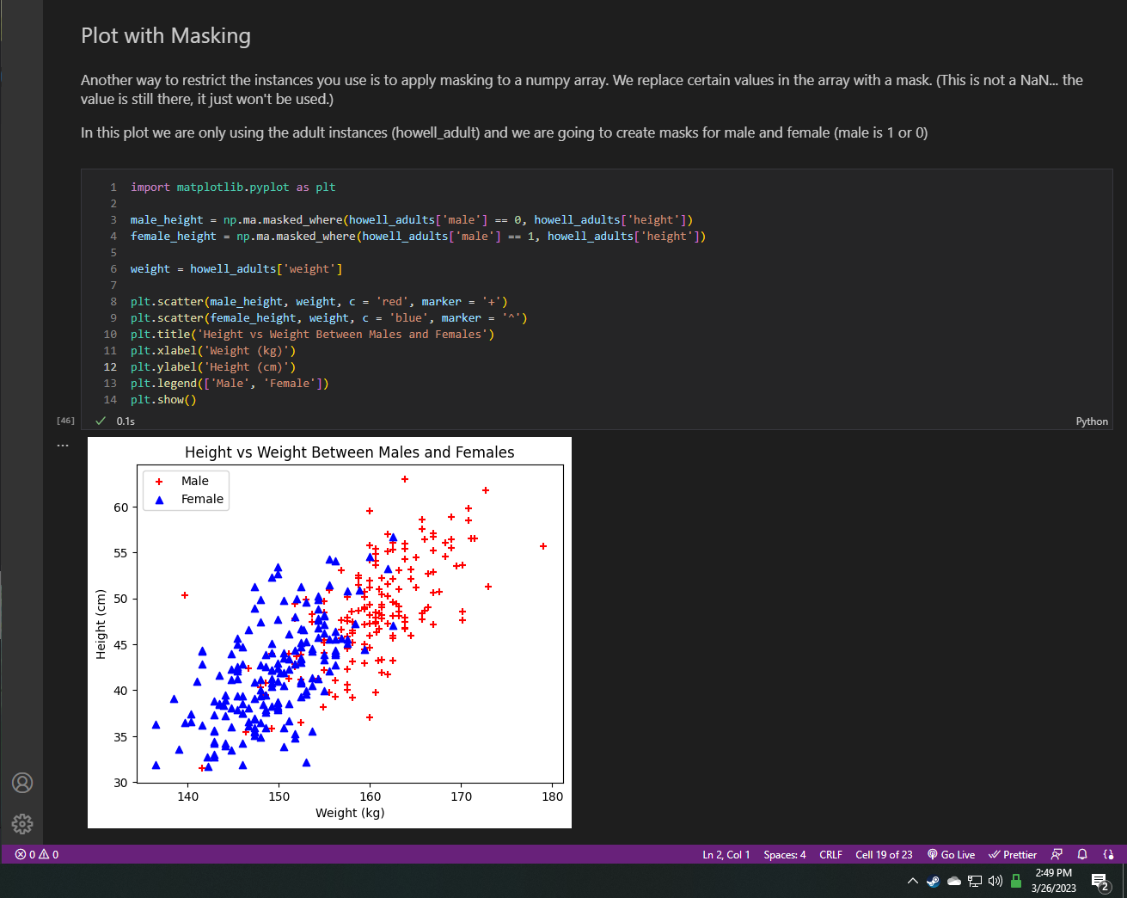

Submission 13:

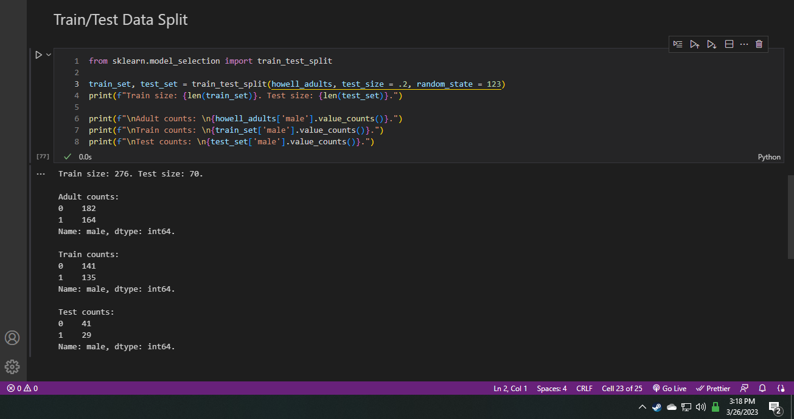

Submission 14:

