Submission 01:

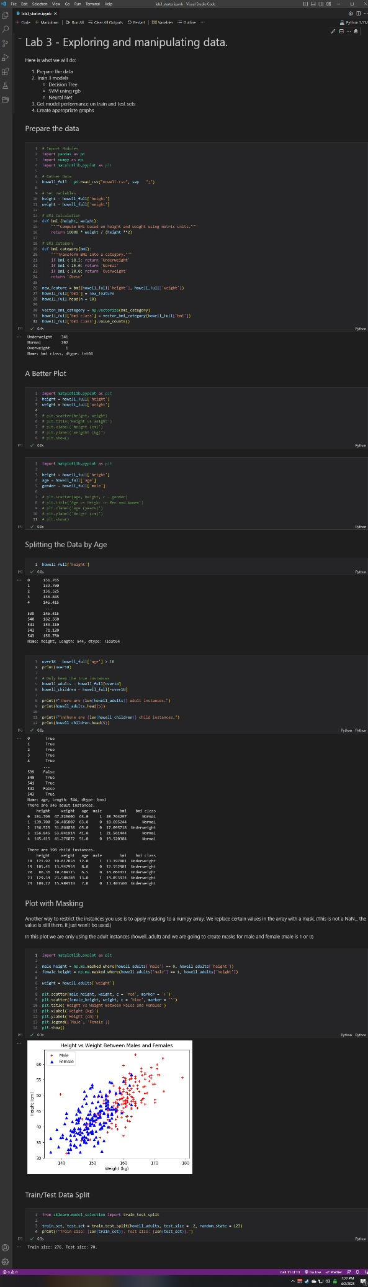

Submission 02:

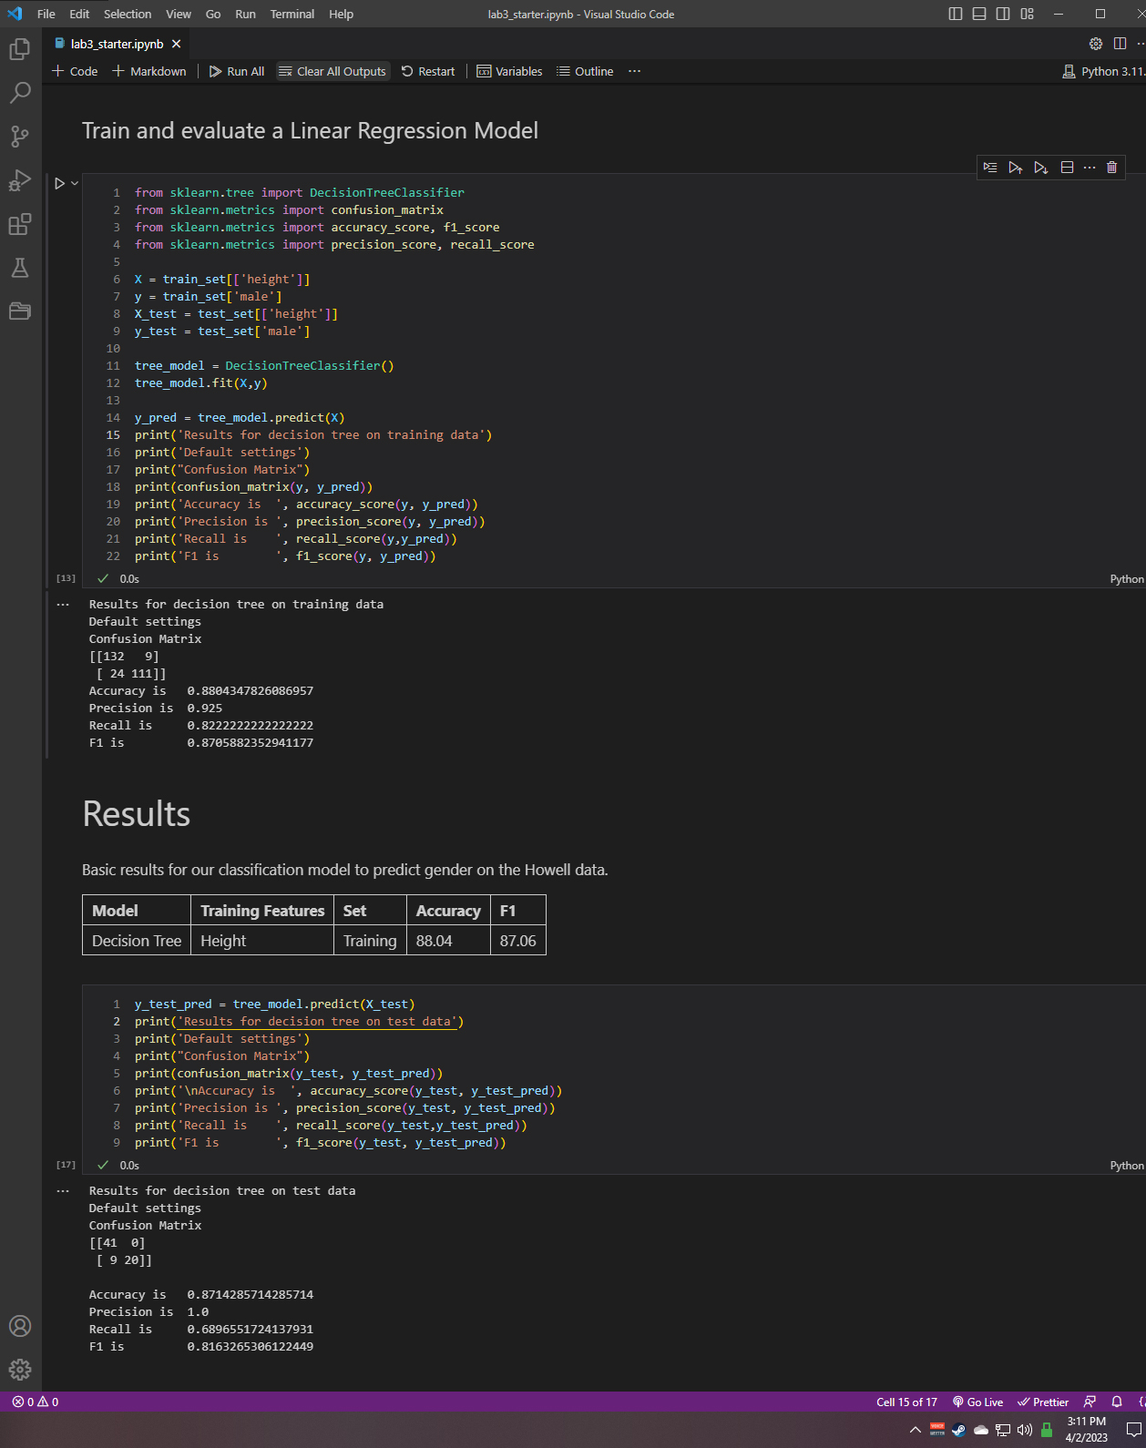

Submission 03:

I believe there is an argument for and against overfitting in the latest model. I say for as we have achieved perfection with a 1.0 precision. I also say against as the sample size of our testing data is relatively low, so I believe it is not improbable for there to be a 100% precision score.

Submission 04:

I prefer the first model. I believe this model most accurately represents the correlation between gender differences. Also, the accuracy and F1 are higher than the other models, which suggests it’s running more optimally.

Submission 05:

I would personally train on the first feature (height vs gender) based on the data. I believe age would have a major impact due to the growth from babies to adults as well as the loss due to extreme age.

Submission 06:

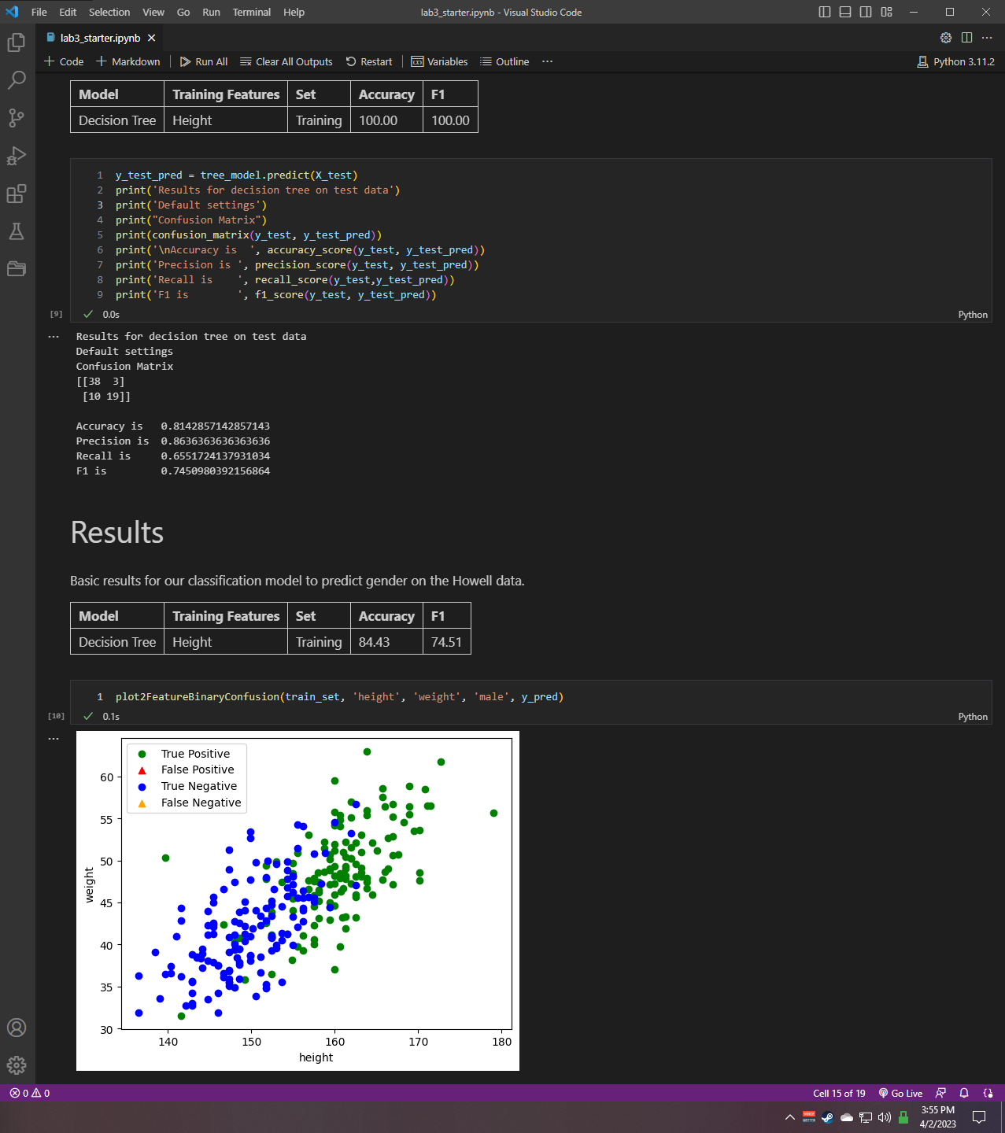

Submission 07:

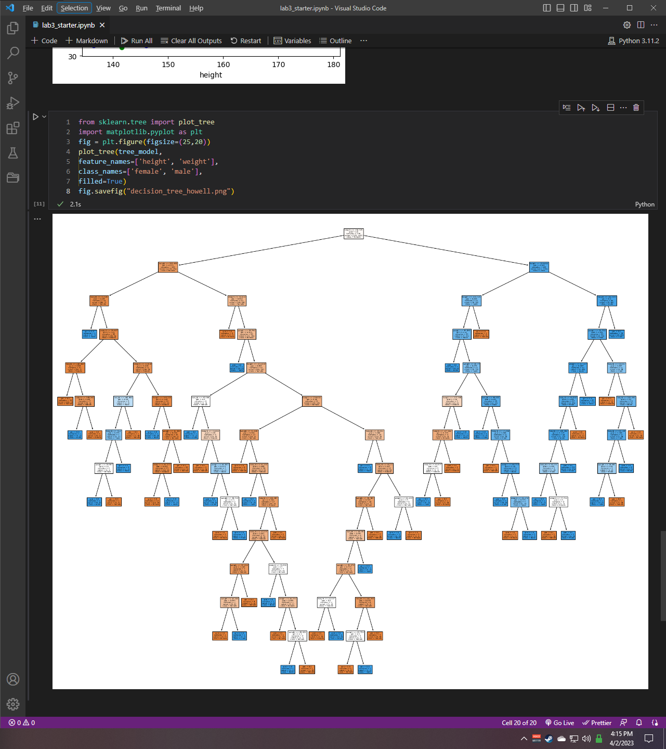

Submission 08:

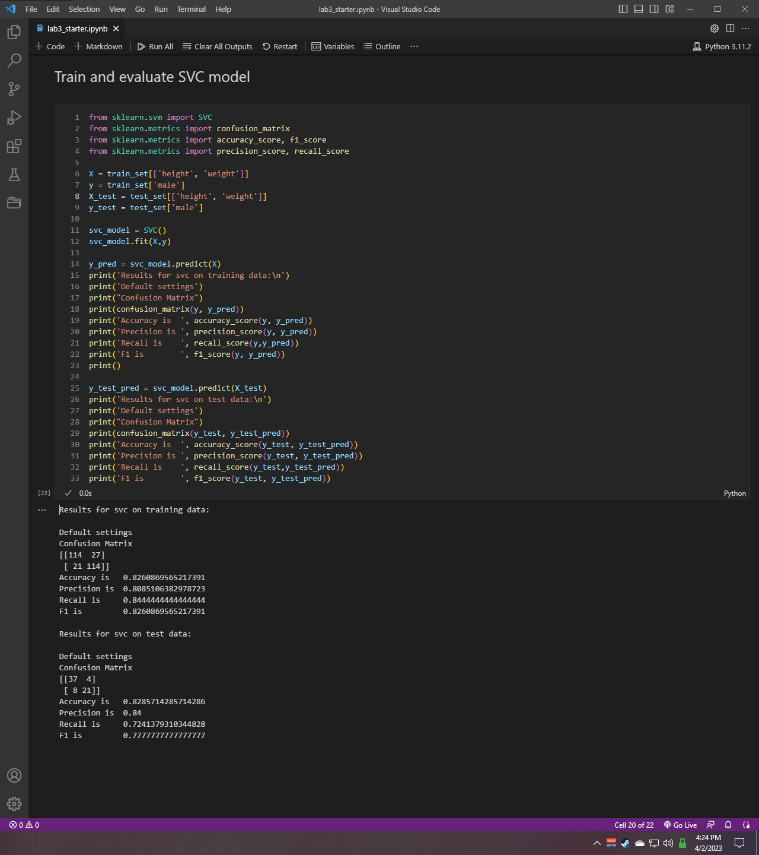

Submission 09:

When compared to the decision tree model, it would appear to have greater precision and harmonic mean scores.

Submission 10: 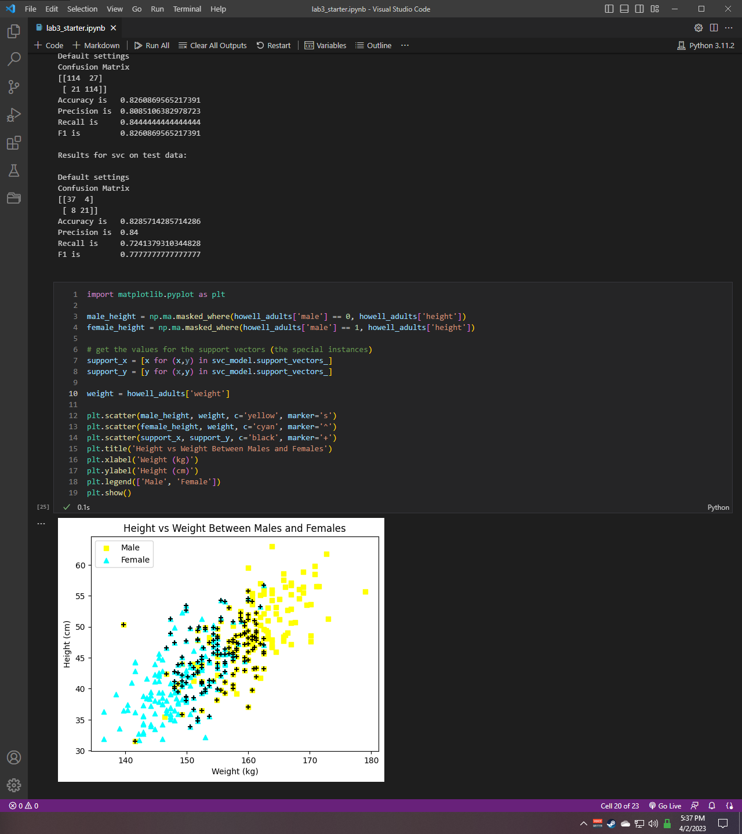

The positive/negative regions are from the left at 150 mark and to the right at the 165 mark.

The tentative regions would have to be the outlier + marks on the left side of the chart.

Submission 11:

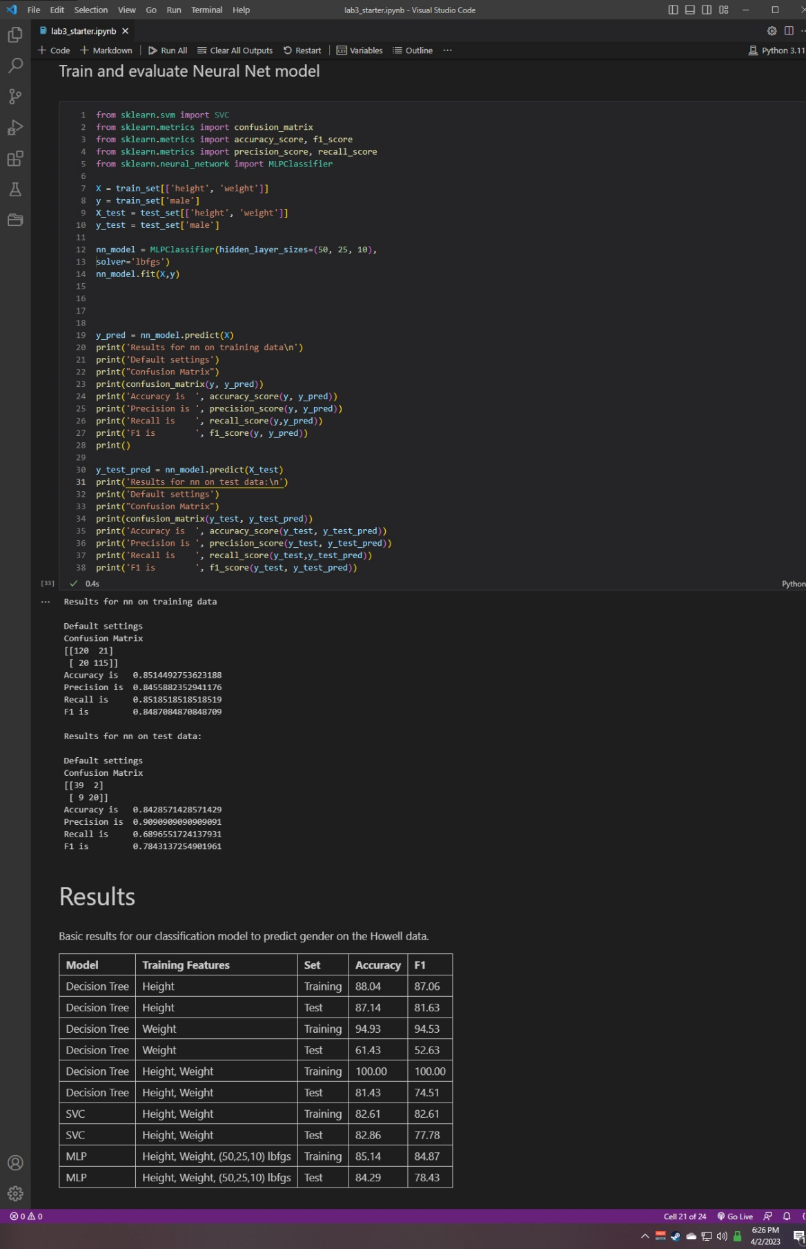

Submission 12:

I believe this model is the most accurate so far as our percentages score 2-3% higher than the other models.