Submission 1:

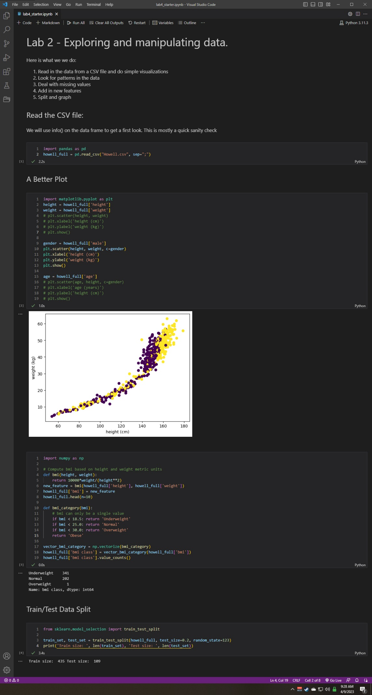

Submission 2:

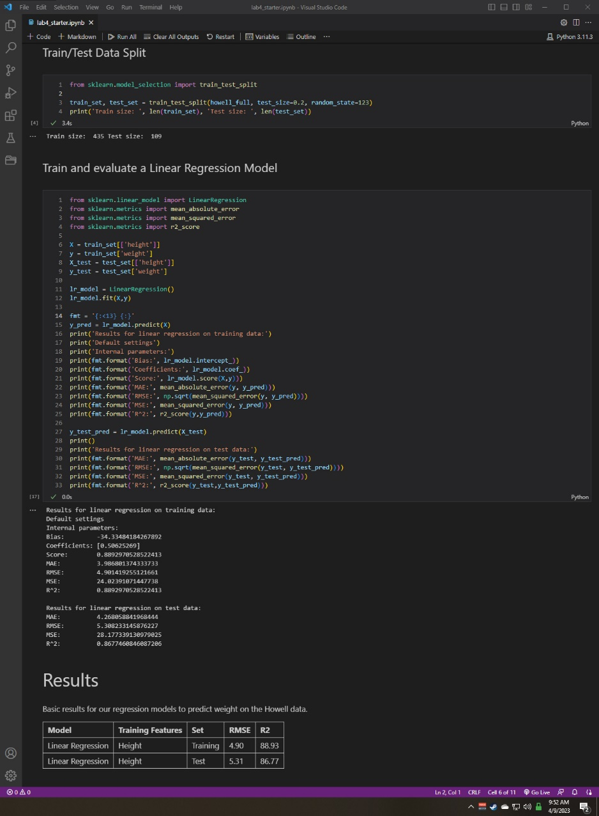

Submission 3:

I believe the model is slightly underfitting, but that is only because I can see that between the training and test set our coefficient of determination has gone down. Based on just the training data however, it has an R2 that is very close to 1 suggesting a good fit for the model.

Submission 4:

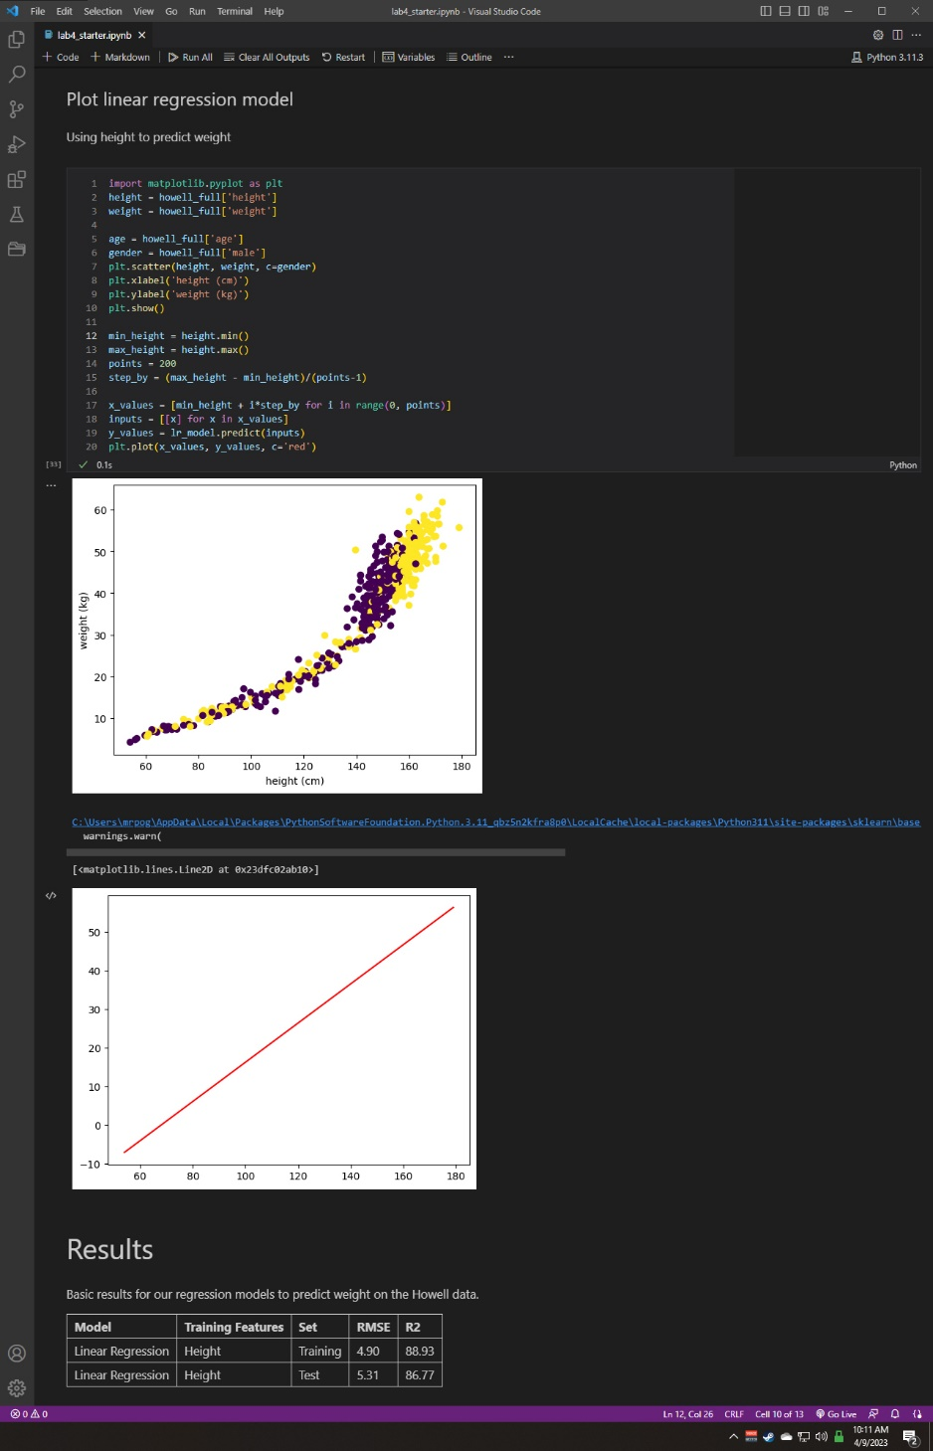

Submission 5:

The model is underfitting as the straight line provides evidence that it doesn’t understand the data. I do not believe that adding data points will help the model.

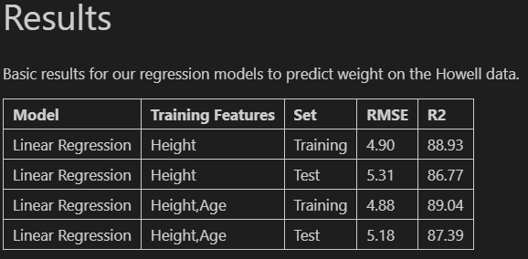Submission 6:

Looking at the data I would say that there was a minor improvement, but not by any significant margin. Adding data points in this instance did not improve the model.

Submission 7:

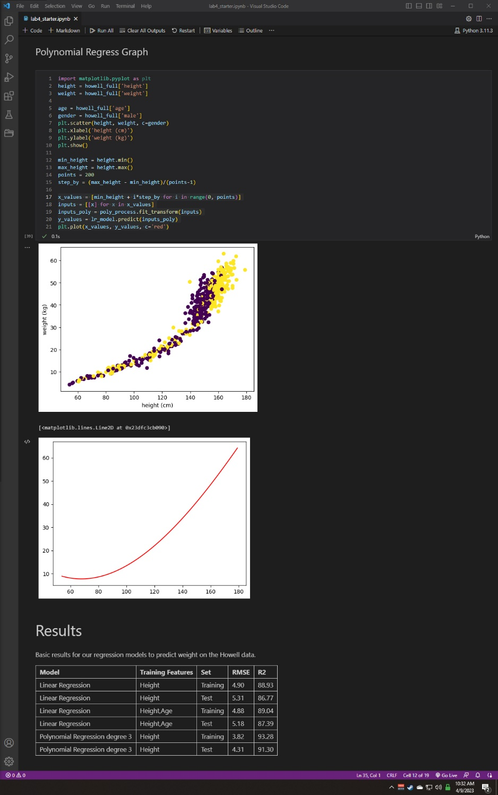

Submission 8:

The polynomial regression did fit better. Given our R2 values, this is a very good fit. The model is closer to representing the data as evident with the regression line.

Submission 9:

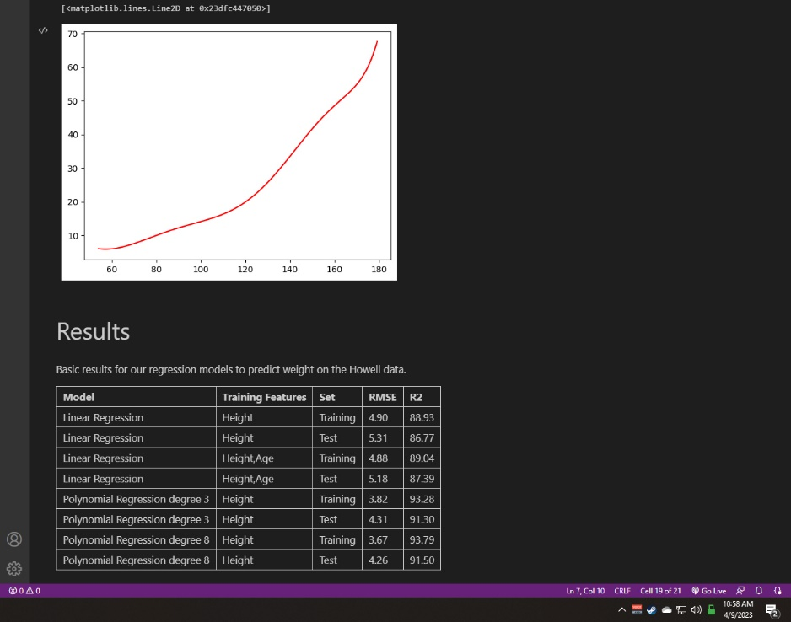

Submission 10:

I would argue that the increase in power is warranted and our model has an increased R2 meaning that we’re closer to achieving a perfect prediction. Also, the regression line more accurately represents the data we see in the scatter plot.

Submission 11:

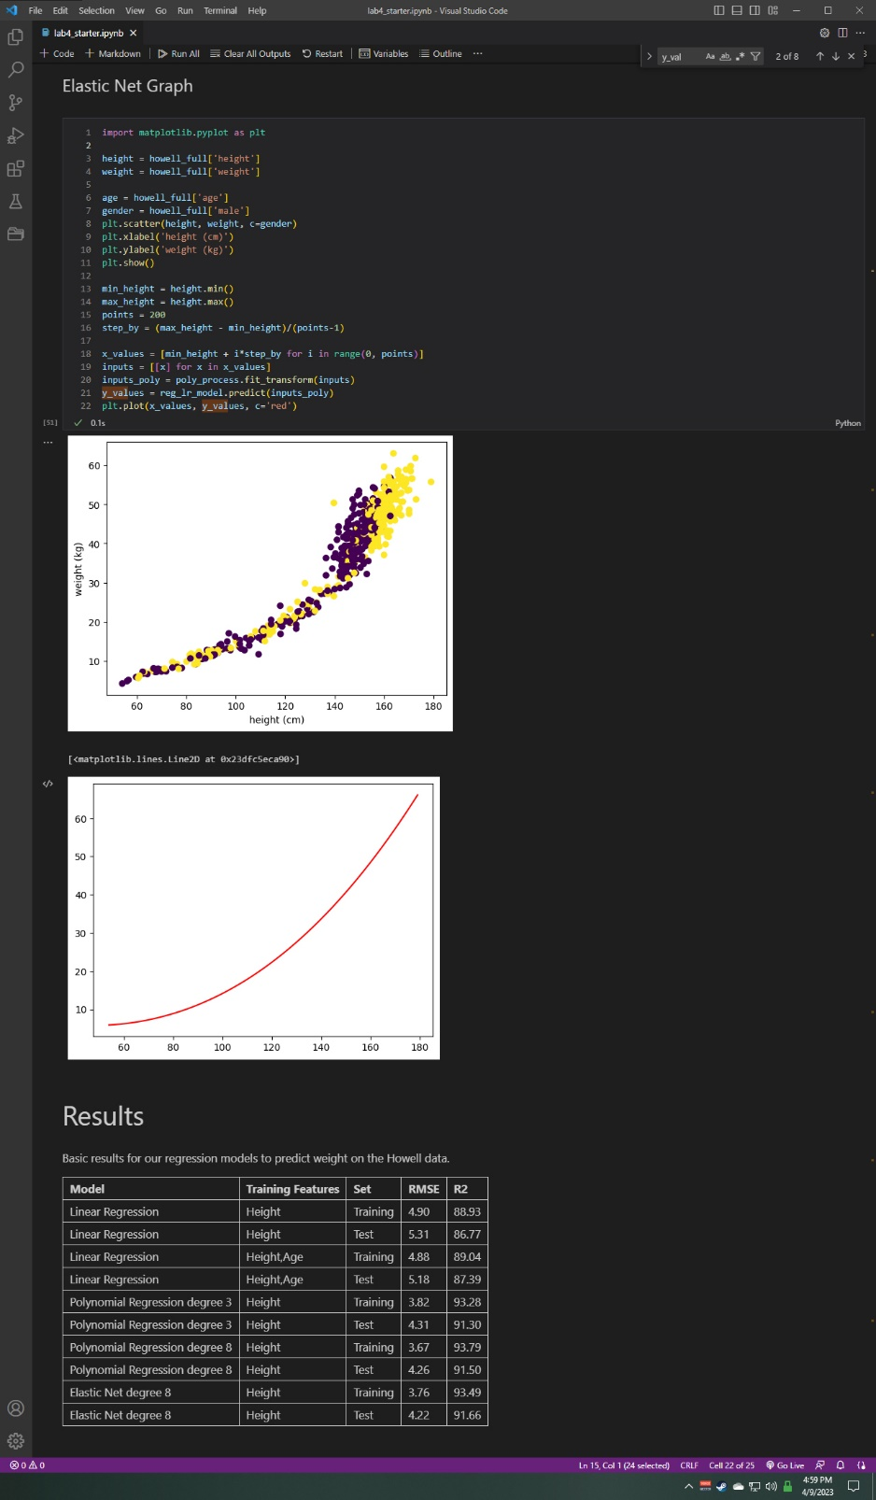

Submission 12:

The closer to 0 we get the greater the correlation between data points. The coefficients for the polynomial regression at a power of 8 were much closer to 0 than the elastic net. I would argue that both models are similar as the R2 for the two are very close to 0.