Submission 1:

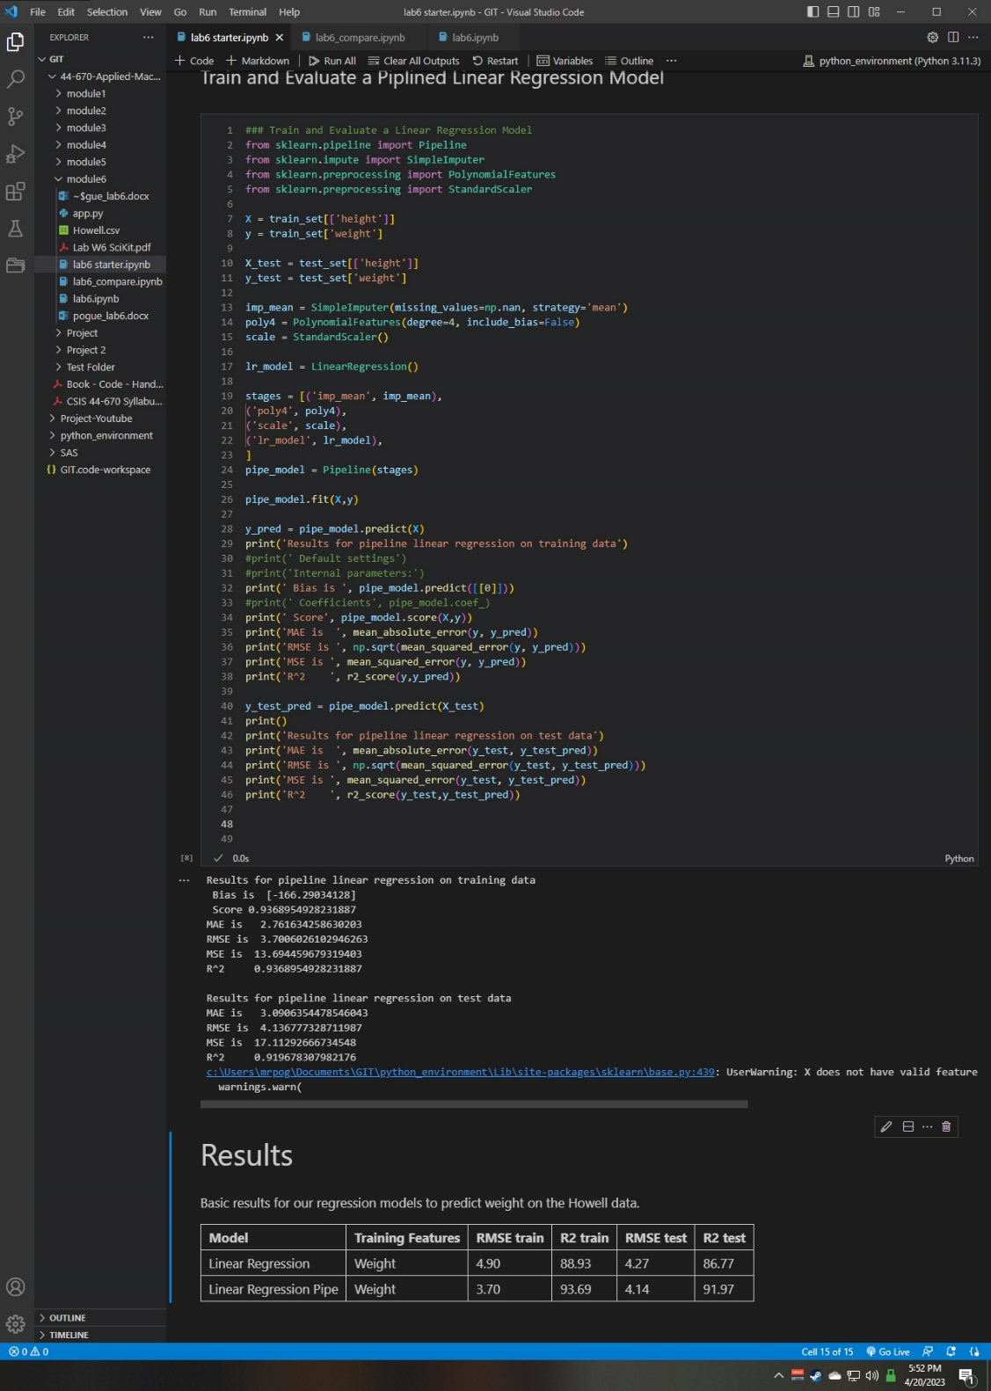

Submission 2:

The model improved with a greater R2 meaning we have a better fit to data.

Submission 3:

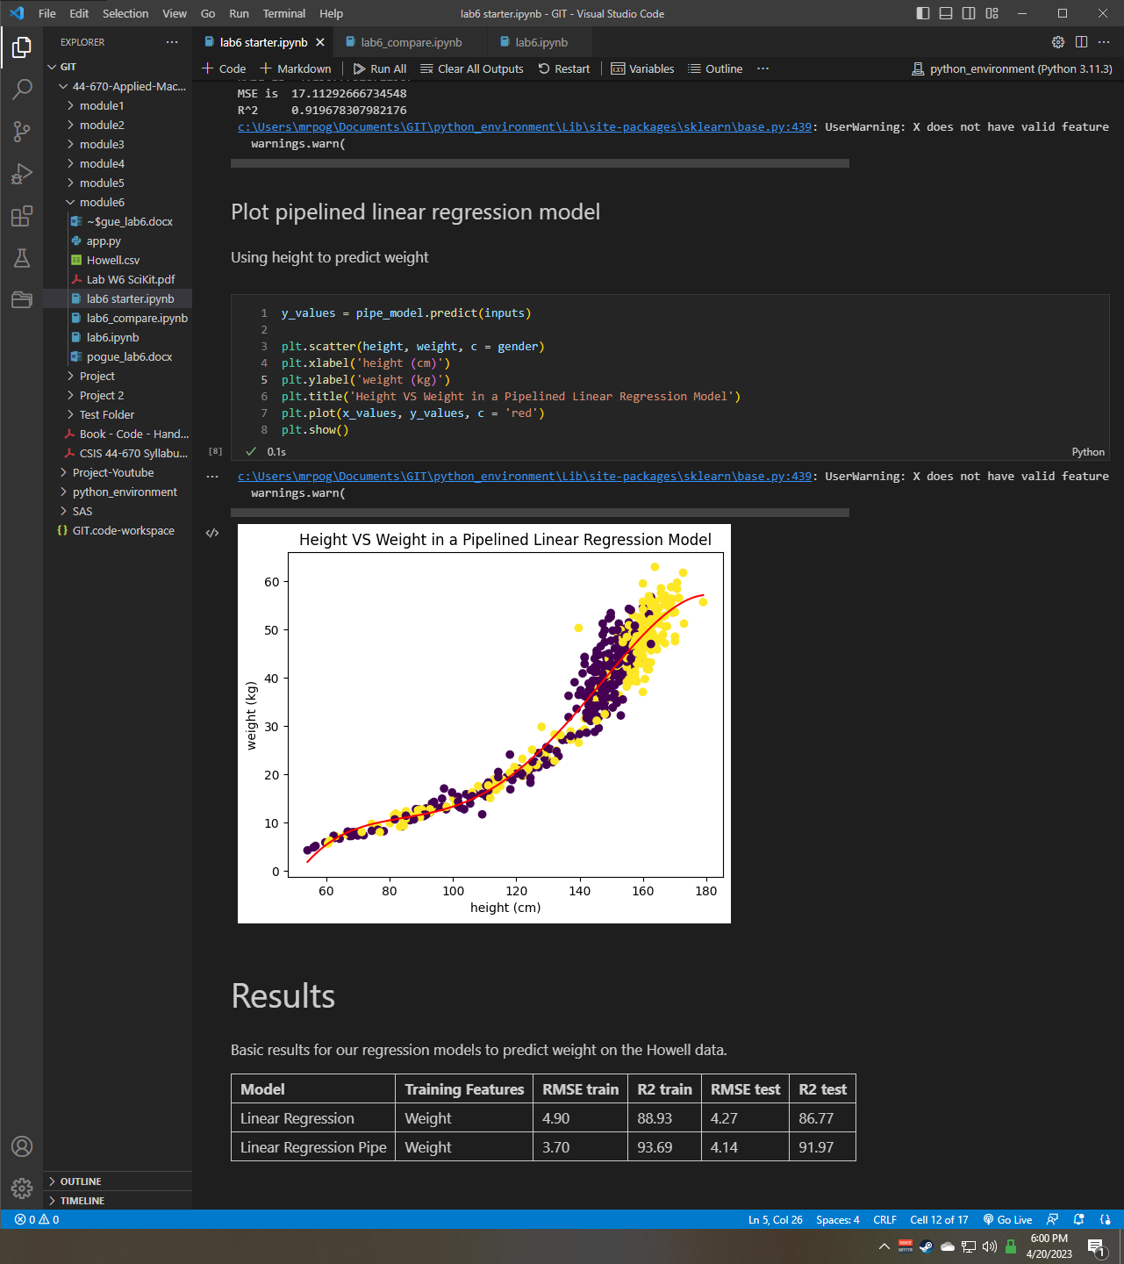

Submission 4:

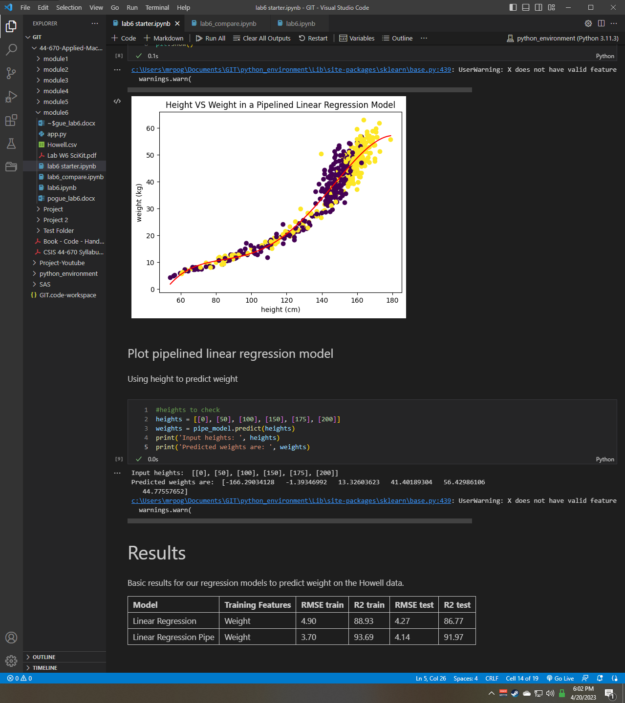

Submission 5:

I would limit the values so that the heights for the predicted weights are within reasonable outcomes. We wouldn’t expect anyone to have a height of 0 nor a predicted weight of -166, regardless of the units.

Submission 6:

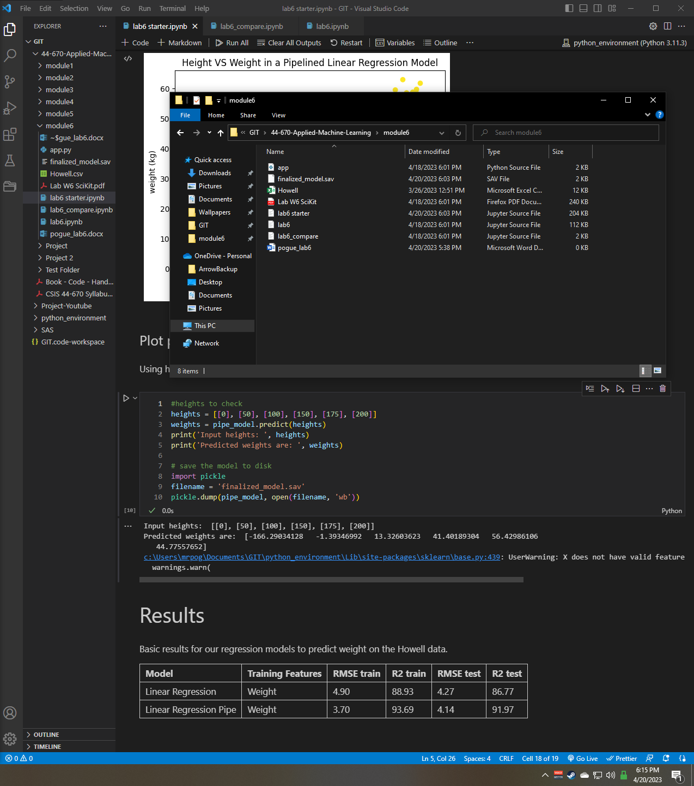

Submission 7:

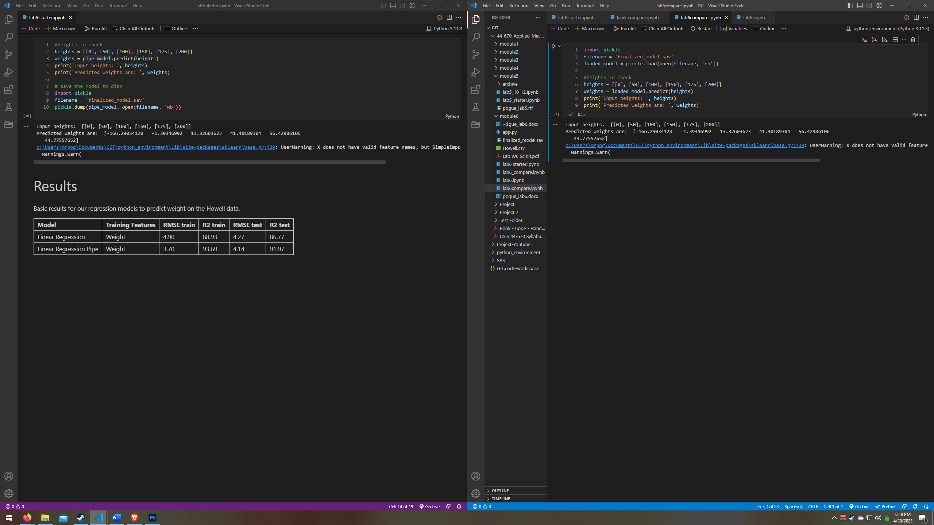

Values appear to match up.

Submission 8:

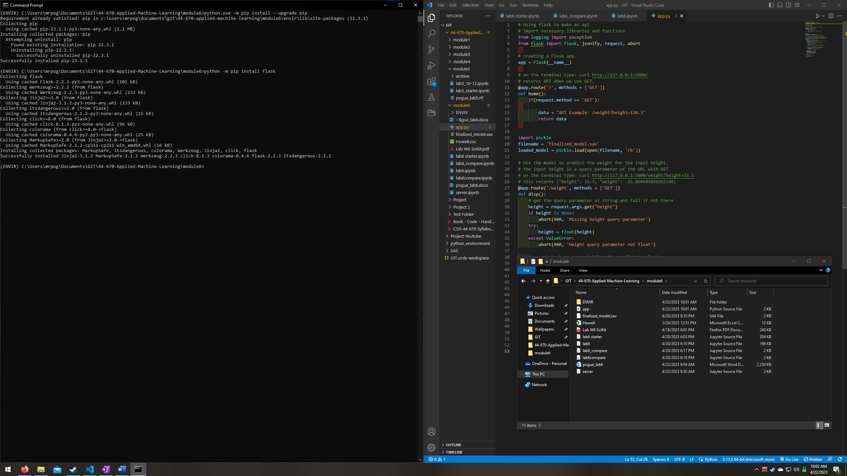

Submission 9:

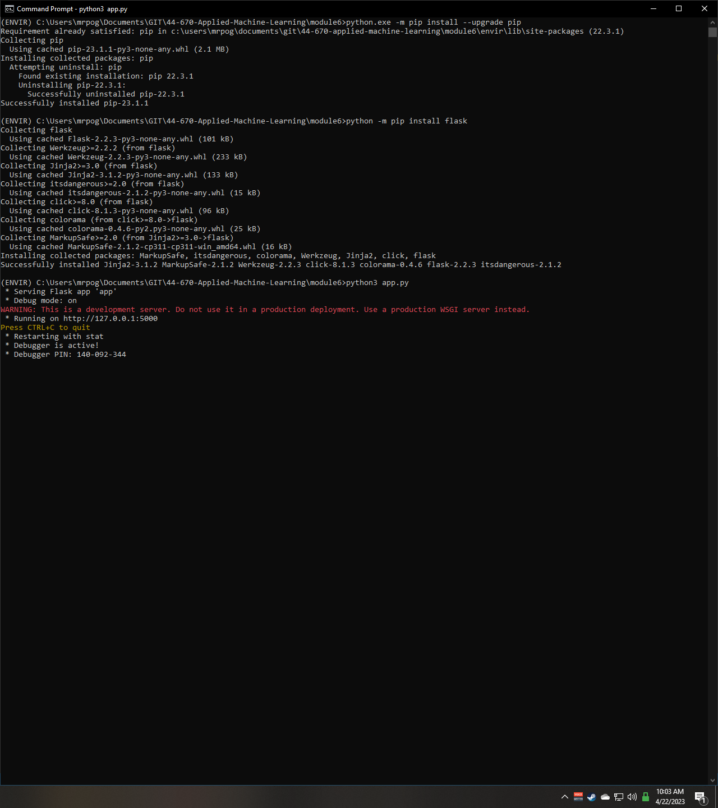

Submission 10:

|  |  |
| --- | --- |
| <http://127.0.0.1:5000/weight> | Bad Request: Missing height query parameter |
| <http://127.0.0.1:5000/weight?height=33.3> | {"height": 33.3, "weight": -25.860609898265366} |
| <http://127.0.0.1:5000/weight?height=0> | {"height": 0.0, "weight": -166.2903412756665} |
| <http://127.0.0.1:5000/weight?height=50> | {"height": 50.0, "weight": -1.3934699237880892} |
| <http://127.0.0.1:5000/weight?height=100> | {"height": 100.0, "weight": 13.326036231750194} |
| <http://127.0.0.1:5000/weight?height=150> | {"height": 150.0, "weight": 41.401893038689934} |
| <http://127.0.0.1:5000/weight?height=175> | {"height": 175.0, "weight": 56.42986106265094} |
| <http://127.0.0.1:5000/weight?height=200> | {"height": 200.0, "weight": 44.77557652322797} |

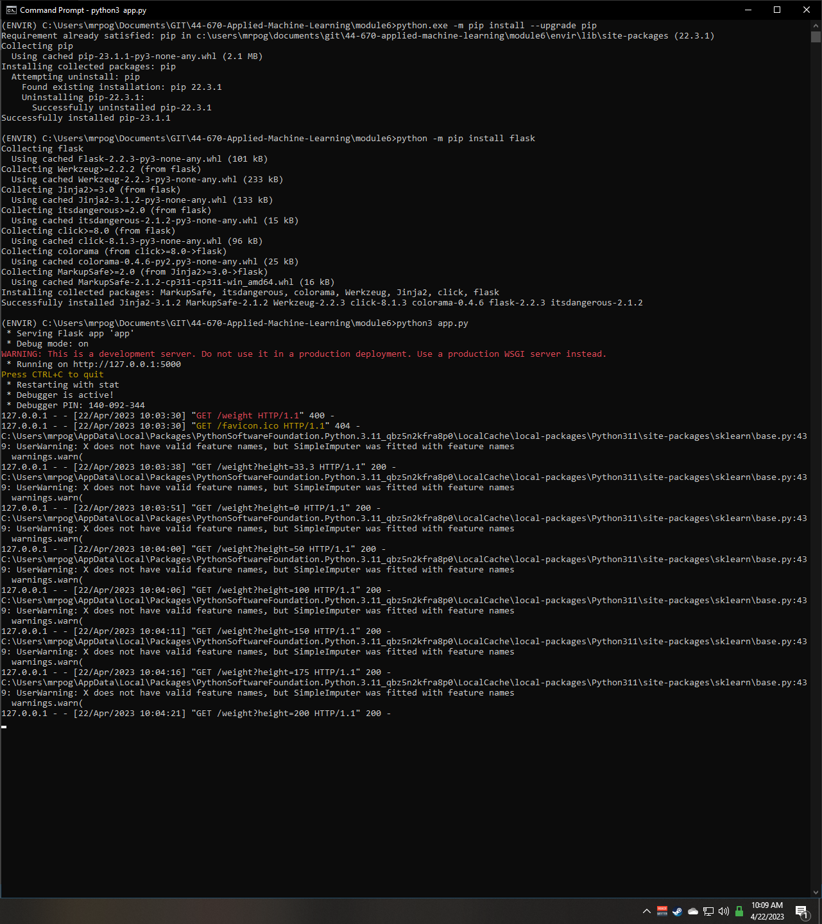

Submission 11:

Values do matchup and there are no known observable discrepancies. As the precision of the model is reduced in python, while the precision using the server is higher, it is unknown. As the values matchup almost perfectly (minus the rounding) I would say this is unlikely.