Submission 1-A:

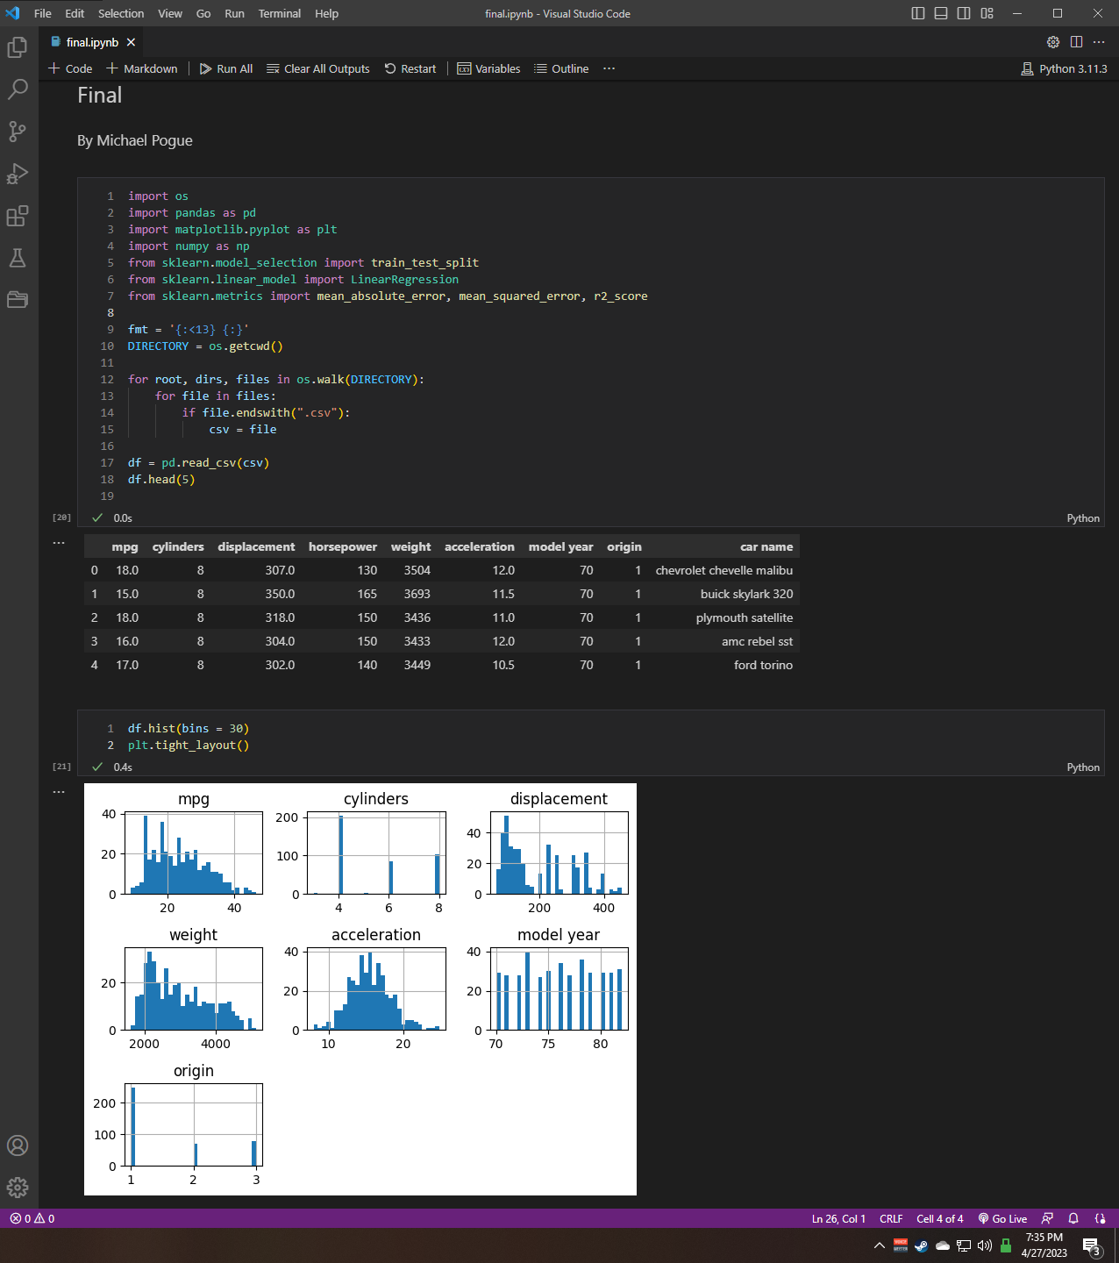

Submission 1-B:

Most of the data is skewed to the left, model year is somewhat bimodal, and acceleration is gaussian. Horsepower is lacking a distribution. Horsepower would be the uneven option as it has no distribution graph.

Submission 1-C:

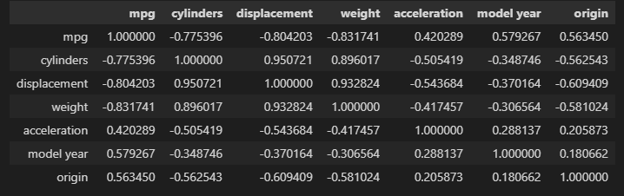I originally assumed that there would be a correlation with model years and weight. Ideally my guess would be as technology advanced, so too did our fuel efficiency. Obviously, weight would have a factor in fuel economy. Given the correlations listed above with weight, I’m now not so sure of my prediction.

Submission 2-A:

The biggest factor that I would like to see would be shape. Driving a box-shaped auto would not have the same fuel efficiency as something that was streamlined and overall closer to the ground.

Submission 2-B & C:

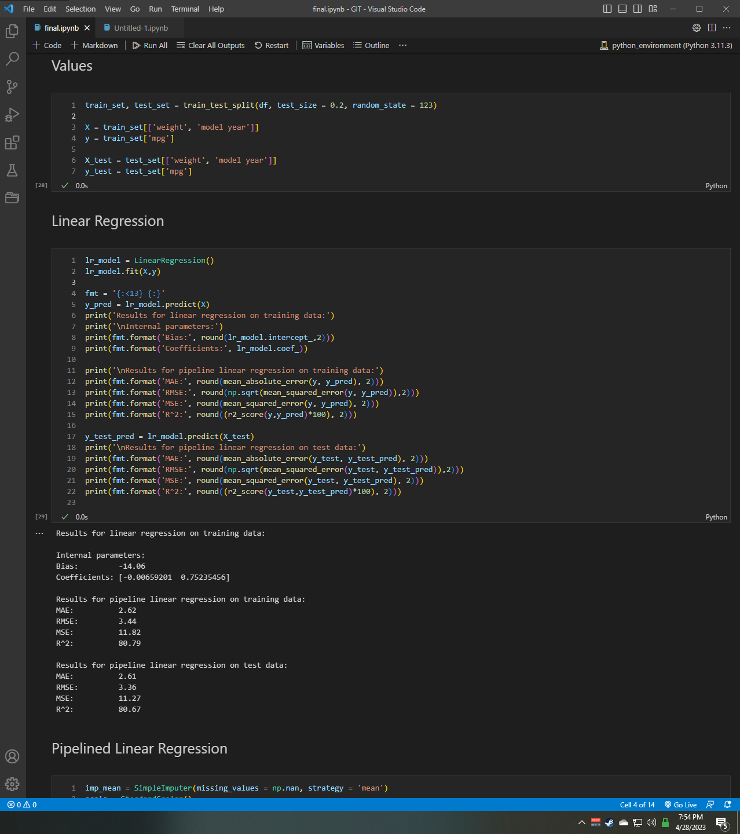

Submission 2-D:

Based on the results, much like I predicted above there is a slightly negative relationship between MPG and weight, which I find astonishing as I believed it to be the most obvious. There is a positive relationship with model year.

Submission 3-A & B:

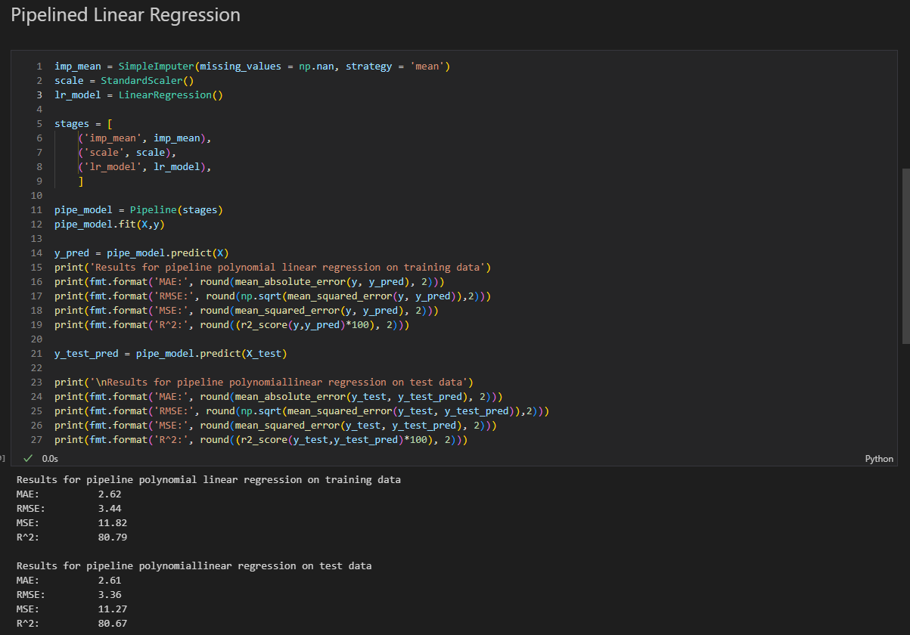

Submission 3-A & C:

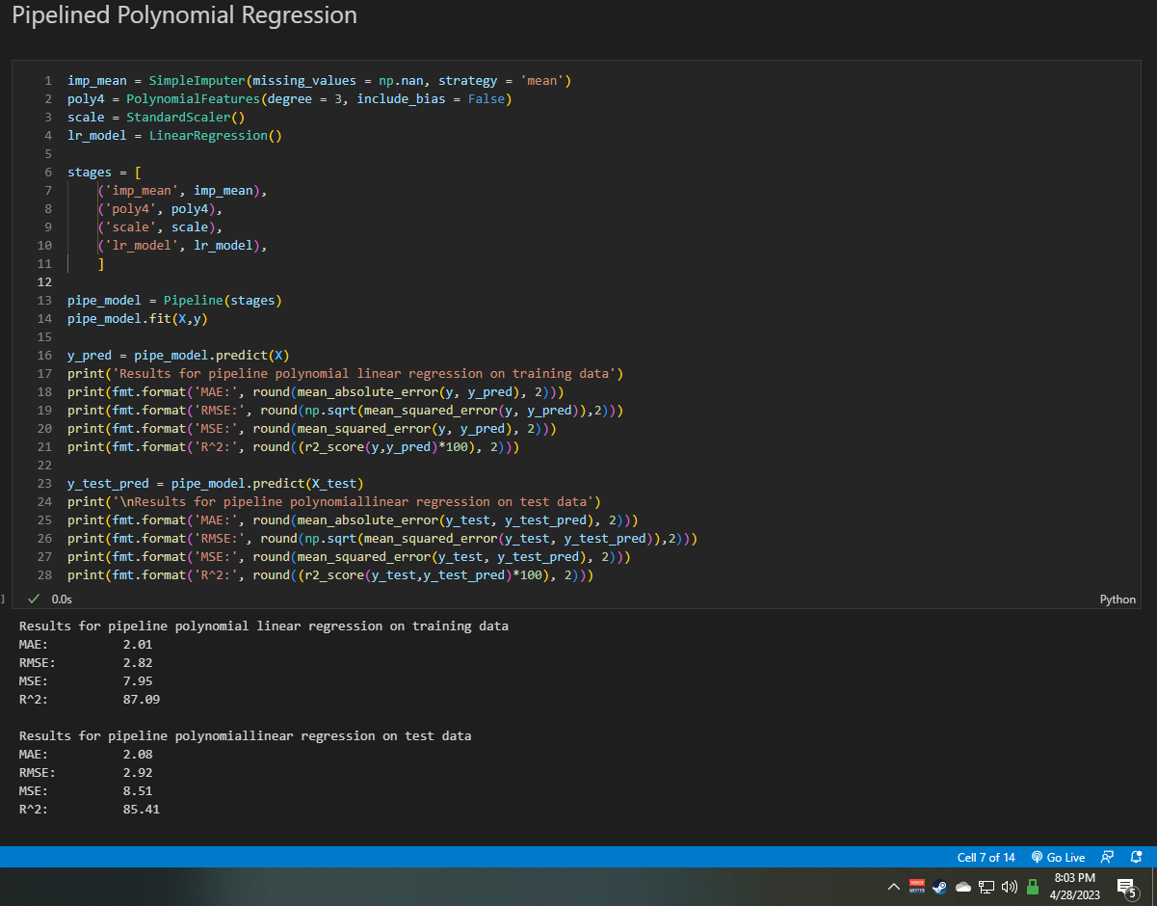

Submission 3-D:

Two linear models behaved the same. There was a rather large increase in performance based on the r2 values between the two pipelines. With an increased fit from the polynomial regression. Given the RMSE values, there may be some underfitting in the linear regressions as the test value is lower than the train. The exact opposite can be said for the polynomial, which I believe there is slightly overfitting the values.