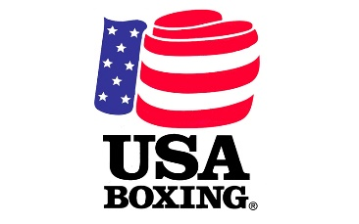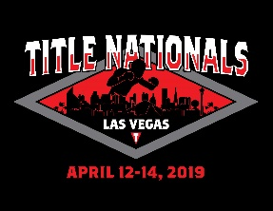

CAMP HARDER

**NV TITLE NATIONALS AGENDA**

**DURANGO HILLS COMMUNITY CENTER - YMCA**

2521 N. Durango Drive

Las Vegas, NV, 89129

**REGISTRATION DAY**

There will be No walk ups allowed to register at the time of the weigh ins.

Location: YMCA

**Must register by**

Friday @ 8:00am

**WEIGH-INS**

Friday:     10:00am-1:00pm

Saturday: 8:00am- 10:00am

Sunday:    8:00am -10:00am

**BRIEF COACHES MEETING**

Friday April 26th

Time: 1:00 pm @ the YMCA

Please have your current pass books to receive

Wrist band for the 3-day duration of the event.

If you have fighters in this tournament, please attend this meeting!

You will not be able to enter the event without the wrist band we will distribute, and you will have to pay an entrance fee.

**FIGHT SCHEDULE:**

Friday:      5:00pm - 9:00pm

Saturday: 2:00pm

Sunday:   2:00pm

All boxers MUST be on weight to compete in the tournament and must weigh in every day that they compete (and at least one time if unopposed to receive the title for their division).   
  
There is a 1/2 pound weight allowance (ie a boxer competing at 101 lbs may weigh in at 101.5 and not be penalized).   
  
Those who are unopposed in the tournament may still compete in a matched bout with another unopposed boxer so long as they are within USA Boxing age and weight requirements for matched bouts.

**QUESTIONS? Please Contact:**

Nate G (702)664-5967

Mallory Triplett (702)321-6506

Danny Vella (702) 328-3142