Hands-on Lab: Building a Joule Agent with SAP Build

Aleksandrs Antonuks, Vass, aleksandrs.antonuks@vasscompany.com
Michael Pytel, Vass, michael.pytel@vasscompany.com
Sheldon Lipshitz, Vass, sheldon.lipshitz@vasscompany.com
https://vasscompany.com

Index

Table of Contents
Environment Information 2
Lab Goal 3
Create a Joule Skills 3
Create a Joule Agent 14
Test your Joule Agent 17

Environment Information
- Please use GOOGLE CHROME as your browser
- SAP Build App URLs
  - SAP Build Apps
- Lab User Information
  - User: labuser<##>@vasscompany.com
  - Password: Newpa55!
- Replace <##> with your Lab User Number assigned by the instructors
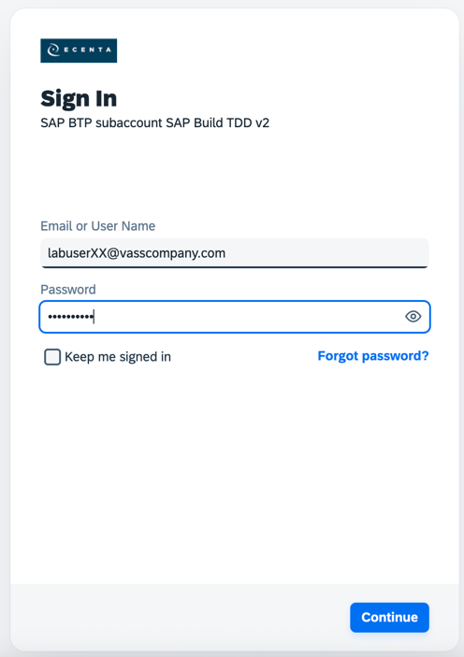

Lab Goal
We will be building a Joule Agent that can review Opportunities within Salesforce.com and then create a corresponding Sales Order within S/4HANA. For this lab, we have already set up the ‘Actions’ which call the API endpoints in Salesforce.com and S/4HANA. Screenshots will be provided in the Lab Overview presentation. This is a very simple, self-contained scenario to demo the low-code environment where developers or analysts can create Joule Agents. This is not a production-ready scenario as all environments are distinctly different and require different inputs. This lab should provide a good, first, hands-on experience to encourage the lab user to explore more.

Create a Joule Skills
- From the SAP Build Lobby click the Create button, then select Create
- 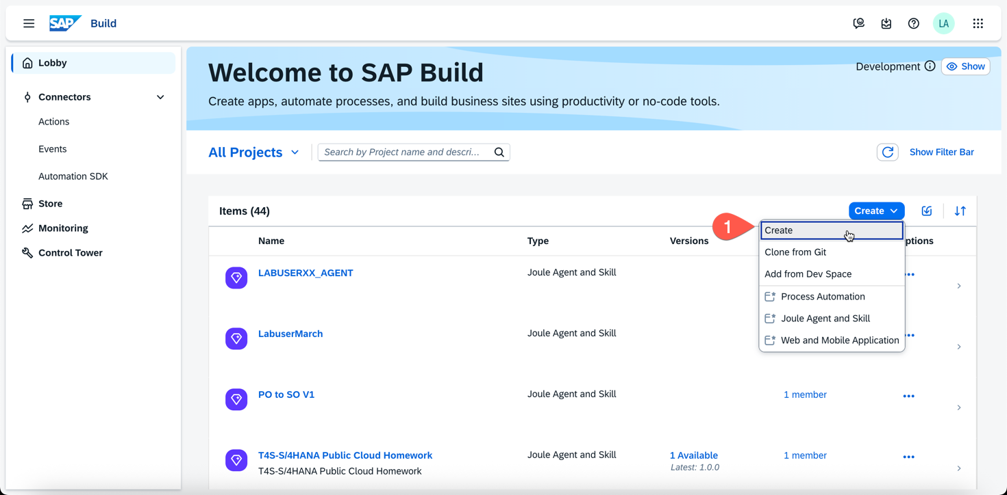
- Select Joule Agent & Skill and click Next
- 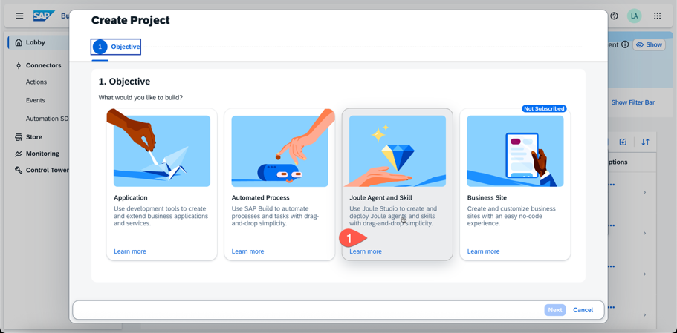
- Enter a name for your Joule Skill in the following format
  - Name: LABUSER##_AGENT
- 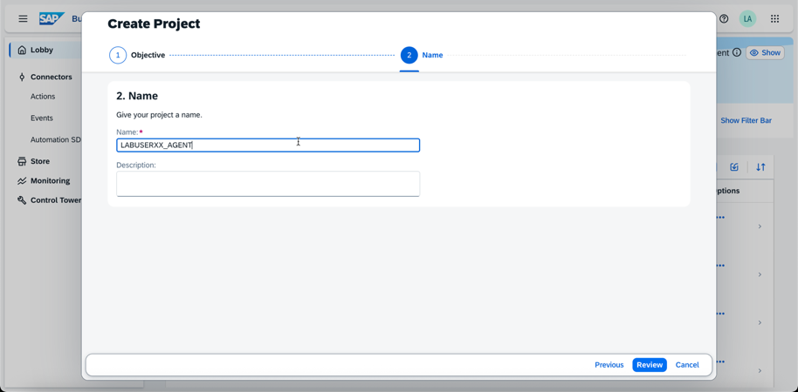
- Click Review. Then click Create
- 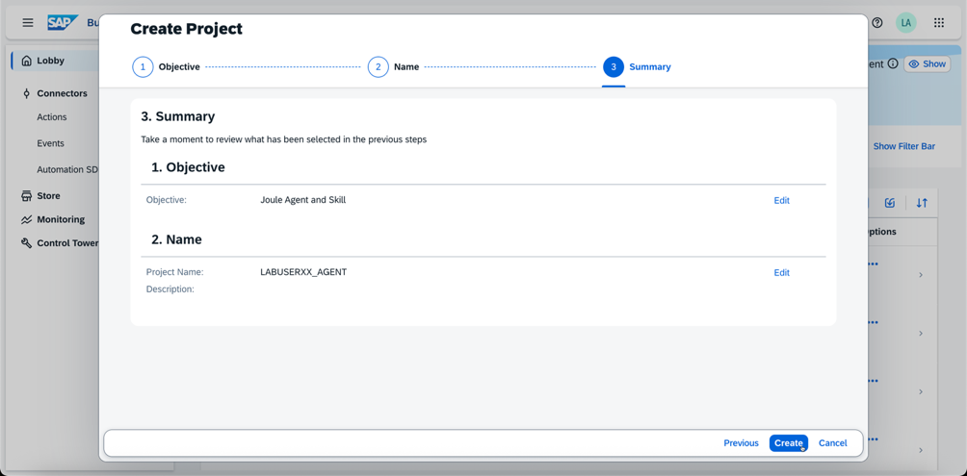
- A new browser tab will open (suppress the pop-up blocker)
- Accept the Disclaimer if shown.
- Click Settings on the upper right
- 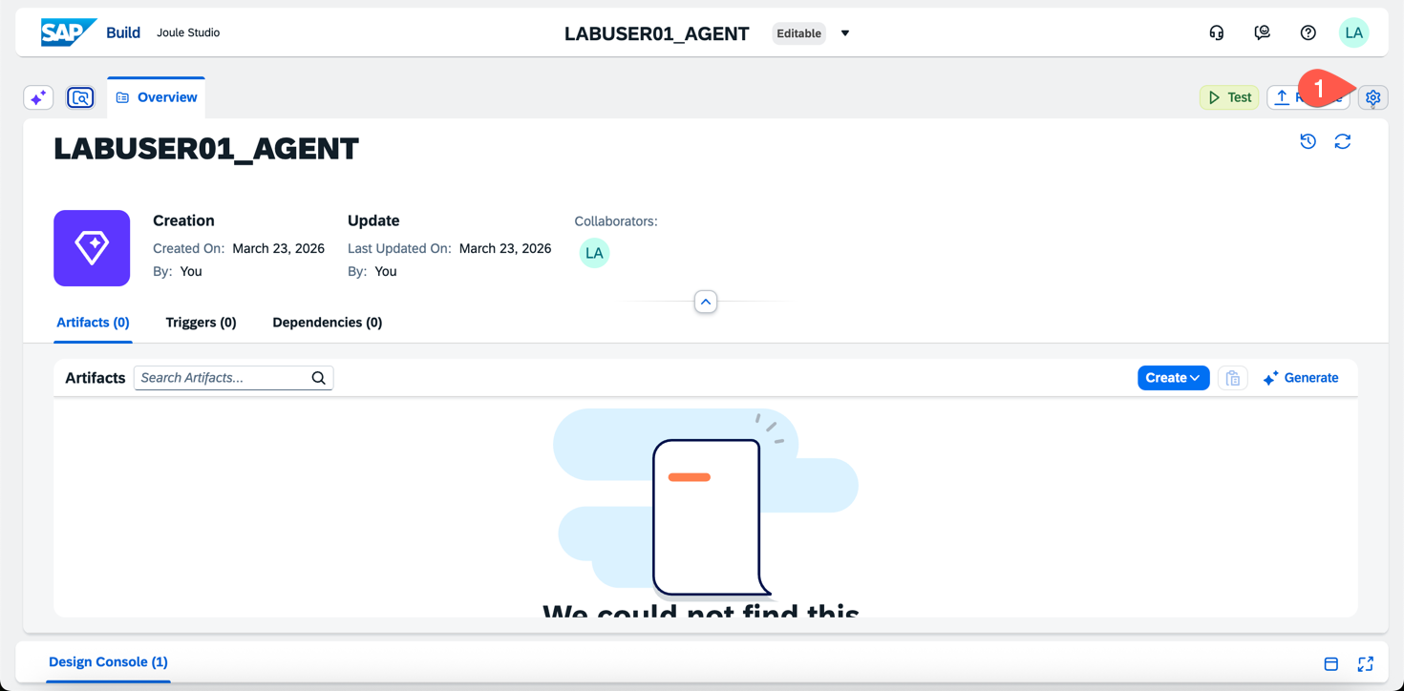
- Click on Environment Variables then select Create
- 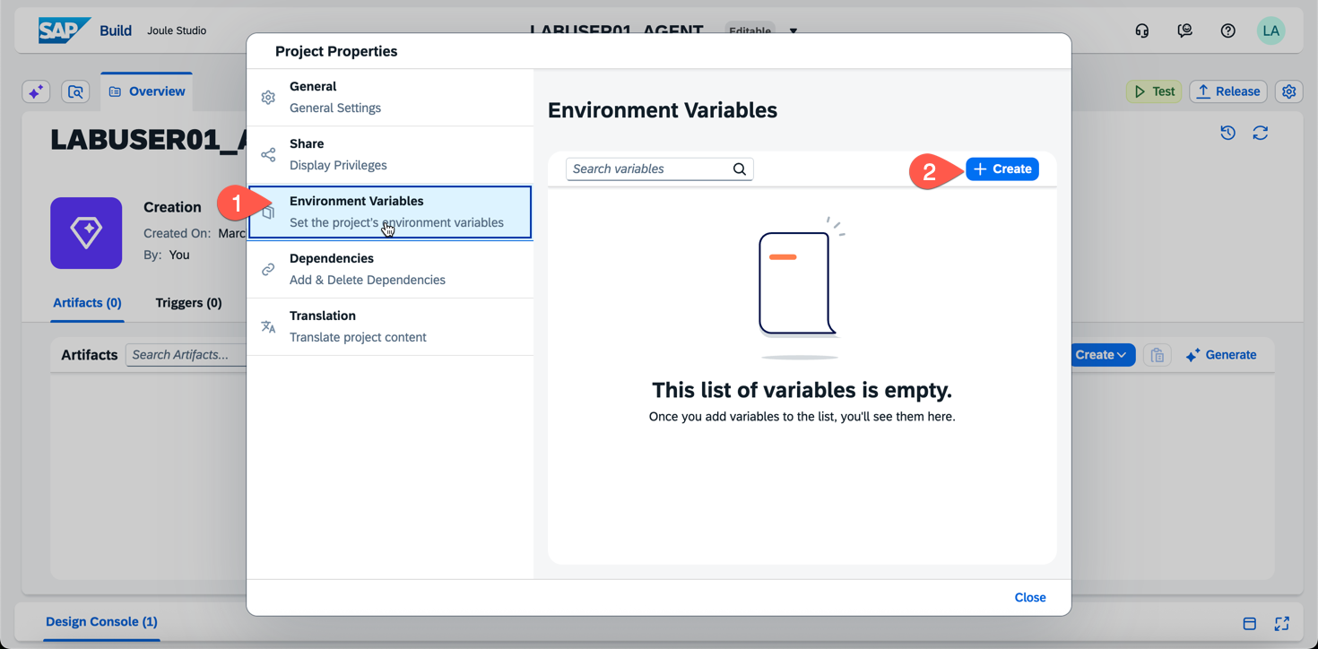
- Create the Destination with the data below and click Create again
  - Identifier: SalesForceDest
  - Description: Sales Force Destination
  - Type: Destination
- 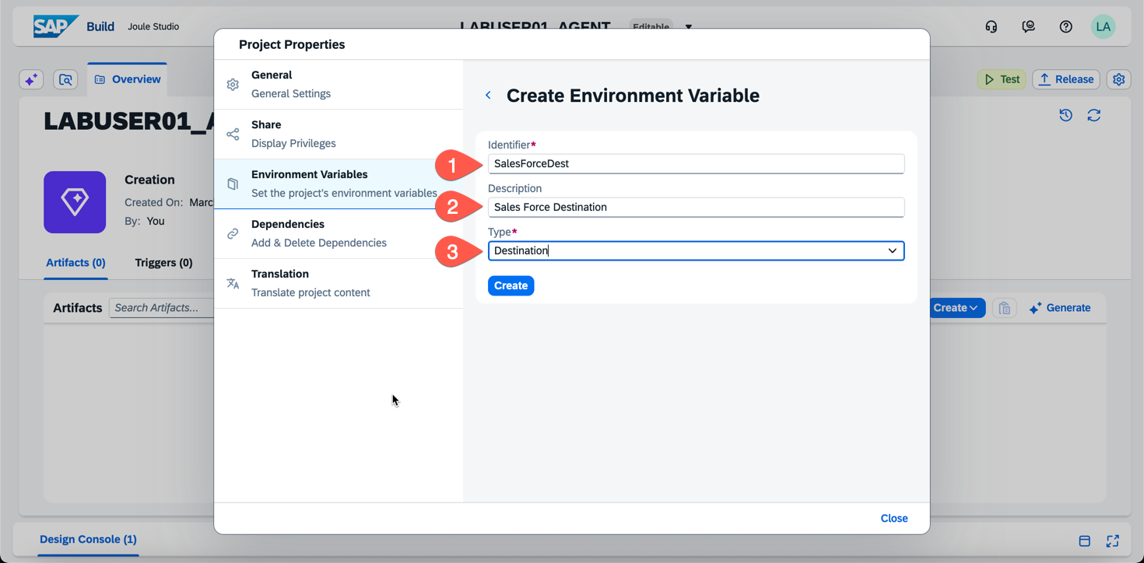
- Repeat for S/4HANA with the data below
  - Identifier: S4HANADest
  - Description: S4HANA Destination
  - Type: Destination
- Confirm you have two environment variables for Destinations
- 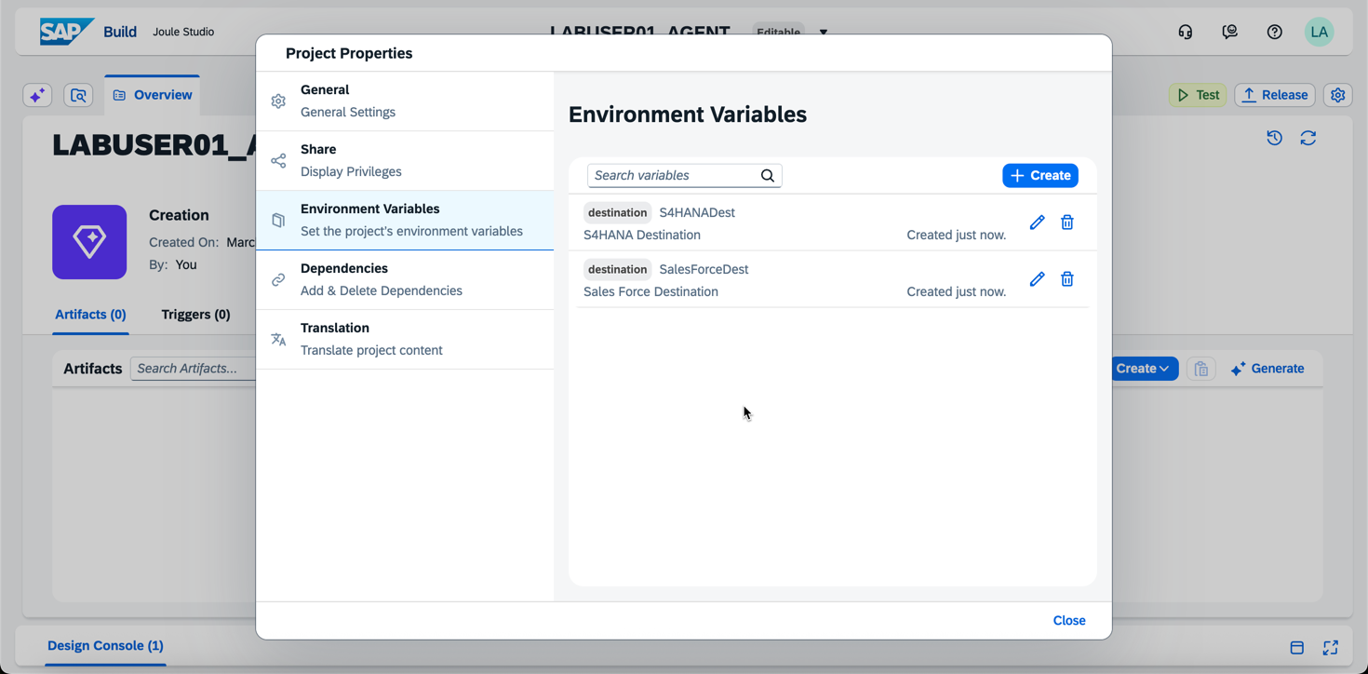
- Next, Click on Dependencies, Click Add, Select ‘Add an Actions Project Dependency’
- 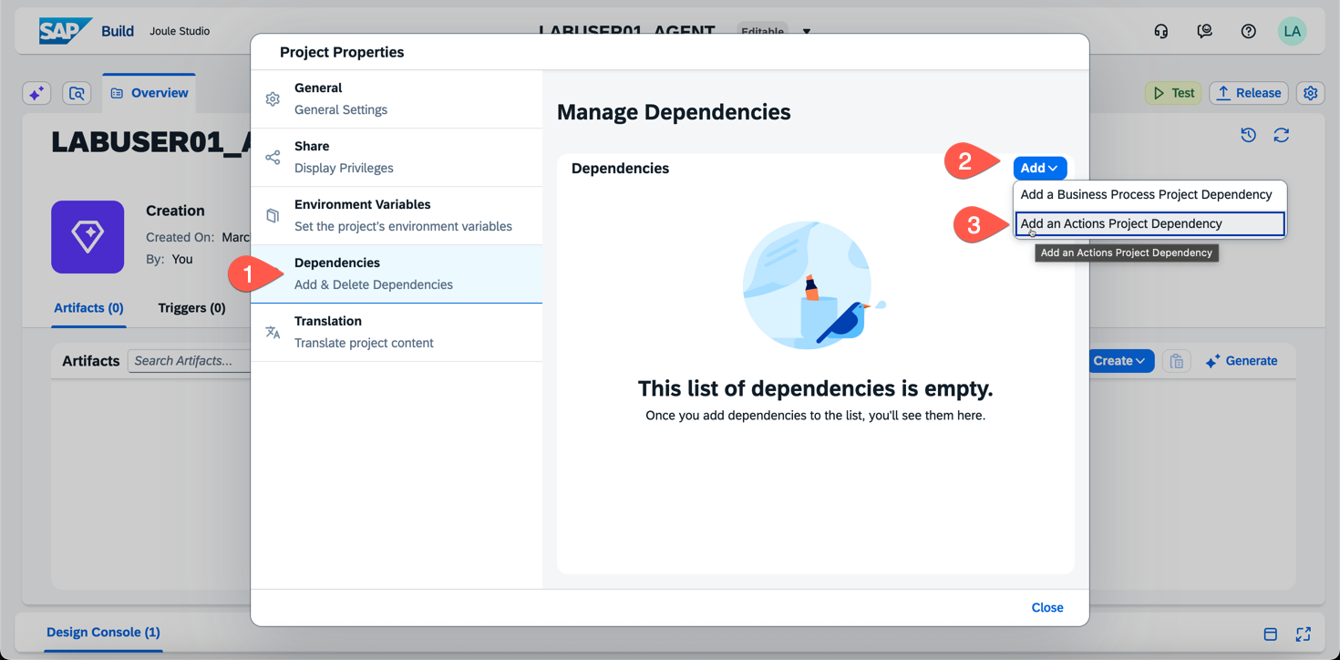
- When prompted to Search, enter ‘Opportunity’ and select the Add button next to ‘Fetch Negotiation Opportunities’
- 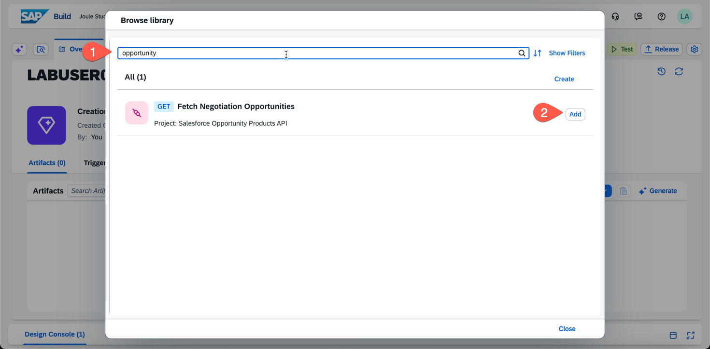
- Add another Dependency for the ‘Creates a sales order’ by searching
- 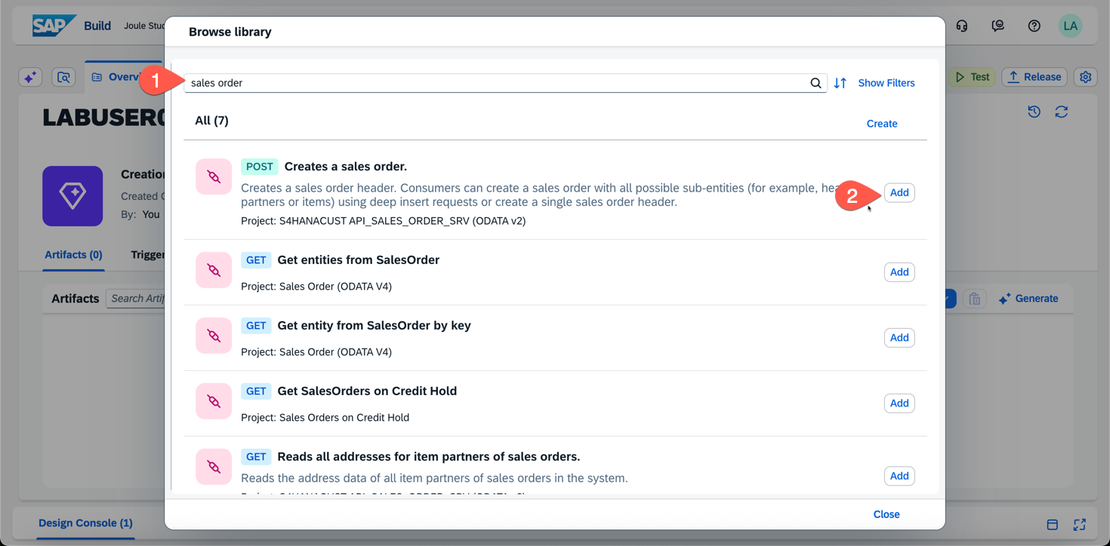
- Confirm you have two dependencies added and click Close
- 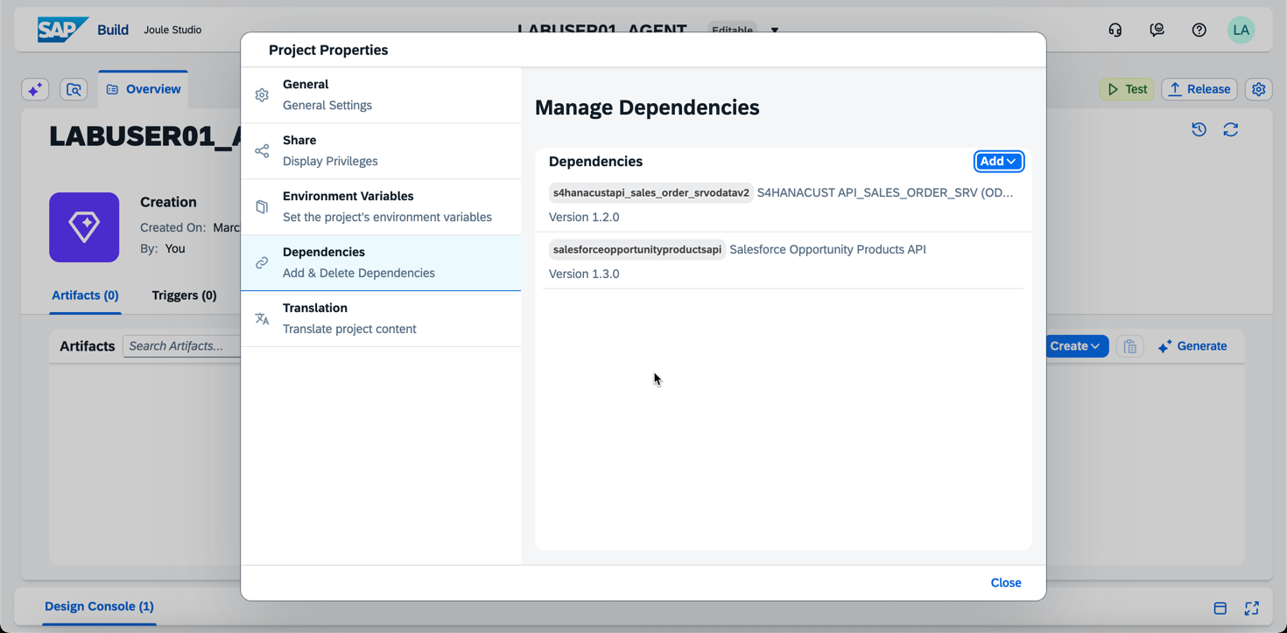
- Next, we’re going to create a Data Type to persist the results of the SalesForce API. Click the Create button again and select Data Type
- 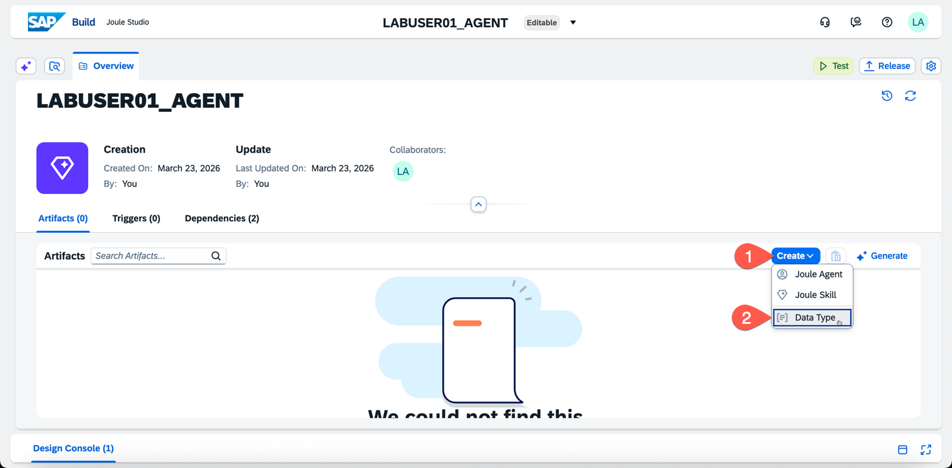
- Enter the following details and click Create
  - Name: OpportunityList
  - Description: A list of opportunities from SalesForce
- 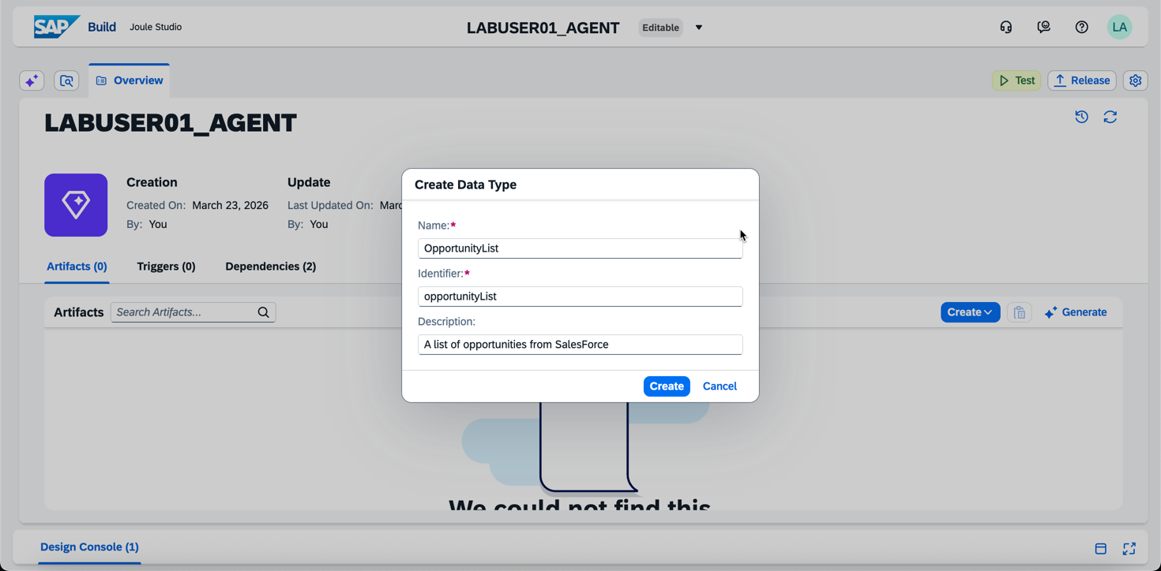
- Click New Field when the Data Type is displayed
- 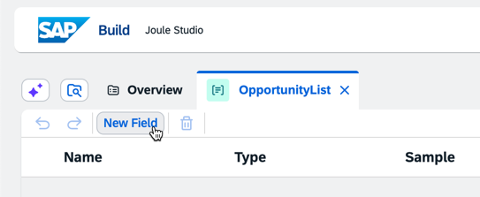
- Enter the name ‘API’
- 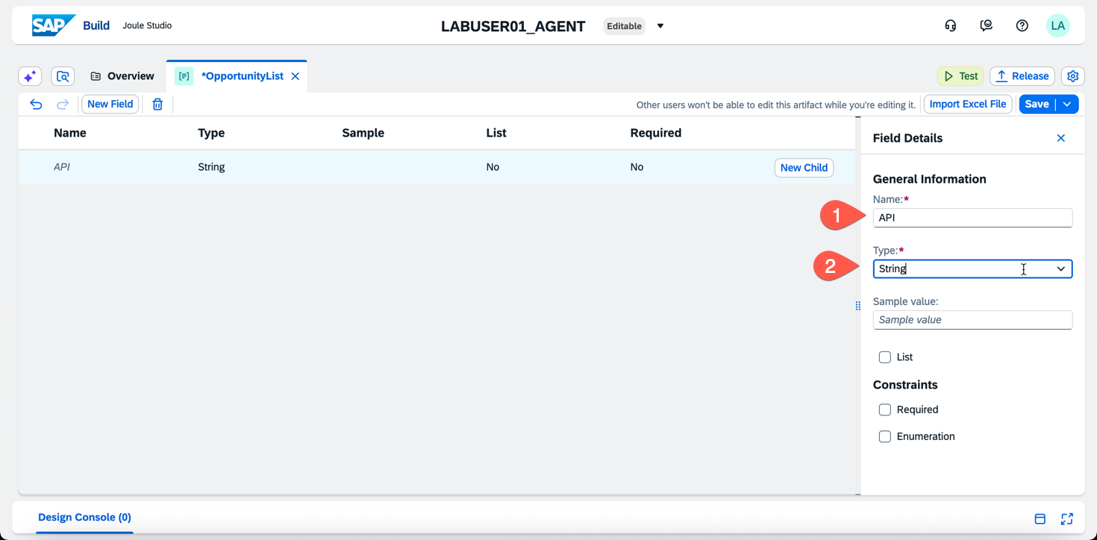
- Select the Drop Down for Type and select the schema for the API.
- 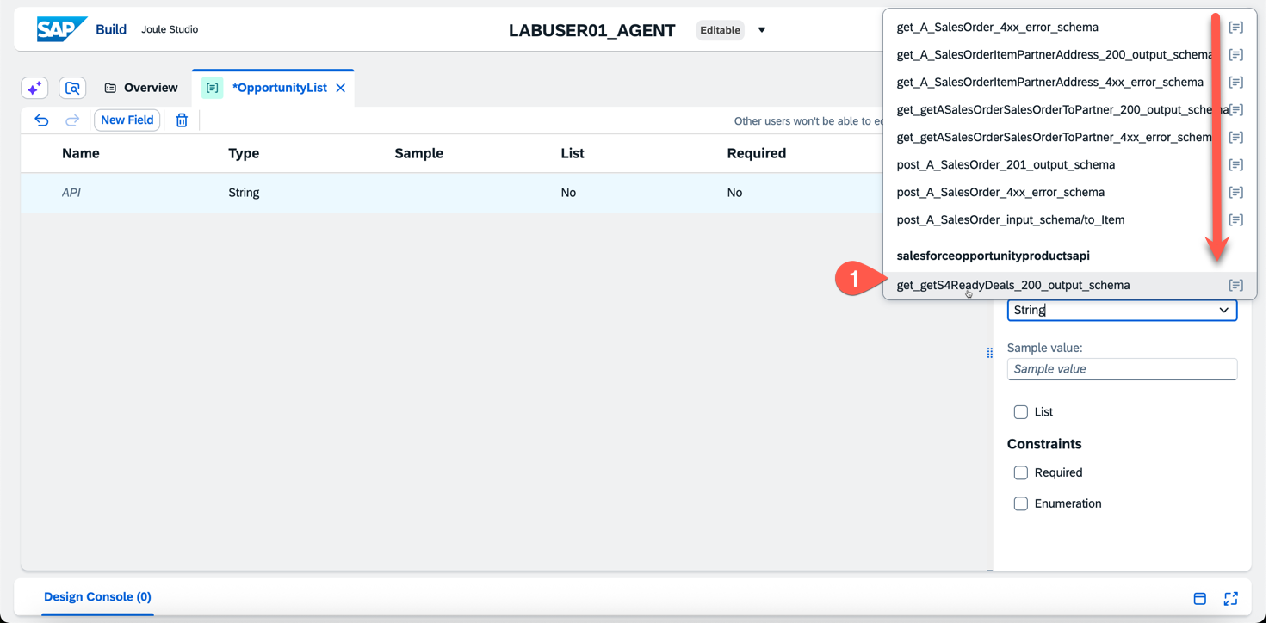
- Click Tab Button and the resulting API schema should be displayed.
- Click Save and then close the Tab for the Data Type
- 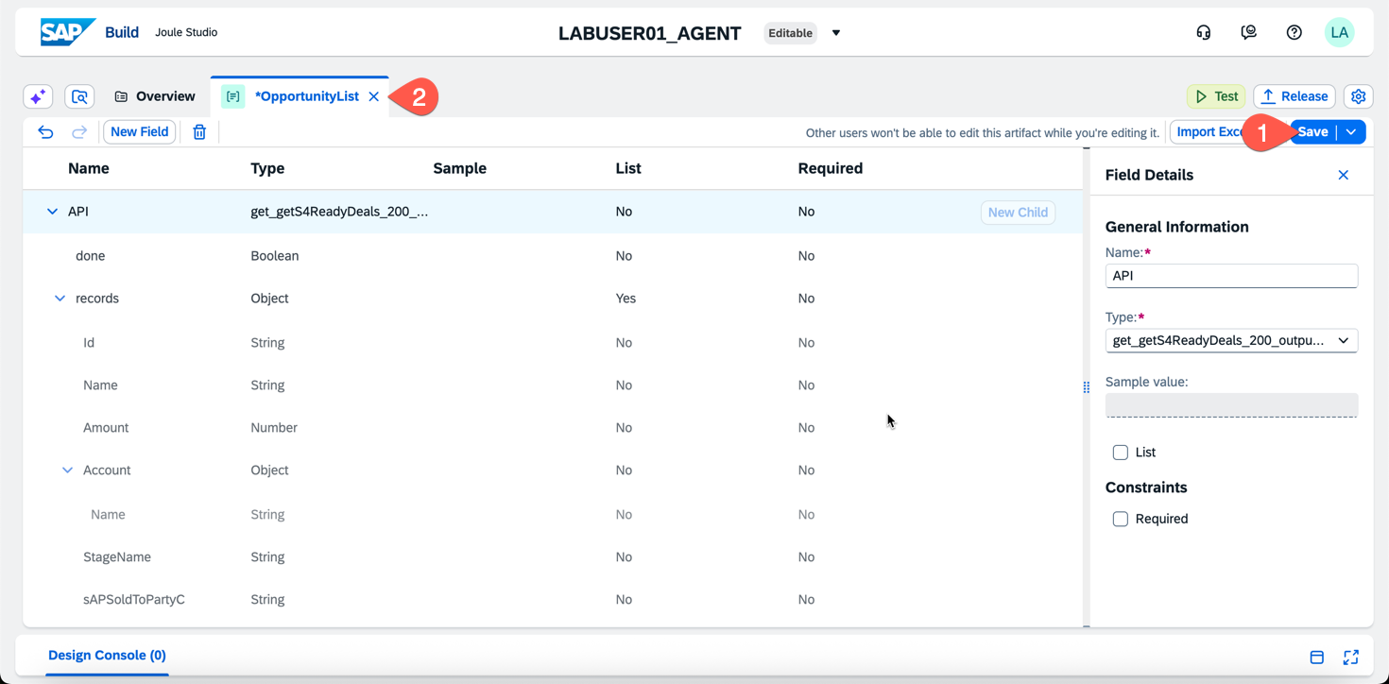
- On the Overview screen, click Create > Joule Skill
- 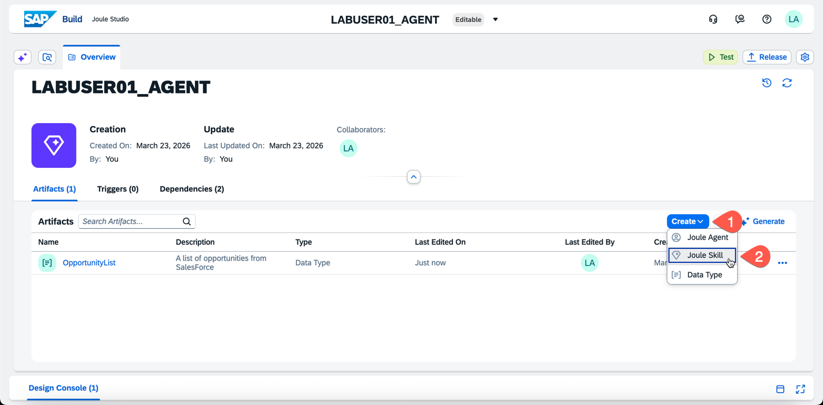
- Enter the following details on the Joule Skill
  - Name: GetNegotiationDeals
  - Description: Retrieves a list of Salesforce Opportunities currently in the 'Negotiation/Review' stage. For each opportunity, it provides the Opportunity ID, the Deal Name, the associated Account Name, and a nested list of products (Line Items). The product data includes the Quantity, Unit Price, Salesforce Product Name, and the Product Code (Material) required for SAP S/4HANA mapping.
- 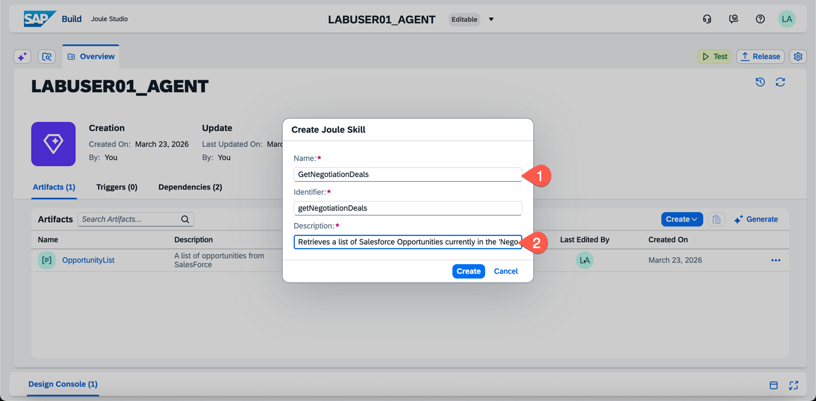
- When the new Joule Skill opens select the “plus” sign below Trigger
- 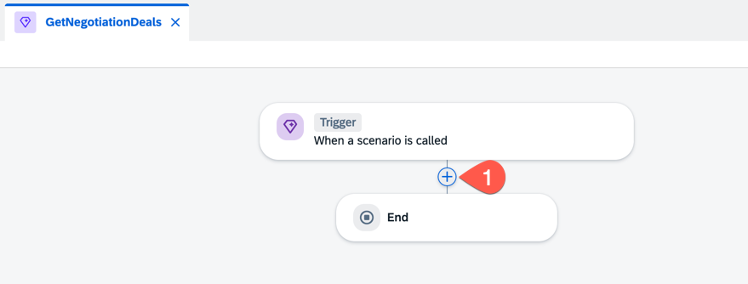
- Select a Call Action
- 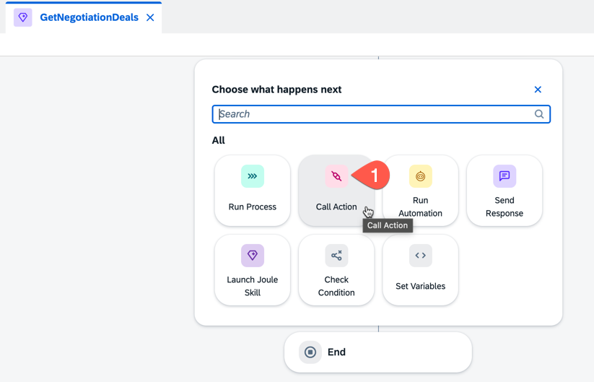
- Search for ‘Opportunity’ and select the Action shown below
- 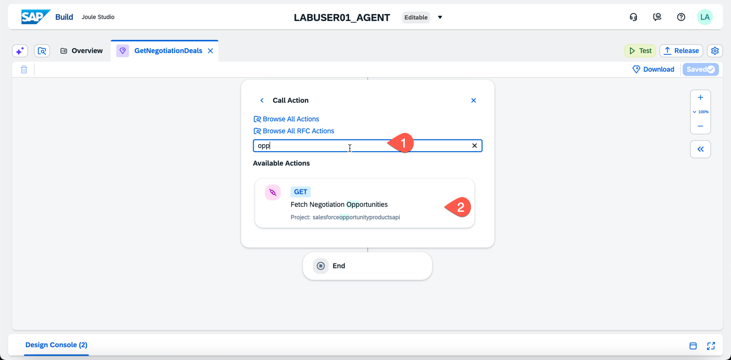
- When the Action is added select the Destination dropdown
- Choose your SalesForce Destination created above
- 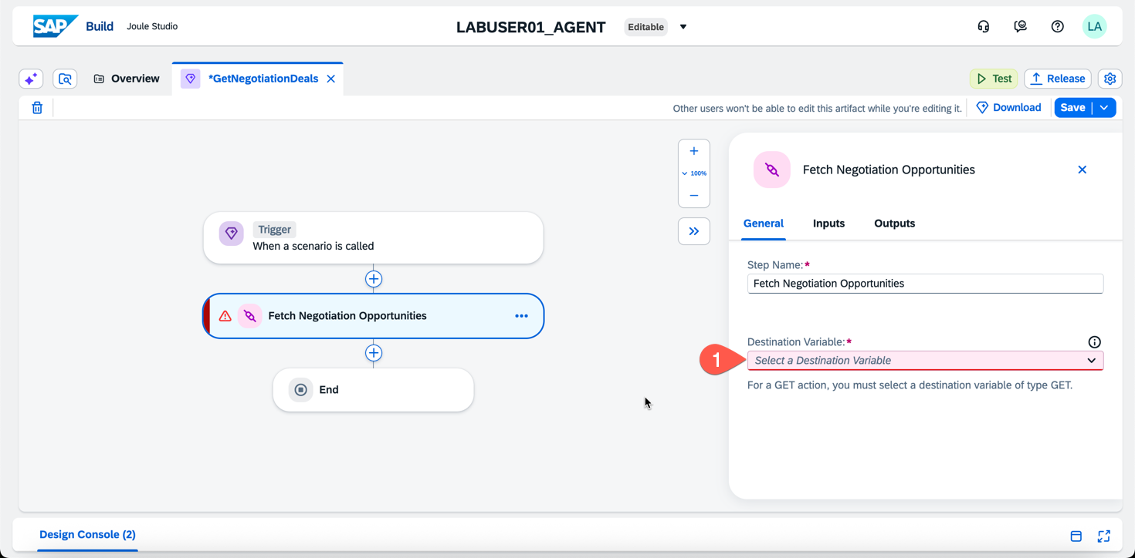
- 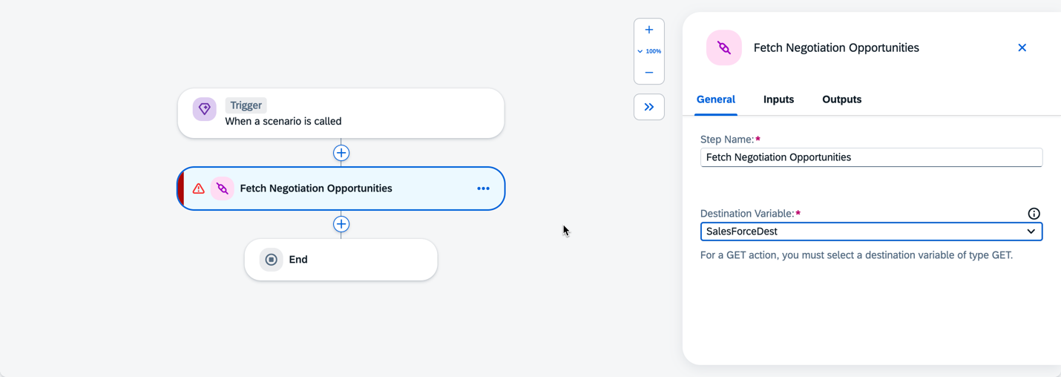
- Click Save in the upper right.
- Next, Click on Trigger then select Parameters > Skill Outputs > Configure
- 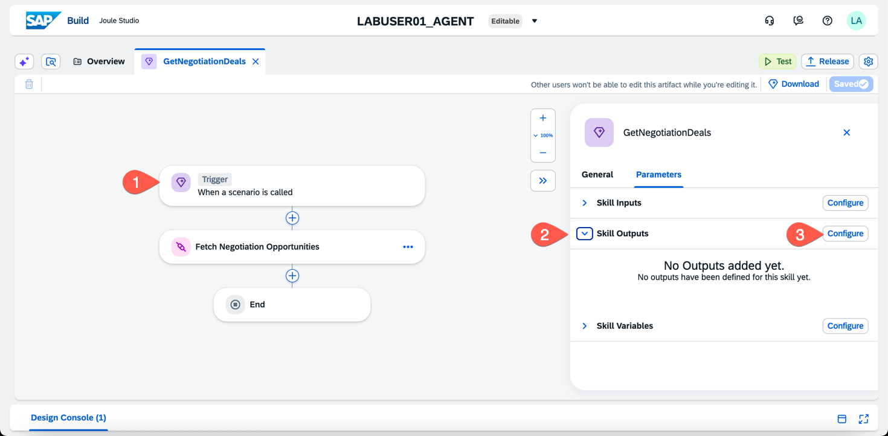
- Click Add Output and enter the following details
  - Name: OppList
  - Description: Opportunity List
  - Type: Scroll to select your Data Type created above
  - List: Checked
- 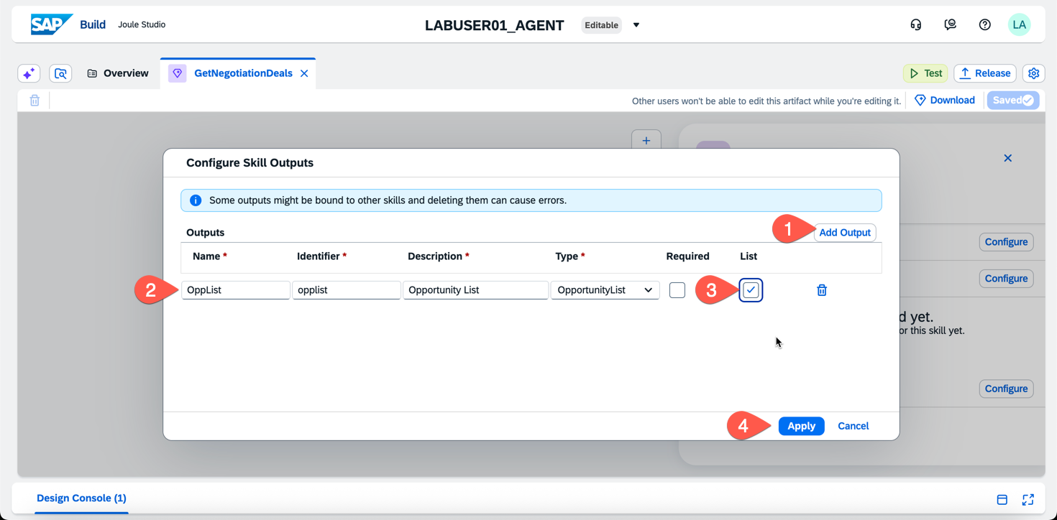
- Click Apply
- Note: The screen will take a few seconds to refresh. Click Save when the Output is shown.
- 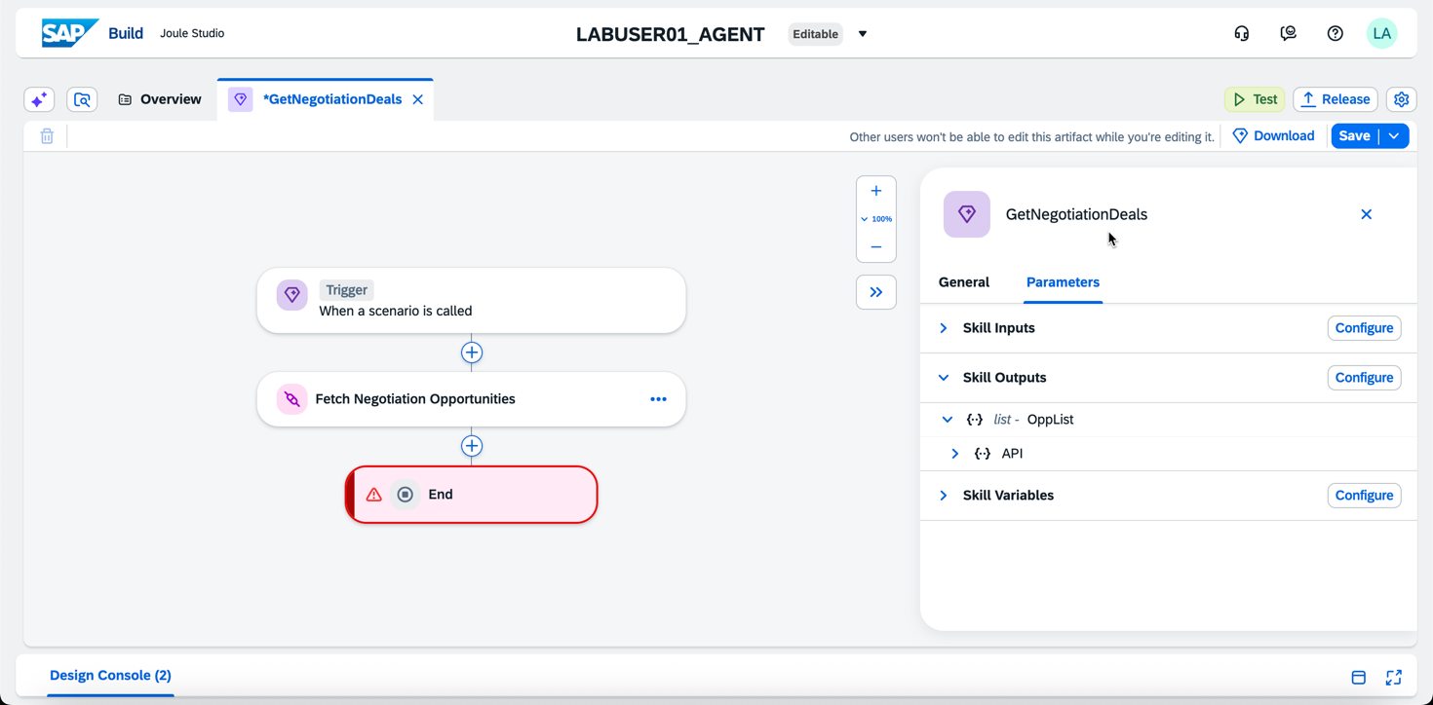
- Click on End in red
- Click on Opp List, then select Single Item
- 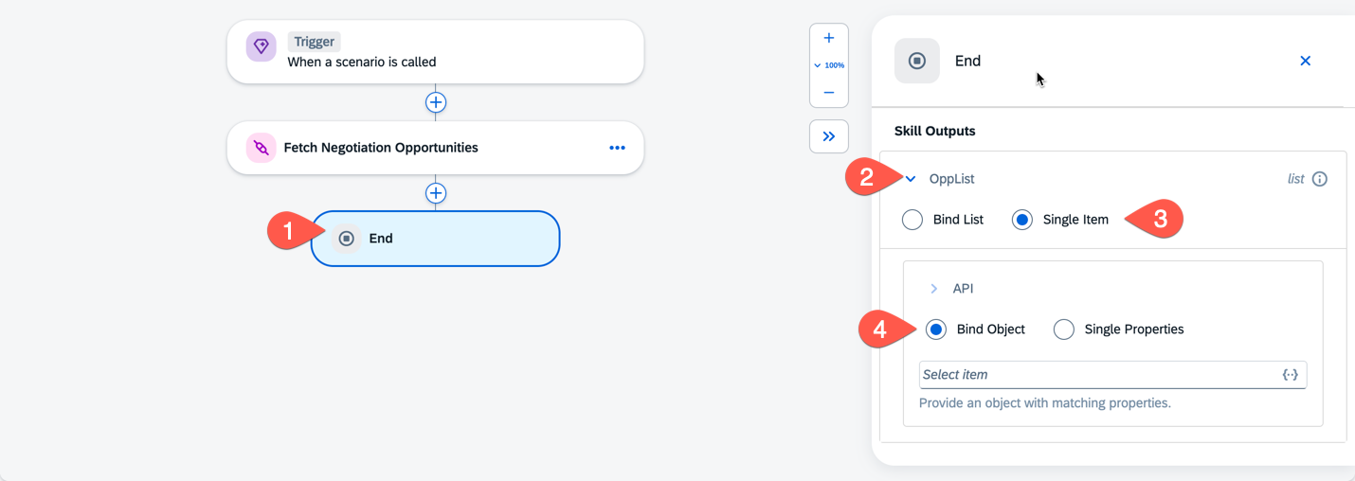
- Under API > Bind Object click into the box and select results
- 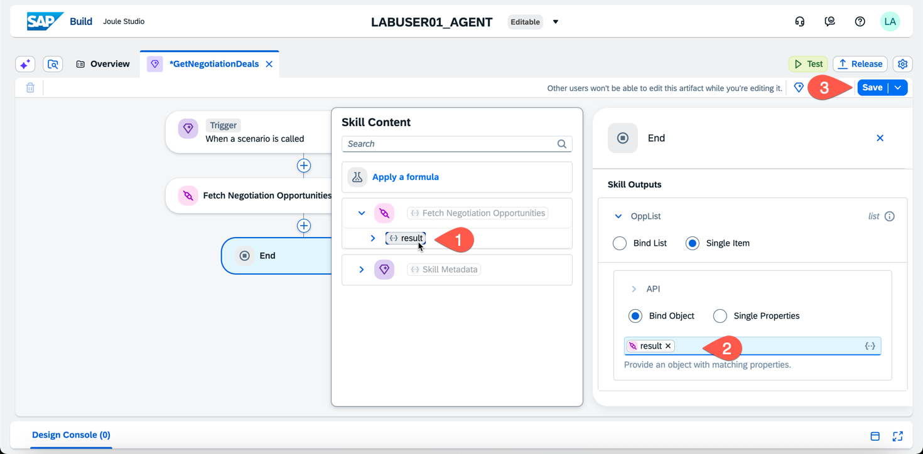
- Click Save again
- Close the tab for the Joule Skill
- Click Create > Joule Skill again
- Enter the following details and click Create
  - Name: CreateS4SalesOrder
  - Description: Creates a new Sales Order in SAP S/4HANA based on finalized Opportunity data. It maps the Salesforce 'ProductCode' to the S/4HANA 'Material' field, sets the 'RequestedQuantity', and assigns the 'SoldToParty' based on the SalesForce field SAP_Sold_To_Party__c. This skill should be triggered only after the user confirms the line items retrieved from Salesforce are correct for order entry. The result is a confirmation of the sales order creation with the sales order number from the JSON result.
- Select the Trigger, then select Parameters, Skill Inputs and Configure
- 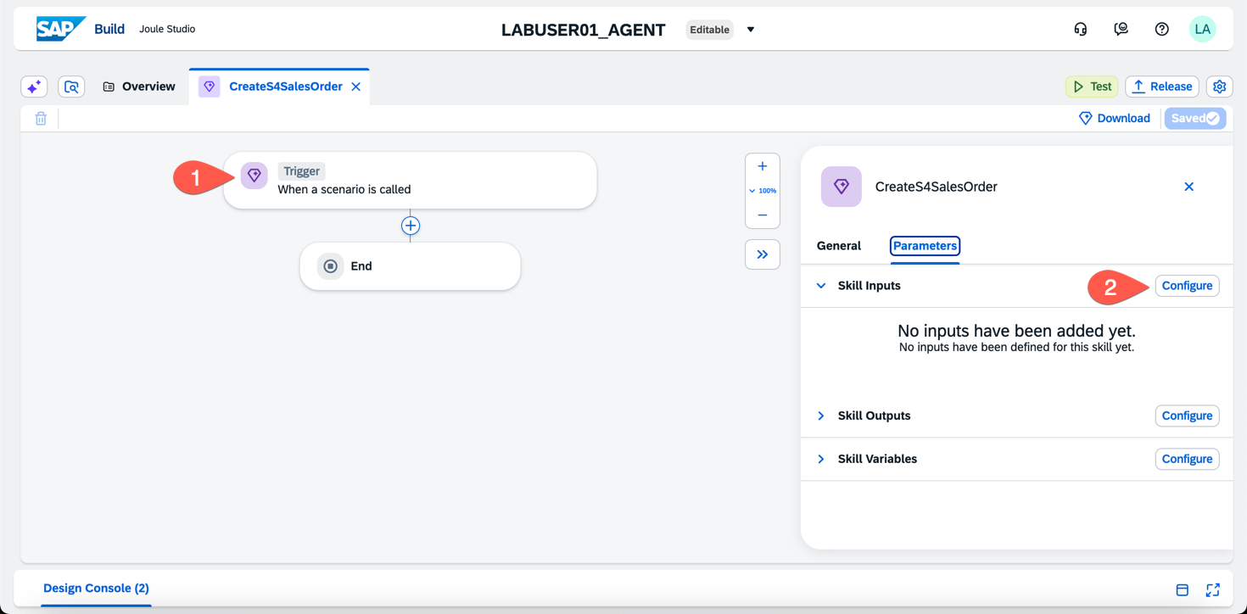

- Enter the following Input Parameters
Name: | Description
CustomerRef | Customer Reference
SoldToParty | SAP Sold to Party
Material | SAP Material
RequestedQty | Requested Qty
RegQtyUnit | Requested UoM
- Check Required for all parameters
- Confirm you have entered the following and click Apply
- 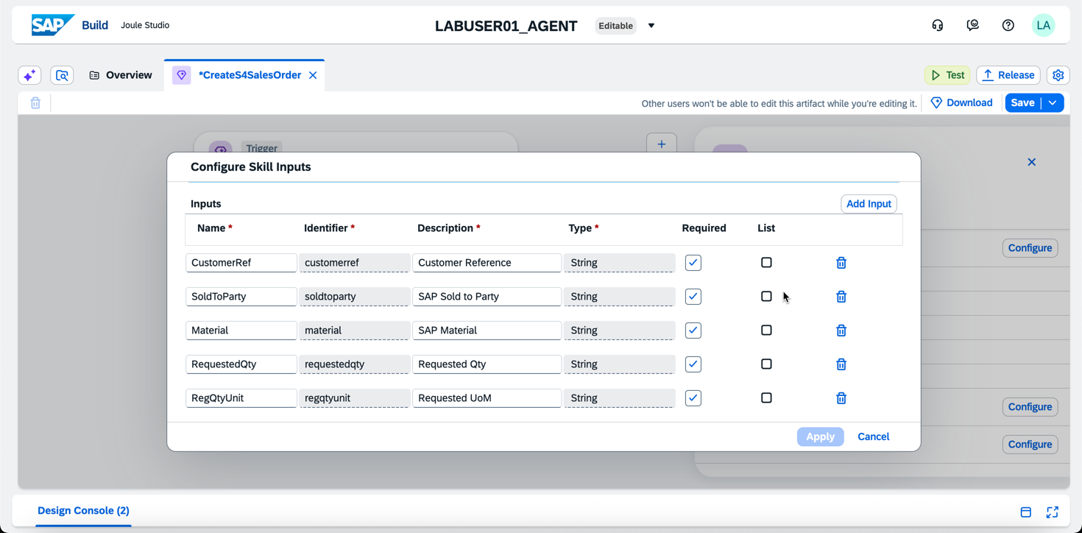
- Next, click the ‘plus’ sign below the Trigger
- 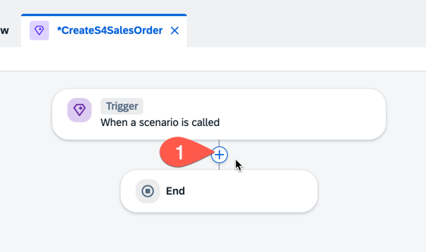
- Select Call Action
- Search for ‘Create’ and select the ‘Creates a sales order’ action
- 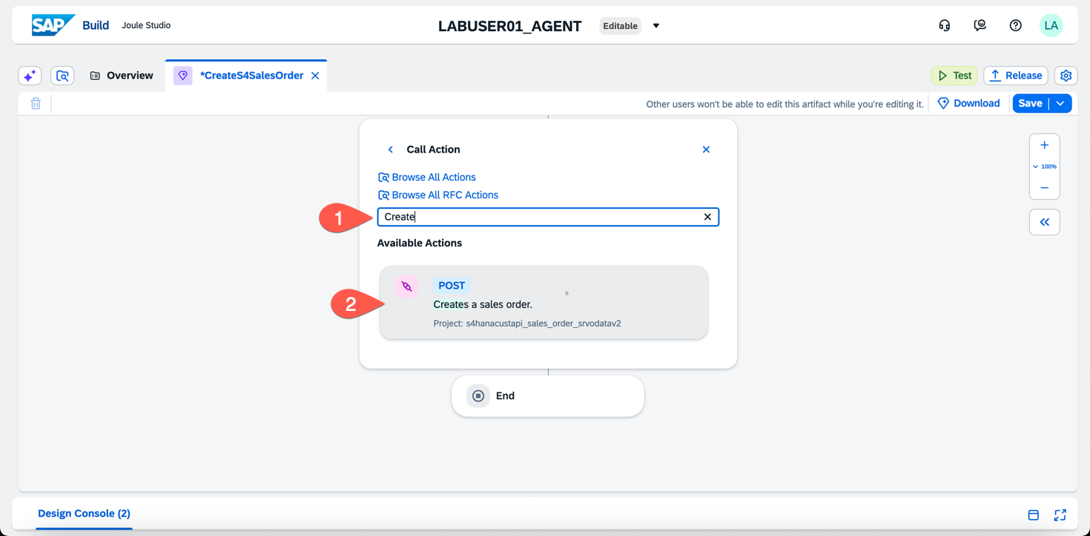
- Select your S4HANA Destination
- 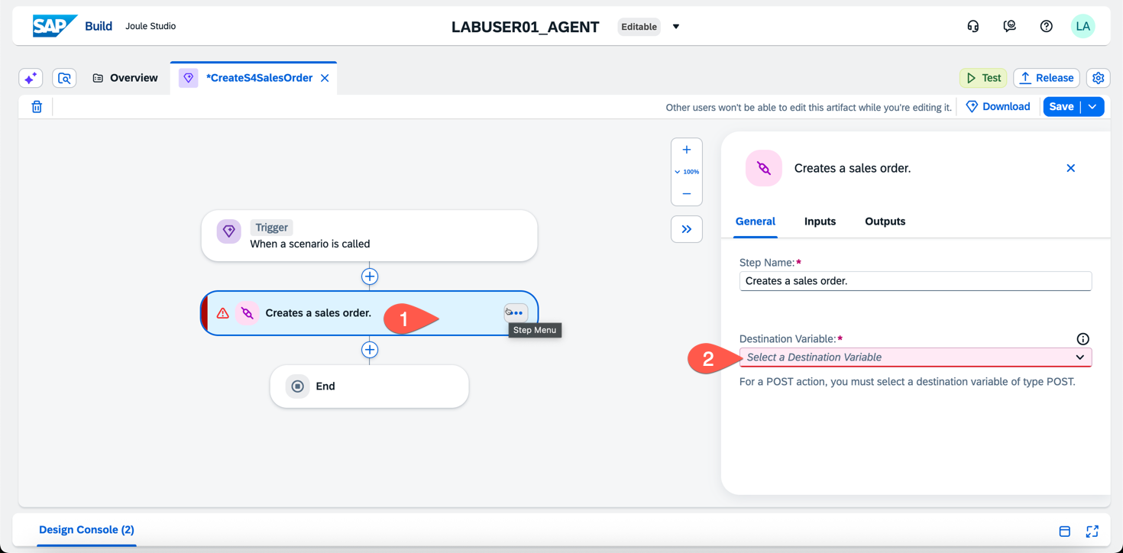
- Click the Inputs on your Action
- Map the Skil Input Parameters to the Action Input Parameters
- 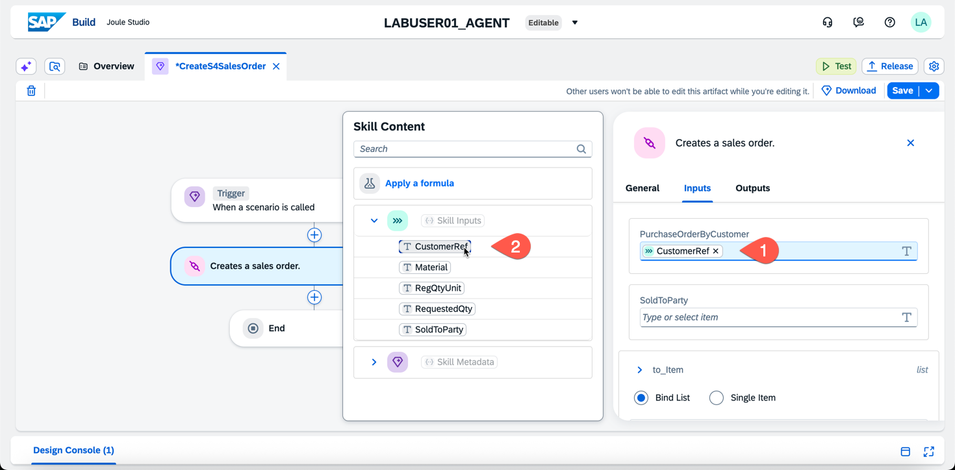
- Scroll Down to ‘to_Item’ and open the field
- Select ‘Single Item’ and map the parameters
- 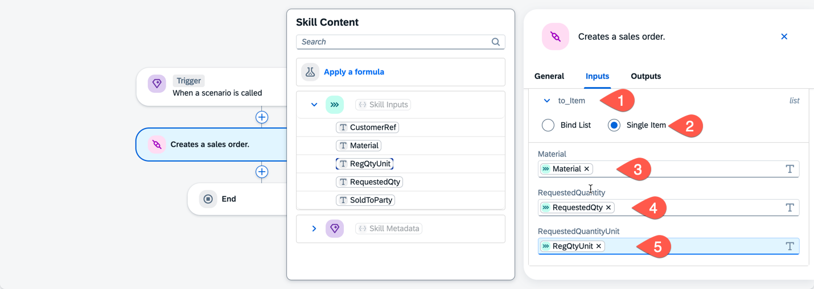
- Click the Save Button in upper right again
- After the Save is complete, click on Trigger.
- Select Parameters, and Skill Outputs
- 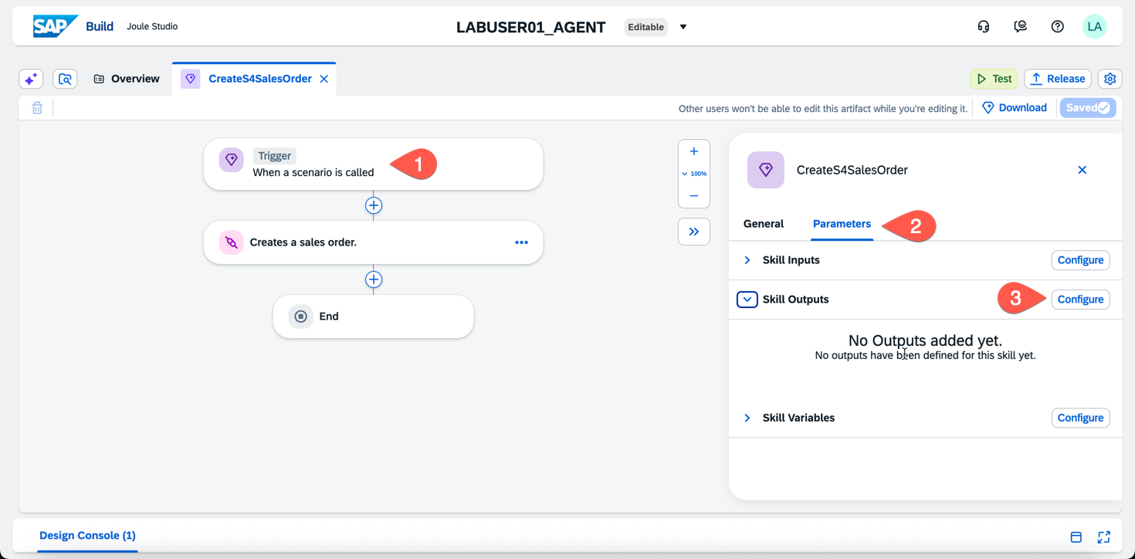
- Click Configure
- Click Add Output and enter the following
  - Name: SalesOrderNum
  - Description: Sales Order Number
  - Type: String
  - Required: Checked
- 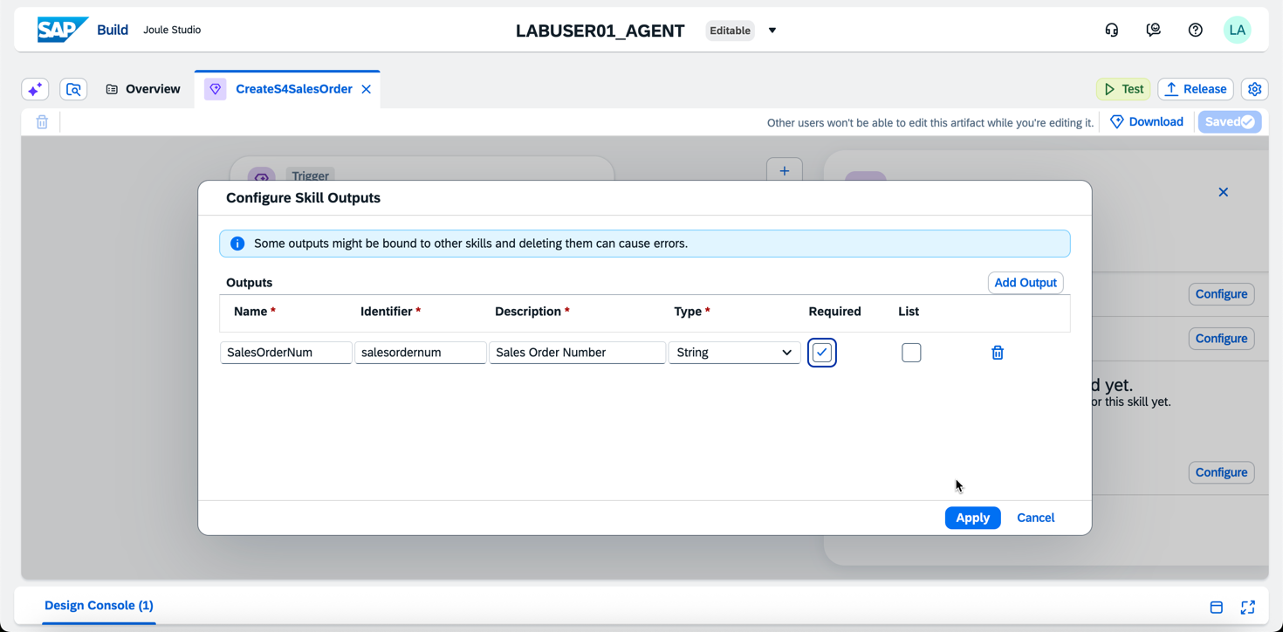
- Click Apply
- Next, click on End, and click into the field SalesOrderNum
- Browse the API Results and assign the field SalesOrder
- 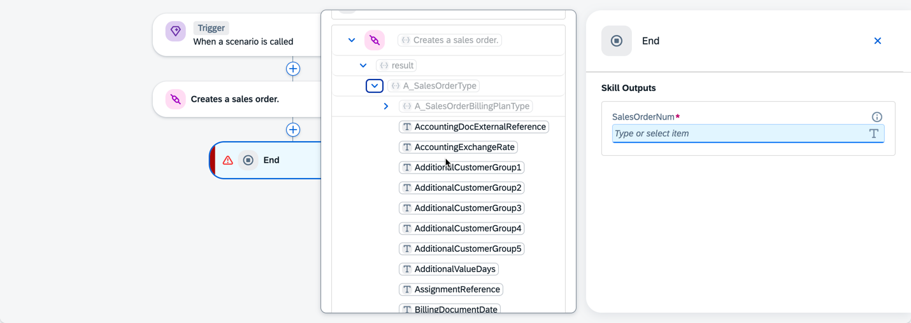
- 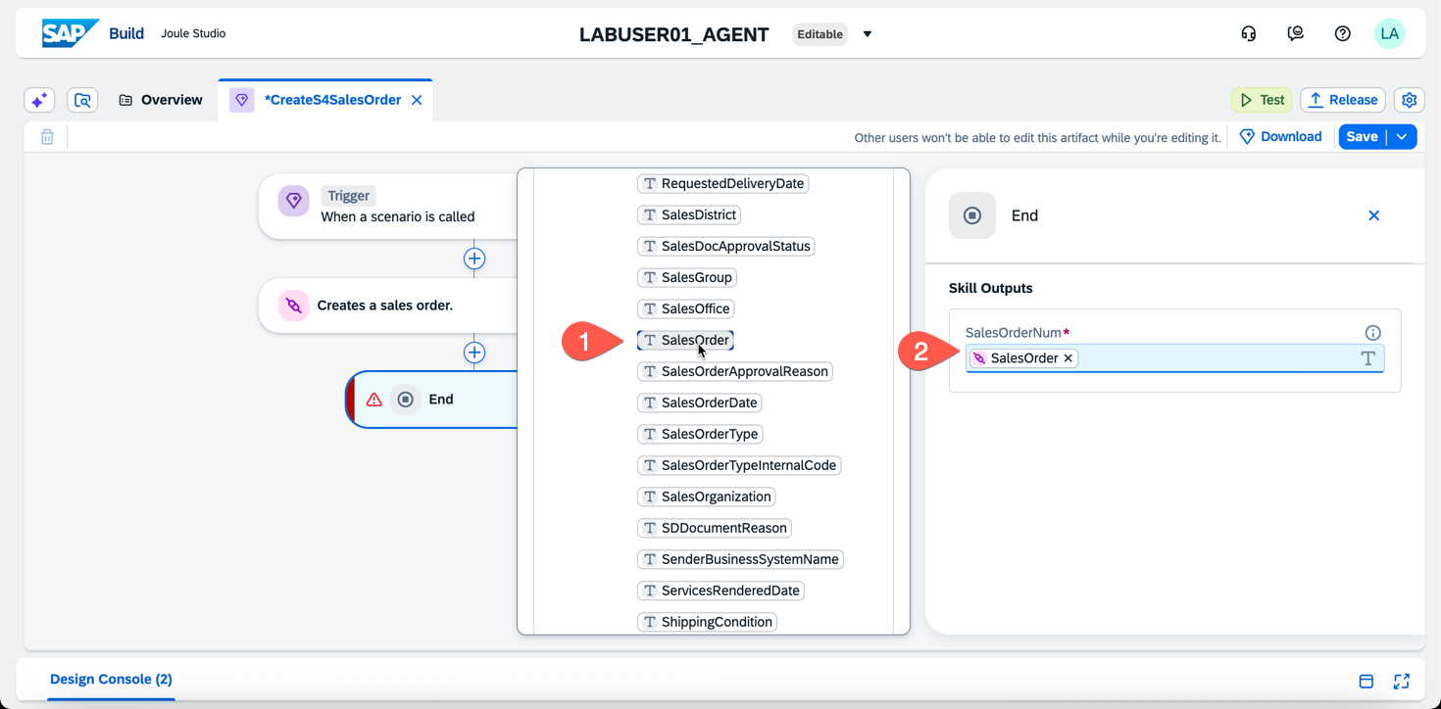
- Click Save

Create a Joule Agent
- One the SAP Joule Studio Overview, click Create > Joule Agent
- 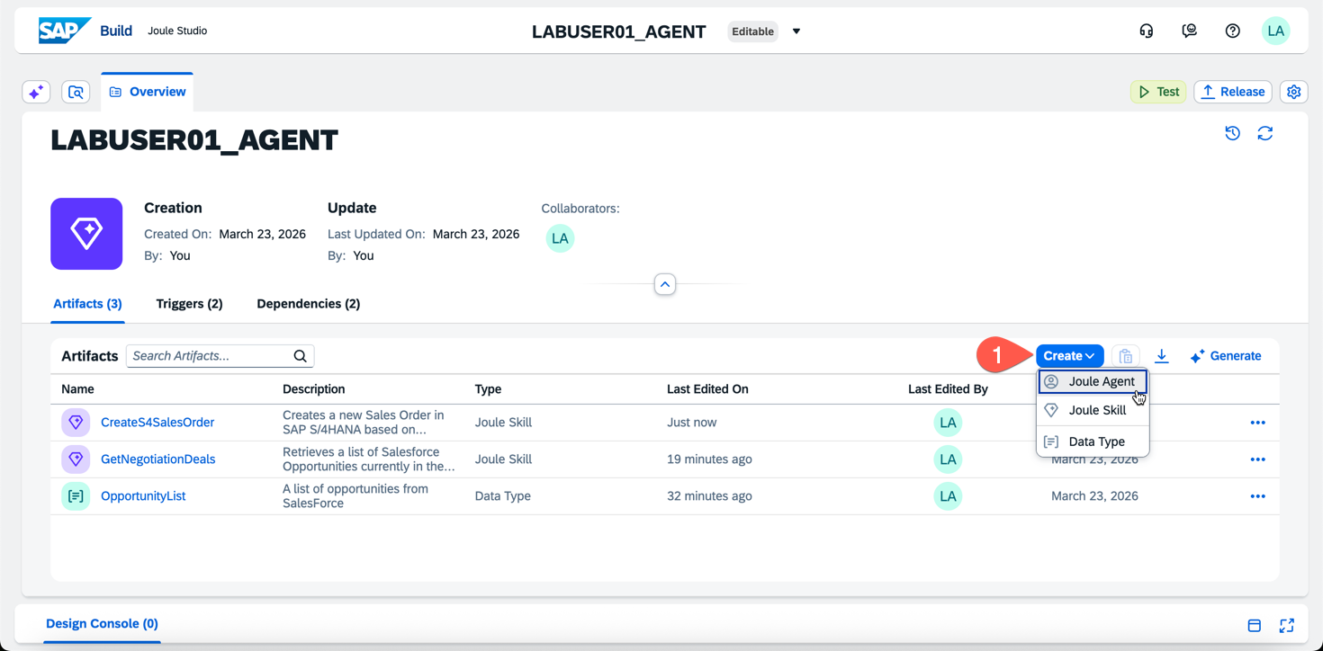
- Enter the following details
  - Name: SalesAssistant
  - Description: Acts as a Sales Assistant to bridge Salesforce and SAP S/4HANA. It identifies Salesforce Opportunities currently in the 'Negotiation/Review' stage, retrieves their associated product line items (including Product Codes and Quantities), and automates the creation of corresponding Sales Orders in the SAP S/4HANA system. Use this agent when a user wants to sync finalized deal data from CRM to ERP or check for pending sales transitions.
- 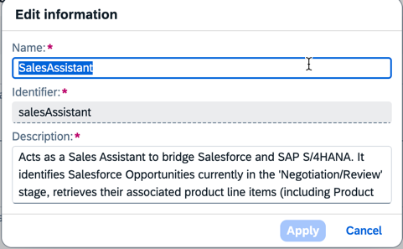
- On the Joule Agent screen, enter the following text notes
- 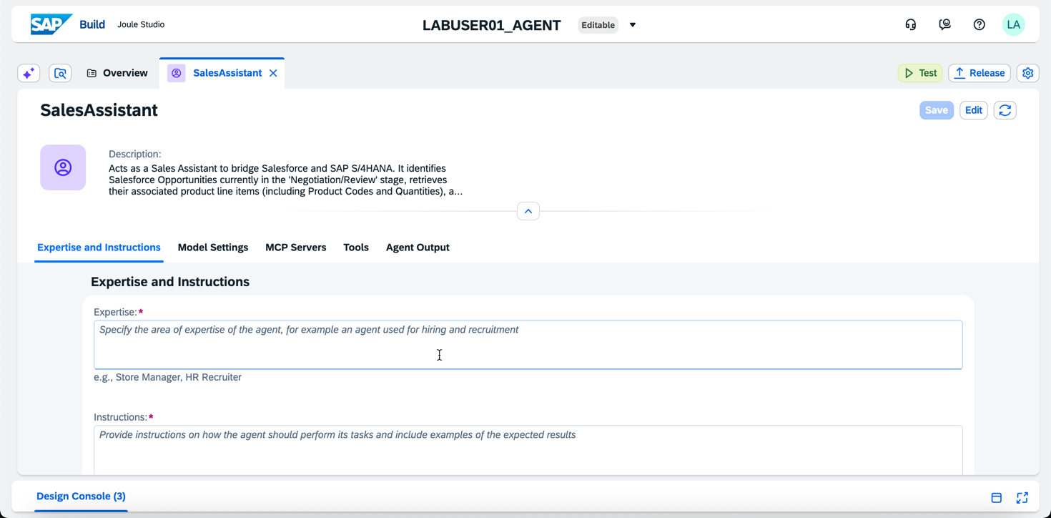
- Text Detail
Expertise | Expert in Salesforce CRM Opportunity Management, specifically the 'Negotiation/Review' sales stage and related Opportunity Line Items. Proficient in SAP S/4HANA Sales Order processing (API_SALES_ORDER). Skilled in data mapping between CRM Product Codes and ERP Material Numbers, ensuring quantity and unit price alignment during the lead-to-order transition.
Instructions | Trigger: When a user asks to check Salesforce opportunities, call the GetNegotiationDeals action which will get a list of Opportunities and associated line items by Opportunity Name which includes SoldToParty as SAP_Sold_To_Party__c in the response.  Data Retrieval: Extract the Opportunity Name, Amount, Account Name, SoldToParty and the nested OpportunityLineItems (specifically ProductCode and Quantity).  Validation: Before creating an order in S/4HANA, display the list of found products to the user and ask: "I found these opportunities with items in Salesforce. Should I proceed with creating the S/4HANA Sales Order?"  Mapping from SalesForce output to SAP required inputs for CreateS4SalesOrder:  1) Name to CustomerRef  2) ProductCode to Material  3) Set RegQtyUnit to 'PC'  4) Quantity to RequestedQty  5) SAP_Sold_To_Party__c to SoldToParty  Execution: Once confirmed, call the S/4HANA Sales Order creation API and confirm with the resulting sales order number (salesordernum)  Confirmation: Provide the user with the new S/4HANA Sales Order Number.
Additional Context | <blank>
- For Model Settings, select the following
- 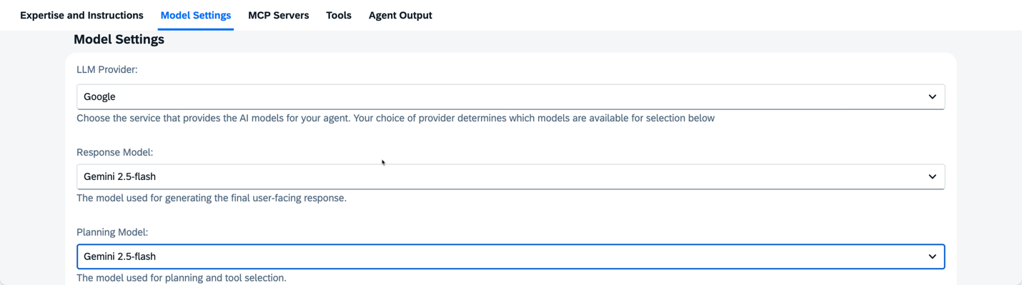
- Leave all other Model Settings as Default
- Skip MCP Servers
- Under Tools, click Add Tool > Joule Skill
- 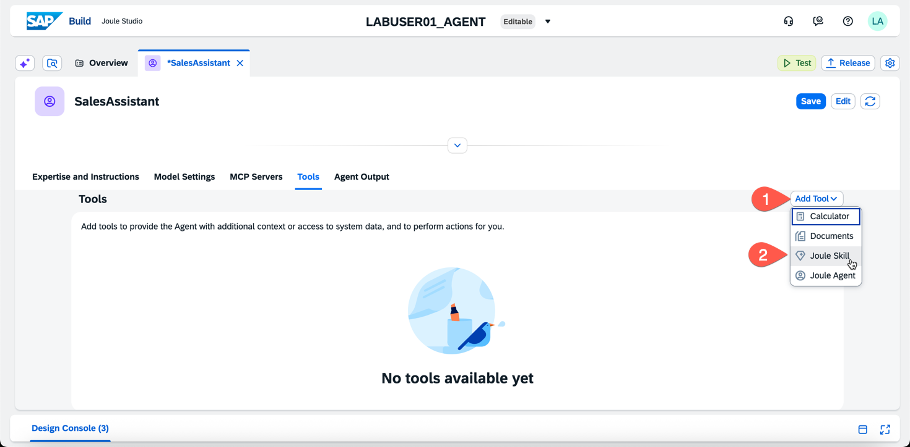
- Add both Joule Skills you created
- 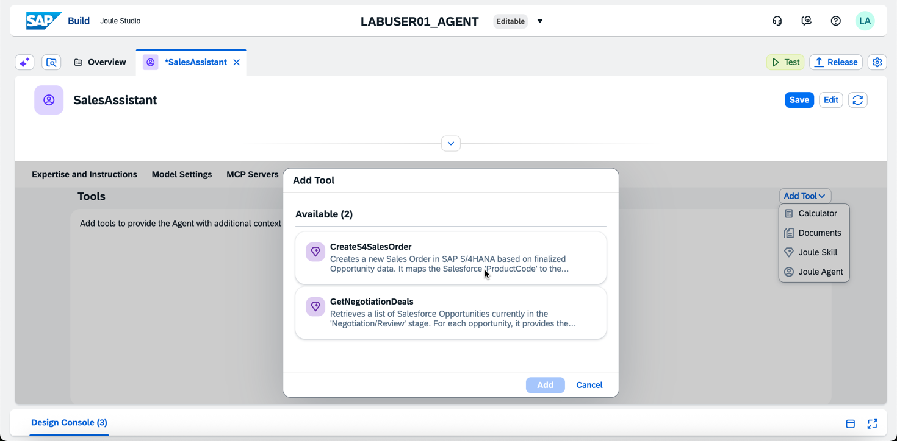
- Leave the defaults under Agent Output
- Click Save
- You’re now ready to Test!

Test your Joule Agent
- Click the Test Button on the upper right
- 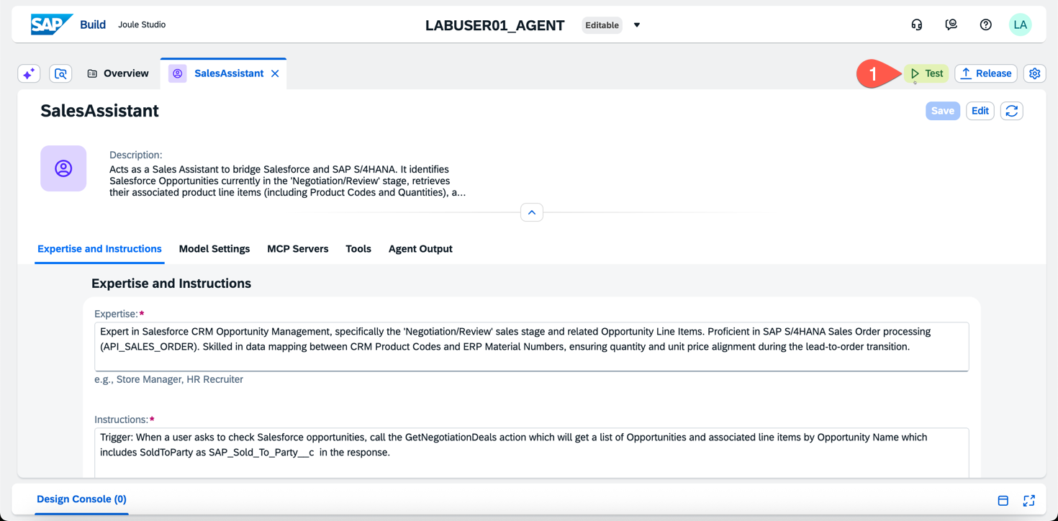
- Enter the Destinations as shown
  - SalesForceDest: SalesForce
  - S4HANADest: S4HANACUST_API
- 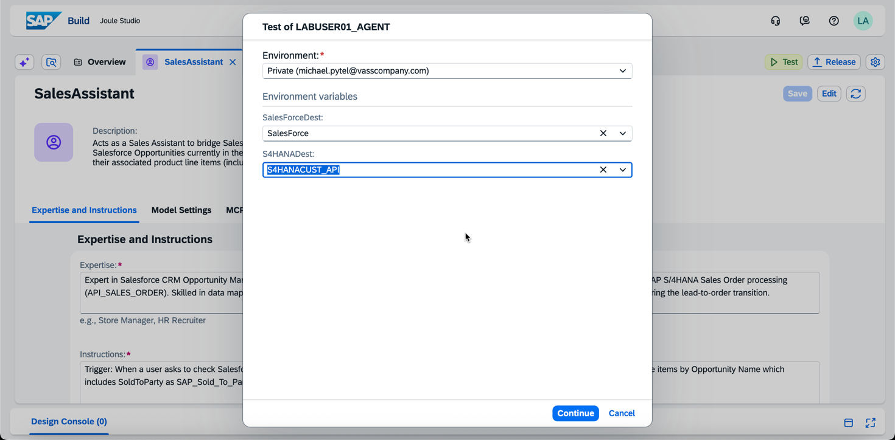
- Click Continue, this will open a new tab
- Enter a request that aligns with the instructions we gave above. For example, “What are the opportunities in salesforce and the associated line items?”
- 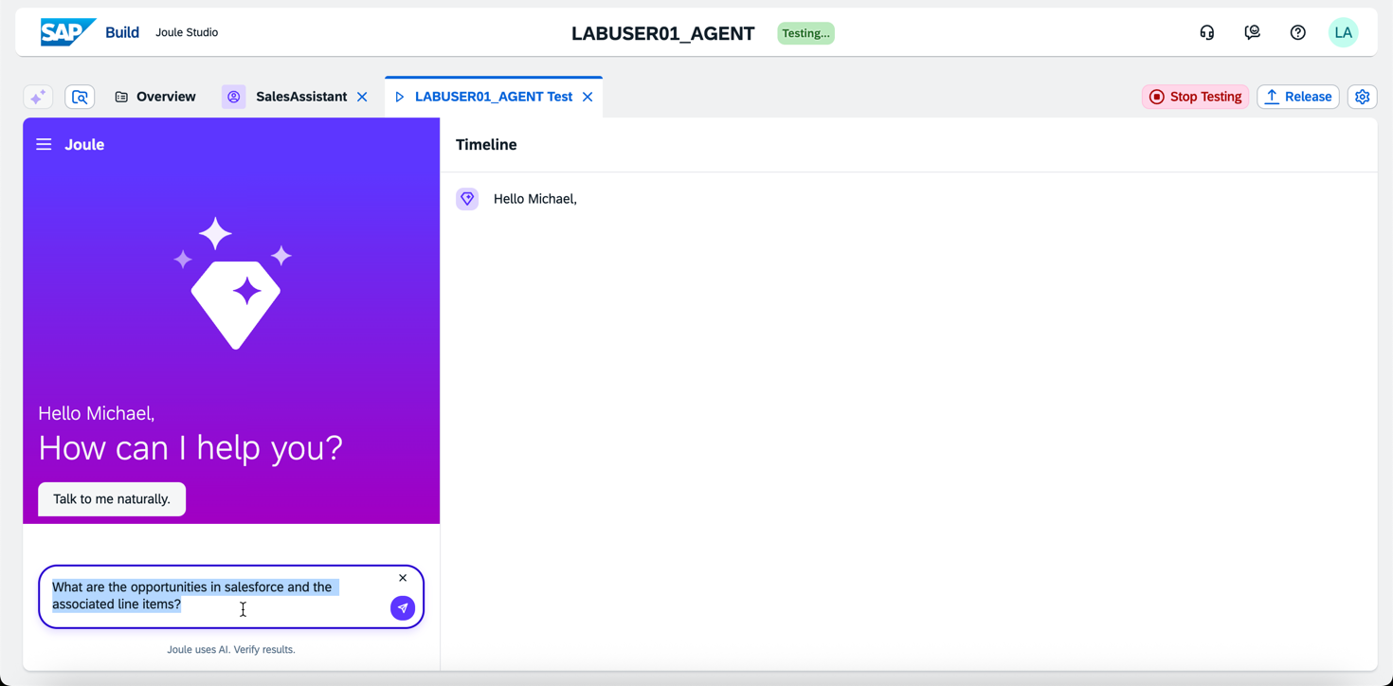
- And a result
- 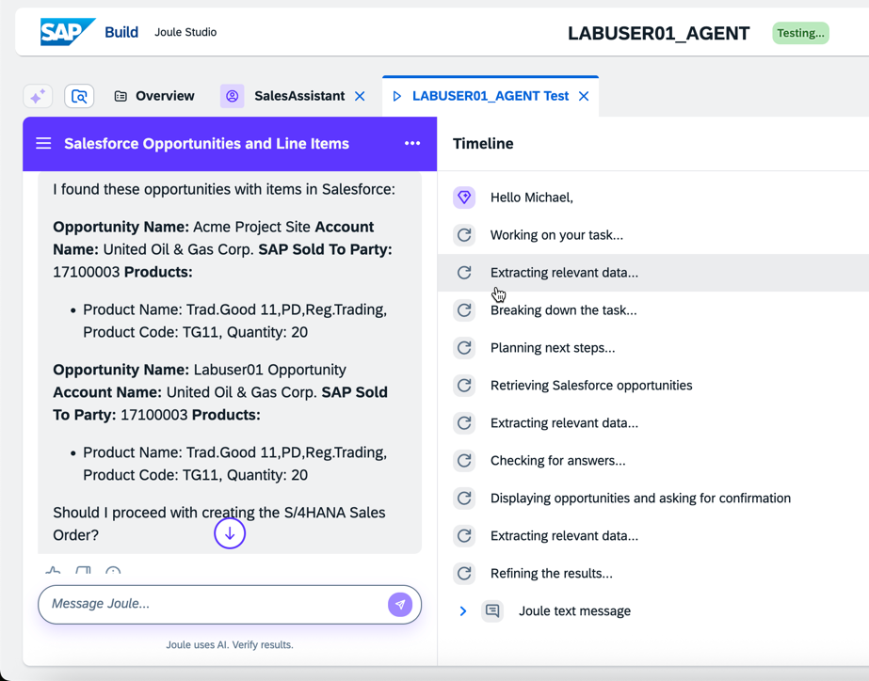
- Next, test the S/4HANA Sales Order entry with “Lets create a sales order for the XYZ Opportunity”; choose any opportunity you see fit.
- 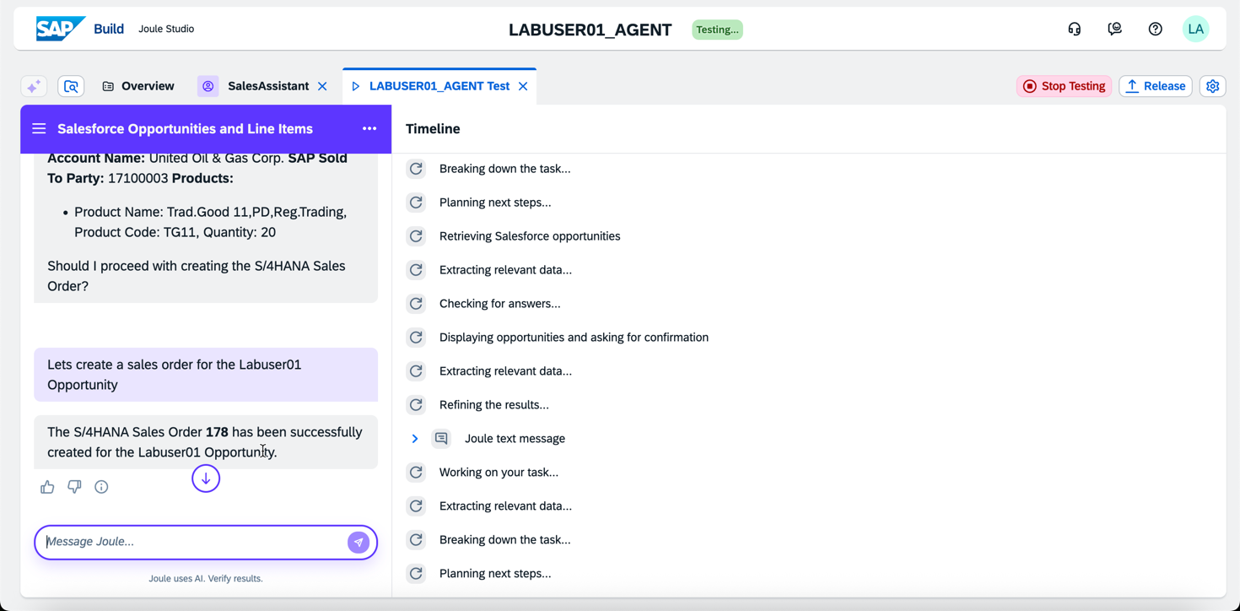
- And confirm the results in S/4HANA!
- Logon to https://my421457.s4hana.cloud.sap/
- Navigate to the app Manage Sales Orders
- 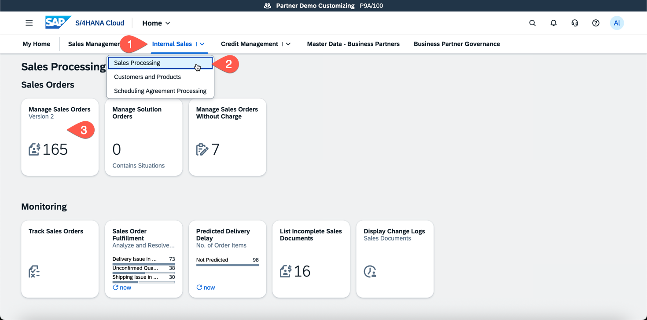
- 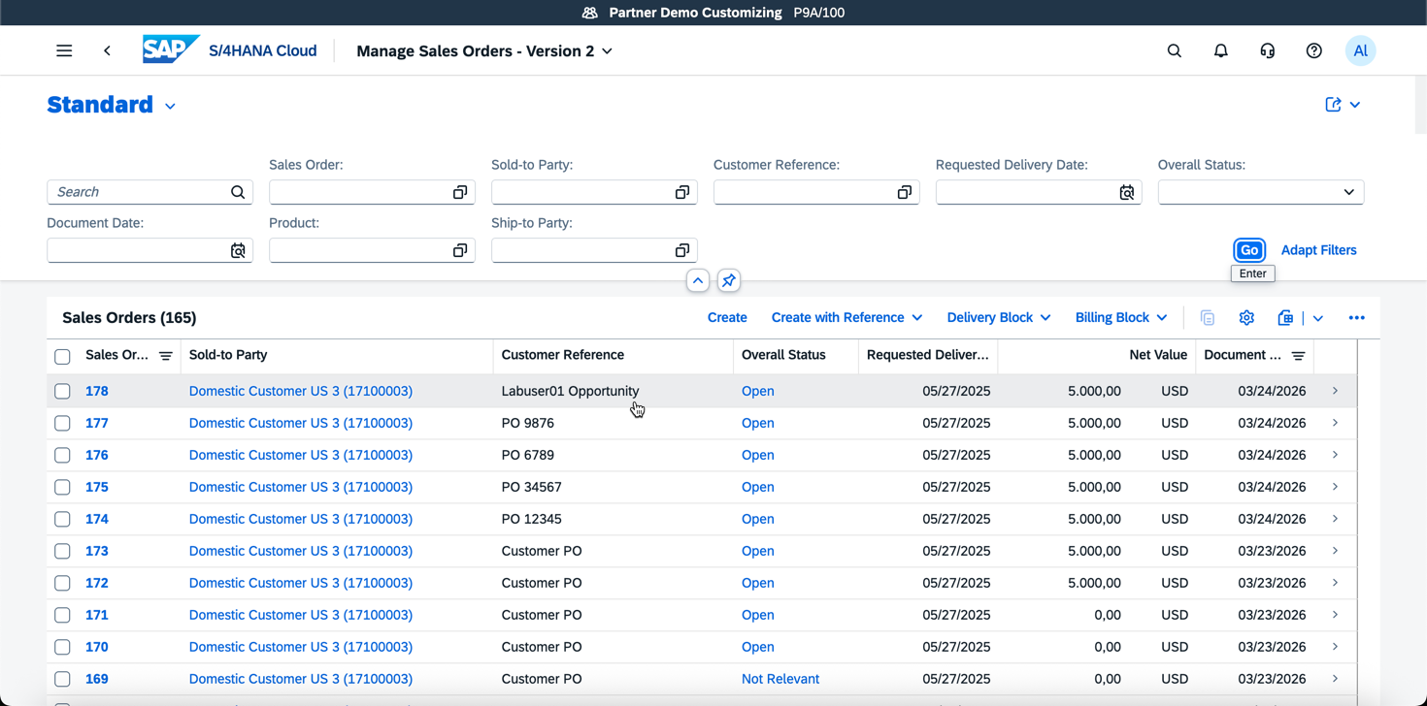
- 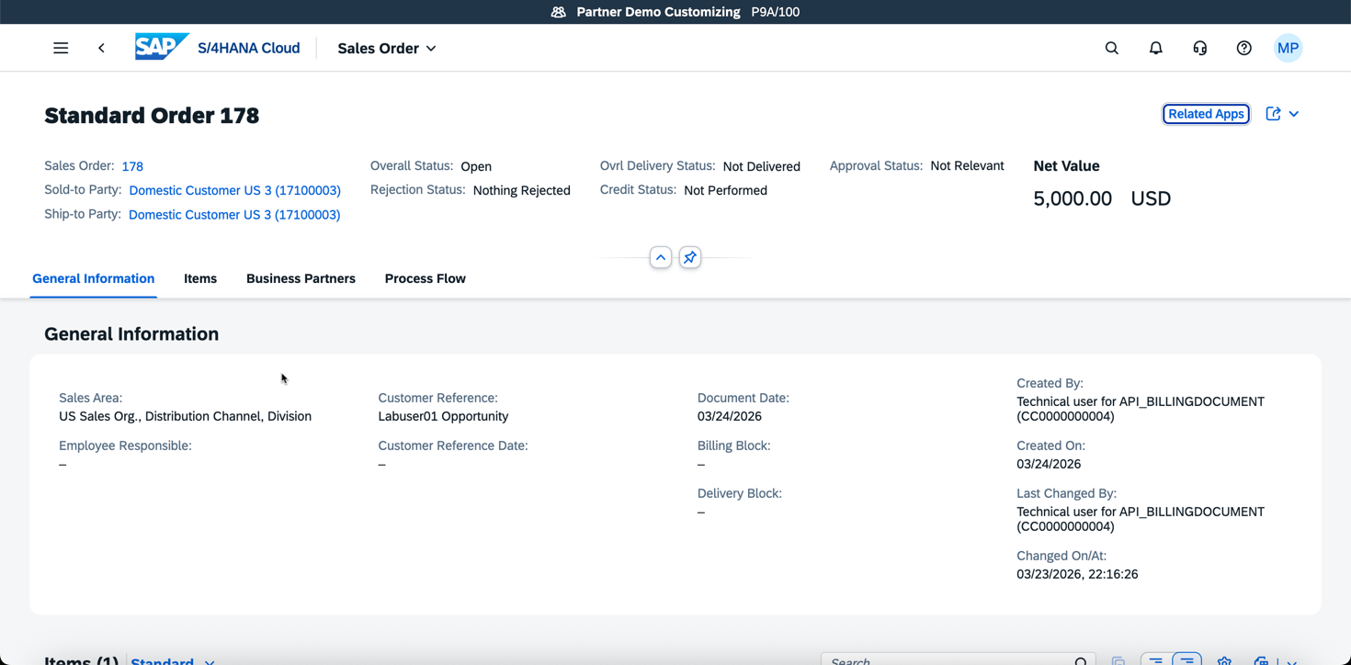

Thank you for completing our Hands-On Lab! Please email if you have any questions!

