Question 2

Code:

select \* From project

WHERE projname LIKE '%urn%

Answer:

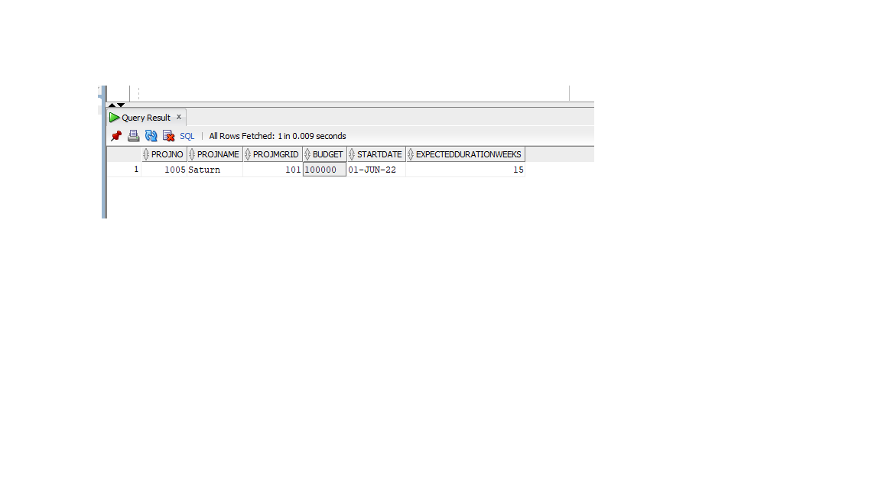

Question 4

Code:

select firstname,lastname

from worker, project

where worker.empid = project.projmgrid and project.projno = 1001

order by lastname asc

Answer:



Question 6

Code:

select \* from project

where budget =

(select max(budget) from project);

Answer:

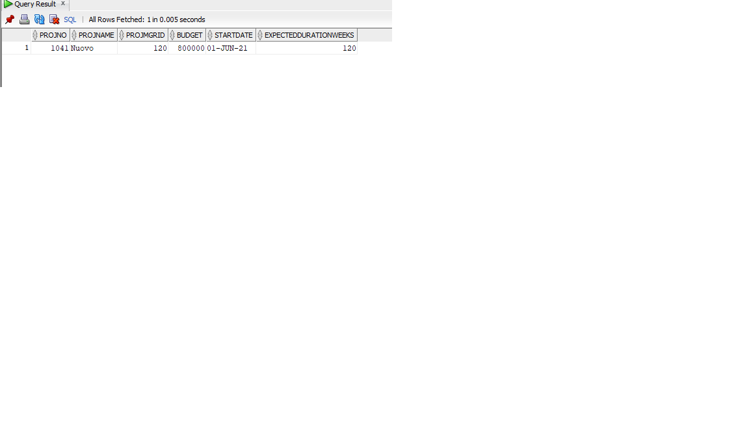

Question 8

Code

Answer

Question 10

Code: select projno,projname

from view.proj

where empid = 101

Answer:

Question 12

Code:

update assign

set

hoursassigned = 10

where empid = 110 and projno = 1019

Answer:



Question 14

Code:

select projno,count(empid) as "number of workers", sum(hoursassigned) as "hoursassigned"

from assign

group by projno1019

Answer:

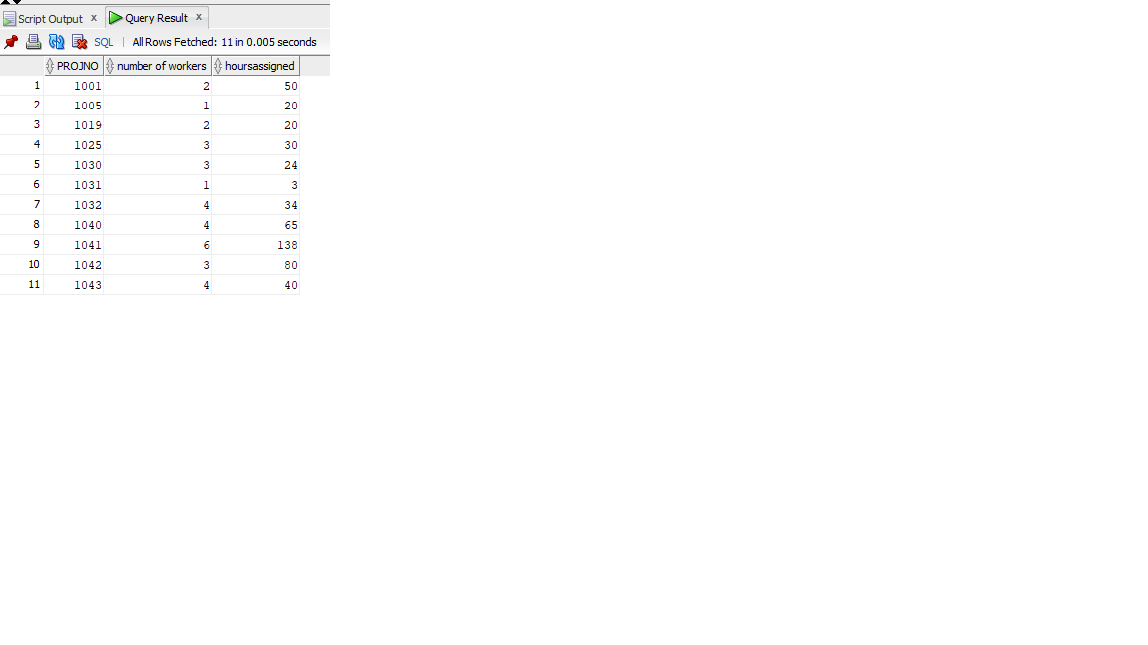

Question 16

Code:

Select project.startdate, project.projname, project.projno

from project

Join(select startdate,count(\*)

from project

group by startdate

having count(\*) >1)

b on project.startdate = b.startdate

order by project.projname

Answer:



Question 18

Code:

select empid,projno,rating

from assign

where rating is null;

Answer:

